

**Capstone Project Report**

**Report 7 – Software Design Document**

– Ho Chi Minh, January 2021 –

Table of Contents

I. Project Report 3

1. Status Report 3

2. Team Involvements 3

3. Issues/Suggestions 3

II. System Requirement Specification 4

1. Overall Description 4

1.1 Product Overview 4

1.2 Business Rules 5

2. User Requirements 9

2.1 Overview 9

2.2 User case specification 11

3. Other Requirements 57

3.1 Messages List 57

**Acknowledge**

First of all, we would like to express our sincere and deepest gratitude to our supervisors, Mr. Pham Cong Thanh and Mr. Doan Nguyen Thanh Hoa, for giving us the precious opportunity to participate in this project. During the process of making the project, the enthusiasm, understanding and valuable knowledge you bring to us are what makes us very grateful. No matter day or night, as long as we have problems, you are always ready to support without complaining, once again we would like to sincerely thank you Mr. Thanh and Mr. Hoa.

We owe deep thanks to lecturers for taking valuable time to help us review this project. Furthermore, all of you also gave very sincere and accurate suggestions to help us realize where the problem is and what we should do to make this project more complete.

We would like to thanks to each individual in our group for our enthusiasm, hard-working, and non-stop effort. Sometimes our group fell into a state of deadlock, stress, and fatigue, but luckily, we all tried to overcome them to reach today. Special thanks to Than Nhat Truong for being a great leader, always be the one who gives the best effort and direction for group members. Thank you Do Ngoc Huu for always tolerating the mistakes of us and the diligent no matter day or night. Much appreciations to Nguyen Thanh Hieu for his silent contributions and always actively taking care of other members. Thank you Nguyen Minh Luan for not giving up and always trying to care about the smallest things.

Last but not least, we would like to extend our gratitude to our families and friends who have provided emotional and practical support for this project. Thanks for everything all of you give us, we will forever be engraved in our heart.

# Defintion and Acronyms

|  |  |
| --- | --- |
| **Acronym** | **Definition** |
| BR | Business Rule |
| BA | Business Analysis |
| ERD | Entity Relationship Diagram |
| GUI | Graphical User Interface |
| UC | Use Case |
| API | Application Programming Interface |
| FE | Feature |
| LI | Limitation |
| EX | Exclusion |
| WBS | Work Breakdown Structure |
| JSON | JavaScript Object Notation |
| CUDA | Compute Unified Device Architecture |
| IIS | Internet Information Services |
| CFFE | Customer Feedback Through Facial Expression Analysis |
| Hot Spot | Count number of customer in specific area |

**I. Project Introduction**

**1. Overview**

**1.1 Project Information**

* Project name: Customer feedback through facial expression analysis
* Project code: CFFE
* Group name: CFFE Team
* Software type: Web App, Mobile App

**1.2 Project Team**

**a. Supervisors**

**Table 2. Supervisors**

|  |  |  |  |
| --- | --- | --- | --- |
| **Full Name** | **Email** | **Phone Number** | **Title** |
| Pham Cong Thanh | thanhpc@fe.edu.vn | 0908316748 | Lecturer |
| Doan Nguyen Thanh Hoa | hoadnt@fe.edu.vn |  | Lecturer |

**b. Team Members**

**Table 3. Team members**

|  |  |  |  |
| --- | --- | --- | --- |
| **Full Name** | **Email** | **Mobile** | **Role** |
| Than Nhat Truong | truongtnse130426@fpt.edu.vn | 0971601584 | Leader |
| Do Ngoc Huu | huudnse130557@fpt.edu.vn | 0397189696 | Member |
| Nguyen Thanh Hieu | hieuntse130434@fpt.edu.vn | 0392997510 | Member |
| Nguyen Minh Luan | luannmse62431@fpt.edu.vn | 0336808288 | Member |

**2. Product Background**

When

**3. Existing Systems**

Currently

**4. Business Opportunity**

Many

**5. Software Product Vision**

For managers

**6. Project Scope & Limitations**

**6.1 Major Features**

1. **Admin**

**FE-01:** Create, view, update, delete, reset password for user.

**FE-02**: Create, view, update, delete area.

**FE-03**: Create, view, update, delete repairer.

1. **Manager**

**FE-04:** View list of staffs in area.

**FE-05:** View list of areas.

**FE-06:** Assign staff to area.

**FE-07:** Update area for user.

1. **Staff**

**FE-08:** Record, verify, update crack.

**FE-09:** Record repair time, process and results.

**FE-10**: Evaluate repair result.

**FE-11:** Receive notification when BCDS completes cracks detection.

1. **Unauthenticated User**

**FE-12:** Login, reset password.

1. **Authenticated User**

**FE-13:** View profile, view notifications, change password.

**FE-14:** View list of cracks, repairers, repair records in area.

**FE-15:** View statistics number of cracks,  number of repair records,…

**6.2 Limitations & Exclusions**

**LI-01:** The BCD system only assists humans in detecting building's cracks, does not completely replace humans, and still need human participation to record and re-check accuracy because of AI errors.

**LI-02:** This system is only for the purpose of recording the condition, repair history, not to schedule repairs or work arrangements for repairer.

**LI-03:** The system is currently only used for buildings, and has not been applied for many other types of spaces.

**LI-04:** The detection result depends on the accuracy of the drone control.

**LI-05:** Only detect the painted walls, no moss.

**LI-06:** Removing duplicates process only applies on one direction recording video.

# III. System Requirement Specification

## 1. Overall Description

### 1.1 Product Overview

#### Unauthenticated User Requirements

Unauthenticated user who has not been identified by CFFE system. Unauthenticated user has limited access to the system with the following feature:

* Login by account

#### Authenticated User Requirements

Authenticated User who has been logged into the CFFE system. Authenticated user can use the following functions:

* Logout
* Get own profile
* Update own profile
* Get the report
* Download the report
* Get the video
* Get the products
* Get product detail
* Get the categories
* Get category detail
* Get the cameras
* Get camera detail

#### Manager Requirements

Manager is a person who accesses to the system as manager role. Manager can use the following functions:

* Get the shelves
* Get shelf detail
* Update the shelf
* Delete the shelf
* Create the shelf
* Get the stacks
* Get stack detail
* Update the stack
* Delete the stack
* Create the stack
* Upload the videos

#### Admin Requirements

Admin is a person who accesses to the system as admin role. Admin can use the following functions:

* Get the stores
* Get store detail
* Update the store
* Delete the store
* Create the store
* Get the managers
* Get manager detail
* Update the manager
* Reset account's password
* Delete the manager
* Create the manager
* Create new account
* Update the product
* Delete the product
* Create new product
* Update the camera
* Delete the camera
* Create new camera
* Update the category
* Delete the category
* Create new category

#### System AI Requirements

System AI is an actor which can do:

* Analyze facial expression
* Count the customers

### 1.2 Business Rules

|  |  |
| --- | --- |
| ID | Rule Definition |
| BR-001 | User logs in CFFE system by username and password are registered. If the username and password are correct, CFFE system redirects users to "Dash board" page. |
| BR-002 | After successful login, the system will automatically generate a token and send it to the client. The client will save in local storage and cookies. |
| BR-003 | When changing the manager status to inactive, there must be a reason and sure that this store is removed from the manager. |
| BR-004 | After logging out successfully, user becomes the “Unauthenticated User” and CFFE system will redirect to login page. |
| BR-005 | Information on local storage will be removed on the client-side. |
| BR-006 | Cookies will be destroyed on the client-side. |
| BR-007 | The password must be SHA256 encrypted before sending it to the server. |
| BR-008 | After resting account's password or creating account successfully, CFFE system sends an email for the manager that includes:   * Username * Password |
| BR-009 | Stack's status has three options:   * Active (active and has added the camera and the product) * Pending (active but has not added the product or camera) * Inactive (inactive) |
| BR-010 | CFFE system only allows users to play video that has been analyzed and stored. |
| BR-011 | Displays a list of videos with the following information:   * Store * Shelf (Counting type) * Video name * Start time * End time * Upload time * Analyzed result |
| BR-012 | Password must be at least 8 characters and contain the following:   * At least one uppercase letter * At least one lowercase letter * At least one digits |
| BR-013 | User can search the categories with following conditions:   * Category name * Status (Category’s status includes all statuses, active, and inactive) * Status's default value is all statuses. |
| BR-014 | Shelf select box can select multiple values that include:   * All shelves * Specific shelves (including active, pending, and inactive shelves that sort by shelf's name)   Default value is all shelves. |
| BR-015 | Displays a list of managers with the following information:   * No * Username * Full name * Store * Updated Time * Status |
| BR-016 | Product select box can select multiple values that include:   * All products * Specific products (including active, and inactive products that sort by product's name   Default value is all products |
| BR-017 | Admin can search the manager with following conditions:   * Search text * Option (Option includes Full name, User name) * Status (Manager’s status includes all statuses, active, pending, and inactive)   Option's default value is username  Status's default value is all status. |
| BR-018 | Analyzed options checkbox can select single values that include:   * Counting * Emotion   Default value is emotion and counting. |
| BR-019 | Video uploading is mp4 format and their name must follow the pattern:  [Camera type]_[MAC address]_[File order]  In there:   * Value of camera type is 1: counting or 2: emotion. * MAC address is for the added cameras on the shelves or stacks. |
| BR-020 | Duplicate videos could not be uploaded by checking video name, video creation date, and checking in Database. |
| BR-021 | User can search the videos with following conditions:   * Start Date * End Date * Video type: counting/emotion * Store * Shelf * Product   Start Date and End Date's default interval value is 10 days from the current date.  Store's default value is all stores.  Shelf's default value is all shelves.  Product's default value is the first value.  Video type's default value is counting.  If counting checkbox is chosen, shelf field is hidden. Else if emotion checkbox is chosen,  product field is hidden.  If user is a manager, the store will be specifically assigned the managing store and hide the store field. |
| BR-022 | Managers can only view the camera in the store they are managing and the camera has pending and inactive status. |
| BR-023 | Displays the user detail with the following information:   * Full name * Email * Gender Birthday * Phone * Identity Card * Username * Store |
| BR-024 | The shelf can add maximum of two cameras. |
| BR-025 | After creating a successful shelf, the stacks will automatically create based on the number of stacks. |
| BR-026 | Manager can search the shelves with following conditions:   * Shelf name * Status (Shelf’s status includes all status, active, and inactive)   Status's default value is all status. |
| BR-027 | Displays a list of shelves with the following information:   * No * Shelf name * Description * Number of stacks * Updated time * Status |
| BR-028 | Displays the shelf detail with the following information:   * Shelf name * Description * Number of stacks * Created * Updated time * Reason inactive * Status * Camera Added * List of stacks * Stack detail |
| BR-029 | If the pending camera is used by any shelf or stack, the camera's status will change to active automatically.  If the active camera is removed from any shelf or stack, the camera's status will change to pending automatically. |
| BR-030 | When changing the shelf's status to inactive, there must be a reason and sure that all the stacks are inactive and all cameras on the shelf are removed. |
| BR-031 | A shelf information required fields:   * Name: between 1 - 100 characters, unique in a store * Description: between 1 - 250 characters * Number of stacks: between 1 - 30 stacks * Status: active/pending/inactive |
| BR-032 | After updating or deleting, CFFE system updates the Updated Time. |
| BR-033 | Deletion is a change to inactive status |
| BR-034 | Manager's status has three options:   * Active (Manager is active and is managing a store) * Pending (Manager is active and isn't managing a store) * Inactive (Manager is inactive) |
| BR-035 | After creation, CFFE system stores the create time. |
| BR-036 | The product must be added before the camera can be added to the stack. Conversely, camera removal is required before the product is removed from the stack. |
| BR-037 | * Displays a list of stacks with the following information: * No * Product * Camera * Status |
| BR-038 | * Displays the stack detail with the following information: * No * Product added * Camera added * Created Time * Updated Time * Reason inactive * Status |
| BR-039 | Manager only can select a pending camera, product to set up on the shelf, stack. |
| BR-040 | * Only stores and managers with pending status can be selected for manager and store management. |
| BR-041 | When changing the stack status from pending to inactive, there must be a reason and sure that the product and camera on the stack are removed. |
| BR-042 | If the product and camera are already on the stack, the stack's status will change to active automatically. If the product or camera on the stack is missed, the status will change to pending automatically. |
| BR-043 | A new account will be generated by the following method:   * Username: [Manager's first name] + [First letter of manager's last name] + [Sequence number]. * Password: automatically generate. |
| BR-044 | User can search the products with following conditions:   * Product name * Product category * Status (Product’s status includes all statuses, active, and inactive)   Product category's default value is all categories.  Status's default value is all statuses. |
| BR-045 | * Displays a list of products with the following information: * No * Product name * Product image * Description * Category * Updated time * Status |
| BR-046 | * Displays the product detail with the following information: * Product name * Product image * Category * Description * List of stores * List of stacks * Created * Updated time * Reason inactive * Status |
| BR-047 | * A product information required fields: * Product name: between 1 - 100 characters, unique * Image: must be png, jpg, jpeg format * Category: 1 - 3 categories * Description: between 1 - 250 characters * Status: active/inactive |
| BR-048 | * Shelf's status has three options: * Active (active and has added one or two cameras) * Pending (active but has not added the camera) * Inactive (inactive) |
| BR-049 | When changing the product status to inactive, there must be a reason and sure that this product on all stacks is removed. |
| BR-050 | Stack's No is the position on the shelf that is automatically generated by the CFFE system in the order of creation. |
| BR-051 | If the camera is already on the shelf, the shelf's status will change to active automatically.  If the camera on the shelf is missed, the shelf's status will change to pending automatically. |
| BR-052 | User can search the cameras with following conditions:   * Camera name * Store * Status (Camera’s status includes all status, active, pending, and inactive)   Store's default value is all stores  Status's default value is all status. |
| BR-053 | * Displays a list of cameras with the following information: * No * Camera name * Camera image * Store * MAC Address * Updated Time * Status |
| BR-054 | * Displays the camera detail with the following information: * Camera name * Camera image * Ip address * RTSP string * Shelf * Stack * Created * Updated time * Reason inactive * Status |
| BR-055 | * A camera information required fields: * Camera name: between 1 - 100 characters, unique * Image: must be png, jpg, jpeg format * IP address: x.x.x.x (x is number between 0 to 255), unique * MAC address: hexadecimal separated by "-", unique * RTSP string: at least 1 character, unique * Status: active/pending/inactive |
| BR-056 | * Camera status has three options: * Active (active and has added on a shelf or stack) * Pending (active but has not added on a shelf or stack) * Inactive (inactive) |
| BR-057 | When changing the category status to inactive, make sure that all products that have this category remove mapping. |
| BR-058 | When changing the camera status to inactive, there must be a reason and sure that this camera are removed from the shelf or stack. |
| BR-059 | Store's status has three options:   * Active (active and had added the manager) * Pending (active but hadn't added the manager) * Inactive (inactive) |
| BR-060 | A user information required fields:   * Full name: between 1 - 100 characters * Username: between 1 - 30 characters * Image: must be png, jpg, jpeg format + Gender: Male/Female * Birthday: must be DD:MM:YYYY * Identity card: between 9 - 12 digits * Phone: between 10 - 13 digits * Email: must match /^(([^<>()[\]\\.,;:\s@"]+(\.[^<>()[\]\\.,;:\s@"]+)*)|(".+"))@((\[[0-9]{1,3}\.[0-9]{1,3}\.[0-9]{1,3}\.[0-9]{1,3}\])|(([a-zA-Z\-0-9]+\.)+[a-zA-Z]{2,}))$/ regex * Address: between 1 - 250 characters + City + District * Status: active/pending/inactive |
| BR-061 | * Displays the store detail with the following information: * Full name * Username * Avatar * Gender * Birthday * Identity Card * Phone * Email * Store * Address * City * District * Created Time * Updated time * Reason inactive * Status |
| BR-062 | * Displays the category detail with the following information: * Category name * Products belongs to the category |
| BR-063 | * A category information required fields: * Category name: between 1 - 100 characters, unique |
| BR-064 | * Admin can search the stores with following conditions: * Store name * City * Status (Store’s status includes all status, active and inactive) * Status's default value is all status. * City's default value is all cities. |
| BR-065 | * Displays a list of stores with the following information: * No * Store name * Image * Manager * Address * District * City * Updated Time * Status |
| BR-066 | * Displays the store detail with the following information: * Store name * Image * Manager * Address * City * District * Product list * Camera list * Created * Updated time * Reason inactive * Status |
| BR-067 | * A store information required fields: * Store name: between 1 - 100 characters, unique * Image: must be png, jpg, jpeg format * Address: between 1 - 250 characters * City: 1 city * District: 1 district * Status: active/pending/inactive |
| BR-068 | * When granting store management rights to the manager, the status of the store and manager will automatically change to active. * When removing the manager from the store, the status of the store and manager will automatically change to pending. |
| BR-069 | When changing the store status to inactive, there must be a reason and sure that this manager is removed from the store and all shelves of this store are inactive. |
| BR-070 | After creating, the objects have the following status:   * Store: Pending * Manager: Pending * Camera: Pending * Shelf: Pending * Stack: Pending * Product: Active * Category: Active |

*Table 1 - Business rules*

## 2. User Requirements

### 2.1 Overview

#### Use Case Diagram

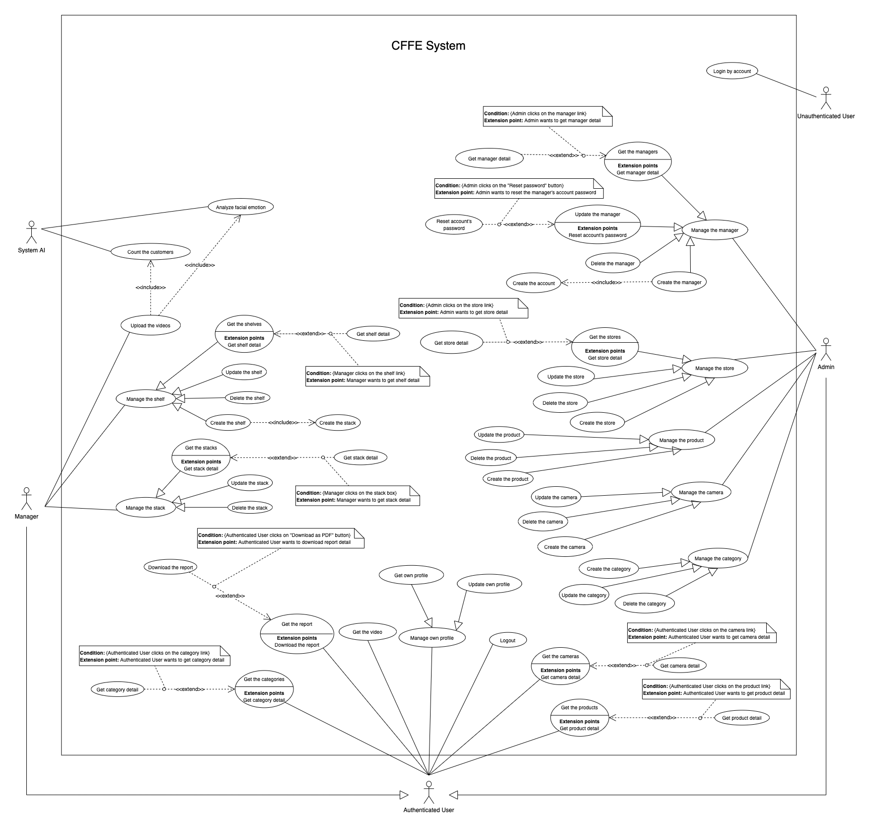

*Figure 1 - <Use Case Overview> Overview*

#### System Actors

|  |  |  |
| --- | --- | --- |
| **#** | **Actor** | **Description** |
| 1 | Unauthenticated User | Unauthenticated User is person who has no account. |
| 2 | Authenticated User | Authenticated User is a person who has an account in the system (There are two roles that are admin and manager). |
| 3 | Manager | Manager manages the store's products, shelves, stacks, and cameras. |
| 4 | Admin | Admin manages the managers, accounts, and stores in the system. |
| 5 | System AI | System AI analyses customers' emotions and count the customers in the stores. |

*Table 2 - System actors*

#### Use Case List

|  |  |  |  |
| --- | --- | --- | --- |
| **ID** | **Use Case** | **Primary Actors** | **Secondary Actors** |
| UC-01 | **Login by account** | Unauthenticated User | N/A |
| UC-02 | **Logout** | Authenticated User | N/A |
| UC-03 | **Get own profile** | Authenticated User |  |
| UC-04 | **Update own profile** | Authenticated User | N/A |
| UC-05 | **Get the report** | Authenticated User | N/A |
| UC-06 | **Download the report** | Authenticated User | N/A |
| UC-07 | **Get the video** | Authenticated User | ~~N/A~~ |
| UC-08 | **Get the products** | Authenticated User | N/A |
| UC-09 | **Get product detail** | Authenticated User | N/A |
| UC-10 | **Get the categories** | Authenticated User | N/A |
| UC-11 | **Get category detail** | Authenticated User | N/A |
| UC-12 | **Get the cameras** | Authenticated User | N/A |
| UC-13 | **Get camera detail** | Authenticated User | N/A |
| UC-14 | **Get the shelves** | Manager | N/A |
| UC-15 | **Get shelf detail** | Manager | N/A |
| UC-16 | **Update the shelf** | Manager | N/A |
| UC-17 | **Delete the shelf** | Manager | N/A |
| UC-18 | **Create the shelf** | Manager | N/A |
| UC-19 | **Get the stacks** | Manager | N/A |
| UC-20 | **Get stack detail** | Manager | N/A |
| UC-21 | **Update the stack** | Manager | N/A |
| UC-22 | **Delete the stack** | Manager | N/A |
| UC-23 | **Create the stack** | Manager | N/A |
| UC-24 | **Upload the videos** | Manager | N/A |
| UC-25 | **Get the stores** | Admin | N/A |
| UC-26 | **Get store detail** | Admin | N/A |
| UC-27 | **Update the store** | Admin | N/A |
| UC-28 | **Delete the store** | Admin | N/A |
| UC-29 | **Create the store** | Admin | N/A |
| UC-30 | **Get the managers** | Admin | N/A |
| UC-31 | **Get manager detail** | Admin | N/A |
| UC-32 | **Update the manager** | Admin | N/A |
| UC-33 | **Reset account's password** | Admin | N/A |
| UC-34 | **Delete the manager** | Admin | N/A |
| UC-35 | **Create the manager** | Admin | N/A |
| UC-36 | **Create new account** | Admin | N/A |
| UC-37 | **Update the product** | Admin | N/A |
| UC-38 | **Delete the product** | Admin | N/A |
| UC-39 | **Create new product** | Admin | N/A |
| UC-40 | **Update the camera** | Admin | N/A |
| UC-41 | **Delete the camera** | Admin | N/A |
| UC-42 | **Create new camera** | Admin | N/A |
| UC-43 | **Update the category** | Admin | N/A |
| UC-44 | **Delete the category** | Admin | N/A |
| UC-45 | **Create new category** | Admin | N/A |
| UC-46 | **Analyze facial emotion** | System AI | N/A |
| UC-47 | **Count the customers** | System AI | N/A |

*Table 3 - Use case list*

### User case specification



#### 2.2.1 <Unauthenticated User> Overview Use Case

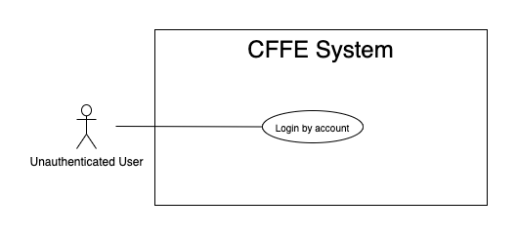

*Figure 2 - <Overview Use Case> Unauthenticated User*

##### 2.2.1.1 <Unauthenticated User> Login by account



*Figure 3 - <Use Case> Login by account*

|  |  |  |  |
| --- | --- | --- | --- |
| ID and Name: | **UC-01 Login by account** | | |
| Created By: | TruongTN | Date Created: | 25/06/2021 |
| Primary Actor: | Unauthenticated User | Secondary Actors: | N/A |
| Description: | This feature allows the unauthenticated user to login to CFFE system to verify the role and gives them access to more features. | | |
| Trigger: | Unauthenticated User sends a request to login to CFFE system. | | |
| Pre-conditions: | PRE-01. User's account has been created.  PRE-02. User's account has been authorized as Admin or Manager role.  PRE-03. User has not logged in to CFFE system. | | |
| Post-conditions: | POST-01:   * Success: User logins to CFFE system with own role successfully and redirect to "Dashboard" page. * Fail: CFFE system shows error message. | | |
| Normal Flow: | **1.0 Login by account**   1. Unauthenticated User send a request to login to the CFFE system. 2. CFFE system requires information from Unauthenticated User:  * “Username”: input text * “Password”: input text * “Login”: button  1. Unauthenticated User inputs a login form: username, password. 2. Unauthenticated User clicks to “Login” button. 3. CFFE system validates the username and password. (Exception 1.0.E1, 1.0.E2) 4. CFFE system determines the user’s identity, role, and permission then redirects to the "Dashboard" page. | | |
| Alternative Flows: | N/A | | |
| Exceptions: | **1.0.E1 Unauthenticated User does not enter the required fields**   1. CFFE system returns to Unauthenticated User to fill the required fields again (MSG-001, MSG-002). 2. If Unauthenticated User inputs the required fields again, CFFE system returns to step 3 of the normal flow. 3. Else if Unauthenticated User cancels the login process, then CFFE system terminates this use case.   **1.0.E2 Unauthenticated User enters wrong username or password.**   1. CFFE system returns to Unauthenticated User to fill the required fields again (MSG-003). 2. If Unauthenticated User inputs username and password again, CFFE system returns to step 3 of the normal flow. 3. Else if Unauthenticated User cancels the login process, then CFFE system terminates this use case. | | |
| Priority: | High | | |
| Frequency of Use: | Always | | |
| Business Rules: | BR-001, BR-002, BR-007 | | |
| Other Information: | In case of internet connection failure, Unauthenticated User cannot finish this use case. | | |
| Assumptions: | N/A | | |

*Table 4 - <Use Case> Login by account*

#### 2.2.2 <Authenticated User> Overview Use Case

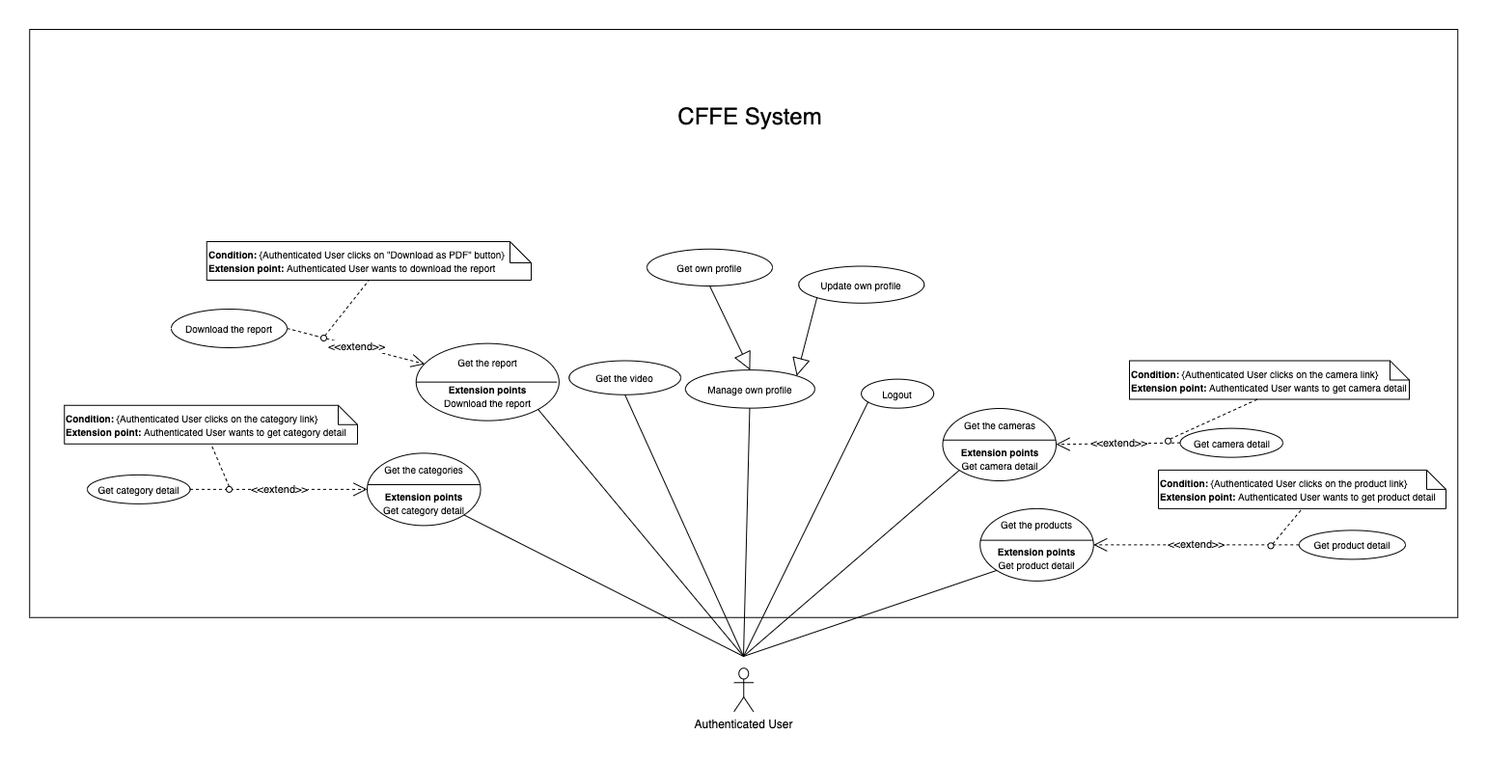

*Figure 4 - <Overview Use Case> Authenticated User*

##### 2.2.2.1 <Authenticated User> Logout

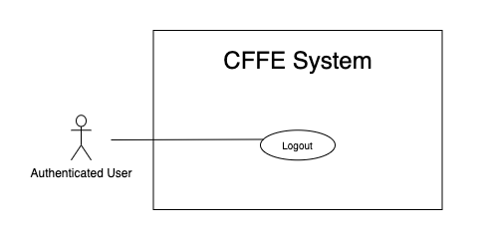

*Figure 5 - <Use Case> Logout*

|  |  |  |  |
| --- | --- | --- | --- |
| ID and Name: | **UC-02 Logout** | | |
| Created By: | TruongTN | Date Created: | 25/06/2021 |
| Primary Actor: | Authenticated User | Secondary Actors: | N/A |
| Description: | This feature allows the authenticated user to log out from CFFE system. | | |
| Trigger: | Authenticated user sends a request to log out from CFFE system. | | |
| Pre-conditions: | PRE-01. User has logged into CFFE system. | | |
| Post-conditions: | POST-01. User has successfully logged out CFFE system. | | |
| Normal Flow: | **2.0 Logout**   1. Authenticated user focus on username then clicks on “Logout” button on the navigation bar. 2. CFFE system deletes information on their local storage and cookie. 3. CFFE system redirects to "Login" page. | | |
| Alternative Flows: | N/A | | |
| Exceptions: | N/A | | |
| Priority: | Medium | | |
| Frequency of Use: | Usually | | |
| Business Rules: | BR-004, BR-005, BR-006 | | |
| Other Information: | In case of internet connection failure, Authenticated User cannot finish this use case. | | |
| Assumptions: | N/A | | |

*Table 5 - <Use Case> Logout*

##### 2.2.2.2 <Authenticated User> Get own profile

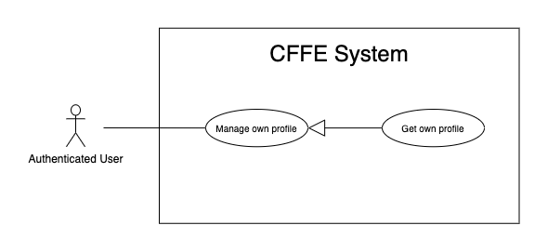

*Figure 43 - <Use Case> Get own profile*

|  |  |  |  |
| --- | --- | --- | --- |
| ID and Name: | **UC-03 Get own profile** | | |
| Created By: | HuuDN | Date Created: | 17/06/2021 |
| Primary Actor: | Authenticated User | Secondary Actors: | N/A |
| Description: | This feature allows the authenticated user to get own profile. | | |
| Trigger: | Authenticated User sends a request to get own profile. | | |
| Preconditions: | PRE-01. User has logged into CFFE system. | | |
| Post-conditions: | POST-01:   * Success: CFFE system redirects to own profile page. * Fail: CFFE system shows error message. | | |
| Normal Flow: | **3.0 Get own profile**   1. Authenticated User focus on username then clicks on "Profile" button on the navigation bar. 2. CFFE system returns own profile and redirects to profile page. (Exception 3.0.E1) | | |
| Alternative Flows: | N/A | | |
| Exceptions: | **3.0.E1 Authenticated User does not exist.**  1. CFFE system returns the message (MSG-041) and terminates this use case. | | |
| Priority: | Normal | | |
| Frequency of Use: | Sometime | | |
| Business Rules: | N/A | | |
| Other Information: | In case of internet connection failure, Authenticated User cannot finish this use case properly. | | |
| Assumptions: | N/A | | |

*Table 42 - <Use Case> Get own profile*

##### 2.2.2.3 <Authenticated User> Update own profile

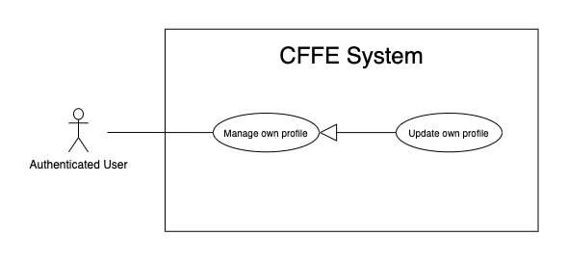

*Figure 44 - <Use Case> Update own profile*

|  |  |  |  |
| --- | --- | --- | --- |
| ID and Name: | **UC-04 Update own profile** | | |
| Created By: | HuuDN | Date Created: | 17/06/2021 |
| Primary Actor: | Authenticated User | Secondary Actors: | N/A |
| Description: | This feature allows the authenticated user to update own profile. | | |
| Trigger: | Authenticated User sends a request to update own profile. | | |
| Preconditions: | PRE-01. User has logged in CFFE system.  PRE-02. User is on “Profile” page. | | |
| Post-conditions: | POST-01:   * Success: CFFE system shows success message and reloads "Profile" page. * Fail: CFFE system shows error message. | | |
| Normal Flow: | **4.0 Update information** (Alternative 4.0, 4.1)   1. Authenticated User clicks on "Edit Information" button. 2. CFFE system requires profile that includes:  * “Full name”: input text * “Gender”: radio button * “Birthday”: date picker * “Identity card”: input text * “Phone number”: input text * “Email”: input text * “Address”: input text * “City”: select box * “District”: select box * “Cancel”: button * “Update”: button  1. Authenticated User inputs/selects the required fields. 2. Authenticated User clicks on “Update” button. (Alternative 4.2) 3. CFFE system validates the fields (Exception 4.0.E1, 4.0.E2) 4. CFFE system updates own profile and returns the success message (MSG-013). | | |
| Alternative Flows: | **4.0 Update Avatar**   1. Authenticated User clicks on "Update avatar" button. 2. CFFE system shows popup that includes:    * "Avatar": label    * "Choose": button    * "OK": button    * "Cancel": button 3. Authenticated User clicks on "Choose" button and selects an image. 4. Authenticated User clicks on "OK" button. (Alternative 4.2, 4.3) 5. CFFE system validates the image (Exception 4.0.E3, 4.0.E4, 4.0.E7) 6. CFFE system updates own avatar and returns the success message (MSG-013).   **4.1 Update password**   1. Authenticated User clicks on "Change password" button. 2. CFFE system shows popup that includes:    * "Old password": input text    * "New password": input text    * "Retype password": input text    * "OK": button    * "Cancel": button 3. Authenticated User inputs all fields. 4. Authenticated User clicks on "OK" button. (Alternative 4.2, 4.3) 5. CFFE system validates the image (Exception 4.0.E5, 4.0.E6) 6. CFFE system updates own password and returns the success message (MSG-013).   **4.2 Authenticated User cancels the updating process.**   1. Authenticated User clicks on "Cancel" button. 2. CFFE system closes this popup and terminates this use case.   **4.3 Authenticated User clicks outside of popup.**   1. Authenticated User clicks outside of popup. 2. CFFE system closes this popup and terminates this use case. | | |
| Exceptions: | **4.0.E1 Authenticated User does not input/select the required fields**   1. CFFE system returns to Authenticated User to input/select the required fields again (MSG-014, MSG-036, MSG-038, MSG-039, MSG-049, MSG-044, MSG-047, MSG-051, MSG-054). 2. If Authenticated User inputs/selects the required fields again, CFFE system returns to step 3 of the normal flow. 3. Else if Authenticated User cancels the updating process, then CFFE system terminates this use case.   **4.0.E2 Authenticated User inputs/selects the fields that are not valid**   1. CFFE system returns to Authenticated Users to input/select the fields again (MSG-015, MSG-037, MSG-042, MSG-045, MSG-052, MSG-073). 2. If Authenticated User inputs/selects the fields again, CFFE system returns to step 3 of the normal flow. 3. Else if Authenticated User cancels the updating process, then CFFE system terminates this use case.   **4.0.E3 Authenticated User does not select an image**   1. CFFE system returns to Authenticated User to select the required fields again (MSG-112). 2. If Authenticated User inputs/selects the required fields again, CFFE system returns to step 3 of the alternative flow 4.0. 3. Else if Authenticated User cancels the updating process, then CFFE system terminates this use case.   **4.0.E4 Image is not png/jpg/jpeg format.**   1. CFFE system shows message (MSG-027) and terminates this use case.   **4.0.E5 Authenticated User does not input the required fields**   1. CFFE system returns to Authenticated User to input/select the required fields again (MSG-004, MSG-005, MSG-006). 2. If Authenticated User inputs/selects the required fields again, CFFE system returns to step 3 of the alternative flow 4.1. 3. Else if Authenticated User cancels the updating process, then CFFE system terminates this use case.   **4.0.E6 Authenticated User inputs the fields that are not valid**   1. CFFE system returns to Authenticated Users to input/select the fields again (MSG-007, MSG-008, MSG-068). 2. If Authenticated User inputs/selects the fields again, CFFE system returns to step 3 of the alternative flow 4.1. 3. Else if Authenticated User cancels the updating process, then CFFE system terminates this use case.   **4.0.E7 CFFE system cannot upload the image.**   1. CFFE system shows error message (MSG-114) and terminates this use case. | | |
| Priority: | Medium | | |
| Frequency of Use: | Often | | |
| Business Rules: | BR-032, BR-034, BR-060 | | |
| Other Information: | In case of internet connection failure, Authenticated User cannot finish this use case properly. | | |
| Assumptions: | N/A | | |

*Table 37 - <Use Case> Update own profile*

##### 2.2.2.4 <Authenticated User> Get the report

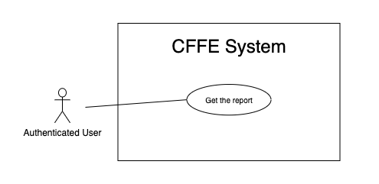

*Figure 7 - <Use Case> Get the report*

|  |  |  |  |
| --- | --- | --- | --- |
| ID and Name: | **UC-05 Get the report** | | |
| Created By: | HuuDN | Date Created: | 15/06/2021 |
| Primary Actor: | Authenticated User | Secondary Actors: | N/A |
| Description: | This feature allows the Authenticated User to get the report. | | |
| Trigger: | Authenticated User sends a request to get the report. | | |
| Preconditions: | PRE-01. User has logged into CFFE system as admin or manager role. | | |
| Post-conditions: | POST-01. Authenticated User has successfully got the report. | | |
| Normal Flow: | **5.0 Get the facial expression analysis report** (Alternative 5.0)   1. Authenticated User clicks on "Dashboard" button on the navigation bar 2. Authenticated User clicks on "Emotion" button on the left-bottom navigation bar of the frame. 3. CFFE system requires the report's information from Authenticated User:  * “Product name”: select box * “Store name”: select box * “Date rage”: date range picker  1. Authenticated User selects all fields. 2. CFFE system returns the reports (Exception 5.0.E1). | | |
| Alternative Flows: | **5.0 Get the counting customer report**   1. Authenticated User clicks on "Dashboard" button on the navigation bar. 2. Authenticated User clicks on "Counting customer" button on the left-bottom navigation bar of the frame. 3. CFFE system requires the report's information from Authenticated User:  * “Store name”: select box * “Shelf name”: select box * “Date rage”: date range picker  1. Authenticated User selects all fields. 2. CFFE system returns the reports (Exception 5.0.E1). | | |
| Exceptions: | **5.0.E1 The report has no data.**   1. CFFE system returns the message (MSG-009). | | |
| Priority: | High | | |
| Frequency of Use: | Often | | |
| Business Rules: | BR-013, BR-014, BR-016 | | |
| Other Information: | In case of internet connection failure, Authenticated User cannot finish this use case properly. | | |
| Assumptions: | N/A | | |

*Table 7 - <Use Case> Get the report*

##### 2.2.2.5 <Authenticated User> Download the report

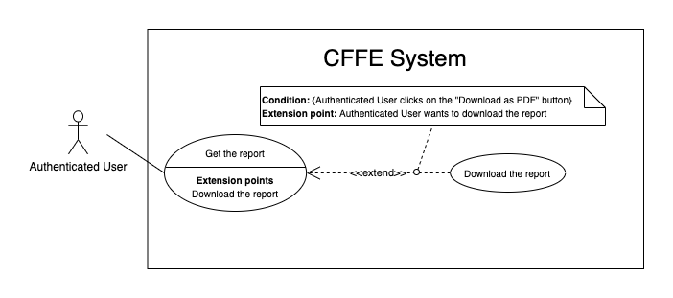

*Figure 8 - <Use Case> Download the report*

|  |  |  |  |
| --- | --- | --- | --- |
| ID and Name: | **UC-06 Download the report** | | |
| Created By: | HuuDN | Date Created: | 18/06/2021 |
| Primary Actor: | Authenticated User | Secondary Actors: | N/A |
| Description: | This feature allows Authenticated User to download the report. | | |
| Trigger: | Authenticated User sends a request to download the report. | | |
| Preconditions: | PRE-01. User has logged into CFFE system as admin or manager role.  PRE-02. Authenticated User on "Dashboard" page. | | |
| Post-conditions: | POST-01. Authenticated User has successfully downloaded the report. | | |
| Normal Flow: | **6.0 Download the report**   1. Authenticated User right clicks on "Dashboard" page. 2. Authenticated User clicks on "Download as PDF" 3. CFFE system shows the popup that includes:    * "All pages": radio button    * "Select pages": radio button    * "Additional Options": dropdown list      1. "Ignore custom background color": check box      2. "Add a link back to report": check box      3. "Password protect report": check box    * "Download": button    * "Cancel": button 4. Authenticated User selects that fields 5. Authenticated User clicks on "Download" button. (Alternative 6.0, 6.1) 6. CFFE system downloads this report on client-side. | | |
| Alternative Flows: | **6.0 Authenticated User cancels the downloading process.**   1. Authenticated User clicks on "Cancel" button. 2. CFFE system closes this popup and terminates this use case.   **6.1 Authenticated User clicks outside of popup.**   1. Authenticated User clicks outside of popup. 2. CFFE system closes this popup and terminates this use case. | | |
| Exceptions: | N/A | | |
| Priority: | High | | |
| Frequency of Use: | Often | | |
| Business Rules: | BR-008, BR-009. | | |
| Other Information: | In case of internet connection failure, Authenticated User cannot finish this use case properly. | | |
| Assumptions: | N/A | | |

*Table 8 - <Use Case> Download the report*

##### 2.2.2.6 <Authenticated User> Get the video

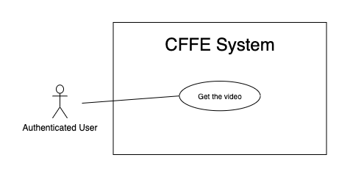

*Figure 9 - <Use Case> Get the video*

|  |  |  |  |
| --- | --- | --- | --- |
| ID and Name: | **UC-07 Get the video** | | |
| Created By: | HuuDN | Date Created: | 11/06/2021 |
| Primary Actor: | Authenticated User | Secondary Actors: | N/A |
| Description: | This feature allows Authenticated User to get the video. | | |
| Trigger: | Authenticated User sends a request to get the video. | | |
| Preconditions: | PRE-01. User has logged into CFFE system as admin or manager role. | | |
| Post-conditions: | POST-01. Authenticated User has successfully got the video. | | |
| Normal Flow: | **7.0 Get the video**   1. Authenticated User clicks on "Video" button on the navigation bar. 2. CFFE system requires the video's information from Authenticated User:  * “Start Date”: text input * “End Date”: text input * “Counting”: check box * “Emotion”: check box * “Store”: select box * “Shelf”: select box * “Product”: select box  1. Authenticated User inputs/selects the fields. 2. CFFE system returns the corresponding videos (Exception 7.0.E1). | | |
| Alternative Flows: | N/A | | |
| Exceptions: | **7.0.E1 The video list has no data.**   1. CFFE system returns the message (MSG-009). | | |
| Priority: | High | | |
| Frequency of Use: | Often | | |
| Business Rules: | BR-010, BR-011, BR-021 | | |
| Other Information: | In case of internet connection failure, Authenticated User cannot finish this use case properly. | | |
| Assumptions: | N/A | | |

*Table 9 - <Use Case> Get the video*

##### 2.2.3.7 <Authenticated User> Get the products

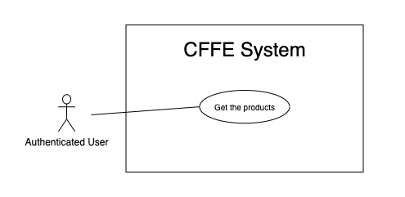

*Figure 22 - <Use Case> Get the products*

|  |  |  |  |
| --- | --- | --- | --- |
| ID and Name: | **UC-08 Get the products** | | |
| Created By: | HieuNT | Date Created: | 08/05/2021 |
| Primary Actor: | Authenticated User | Secondary Actors: | N/A |
| Description: | This feature allows authenticated user to get the products. | | |
| Trigger: | Authenticated user sends a request to get the products. | | |
| Pre-conditions: | PRE-01. User has logged into the system as admin or manager role. | | |
| Post-conditions: | POST-01. CFFE system returns the list of products. | | |
| Normal Flow: | **8.0 Get the products**   1. Authenticated User clicks on "Product" button on the navigation bar. 2. CFFE system requires the product information:  * “Product name”: input text * “Category”: select box * “Status”: select box  1. Authenticated user inputs/selects the fields: product name, category, status. 2. CFFE system returns the list of products based on below conditions and display them (Exception 8.0.E1). | | |
| Alternative Flows: | N/A | | |
| Exceptions: | **8.0.E1 The list of product has no data.**   1. CFFE system returns the message (MSG-009). | | |
| Priority: | High | | |
| Frequency of Use: | Usually | | |
| Business Rules: | BR-044, BR-045 | | |
| Other Information: | In case of internet connection failure, authenticated user cannot finish this use case properly. | | |
| Assumptions: | N/A | | |

*Table 21 - <Use Case> Get the products*

##### 2.2.3.8 <Authenticated User> Get product detail

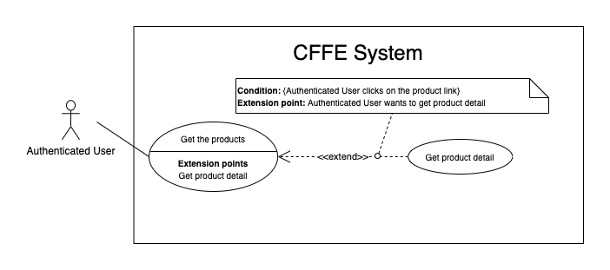

*Figure 23 - <Use Case> Get product detail*

|  |  |  |  |
| --- | --- | --- | --- |
| ID and Name: | **UC-09 Get product detail** | | |
| Created By: | HieuNT | Date Created: | 10/05/2021 |
| Primary Actor: | Authenticated User | Secondary Actors: | N/A |
| Description: | This feature allows the authenticated user to getproductdetail. | | |
| Trigger: | Authenticated user sends a request to get product detail. | | |
| Preconditions: | PRE-01. User has logged in the system as admin or manager role.  PRE-02. There is at least one product link. | | |
| Post-conditions: | POST-01:   * Success: CFFE system redirects to "Product Detail" page. * Fail: CFFE system shows error message. | | |
| Normal Flow: | **9.0 Get product detail**   1. Authenticated user clicks on the product link. 2. CFFE system validates the product exists (Exception 19.0.E1) 3. CFFE system returns the product information and redirects to product detail page. | | |
| Alternative Flows: | N/A | | |
| Exceptions: | **9.0.E1 The product does not exist.**  1. CFFE system returns the message (MSG-023) and terminates this use case. | | |
| Priority: | High | | |
| Frequency of Use: | Usually | | |
| Business Rules: | BR-046 | | |
| Other Information: | In case of internet connection failure, Authenticated user cannot finish this use case properly. | | |
| Assumptions: | N/A | | |

*Table 22 - <Use Case> Get product detail*

##### 2.2.3.9 <Authenticated User> Get the categories

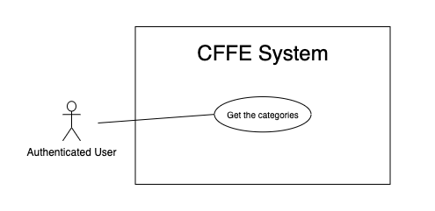

*Figure 32 - <Use Case> Get the categories*

|  |  |  |  |
| --- | --- | --- | --- |
| ID and Name: | **UC-10 Get the categories** | | |
| Created By: | TruongTN | Date Created: | 08/05/2021 |
| Primary Actor: | Authenticated user | Secondary Actors: | N/A |
| Description: | This feature allows manager to get the categories. | | |
| Trigger: | Authenticated user sends a request to get the categories. | | |
| Pre-conditions: | PRE-01. User has logged into the system as admin or manager role. | | |
| Post-conditions: | POST-01. CFFE system returns the list of categories. | | |
| Normal Flow: | **10.0 Get the categories**   1. Authenticated user clicks on "Category" button on the navigation bar. 2. CFFE system requires the category information:  * “Category name”: input text * “Status”: select box  1. Authenticated user inputs/selects the fields: category name, status 2. CFFE system returns the list of categories based on below conditions and display them (Exception 10.0.E1). | | |
| Alternative Flows: | N/A | | |
| Exceptions: | **10.0.E1 The list of categories has no data.**   1. CFFE system returns the message (MSG-009). | | |
| Priority: | High | | |
| Frequency of Use: | Usually | | |
| Business Rules: | BR-013, BR-062 | | |
| Other Information: | In case of internet connection failure, authenticated user cannot finish this use case properly. | | |
| Assumptions: | N/A | | |

*Table 31 - <Use Case> Get the categories*

##### 2.2.3.10 <Authenticated User> Get category detail

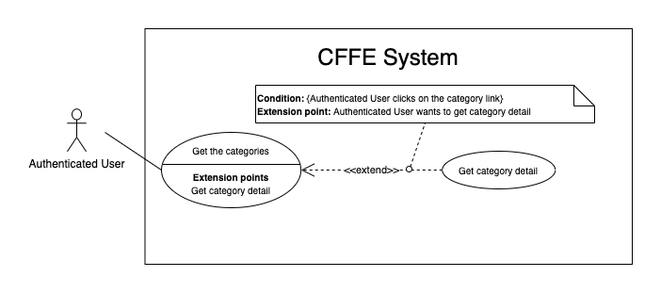

*Figure 33 - <Use Case> Get category detail*

|  |  |  |  |
| --- | --- | --- | --- |
| ID and Name: | **UC-11 Get category detail** | | |
| Created By: | HuuDN | Date Created: | 10/05/2021 |
| Primary Actor: | Authenticated User | Secondary Actors: | N/A |
| Description: | This feature allows the authenticated user to getcategorydetail. | | |
| Trigger: | Authenticated user sends a request to get categorydetail. | | |
| Preconditions: | PRE-01. User has logged in the system as admin or manager role.  PRE-02. User is on "Category" page. | | |
| Post-conditions: | POST-01:   * Success: CFFE system returns category detail successfully. * Fail: CFFE system shows error message. | | |
| Normal Flow: | **11.0 Get category detail**   1. Authenticated user clicks on the category button of the left-side list. 2. CFFE system validates the categoryexists (Exception 11.0.E1) 3. CFFE system returns the categoryinformation. | | |
| Alternative Flows: | N/A | | |
| Exceptions: | **11.0.E1 The category does not exist.**  1. CFFE system returns the message (MSG-029) and terminates this use case.  **11.0.E2 The list of products that belong to this category has no data.**  1. CFFE system returns the message (MSG-009). | | |
| Priority: | High | | |
| Frequency of Use: | Usually | | |
| Business Rules: | BR-062 | | |
| Other Information: | In case of internet connection failure, Authenticated User cannot finish this use case properly. | | |
| Assumptions: | N/A | | |

*Table 32 - <Use Case> Get category detail*

##### 2.2.3.11 <Authenticated User> Get the cameras

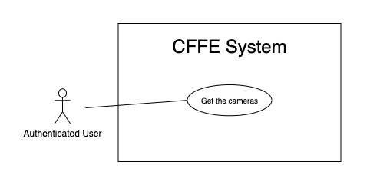

*Figure 27 - <Use Case> Get the cameras*

|  |  |  |  |
| --- | --- | --- | --- |
| ID and Name: | **UC-12 Get the cameras** | | |
| Created By: | HuuDN | Date Created: | 08/05/2021 |
| Primary Actor: | Authenticated user | Secondary Actors: | N/A |
| Description: | This feature allows authenticated user to get the cameras. | | |
| Trigger: | Authenticated user sends a request to get the cameras. | | |
| Pre-conditions: | PRE-01. User has logged into the system as admin or manager role. | | |
| Post-conditions: | POST-01. CFFE system returns the list of cameras. | | |
| Normal Flow: | **12.0 Get the cameras**   1. Authenticated user clicks on "Camera" button on the navigation bar. 2. CFFE system requires the camera information:  * “Camera name”: input text * “Store”: select box * “Status”: select box  1. Authenticated user inputs/selects the fields. 2. CFFE system returns the list of cameras based on below conditions and display them (Exception 12.0.E1). | | |
| Alternative Flows: | N/A | | |
| Exceptions: | **12.0.E1 The list of cameras has no data.**   1. CFFE system returns the message (MSG-009). | | |
| Priority: | High | | |
| Frequency of Use: | Usually | | |
| Business Rules: | BR-052, BR-053, BR-056 | | |
| Other Information: | In case of internet connection failure, authenticated user cannot finish this use case properly. | | |
| Assumptions: | N/A | | |

*Table 26 - <Use Case> Get the cameras*

##### 2.2.3.11 <Authenticated User> Get camera detail

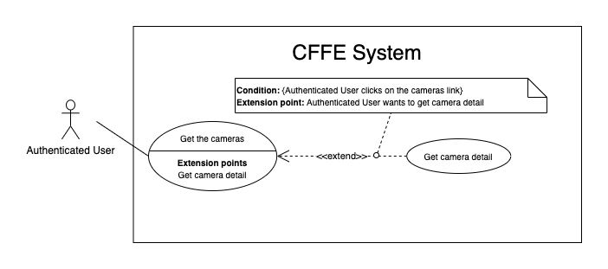

*Figure 28 - <Use Case> Get camera detail*

|  |  |  |  |
| --- | --- | --- | --- |
| ID and Name: | **UC-13 Get camera detail** | | |
| Created By: | HuuDN | Date Created: | 10/05/2021 |
| Primary Actor: | Authenticated User | Secondary Actors: | N/A |
| Description: | This feature allows the authenticated user to getcameradetail. | | |
| Trigger: | Authenticated User sends a request to get camera detail. | | |
| Preconditions: | PRE-01. User has logged in the system as admin or manager role.  PRE-02. There is at least one camera link. | | |
| Post-conditions: | POST-01:   * Success: CFFE system returns camera detail successfully and redirects to "Camera Detail" page. * Fail: CFFE system shows error message. | | |
| Normal Flow: | **13.0 Get camera detail**   1. Authenticated User clicks on the camera link. 2. CFFE system validates the camera exists (Exception 13.0.E1). 3. CFFE system returns the camera information and redirects to camera detail page. | | |
| Alternative Flows: | N/A | | |
| Exceptions: | **13.0.E1 The camera does not exist.**  1. CFFE system returns the message (MSG-009) and terminates this use case. | | |
| Priority: | High | | |
| Frequency of Use: | Usually | | |
| Business Rules: | BR-022, BR-054, BR-056 | | |
| Other Information: | In case of internet connection failure, Authenticated User cannot finish this use case properly. | | |
| Assumptions: | N/A | | |

*Table 27 - <Use Case> Get camera detail*

#### 2.2.3 <Manager> Overview Use Case

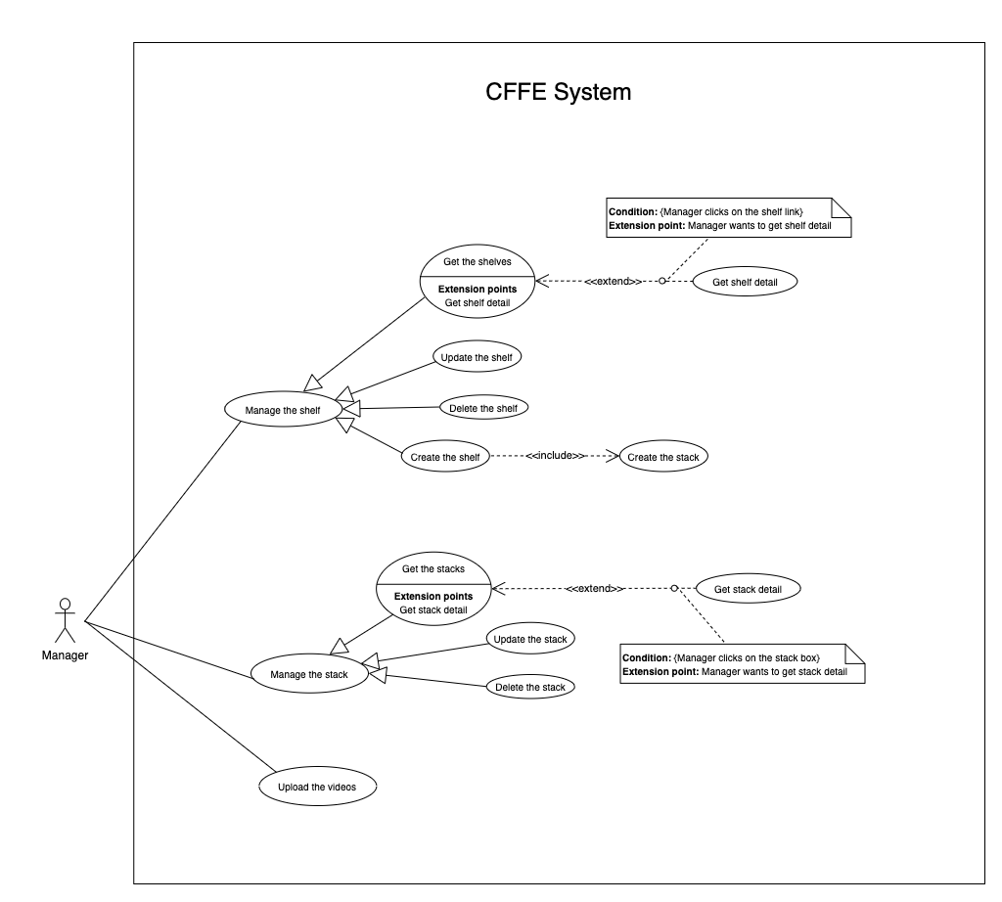

*Figure 11 - <Overview Use Case> Manager*

##### 2.2.3.1 <Manager> Get the shelves

*Figure 12 - <Use Case> Get the shelves*

|  |  |  |  |
| --- | --- | --- | --- |
| ID and Name: | **UC-14 Get the shelves** | | |
| Created By: | TruongTN | Date Created: | 08/05/2021 |
| Primary Actor: | Manager | Secondary Actors: | N/A |
| Description: | This feature allows the manager to get the shelves. | | |
| Trigger: | Manager sends a request to get the shelves. | | |
| Pre-conditions: | PRE-01. User has logged into the system as manager role.  PRE-02. Manager is managing a store. | | |
| Post-conditions: | POST-01. CFFE system returns the list of shelves. | | |
| Normal Flow: | **14.0 Get the shelves**   1. Manager clicks on "Shelf" button on the navigation bar. 2. CFFE system requires the shelf information from Manager:  * “Shelf name”: input text * “Status”: select box  1. Manager inputs/selects the fields. 2. CFFE system returns the shelves based on below conditions and display them (Exception 14.0.E1). | | |
| Alternative Flows: | N/A | | |
| Exceptions: | **14.0.E1 The list of shelves has no data.**   1. CFFE system returns the message (MSG-009). | | |
| Priority: | High | | |
| Frequency of Use: | Usually | | |
| Business Rules: | BR-026, BR-027, BR-048 | | |
| Other Information: | In case of internet connection failure, Manager cannot finish this use case properly. | | |
| Assumptions: | N/A | | |

*Table 11 - <Use Case> Get the shelves*

##### 2.2.3.2 <Manager> Get shelf detail

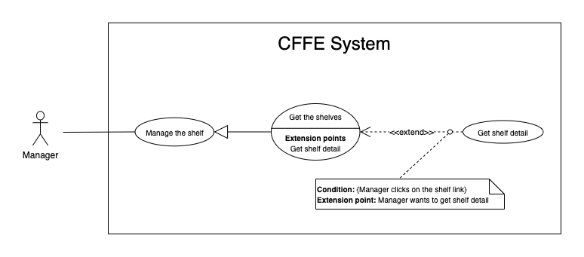

*Figure 13 - <Use Case> Get shelf detail*

|  |  |  |  |
| --- | --- | --- | --- |
| ID and Name: | **UC-15 Get shelf detail** | | |
| Created By: | TruongTN | Date Created: | 10/05/2021 |
| Primary Actor: | Manager | Secondary Actors: | N/A |
| Description: | This feature allows the Manager to get shelf detail. | | |
| Trigger: | Manager sends a request to get shelf detail. | | |
| Preconditions: | PRE-01. User has logged in the system as manager role.  PRE-02. There is at least one shelf link. | | |
| Post-conditions: | POST-01:   * Success: CFFE system returns shelf detail successfully and redirects to "Shelf Detail" page. * Fail: CFFE system shows error message. | | |
| Normal Flow: | **15.0 Get shelf detail**   1. Manager clicks on the shelf link. 2. CFFE system validates the shelf exists (Exception 15.0.E1) 3. CFFE system returns the shelf information and redirects to "Shelf Detail" page. | | |
| Alternative Flows: | N/A | | |
| Exceptions: | **15.0.E1 The shelf does not exist.**  1. CFFE system returns the message (MSG-009) and terminates this use case. | | |
| Priority: | High | | |
| Frequency of Use: | Usually | | |
| Business Rules: | BR-028, BR-048 | | |
| Other Information: | In case of internet connection failure, Manager cannot finish this use case properly. | | |
| Assumptions: | N/A | | |

*Table 12 - <Use Case> Get shelf detail*

##### 2.2.3.3 <Manager> Update the shelf

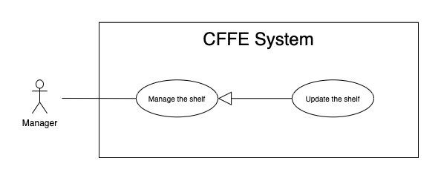

*Figure 14 - <Use Case> Update the shelf*

|  |  |  |  |
| --- | --- | --- | --- |
| ID and Name: | **UC-16 Update the shelf** | | |
| Created By: | TruongTN | Date Created: | 18/06/2021 |
| Primary Actor: | Manager | Secondary Actors: | N/A |
| Description: | This feature allows Manager to update shelf in CFFE system. | | |
| Trigger: | Manager sends a request to update the shelf. | | |
| Preconditions: | PRE-01. User has logged in the system as manager role.  PRE-02. Manager is on “Shelf detail” page. | | |
| Post-conditions: | POST-01:   * Success: CFFE system shows success message and reloads "Shelf Detail" page. * Fail: CFFE system shows error message. | | |
| Normal Flow: | **16.0 Update the shelf information** (Alternative 16.0, 16.1, 16.2)   1. Manager clicks on "Edit Information" button on the shelf box. 2. CFFE system requires shelf information that includes:  * “Shelf name”: input text * “Description”: input text * “Update”: button * “Cancel”: button  1. Manager inputs the required fields. 2. Manager clicks on “Update” button. (Alternative 16.3) 3. CFFE system validates the required fields (Exception 16.0.E1, 16.0.E2) 4. CFFE system updates shelf information and returns the success message (MSG-013). | | |
| Alternative Flows: | **16.0 Adding the camera to the shelf**   1. Manager clicks on "Add camera" button on the camera box. 2. CFFE system shows popup that includes:    * "Camera": list box    * "OK": button    * "Cancel": button 3. Manager selects a camera box. 4. Manager clicks on "OK" button. (Alternative 16.3, 16.4) 5. CFFE system validates the chosen camera and shelf. (Exception 16.0.E3, 16.0.E4, 16.0.E5) 6. CFFE system adds the camera to the shelf and returns the success message (MSG-013).   **16.1 Removing the camera from the shelf**   1. Manager clicks on "Remove camera" button on the camera box. 2. CFFE system shows confirm popup with message "Do you want to remove this camera from this shelf?" and two buttons for Manager selecting:    * "OK" button    * "Cancel" button 3. Manager clicks on "OK" button. (Alternative 16.3, 16.4) 4. CFFE system validates the camera and shelf. (Exception 16.0.E6) 5. CFFE system remove the camera from the shelf and returns the success message (MSG-013).   **16.2 Reactivate the inactive shelf.**   1. Manager focus on "Inactive" button then clicks on "Pending" button. 2. CFFE system shows confirm popup with message "Do you want to active this shelf?" and two buttons for Manager select:    * "OK" button    * "Cancel" button 3. Manager clicks on "OK" button. (Alternative 16.3, 16.4) 4. CFFE system validates the shelf. (Exception 16.0.E7) 5. CFFE system updates the shelf's status and returns the success message (MSG-013).   **16.3 Manager cancels the updating process.**   1. Manager clicks on "Cancel" button. 2. CFFE system closes this popup and terminates this use case.   **16.4 Manager clicks outside of popup.**   1. Manager clicks outside of popup. 2. CFFE system closes this popup and terminates this use case. | | |
| Exceptions: | **16.0.E1 Manager does not input the required fields**   1. CFFE system returns to Manager to fill the required fields again (MSG-079, MSG-016). 2. If Manager inputs the required fields again, CFFE system returns to step 3 of the normal flow. 3. Else if Manager cancels the updating process, then CFFE system terminates this use case.   **16.0.E2 Manager inputs the required fields that are not valid**   1. CFFE system returns to Manager to fill the required fields again (MSG-080, MSG-017). 2. If Manager inputs the required fields again, CFFE system returns to step 3 of the normal flow. 3. Else if Manager cancels the updating process, then CFFE system terminates this use case.   **16.0.E3 Shelf does not exist or is active.**   1. CFFE system returns error message (MSG-085) and terminates this use case.   **16.0.E4 Camera does not exist or is active.**   1. CFFE system returns the error message (MSG-086) and terminates this use case.   **16.0.E5 Shelf does not exist.**   1. CFFE system returns the error message (MSG-012) and terminates this use case.   **16.0.E6 Camera on the shelf is full.**   1. CFFE system returns the error message (MSG-128) and terminates this use case.   **16.0.E7 Camera is not on the shelf.**   1. CFFE system returns the error message (MSG-088) and terminates this use case. | | |
| Priority: | High | | |
| Frequency of Use: | Usually | | |
| Business Rules: | BR-024, BR-031, BR-032, BR-039, BR-048, BR-051 | | |
| Other Information: | In case of internet connection failure, Manager cannot finish this use case properly. | | |
| Assumptions: | N/A | | |

*Table 13 - <Use Case> Update the shelf*

##### 2.2.3.4 <Manager> Delete the shelf

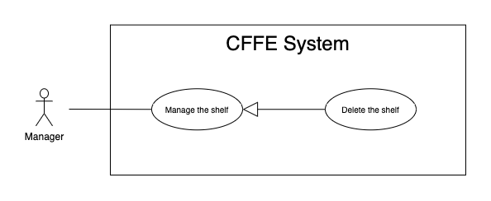

*Figure 15 - <Use Case> Delete the shelf*

|  |  |  |  |
| --- | --- | --- | --- |
| ID and Name: | **UC-17 Delete the shelf** | | |
| Created By: | TruongTN | Date Created: | 18/06/2021 |
| Primary Actor: | Manager | Secondary Actors: | N/A |
| Description: | This feature allows Manager to delete the shelf. | | |
| Trigger: | Manager sends a request to delete the shelf. | | |
| Preconditions: | PRE-01. User has logged in the system as manager role.  PRE-02. Manager is on “Shelf detail” page. | | |
| Post-conditions: | POST-01:   * Success: CFFE system shows success message and reloads "Shelf Detail" page. * Fail: CFFE system shows error message. | | |
| Normal Flow: | **17.0 Delete the shelf**   1. Manager focus on "Pending" button then clicks on "Inactive" button. 2. CFFE system shows delete popup with message: "Do you want to inactive this shelf?" and required form:  * "Inactive reason": text area * "OK": button * "Cancel": button  1. Manager inputs the field. 2. Manager clicks on "OK" button. (Alternative 17.0, 17.1) 3. CFFE system validates the required field and the shelf. (Exception 17.0.E1, 17.0.E2, 17.0.E3) 4. CFFE system updates the shelf's status and returns the success message (MSG-040). | | |
| Alternative Flows: | **17.0 Manager cancels the deleting process.**   1. Manager clicks on "Cancel" button. 2. CFFE system closes this popup and terminates this use case.   **17.1 Manager clicks outside of popup.**   1. Manager clicks outside of popup. 2. CFFE system closes this popup and terminates this use case. | | |
| Exceptions: | **17.0.E1 The shelf does not exist**   1. CFFE system returns error message (MSG-012) and terminates this use case.   **17.0.E2 Manager does not input the inactive reason and remove all stacks, cameras.**   1. CFFE system returns error message (MSG-066) and terminates this use case.   **17.0.E3 Manager inputs the inactive reason fields that are not valid**   1. CFFE system returns error message (MSG-067) and terminates this use case. | | |
| Priority: | Medium | | |
| Frequency of Use: | Often | | |
| Business Rules: | BR-030, BR-032, BR-033, BR-048 | | |
| Other Information: | In case of internet connection failure, Manager cannot finish this use case properly. | | |
| Assumptions: | N/A | | |

*Table 14 - <Use Case> Delete the shelf*

##### 2.2.3.5 <Manager> Create the shelf

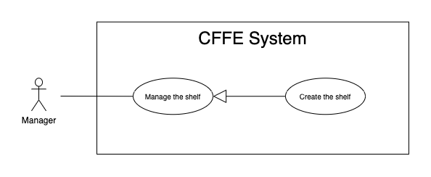

*Figure 16 - <Use Case> Create the shelf*

|  |  |  |  |
| --- | --- | --- | --- |
| ID and Name: | **UC-18 Create the shelf** | | |
| Created By: | TruongTN | Date Created: | 10/05/2021 |
| Primary Actor: | Manager | Secondary Actors: | N/A |
| Description: | This feature allows Manager to create the shelf. | | |
| Trigger: | Manager sends a request to create the shelf. | | |
| Preconditions: | PRE-01. User has logged in the system as manager role.  PRE-02. Manager is on “Manage Shelf” page. | | |
| Post-conditions: | POST-01:   * Success: CFFE system shows success message and reloads "Shelf" page. * Fail: CFFE system shows error message. | | |
| Normal Flow: | **18.0 Create the** **shelf**   1. Manager clicks on "New" button. 2. CFFE system shows the popup that includes:  * “Shelf name”: input text * “Description”: input text * “Number of stacks”: input text * “Create”: button * “Cancel”: button  1. Manager inputs the required fields. 2. Manager clicks on “Create” button. (Alternative 18.0, 18.1) 3. CFFE system validates the required fields. (Exception 18.0.E1, 18.0.E2) 4. CFFE system creates newly shelf and returns the success message (MSG-011). | | |
| Alternative Flows: | **18.0 Manager cancels the creating process.**   1. Manager clicks on "Cancel" button. 2. CFFE system closes this popup and terminates this use case.   **18.1 Manager clicks outside of popup.**   1. Manager clicks outside of popup. 2. CFFE system closes this popup and terminates this use case. | | |
| Exceptions: | **18.0.E1 Manager does not input the required fields**   1. CFFE system returns to Manager to fill the required fields again (MSG-079, MSG-016). 2. If Manager inputs the required fields again, CFFE system returns to step 3 of the normal flow. 3. Else if Manager cancels the creating process, then CFFE system terminates this use case.   **18.0.E2 Manager inputs the required fields that are not valid**   1. CFFE system returns to Manager to fill the required fields again (MSG-080, MSG-017, MSG-019). 2. If Manager inputs the required fields again, CFFE system returns to step 3 of the normal flow. 3. Else if Manager cancels the creating process, then CFFE system terminates this use case. | | |
| Priority: | Medium | | |
| Frequency of Use: | Often | | |
| Business Rules: | BR-025, BR-031, BR-035, BR-048, BR-070 | | |
| Other Information: | In case of internet connection failure, Manager cannot finish this use case properly. | | |
| Assumptions: | N/A | | |

*Table 15 - <Use Case> Create the shelf*

##### 2.2.3.6 <Manager> Get the stacks

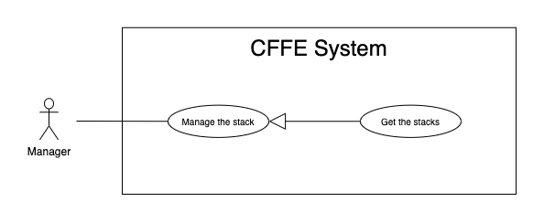

*Figure 17 - <Use Case> Get the stacks*

|  |  |  |  |
| --- | --- | --- | --- |
| ID and Name: | **UC19- Get the stacks** | | |
| Created By: | LuanNM | Date Created: | 08/05/2021 |
| Primary Actor: | Manager | Secondary Actors: | N/A |
| Description: | This feature allows manager to get the stacks. | | |
| Trigger: | Manager sends a request to get the stacks. | | |
| Pre-conditions: | PRE-01. User has logged into the system as manager role.  PRE-02. Manager is managing a store.  PRE-03. There is at least one shelf link. | | |
| Post-conditions: | POST-01. CFFE system returns the list of stacks. | | |
| Normal Flow: | **19.0 Get the stacks**   1. Manager clicks on the shelf link. 2. CFFE system validates the shelf and stacks exists (Exception 19.0.E1, 19.0.E2) 3. CFFE system returns the stack list and redirects to "Shelf Detail" page. | | |
| Alternative Flows: | N/A | | |
| Exceptions: | **19.0.E1 The shelf does not exist.**  1. CFFE system returns the message (MSG-009) and terminates this use case.  **19.0.E2 The list of stacks has no data.**   1. CFFE system returns the message (MSG-009) and terminates this use case. | | |
| Priority: | High | | |
| Frequency of Use: | Usually | | |
| Business Rules: | BR-009, BR-037 | | |
| Other Information: | In case of internet connection failure, Manager cannot finish this use case properly. | | |
| Assumptions: | N/A | | |

*Table 16 - <Use Case> Get the stacks*

##### 2.2.3.7 <Manager> Get stack detail

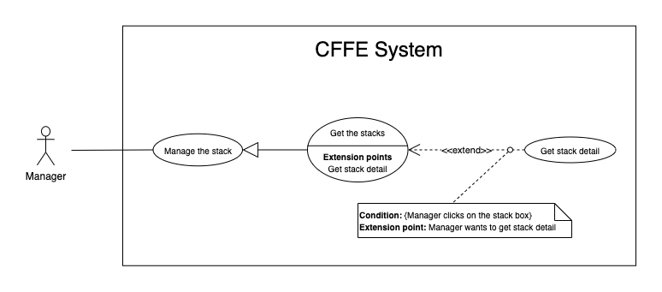

*Figure 18 - <Use Case> Get stack detail*

|  |  |  |  |
| --- | --- | --- | --- |
| ID and Name: | **UC-20 Get stack detail** | | |
| Created By: | LuanNM | Date Created: | 10/05/2021 |
| Primary Actor: | Manager | Secondary Actors: | N/A |
| Description: | This feature allows the Manager to getstackdetail. | | |
| Trigger: | Manager sends a request to get stack detail. | | |
| Preconditions: | PRE-01. User has logged in the system as manager role.  PRE-02. Manager is on "Shelf Detail" page. | | |
| Post-conditions: | POST-01. CFFE system returns stack information. | | |
| Normal Flow: | **20.0 Get stack detail**   1. Manager clicks on the stack box. 2. CFFE system validates the stack exists (Exception 20.0.E1) 3. CFFE system returns the stack information and displays it. | | |
| Alternative Flows: | N/A | | |
| Exceptions: | **20.0.E1 The stack does not exist.**  1. CFFE system returns the message (MSG-022) and terminates this use case. | | |
| Priority: | High | | |
| Frequency of Use: | Usually | | |
| Business Rules: | BR-009, BR-038 | | |
| Other Information: | In case of internet connection failure, Manager cannot finish this use case properly. | | |
| Assumptions: | N/A | | |

*Table 17 - <Use Case> Get stack detail*

##### 2.2.3.8 <Manager> Update the stack

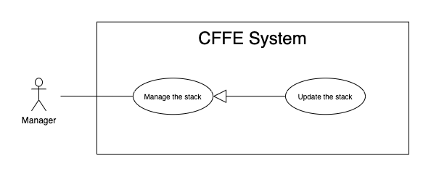

*Figure 19 - <Use Case> Update the stack*

|  |  |  |  |
| --- | --- | --- | --- |
| ID and Name: | **UC-21 Update the stack** | | |
| Created By: | LuanNM | Date Created: | 18/06/2021 |
| Primary Actor: | Manager | Secondary Actors: | N/A |
| Description: | This feature allows Manager to update stack in CFFE system. | | |
| Trigger: | Manager sends a request to update the stack. | | |
| Preconditions: | PRE-01. User has logged in the system as manager role.  PRE-02. Manager is on “Shelf detail” page.  PRE-03. Manager selects a stack. | | |
| Post-conditions: | POST-01:   * Success: CFFE system shows success message and reloads "Shelf Detail" page. * Fail: CFFE system shows error message. | | |
| Normal Flow: | **21.0 Reactive the inactive stack.** (Alternative 21.0, 21.1, 21.2, 21.3)   1. Manager focus on "Inactive" button then clicks on "Pending" button. 2. CFFE system shows confirm popup with message "Do you want to active this stack?" and two buttons for Manager selecting:  * “OK” button * “Cancel” button  1. Manager clicks on "OK" button. (Alternative 21.4, 21.5) 2. CFFE system validates the stack. (Exception 21.0.E1) 3. CFFE system updates stack information and returns the success message (MSG-013). | | |
| Alternative Flows: | **21.0 Adding the product to the stack**   1. Manager clicks on "Add product" button on the product box. 2. CFFE system shows popup that includes:    * "Product": list box    * "OK": button    * "Cancel": button 3. Manager selects a product box. 4. Manager clicks on "OK" button. (Alternative 21.4, 21.5) 5. CFFE system validates the chosen product and stack (Exception 21.0.E1, 21.0.E2, 21.0.E3, 21.0.E4) 6. CFFE system adds the product to the stack and returns the success message (MSG-013).   **21.1 Removing the product from the stack**   1. Manager clicks on "Remove product" button on the product box. 2. CFFE system shows confirm popup with message "Do you want to remove this product from this stack?" and two buttons for Manager selecting:    * "OK" button    * "Cancel" button 3. Manager clicks on "OK" button. (Alternative 21.4, 21.5) 4. CFFE system validates the product and stack. (Exception 21.0.E1, 21.0.E5) 5. CFFE system remove the product from the stack and returns the success message (MSG-013).   **21.2 Adding the camera to the stack**   1. Manager clicks on "Add camera" button on the camera box. 2. CFFE system shows popup that includes:    * "Camera": list box    * "OK": button    * "Cancel": button 3. Manager selects a camera box. 4. Manager clicks on "OK" button. (Alternative 21.4, 21.5) 5. CFFE system validates the chosen camera and stack. (Exception 21.0.E1, 21.0.E6, 21.0.E7, 21.0.E8) 6. CFFE system adds the camera to the stack and returns the success message (MSG-013).   **21.3 Removing the camera from the stack**   1. Manager clicks on "Remove camera" button on the camera box. 2. CFFE system shows confirm popup with message "Do you want to remove this camera from this stack?" and two buttons for Manager selecting:    * "OK" button    * "Cancel" button 3. Manager clicks on "OK" button. (Alternative 21.4, 21.5) 4. CFFE system validates the camera and stack. (Exception 21.0.E1, 21.0.E9) 5. CFFE system remove the camera from the stack and returns the success message (MSG-013).   **21.4 Manager cancels the updating process.**   1. Manager clicks on "Cancel" button. 2. CFFE system closes this popup and terminates this use case.   **21.5 Manager clicks outside of popup.**   1. Manager clicks outside of popup. 2. CFFE system closes this popup and terminates this use case. | | |
| Exceptions: | **21.0.E1 Stack does not exist.**   1. CFFE system returns error message (MSG-022) and terminates this use case.   **21.0.E2 Product does not exist.**   1. CFFE system returns error message (MSG-023) and terminates this use case.   **21.0.E3 Product is inactive.**   1. CFFE system returns error message (MSG-089) and terminates this use case.   **21.0.E4 Stack already has a product.**   1. CFFE system returns error message (MSG-089) and terminates this use case.   **21.0.E5 Product is not on this stack or Camera is already on this stack.**   1. CFFE system returns error message (MSG-092) and terminates this use case.   **21.0.E6 Camera does not exist.**   1. CFFE system returns error message (MSG-020) and terminates this use case.   **21.0.E7 Camera has active or inactive status.**   1. CFFE system returns error message (MSG-093) and terminates this use case.   **21.0.E8 Stack has not a product.**   1. CFFE system returns error message (MSG-100) and terminates this use case.   **21.0.E9 Camera is not on this stack.**   1. CFFE system returns error message (MSG-094) and terminates this use case. | | |
| Priority: | High | | |
| Frequency of Use: | Often | | |
| Business Rules: | BR-009, BR-029, BR-032, BR-036, BR-039, BR-042 | | |
| Other Information: | In case of internet connection failure, Manager cannot finish this use case properly. | | |
| Assumptions: | N/A | | |

*Table 18 - <Use Case> Update the stack*

##### 2.2.3.9 <Manager> Delete the stack

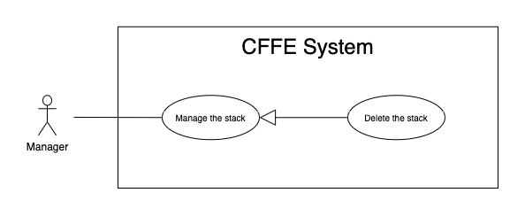

*Figure 20 - <Use Case> Delete the shelf*

|  |  |  |  |
| --- | --- | --- | --- |
| ID and Name: | **UC-22 Delete the stack** | | |
| Created By: | LuanNM | Date Created: | 10/05/2021 |
| Primary Actor: | Manager | Secondary Actors: | N/A |
| Description: | This feature allows Manager to delete the stack. | | |
| Trigger: | Manager sends a request to delete the stack. | | |
| Preconditions: | PRE-01. User has logged in the system as manager role.  PRE-02. Manager is on “Shelf detail” page.  PRE-03. Manager has selected a stack. | | |
| Post-conditions: | POST-01:   * Success: CFFE system shows success message and reloads "Shelf Detail" page. * Fail: CFFE system shows error message. | | |
| Normal Flow: | **22.0 Delete the stack**   1. Manager focus on "Pending" button then clicks on "Inactive" button. 2. CFFE system shows delete popup with message: "Do you want to inactive this stack?" and required form:  * "Inactive reason": text area * "OK": button * "Cancel": button  1. Manager inputs the field. 2. Manager clicks on "OK" button. (Alternative 22.0) 3. CFFE system validates the required field and the stack. (Exception 22.0.E1, 22.0.E2, 22.0.E3) 4. CFFE system updates the stack's status and returns the success message (MSG-040). | | |
| Alternative Flows: | **22.0 Manager cancels the deleting process.**   1. Manager clicks on "Cancel" button. 2. CFFE system closes this popup and terminates this use case. | | |
| Exceptions: | **22.0.E1 The stack does not exist**   1. CFFE system returns error message (MSG-022) and terminates this use case.   **22.0.E2 Manager does not input the inactive reason and remove the product.**   1. CFFE system returns error message (MSG-095) and terminates this use case.   **22.0.E3 Manager inputs the inactive reason fields that are not valid**   1. CFFE system returns error message (MSG-067) and terminates this use case. | | |
| Priority: | Medium | | |
| Frequency of Use: | Often | | |
| Business Rules: | BR-009, BR-032, BR-033, BR-041 | | |
| Other Information: | In case of internet connection failure, Manager cannot finish this use case properly. | | |
| Assumptions: | N/A | | |

*Table 19 - <Use Case> Delete the stack*

##### 2.2.3.10 <Manager> Create the stack

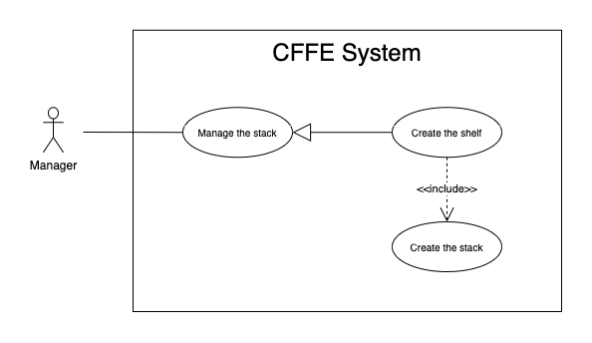

*Figure 21 - <Use Case> Create the stack*

|  |  |  |  |
| --- | --- | --- | --- |
| ID and Name: | **UC-23 Create the stack** | | |
| Created By: | LuanNM | Date Created: | 10/05/2021 |
| Primary Actor: | Manager | Secondary Actors: | N/A |
| Description: | This feature allows Manager to create the stack. | | |
| Trigger: | Manager sends a request to create the stack. | | |
| Preconditions: | PRE-01. User has logged in the system as manager role.  PRE-02. Manager creates the shelf successfully. | | |
| Post-conditions: | POST-01. CFFE system stores newly created stack information. | | |
| Normal Flow: | **23.0 Create the stack**   1. CFFE system creates the stacks based on "number of stacks" of the shelf and returns the success message (Exception 23.0.E1). | | |
| Alternative Flows: | N/A | | |
| Exceptions: | N/A | | |
| Priority: | Medium | | |
| Frequency of Use: | Often | | |
| Business Rules: | BR-009, BR-035, BR-50, BR-070 | | |
| Other Information: | In case of internet connection failure, Manager cannot finish this use case properly. | | |
| Assumptions: | N/A | | |

*Table 20 - <Use Case> Create the stack*

##### 2.2.3.11 <Manager> Upload the videos

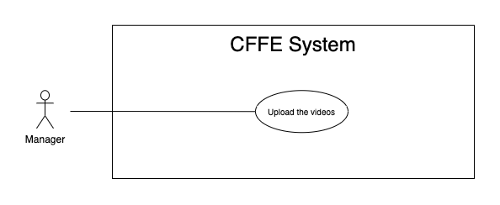

*Figure 21 - <Use Case> Upload the videos*

|  |  |  |  |
| --- | --- | --- | --- |
| ID and Name: | **UC-24 Upload the videos** | | |
| Created By: | HuuDN | Date Created: | 10/05/2021 |
| Primary Actor: | Manager | Secondary Actors: | N/A |
| Description: | This feature allows Manager to upload the videos. | | |
| Trigger: | Manager sends a request to upload the videos. | | |
| Preconditions: | PRE-01. User has logged in the system as manager role.  PRE-02. Manager is on "Video" page. | | |
| Post-conditions: | POST-01:   * Success: CFFE system shows success message and closes "Upload" popup. * Fail: CFFE system shows error message. | | |
| Normal Flow: | **24.0 Upload the videos**   1. Manager clicks on "Upload video" button on the search bar. 2. CFFE systems displays the upload popup that includes:    * "Upload video area": upload area    * "OK": button    * "Cancel": button 3. Manager clicks or drags the videos into the uploading area. 4. Manager clicks on "OK" button. (Alternative 24.0, 24.1) 5. CFFE system validates the videos. (Exception 24.0.E1, 24.0.E2, 24.0.E3) 6. CFFE system uploads the videos and returns the success message (MSG-010). | | |
| Alternative Flows: | **24.0 Manager cancels the updating process.**   1. Manager clicks on "Cancel" button. 2. CFFE system closes this popup and terminates this use case.   **24.1 Manager clicks outside of popup.**   1. Manager clicks outside of popup. 2. CFFE system closes this popup and terminates this use case. | | |
| Exceptions: | **24.0.E1 Manager does not select the required video.**   1. CFFE system returns to Manager to select the video again (MSG-119). 2. If Manager inputs the required fields again, CFFE system returns to step 3 of the normal flow. 3. Else if Manager cancels the uploading process, then CFFE system terminates this use case.   **24.0.E2 Manager selects the videos that do not valid.**   1. CFFE system shows error message (MSG-118, MSG-119, MSG-122, MSG-123) and terminates this use case.   **24.0.E3 CFFE system cannot upload the videos.**   1. CFFE system shows error message (MSG-114) and terminates this use case. | | |
| Priority: | High | | |
| Frequency of Use: | Often | | |
| Business Rules: | BR-019, BR-020 | | |
| Other Information: | In case of internet connection failure, Manager cannot finish this use case properly. | | |
| Assumptions: | N/A | | |

*Table 20 - <Use Case> Upload the videos*

#### 2.2.4 <Admin> Overview Use Case

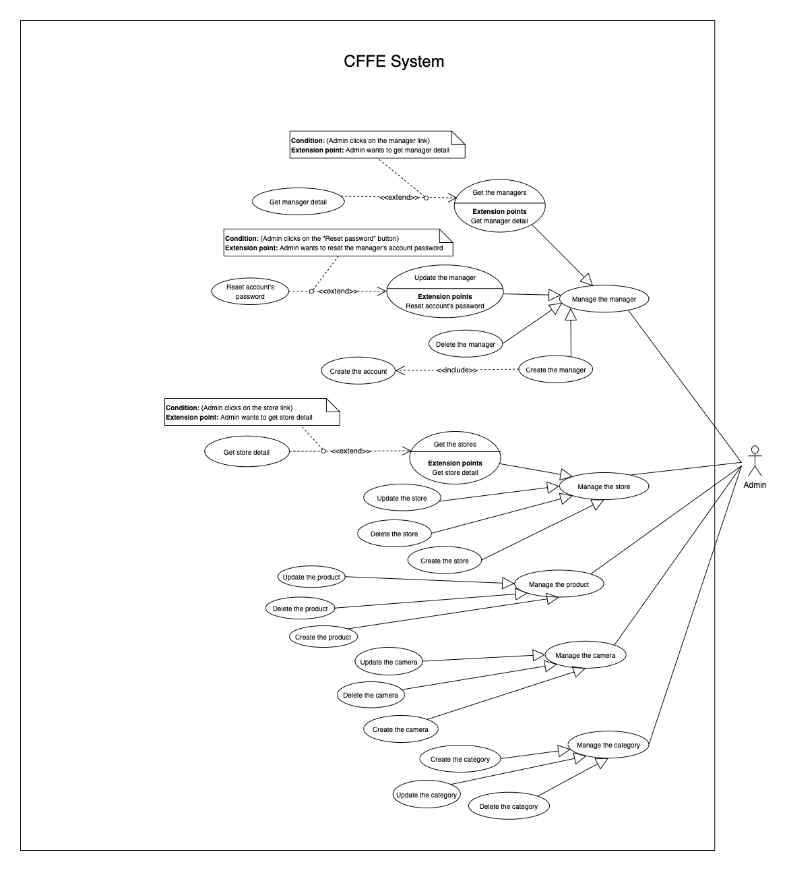*Figure 36 - <Use Case> Get the cameras*

##### 2.2.4.1 <Admin> Get the stores

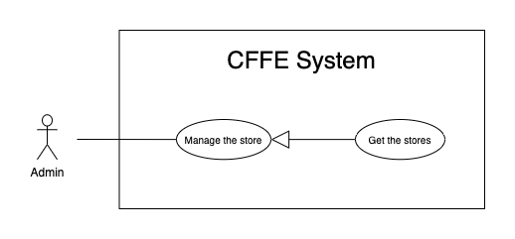

*Figure 37 - <Use Case> Get the stores*

|  |  |  |  |
| --- | --- | --- | --- |
| ID and Name: | **UC-25 Get the stores** | | |
| Created By: | LuanNM | Date Created: | 08/05/2021 |
| Primary Actor: | Admin | Secondary Actors: | N/A |
| Description: | This feature allows admin to get the stores. | | |
| Trigger: | Admin sends a request to get the stores. | | |
| Pre-conditions: | PRE-01. User has logged into the system as admin role. | | |
| Post-conditions: | POST-01. CFFE system returns the list of stores. | | |
| Normal Flow: | **25.0 Get the stores**   1. Admin clicks on "Store" button on the navigation bar. 2. CFFE system requires the store information from Admin:  * “Store name”: input text * “City”: select box * “Status”: select box  1. Admin inputs/selects the fields. 2. CFFE system returns the list of stores based on below conditions and display them (Exception 25.0.E1). | | |
| Alternative Flows: | N/A | | |
| Exceptions: | **25.0.E1 The list of stores has no data.**   1. CFFE system returns the message (MSG-009). | | |
| Priority: | High | | |
| Frequency of Use: | Usually | | |
| Business Rules: | BR-059, BR-064, BR-065 | | |
| Other Information: | In case of internet connection failure, Admin cannot finish this use case properly. | | |
| Assumptions: | N/A | | |

*Table 35 - <Use Case> Get the stores*

##### 2.2.4.2 <Admin> Get store detail

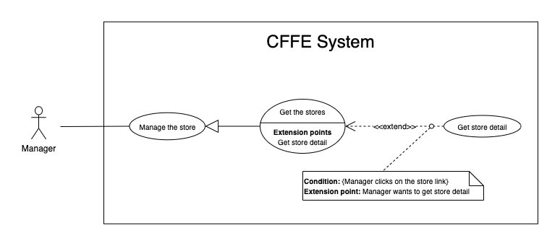

*Figure 38 - <Use Case> Get store detail*

|  |  |  |  |
| --- | --- | --- | --- |
| ID and Name: | **UC-26 Get store detail** | | |
| Created By: | LuanNM | Date Created: | 10/05/2021 |
| Primary Actor: | Admin | Secondary Actors: | N/A |
| Description: | This feature allows the admin to getstoredetail. | | |
| Trigger: | Admin sends a request to get store detail. | | |
| Preconditions: | PRE-01. User has logged in the system as admin role.  PRE-02. There is at least one store link. | | |
| Post-conditions: | POST-01:   * Success: CFFE system returns store detail successfully and redirects to "Store Detail" page. * Fail: CFFE system shows error message. | | |
| Normal Flow: | **26.0 Get store detail**   1. Admin clicks on the store link. 2. CFFE system validates the store exists (Exception 26.0.E1) 3. CFFE system returns the stores information and redirects to store detail page. | | |
| Alternative Flows: | N/A | | |
| Exceptions: | **26.0.E1 The stores does not exist.**  1. CFFE system returns the message (MSG-035) and terminates this use case. | | |
| Priority: | High | | |
| Frequency of Use: | Usually | | |
| Business Rules: | BR-059, BR-066 | | |
| Other Information: | In case of internet connection failure, Admin cannot finish this use case properly. | | |
| Assumptions: | N/A | | |

*Table 36 - <Use Case> Get camera detail*

##### 2.2.4.3 <Admin> Update the store

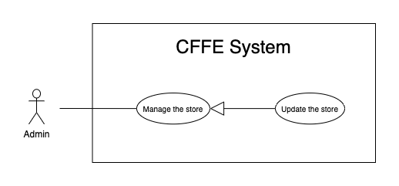

*Figure 39 - <Use Case> Update the store*

|  |  |  |  |
| --- | --- | --- | --- |
| ID and Name: | **UC-27 Update the store** | | |
| Created By: | LuanNM | Date Created: | 18/06/2021 |
| Primary Actor: | Admin | Secondary Actors: | N/A |
| Description: | This feature allows Admin to update store in CFFE system. | | |
| Trigger: | Admin sends a request to update the store. | | |
| Preconditions: | PRE-01. User has logged in the system as admin role.  PRE-02. Admin is on “Store detail” page. | | |
| Post-conditions: | POST-01:   * Success: CFFE system shows success message and reloads "Store Detail" page. * Fail: CFFE system shows error message. | | |
| Normal Flow: | **27.0 Update the store information** (Alternative 27.0, 27.1, 27.2, 27.3)   1. Admin clicks on "Edit Information" button. 2. CFFE system requires store information that includes:  * “Store Name”: input text * “Address”: input text * “City”: select box * “District”: select box * “Update”: button * “Cancel”: button  1. Admin inputs/selects the required fields. 2. Admin clicks on “Update” button. (Alternative 27.4) 3. CFFE system validates the fields (Exception 27.0.E1, 27.0.E2) 4. CFFE system updates store information and returns the success message (MSG-013). | | |
| Alternative Flows: | **27.0 Adding the manager to managing this store**   1. Admin clicks on "Add manager" button. 2. CFFE system shows popup that includes:    * "Manager": list box    * "OK": button    * "Cancel": button 3. Admin selects a manager box. 4. Admin clicks on "OK" button. (Alternative 27.4, 27.5) 5. CFFE system validates the chosen manager and store. (Exception 27.0.E3, 27.0.E4) 6. CFFE system adds the manager to the store and returns the success message. (MSG-013)   **27.1 Removing the manager from this store**   1. Admin clicks on "Remove manager" button. 2. CFFE system shows confirm popup with message "Do you want to remove this manager from this store?" and two buttons for Admin selecting:    * "OK" button    * "Cancel" button 3. Admin clicks on "OK" button. (Alternative 27.4, 27.5) 4. CFFE system validates the manager and store. (Exception 27.0.E5, 27.0.E6, 27.0.E7) 5. CFFE system remove the manager from the store and returns the success message (MSG-013).   **27.2 Updating store's image.**   1. Admin clicks on "Update image" button. 2. CFFE system shows updating image popup for Admin selecting:    * "Image": label    * "Choose": button    * "OK": button    * "Cancel": button 3. Admin clicks on "Choose" button. 4. Admin selects an image. 5. Admin clicks on "OK" button. (Alternative 27.4, 27.5) 6. CFFE system validates the image. (Exception 27.0.E9, 27.0.E10, 27.0.E11) 7. CFFE system updates the store's image and returns the success message (MSG-013).   **27.3 Reactivate the inactive store.**   1. Admin focus on "Inactive" button then clicks on "Pending" button. 2. CFFE system shows confirm popup with message "Do you want to active this store?" and two buttons for Admin selecting:    * "OK" button    * "Cancel" button 3. Admin clicks on "OK" button. (Alternative 27.4, 27.5) 4. CFFE system validates the store. (Exception 27.0.E5) 5. CFFE system updates the store's status and returns the success message (MSG-013).   **27.4 Admin cancels the updating process.**   1. Admin clicks on "Cancel" button. 2. CFFE system closes this popup and terminates this use case.   **27.5 Admin clicks outside of popup.**   1. Admin clicks outside of popup. 2. CFFE system closes this popup and terminates this use case. | | |
| Exceptions: | **27.0.E1 Admin does not input/select the required fields**   1. CFFE system returns to Admin to input/select the required fields again (MSG-106, MSG-036, MSG-038, MSG-039). 2. If Admin inputs/selects the required fields again, CFFE system returns to step 3 of the normal flow. 3. Else if Admin cancels the updating process, then CFFE system terminates this use case.   **27.0.E2 Admin inputs/selects the fields that are not valid**   1. CFFE system returns to Admin to input/select the fields again (MSG-129, MSG-037). 2. If Admin inputs/selects the fields again, CFFE system returns to step 3 of the normal flow. 3. Else if Admin cancels the updating process, then CFFE system terminates this use case.   **27.0.E3 Store does not exist or has not pending status.**   1. CFFE system returns error message (MSG-075) and terminates this use case.   **27.0.E4 Manager does not exist or has not pending status.**   1. CFFE system returns error message (MSG-074) and terminates this use case.   **27.0.E5 Store does not exist.**   1. CFFE system returns error message (MSG-035) and terminates this use case.   **27.0.E6 Manager does not exist.**   1. CFFE system returns error message (MSG-041) and terminates this use case.   **27.0.E7 Manager is not managing this store**   1. CFFE system returns error message (MSG-077) and terminates this use case.   **27.0.E8 Manager is not managing this store**   1. CFFE system returns error message (MSG-077) and terminates this use case.   **27.0.E9 Admin does not select the image**   1. CFFE system returns to Admin to select the image again (MSG-112). 2. If Admin selects the image again, CFFE system returns to step 3 of the alternative flow 27.2. 3. Else if Admin cancels the updating process, then CFFE system terminates this use case.   **27.0.E10 Image is not jpg/jpeg/png format.**   1. CFFE system returns to Admin to select the image again (MSG-113). 2. If Admin selects the image again, CFFE system returns to step 3 of the alternative flow 27.2. 3. Else if Admin cancels the updating process, then CFFE system terminates this use case.   **27.0.E11 CFFE system cannot upload the image.**   1. CFFE system shows error message (MSG-114) and terminates this use case. | | |
| Priority: | Medium | | |
| Frequency of Use: | Often | | |
| Business Rules: | BR-032, BR-040, BR-059, BR-067, BR-68 | | |
| Other Information: | In case of internet connection failure, Admin cannot finish this use case properly. | | |
| Assumptions: | N/A | | |

*Table 37 - <Use Case> Update the store*

##### 2.2.4.4 <Admin> Delete the store

*Figure 40 - <Use Case> Delete the store*

|  |  |  |  |
| --- | --- | --- | --- |
| ID and Name: | **UC-28 Delete the store** | | |
| Created By: | LuanNM | Date Created: | 10/05/2021 |
| Primary Actor: | Admin | Secondary Actors: | N/A |
| Description: | This feature allows Admin to delete the store. | | |
| Trigger: | Admin sends a request to delete the store. | | |
| Preconditions: | PRE-01. User has logged in the system as admin role.  PRE-02. Admin is on “Store detail” page. | | |
| Post-conditions: | POST-01:   * Success: CFFE system shows success message and reloads "Store Detail" page. * Fail: CFFE system shows error message. | | |
| Normal Flow: | **28.0 Delete the store**   1. Admin focus on "Pending" button then clicks on "Inactive" button. 2. CFFE system shows delete popup with message: "Do you want to inactive this store?" and required form:  * "Inactive reason": text area * "OK": button * "Cancel" button  1. Admin inputs the field. 2. Admin clicks on "OK" button. (Alternative 28.0) 3. CFFE system validates the required field and the store. (Exception 28.0.E1, 28.0.E2, 28.0.E3) 4. CFFE system updates the store's status and returns the success message (MSG-040). | | |
| Alternative Flows: | **28.0 Admin cancels the deleting process.**   1. Admin clicks on "Cancel" button. 2. CFFE system closes this popup and terminates this use case. | | |
| Exceptions: | **28.0.E1 The store does not exist**   1. CFFE system returns error message (MSG-012) and terminates this use case.   **28.0.E2 The store has an manager that is managing and has active or pending shelves.**   1. CFFE system returns error message (MSG-066, MSG-081) and terminates this use case.   **28.0.E3 Admin inputs the inactive reason fields that are not valid**   1. CFFE system returns error message (MSG-067) and terminates this use case. | | |
| Priority: | Medium | | |
| Frequency of Use: | Often | | |
| Business Rules: | BR-032, BR-033, BR-059, BR-069 | | |
| Other Information: | In case of internet connection failure, Admin cannot finish this use case properly. | | |
| Assumptions: | N/A | | |

*Table 38 - <Use Case> Delete the store*

##### 2.2.4.5 <Admin> Create the store

*Figure 41 - <Use Case> Create the store*

|  |  |  |  |
| --- | --- | --- | --- |
| ID and Name: | **UC-29 Create the store** | | |
| Created By: | LuanNM | Date Created: | 10/05/2021 |
| Primary Actor: | Admin | Secondary Actors: | N/A |
| Description: | This feature allows Admin to create the store. | | |
| Trigger: | Admin sends a request to create the store. | | |
| Preconditions: | PRE-01. User has logged in the system as admin role.  PRE-02. Admin is on “Store” page. | | |
| Post-conditions: | POST-01:   * Success: CFFE system shows success message and reloads "Store" page. * Fail: CFFE system shows error message. | | |
| Normal Flow: | **29.0 Create the store**   1. Admin clicks on "New" button. 2. CFFE system shows creating store popup that includes:    * "Store name": input text    * "Image": button    * "Address": input text    * "City": select box    * "District": select box    * "Create": button    * "Cancel": button 3. Admin inputs/selects the required fields. 4. Admin clicks on the "Create" button to create new store. (Alternative 29.0, 29.1) 5. CFFE system validates the required fields (Exception 29.0.E1, 29.0.E2). 6. CFFE system stores newly created store and returns the success message (MSG-011). | | |
| Alternative Flows: | **29.0 Admin cancels the creating process.**   1. Admin clicks on "Cancel" button. 2. CFFE system closes this popup and terminates this use case.   **29.1 Admin clicks outside of popup.**   1. Admin clicks outside of popup. 2. CFFE system closes this popup and terminates this use case. | | |
| Exceptions: | **29.0.E1 Admin does not input/select the required fields**   1. CFFE system returns to Admin to input/select the required fields again (MSG-106, MSG-036, MSG-038, MSG-039). 2. If Admin inputs/selects the required fields again, CFFE system returns to step 3 of the normal flow. 3. Else if Admin cancels the creating process, then CFFE system terminates this use case.   **29.0.E2 Admin** **inputs/selects the fields that are not valid**   1. CFFE system returns to Admin to input/select the fields again (MSG-109, MSG-037, MSG-062). 2. If Admin inputs/selects the fields again, CFFE system returns to step 3 of the normal flow. 3. Else if Admin cancels the creating process, then CFFE system terminates this use case. | | |
| Priority: | Medium | | |
| Frequency of Use: | Often | | |
| Business Rules: | BR-035, BR-059, BR-067, BR-070 | | |
| Other Information: | In case of internet connection failure, Admin cannot finish this use case properly. | | |
| Assumptions: | N/A | | |

*Table 39 - <Use Case> Create the store*

##### 2.2.4.6 <Admin> Get the managers

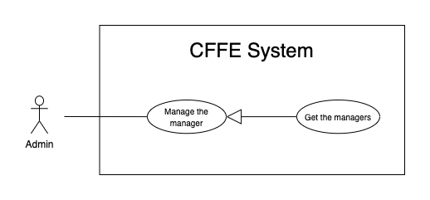

*Figure 37 - <Use Case> Get the manager*

|  |  |  |  |
| --- | --- | --- | --- |
| ID and Name: | **UC-30 Get the managers** | | |
| Created By: | HieuNT | Date Created: | 08/05/2021 |
| Primary Actor: | Admin | Secondary Actors: | N/A |
| Description: | This feature allows admin to get the managers. | | |
| Trigger: | Admin sends a request to get the managers. | | |
| Pre-conditions: | PRE-01. User has logged into the system as admin role. | | |
| Post-conditions: | POST-01. CFFE system returns the list of managers. | | |
| Normal Flow: | **30.0 Get the managers**   1. Admin clicks on "Manager" button on the navigation bar. 2. CFFE system requires the manager information from Admin:  * “Name”: input text, blank * “Options”: input text, blank * “Status”: select box  1. Admin inputs/selects the fields. 2. CFFE system returns the list of managers based on below conditions and display them (Exception 30.0.E1). | | |
| Alternative Flows: | N/A | | |
| Exceptions: | **30.0.E1 The list of managers has no data.**   1. CFFE system returns the message (MSG-009). | | |
| Priority: | High | | |
| Frequency of Use: | Usually | | |
| Business Rules: | BR-015, BR-017, BR-034 | | |
| Other Information: | In case of internet connection failure, Admin cannot finish this use case properly. | | |
| Assumptions: | N/A | | |

*Table 40 - <Use Case> Get the managers*

##### 2.2.4.7 <Admin> Get manager detail

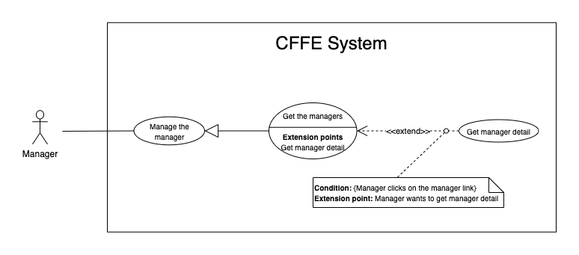

*Figure 43 - <Use Case> Get store detail*

|  |  |  |  |
| --- | --- | --- | --- |
| ID and Name: | **UC-31 Get manager detail** | | |
| Created By: | HieuNT | Date Created: | 10/05/2021 |
| Primary Actor: | Admin | Secondary Actors: | N/A |
| Description: | This feature allows the admin to getmanagerdetail. | | |
| Trigger: | Admin sends a request to get manager detail. | | |
| Preconditions: | PRE-01. User has logged in the system as admin role.  PRE-02. There is at least one manager link. | | |
| Post-conditions: | POST-01:   * Success: CFFE system returns manager detail successfully and redirects to "Manager Detail" page. * Fail: CFFE system shows error message. | | |
| Normal Flow: | **31.0 Get manager detail**   1. Admin clicks on the manager link. 2. CFFE system validates the manager exists. (Exception 31.0.E1) 3. CFFE system returns the manager information and redirects to manager detail page. | | |
| Alternative Flows: | N/A | | |
| Exceptions: | **31.0.E1 The manager does not exist.**  1. CFFE system returns the message (MSG-041) and terminates this use case. | | |
| Priority: | High | | |
| Frequency of Use: | Usually | | |
| Business Rules: | BR-034, BR-061 | | |
| Other Information: | In case of internet connection failure, Admin cannot finish this use case properly. | | |
| Assumptions: | N/A | | |

*Table 42 - <Use Case> Get manager detail*

##### 2.2.4.8 <Admin> Update the manager

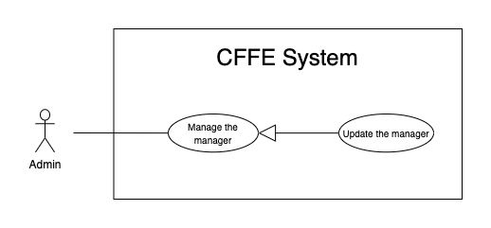

*Figure 44 - <Use Case> Update the manager*

|  |  |  |  |
| --- | --- | --- | --- |
| ID and Name: | **UC-32 Update the manager** | | |
| Created By: | HieuNT | Date Created: | 18/06/2021 |
| Primary Actor: | Admin | Secondary Actors: | N/A |
| Description: | This feature allows Admin to update manager in CFFE system. | | |
| Trigger: | Admin sends a request to update the manager. | | |
| Preconditions: | PRE-01. User has logged in the system as admin role.  PRE-02. Admin is on “Manager detail” page. | | |
| Post-conditions: | POST-01:   * Success: CFFE system shows success message and reloads "Manager Detail" page. * Fail: CFFE system shows error message. | | |
| Normal Flow: | **32.0 Update the manager information** (Alternative 32.0, 32.1, 32.2, 32.3, 32.4)   1. Admin clicks on "Edit information" button. 2. CFFE system requires manager information that includes:  * “Full name”: input text * “Gender”: checkbox * “Birthday”: date picker * “Identity card”: input text * “Phone number”: input text * “Email”: input text * “Address”: input text * “City”: select box * “District”: select box * “Update”: button * “Cancel”: button  1. Admin inputs/selects the required fields. 2. Admin clicks on “Update” button. (Alternative 32.4) 3. CFFE system validates the fields. (Exception 32.0.E1, 32.0.E2) 4. CFFE system updates manager information and returns the success message (MSG-013). | | |
| Alternative Flows: | **32.0 Adding the store to manage**   1. Admin clicks on "Add store" button. 2. CFFE system shows popup that includes:    * "Store": list box    * "OK": button    * "Cancel": button 3. Admin clicks on a store box. 4. Admin clicks on "OK" button. (Alternative 32.4, 32.5) 5. CFFE system validates the chosen manager and store. (Exception 32.0.E3, 32.0.E4) 6. CFFE system adds the store to the manager and returns the success message. (MSG-013)   **32.1 Removing the store that is managing**   1. Admin clicks on "Remove store" button. 2. CFFE system shows confirm popup with message "Do you want to remove this store from this manager?" and two buttons for Admin selecting:    * "OK" button    * "Cancel" button 3. Admin clicks on "OK" button. (Alternative 32.4, 32.5) 4. CFFE system validates the manager and store. (Exception 32.0.E5, 32.0.E6, 32.0.E7) 5. CFFE system removes the store from the manager and returns the success message (MSG-013).   **32.2 Updating manager avatar.**   1. Admin clicks on "Update avatar" button. 2. CFFE system shows updating image popup for Admin selecting:    * "Avatar": label    * "Choose": button    * "OK": button    * "Cancel": button 3. Admin clicks on "Choose" button. 4. Admin selects an image. 5. Admin clicks on "OK" button. (Alternative 32.4, 32.5) 6. CFFE system validates the image. (Exception 32.0.E9, 32.0.E10, 32.0.E11) 7. CFFE system updates the manager's avatar and returns the success message (MSG-013).   **32.3 Reactivate the inactive manager.**   1. Admin focus on "Inactive" button then clicks on "Pending" button. 2. CFFE system shows confirm popup with message "Do you want to active this manager?" and two buttons for Admin selecting:    * "OK" button    * "Cancel" button 3. Admin clicks on "OK" button. (Alternative 32.4, 32.5) 4. CFFE system validates the manager. (Exception 32.0.E6) 5. CFFE system updates the manager's status and returns the success message (MSG-013).   **32.4 Admin cancels the updating process.**   1. Admin clicks on "Cancel" button. 2. CFFE system closes this popup and terminates this use case.   **32.5 Admin clicks outside of popup.**   1. Admin clicks outside of popup. 2. CFFE system closes this popup and terminates this use case. | | |
| Exceptions: | **32.0.E1 Admin does not input/select the required fields**   1. CFFE system returns to Admin to input/select the required fields again (MSG-014, MSG-036, MSG-038, MSG-039, MSG-049, MSG-044, MSG-047, MSG-051, MSG-054). 2. If Admin inputs/selects the required fields again, CFFE system returns to step 3 of the normal flow. 3. Else if Admin cancels the updating process, then CFFE system terminates this use case.   **32.0.E2 Admin inputs/selects the fields that are not valid**   1. CFFE system returns to Admin to input/select the fields again (MSG-015, MSG-037, MSG-042, MSG-045, MSG-052, MSG-073). 2. If Admin inputs/selects the fields again, CFFE system returns to step 3 of the normal flow. 3. Else if Admin cancels the updating process, then CFFE system terminates this use case.   **32.0.E3 Store does not exist or has not pending status.**   1. CFFE system returns error message (MSG-075) and terminates this use case.   **32.0.E4 Manager does not exist or has not pending status.**   1. CFFE system returns error message (MSG-074) and terminates this use case.   **32.0.E5 Store does not exist.**   1. CFFE system returns error message (MSG-035) and terminates this use case.   **32.0.E6 Manager does not exist.**   1. CFFE system returns error message (MSG-041) and terminates this use case.   **32.0.E7 Manager is not managing this store**   1. CFFE system returns error message (MSG-077) and terminates this use case.   **32.0.E9 Admin does not select the image**   1. CFFE system returns to Admin to select the image again (MSG-112). 2. If Admin selects the image again, CFFE system returns to step 3 of the alternative flow 32.2. 3. Else if Admin cancels the updating process, then CFFE system terminates this use case.   **32.0.E10 Image is not jpg/jpeg/png format.**   1. CFFE system returns to Admin to select the image again (MSG-113). 2. If Admin selects the image again, CFFE system returns to step 3 of the alternative flow 32.2. 3. Else if Admin cancels the updating process, then CFFE system terminates this use case.   **32.0.E11 CFFE system cannot upload the image.**   1. CFFE system shows error message (MSG-114) and terminates this use case. | | |
| Priority: | Medium | | |
| Frequency of Use: | Often | | |
| Business Rules: | BR-032, BR-034, BR-040, BR-060, BR-068 | | |
| Other Information: | In case of internet connection failure, Admin cannot finish this use case properly. | | |
| Assumptions: | N/A | | |

*Table 37 - <Use Case> Update the store*

##### 2.2.4.9 <Admin> Reset account's password

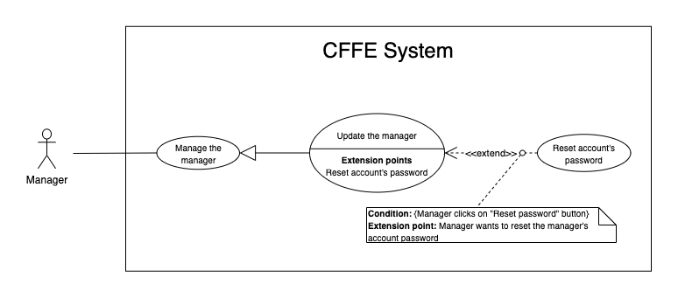

*Figure 44 - <Use Case> Reset account's password*

|  |  |  |  |
| --- | --- | --- | --- |
| ID and Name: | **UC-33 Reset account's password** | | |
| Created By: | HieuNT | Date Created: | 18/06/2021 |
| Primary Actor: | Admin | Secondary Actors: | N/A |
| Description: | This feature allows Admin to reset account's password in CFFE system. | | |
| Trigger: | Admin sends a request to reset account's password. | | |
| Preconditions: | PRE-01. User has logged in the system as admin role.  PRE-02. Admin is on “Manager detail” page. | | |
| Post-conditions: | POST-01:   * Success: CFFE system shows success message and sends account's password to manager's email. * Fail: CFFE system shows error message. | | |
| Normal Flow: | **33.0 Reset account's password**   1. Admin clicks on "Reset password" button. 2. CFFE system shows confirm popup with message "Do you want to reset password?" and two buttons for Admin selecting:    * "OK" button    * "Cancel" button 3. Admin clicks on “OK” button. (Alternative 33.0, 33.1) 4. CFFE system validates the manager and send account's new password to manager's email (Exception 33.0.E1, 33.0.E2) 5. CFFE system updates manager information and returns the success message (MSG-013). | | |
| Alternative Flows: | **33.0 Admin cancels the resetting process.**   1. Admin clicks on "Cancel" button. 2. CFFE system closes this popup and terminates this use case.   **33.1 Admin clicks outside of popup.**   1. Admin clicks outside of popup. 2. CFFE system closes this popup and terminates this use case. | | |
| Exceptions: | **33.0.E1 Manager is not found**   1. CFFE system returns error message (MSG-063) and terminates this use case.   **33.0.E2 Send email failed**   1. CFFE system shows error message (MSG-124). | | |
| Priority: | Medium | | |
| Frequency of Use: | Often | | |
| Business Rules: | BR-008, BR-012 | | |
| Other Information: | In case of internet connection failure, Admin cannot finish this use case properly. | | |
| Assumptions: | N/A | | |

*Table 37 - <Use Case> Reset account's password*

##### 2.2.4.10 <Admin> Delete the manager

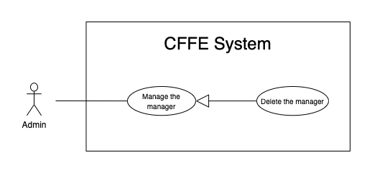

*Figure 45 - <Use Case> Delete the manager*

|  |  |  |  |
| --- | --- | --- | --- |
| ID and Name: | **UC-34 Delete the manager** | | |
| Created By: | LuanNM | Date Created: | 10/05/2021 |
| Primary Actor: | Admin | Secondary Actors: | N/A |
| Description: | This feature allows Admin to delete the manager. | | |
| Trigger: | Admin sends a request to delete the manager. | | |
| Preconditions: | PRE-01. User has logged in the system as admin role.  PRE-02. Admin is on “Manager detail” page. | | |
| Post-conditions: | POST-01:   * Success: CFFE system shows success message and reloads "Manager Detail" page. * Fail: CFFE system shows error message. | | |
| Normal Flow: | **34.0 Delete the manager**   1. Admin focus on "Pending" button then clicks on "Inactive" button. 2. CFFE system shows delete popup with message: "Do you want to inactive this manager?" and required form:  * "Inactive reason": text area * "OK": button * "Cancel" button  1. Admin inputs the field. 2. Admin clicks on "OK" button. (Alternative 34.0) 3. CFFE system validates the required field and the manager. (Exception 34.0.E1, 34.0.E2, 34.0.E3) 4. CFFE system updates the manager's status and returns the success message (MSG-040). | | |
| Alternative Flows: | **34.0 Admin cancels the deleting process.**   1. Admin clicks on "Cancel" button. 2. CFFE system closes this popup and terminates this use case. | | |
| Exceptions: | **34.0.E1 Manager is not found**   1. CFFE system returns error message (MSG-063) and terminates this use case.   **34.0.E2 Manager is managing a store**   1. CFFE system shows error message (MSG-066) and terminates this use case.   **34.0.E3 Admin inputs the inactive reason fields that are not valid**   1. CFFE system returns error message (MSG-067) and terminates this use case. | | |
| Priority: | Medium | | |
| Frequency of Use: | Often | | |
| Business Rules: | BR-003, BR-032, BR-033, BR-034 | | |
| Other Information: | In case of internet connection failure, Admin cannot finish this use case properly. | | |
| Assumptions: | N/A | | |

*Table 38 - <Use Case> Delete the manager*

##### 2.2.4.11 <Admin> Create the manager

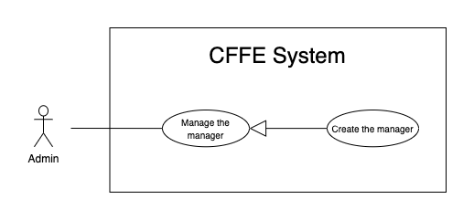

*Figure 46 - <Use Case> Create the manager*

|  |  |  |  |
| --- | --- | --- | --- |
| ID and Name: | **UC-35 Create the manager** | | |
| Created By: | LuanNM | Date Created: | 10/05/2021 |
| Primary Actor: | Admin | Secondary Actors: | N/A |
| Description: | This feature allows Admin to create the manager. | | |
| Trigger: | Admin sends a request to create the manager. | | |
| Preconditions: | PRE-01. User has logged in the system as admin role.  PRE-02. Admin is on “Manager” page. | | |
| Post-conditions: | POST-01:   * Success: CFFE system shows success message and reloads "Manager" page. * Fail: CFFE system shows error message. | | |
| Normal Flow: | **35.0 Create the manager**   1. Admin clicks on "New" button. 2. CFFE system shows creating popup that includes:    * "Avatar": button    * "Full name": input text    * "Email": input text    * "Identity card": input text    * "Phone number": input text    * "Gender": checkbox    * "Birthday": date picker    * "Address": input text    * "City": select box    * "District": select box    * "Create": button    * "Cancel": button 3. Admin inputs/selects the required fields. 4. Admin clicks on the "Create" button to create the manager. (Alternative 35.0, 35.1) 5. CFFE system validates the required fields. (Exception 35.0.E1, 35.0.E2) 6. CFFE system stores newly created manager, returns the success message (MSG-011). | | |
| Alternative Flows: | **35.0 Admin cancels the creating process.**   1. Admin clicks on "Cancel" button. 2. CFFE system closes this popup and terminates this use case.   **35.1 Admin clicks outside of popup.**   1. Admin clicks outside of popup. 2. CFFE system closes this popup and terminates this use case. | | |
| Exceptions: | **35.0.E1 Admin does not input/select the required fields**   1. CFFE system returns to Admin to input/select the required fields again (MSG-014, MSG-036, MSG-038, MSG-039, MSG-044, MSG-047, MSG-049, MSG-051, MSG-054). 2. If Admin inputs/selects the required fields again, CFFE system returns to step 3 of the normal flow. 3. Else if Admin cancels the creating process, then CFFE system terminates this use case.   **35.0.E2 Admin inputs/selects the fields that are not valid**   1. CFFE system returns to Admin to input/select the fields again (MSG-015, MSG-037, MSG-042, MSG-045, MSG-048, MSG-052, MSG-055, MSG-056, MSG-073). 2. If Admin inputs/selects the fields again, CFFE system returns to step 3 of the normal flow. 3. Else if Admin cancels the creating process, then CFFE system terminates this use case. | | |
| Priority: | Medium | | |
| Frequency of Use: | Often | | |
| Business Rules: | BR-034, BR-035, BR-060, BR-070 | | |
| Other Information: | In case of internet connection failure, Admin cannot finish this use case properly. | | |
| Assumptions: | N/A | | |

*Table 47 - <Use Case> Create the manager*

##### 2.2.4.12 <Admin> Create the account

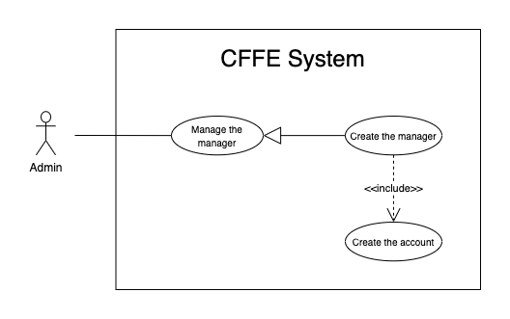

*Figure 46 - <Use Case> Create the account*

|  |  |  |  |
| --- | --- | --- | --- |
| ID and Name: | **UC-36 Create the account** | | |
| Created By: | LuanNM | Date Created: | 10/05/2021 |
| Primary Actor: | Admin | Secondary Actors: | N/A |
| Description: | This feature allows Admin to create the manager. | | |
| Trigger: | Admin sends a request to create the account. | | |
| Preconditions: | PRE-01. User has logged in the system as admin role.  PRE-02. Admin creates a manager successfully. | | |
| Post-conditions: | POST-01. CFFE system stores newly accounts and sends manager's account to manager's email. | | |
| Normal Flow: | **36.0 Create the account**   1. CFFE system creates the account for newly manager and sends account to manager's email. | | |
| Alternative Flows: | N/A | | |
| Exceptions: | **36.0.E1 Send email failed**   1. CFFE system shows error message (MSG-124). | | |
| Priority: | Medium | | |
| Frequency of Use: | Often | | |
| Business Rules: | BR-008, BR-012, BR-043 | | |
| Other Information: | In case of internet connection failure, Admin cannot finish this use case properly. | | |
| Assumptions: | N/A | | |

*Table 47 - <Use Case> Create new account*

##### 2.2.3.13 <Admin> Update the product

*Figure 24 - <Use Case> Update the product*

|  |  |  |  |
| --- | --- | --- | --- |
| ID and Name: | **UC-37 Update the product** | | |
| Created By: | HieuNT | Date Created: | 18/06/2021 |
| Primary Actor: | Admin | Secondary Actors: | N/A |
| Description: | This feature allows admin to update product in CFFE system. | | |
| Trigger: | Admin sends a request to update the product. | | |
| Preconditions: | PRE-01. User has logged in the system as admin role.  PRE-02. Admin is on “Product detail” page. | | |
| Post-conditions: | POST-01:   * Success: CFFE system shows success message and reloads "Product Detail" page. * Fail: CFFE system shows error message. | | |
| Normal Flow: | **37.0 Update the product information** (Alternative 37.0, 37.1)   1. Admin clicks on "Edit information" button on the About box. 2. CFFE system requires product popup that includes:  * “Product name”: input text * “Description”: input text * “Category”: dropdown list * "Update": button * "Cancel": button  1. Admin inputs/selects the required fields. 2. Admin clicks on “Update” button. (Alternative 37.2) 3. CFFE system validates the fields. (Exception 37.0.E1, 37.0.E2, 37.0.E6) 4. CFFE system updates product information and returns the success message (MSG-013). | | |
| Alternative Flows: | **37.0 Updating product image.**   1. Admin clicks on "Update avatar" button. 2. CFFE system shows updating image popup for Admin selecting:    * "Avatar": label    * "Choose": button    * "OK": button    * "Cancel": button 3. Admin clicks on "Choose" button. 4. Admin selects an image. 5. Admin clicks on "OK" button. (Alternative 37.2, 37.3) 6. CFFE system validates the image. (Exception 37.0.E3, 37.0.E4, 37.0.E5, 37.0.E6) 7. CFFE system updates the product's image and returns the success message (MSG-013).   **37.1 Reactivate the inactive product.**   1. Admin focus on "Inactive" button then clicks on "Active" button. 2. CFFE system shows confirm popup with message "Do you want to active this product?" and two buttons for Admin selecting:    * "OK" button    * "Cancel" button 3. Admin clicks on "OK" button. (Alternative 37.2, 37.3) 4. CFFE system validates the product. (Exception 37.0.E6) 5. CFFE system updates the product's status and returns the success message (MSG-013).   **37.2 Admin cancels the updating process.**   1. Admin clicks on "Cancel" button. 2. CFFE system closes this popup and terminates this use case.   **37.3 Admin clicks outside of popup.**   1. Admin clicks outside of popup. 2. CFFE system closes this popup and terminates this use case. | | |
| Exceptions: | **37.0.E1 Admin does not input/select the required fields**   1. CFFE system returns to Admin to input/select the required fields again (MSG-016, MSG-099, MSG-102). 2. If Admin inputs/selects the required fields again, CFFE system returns to step 3 of the normal flow. 3. Else if Admin cancels the updating process, then CFFE system terminates this use case.   **37.0.E2 Admin inputs/selects the fields that are not valid**   1. CFFE system returns to Admin to input/select the fields again (MSG-017, MSG-060, MSG-103, MSG-104, MSG-130). 2. If Admin inputs/selects the fields again, CFFE system returns to step 3 of the normal flow. 3. Else if Admin cancels the updating process, then CFFE system terminates this use case.   **37.0.E3 Admin does not select the image**   1. CFFE system returns to Admin to select the image again (MSG-112). 2. If Admin selects the image again, CFFE system returns to step 3 of the alternative flow 37.0. 3. Else if Admin cancels the updating process, then CFFE system terminates this use case.   **37.0.E4 Image is not jpg/jpeg/png format.**   1. CFFE system returns to Admin to select the image again (MSG-113). 2. If Admin selects the image again, CFFE system returns to step 3 of the alternative flow 37.0. 3. Else if Admin cancels the updating process, then CFFE system terminates this use case.   **37.0.E5 CFFE system cannot upload the image.**   1. CFFE system shows error message (MSG-114) and terminates this use case.   **37.0.E6 Product does not exist.**   1. CFFE system returns error message (MSG-023) and terminates this use case. | | |
| Priority: | Medium | | |
| Frequency of Use: | Often | | |
| Business Rules: | BR-032, BR-047 | | |
| Other Information: | In case of internet connection failure, Admin cannot finish this use case properly. | | |
| Assumptions: | N/A | | |

*Table 13 - <Use Case> Update the product*

##### 2.2.3.15 <Admin> Delete the product

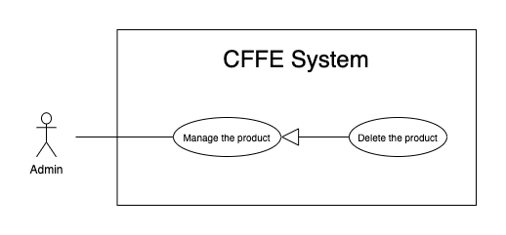

*Figure 24 - <Use Case> Delete the product*

|  |  |  |  |
| --- | --- | --- | --- |
| ID and Name: | **UC-38 Delete the product** | | |
| Created By: | HieuNT | Date Created: | 10/05/2021 |
| Primary Actor: | Admin | Secondary Actors: | N/A |
| Description: | This feature allows Admin to delete the product. | | |
| Trigger: | Admin sends a request to delete the product. | | |
| Preconditions: | PRE-01. User has logged in the system as Admin role.  PRE-02. Admin is on “Product detail” page. | | |
| Post-conditions: | POST-01:   * Success: CFFE system shows success message and reloads "Product Detail" page. * Fail: CFFE system shows error message. | | |
| Normal Flow: | **38.0 Delete the product**   1. Admin focus on "Active" button then clicks on "Inactive" button. 2. CFFE system shows delete popup with message: "Do you want to inactive this product?" and required form:  * "Inactive reason": text area * "OK": button * "Cancel" button  1. Admin inputs the field. 2. Admin clicks on "OK" button. (Alternative 38.0) 3. CFFE system validates the product. (Exception 38.0.E1, 38.0.E2, 38.E3) 4. CFFE system updates the product's status and returns the success message (MSG-040). | | |
| Alternative Flows: | **38.0 Admin cancels the deleting process.**   1. Admin clicks on "Cancel" button. 2. CFFE system closes this popup and terminates this use case. | | |
| Exceptions: | **38.0.E1 Product does not exist**   1. CFFE system returns error message (MSG-023) and terminates this use case.   **38.0.E2 The product is still on the stack.**   1. CFFE system shows error message (MSG-097) and terminates this use case.   **38.0.E3 Admin inputs the inactive reason fields that are not valid**   1. CFFE system returns error message (MSG-067) and terminates this use case. | | |
| Priority: | Medium | | |
| Frequency of Use: | Often | | |
| Business Rules: | BR-032, BR-033, BR-049 | | |
| Other Information: | In case of internet connection failure, Admin cannot finish this use case properly. | | |
| Assumptions: | N/A | | |

*Table 24 - <Use Case> Delete the product*

##### 2.2.3.15 <Admin> Create the product

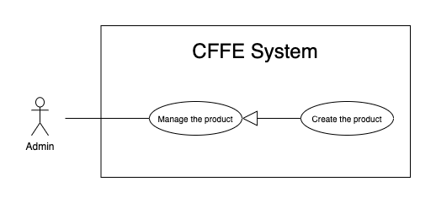

*Figure 26 - <Use Case> Create new product*

|  |  |  |  |
| --- | --- | --- | --- |
| ID and Name: | **UC-39 Create the product** | | |
| Created By: | HieuNT | Date Created: | 10/05/2021 |
| Primary Actor: | Admin | Secondary Actors: | N/A |
| Description: | This feature allows Admin to create the product. | | |
| Trigger: | Admin sends a request to create the product. | | |
| Preconditions: | PRE-01. User has logged in the system as Admin role.  PRE-02. Admin is on “Product” page. | | |
| Post-conditions: | POST-01:   * Success: CFFE system shows success message and reloads "Product" page. * Fail: CFFE system shows error message. | | |
| Normal Flow: | **39.0 Create the product**   1. Admin clicks on "New" button to create new product. 2. CFFE system requires the product information:    * "Image": button    * "Product name": input text    * "Description": input text    * "Category": dropdown list    * "Create": button    * "Cancel": button 3. Admin inputs/selects the required fields. 4. Admin clicks on the "Create" button to create new product. (Alternative 39.0, 39.1) 5. CFFE system validates the required fields (Exception 39.0.E1, 39.0.E2) 6. CFFE system stores newly created product information and returns the success message (MSG-011). | | |
| Alternative Flows: | **39.0 Admin cancels the creating process.**   1. Admin clicks on "Cancel" button. 2. CFFE system closes this popup and terminates this use case.   **39.1 Admin clicks outside of popup.**   1. Admin clicks outside of popup. 2. CFFE system closes this popup and terminates this use case. | | |
| Exceptions: | **39.0.E1 Admin does not input/select the required fields**   1. CFFE system returns to Admin to input/select the required fields again (MSG-016, MSG-099, MSG-102). 2. If Admin inputs/selects the required fields again, CFFE system returns to step 3 of the normal flow. 3. Else if Admin cancels the updating process, then CFFE system terminates this use case.   **39.0.E2 Admin inputs/selects the fields that are not valid**   1. CFFE system returns to Admin to input/select the fields again (MSG-017, MSG-060, MSG-103, MSG-104, MSG-130). 2. If Admin inputs/selects the fields again, CFFE system returns to step 3 of the normal flow. 3. Else if Admin cancels the updating process, then CFFE system terminates this use case. | | |
| Priority: | Medium | | |
| Frequency of Use: | Often | | |
| Business Rules: | BR-035, BR-047, BR-070 | | |
| Other Information: | In case of internet connection failure, Admin cannot finish this use case properly. | | |
| Assumptions: | N/A | | |

*Table 25 - <Use Case> Create new product*

##### 2.2.3.15 <Admin> Update the camera

*Figure 29 - <Use Case> Update the camera*

|  |  |  |  |
| --- | --- | --- | --- |
| ID and Name: | **UC-40 Update the camera** | | |
| Created By: | HuuDN | Date Created: | 18/06/2021 |
| Primary Actor: | Admin | Secondary Actors: | N/A |
| Description: | This feature allows Admin to update camera in CFFE system. | | |
| Trigger: | Admin sends a request to update the camera. | | |
| Preconditions: | PRE-01. User has logged in the system as Admin role.  PRE-02. Manager is on “Camera detail” page. | | |
| Post-conditions: | POST-01:   * Success: CFFE system shows success message and reloads "Camera Detail" page. * Fail: CFFE system shows error message. | | |
| Normal Flow: | **40.0 Update the camera information**   1. Admin clicks on "Edit information" button to update camera information. 2. CFFE system requires camera information that includes:  * “Camera name”: input text * “IP address”: input text * "MAC address": input text * “RTSP string”: input text  1. Admin inputs the required fields. 2. Admin clicks on “Update” button to edit camera information. (Alternative 40.2) 3. CFFE system validates the fields (Exception 40.0.E1, 40.0.E2, 40.0.E6) 4. CFFE system updates camera information and returns the success message (MSG-013). | | |
| Alternative Flows: | **40.0 Updating camera image.**   1. Admin clicks on "Update camera" button. 2. CFFE system shows updating image popup for Admin selecting:    * "Image": label    * "Choose": button    * "OK": button    * "Cancel": button 3. Admin clicks on "Choose" button. 4. Admin selects an image. 5. Admin clicks on "OK" button. (Alternative 40.2, 40.3) 6. CFFE system validates the image. (Exception 40.0.E3, 40.0.E4, 40.0.E5, 40.0.E6) 7. CFFE system updates the camera's image and returns the success message (MSG-013).   **40.1 Reactivate the inactive camera.**   1. Admin focus on "Inactive" button then clicks on "Pending" button. 2. CFFE system shows confirm popup with message "Do you want to active this camera?" and two buttons for Admin selecting:    * "OK" button    * "Cancel" button 3. Admin clicks on "OK" button. (Alternative 40.2, 40.3) 4. CFFE system validates the camera. (Exception 40.0.E6) 5. CFFE system updates the camera's status and returns the success message (MSG-013).   **40.2 Admin cancels the updating process.**   1. Admin clicks on "Cancel" button. 2. CFFE system closes this popup and terminates this use case.   **40.3 Admin clicks outside of popup.**   1. Admin clicks outside of popup. 2. CFFE system closes this popup and terminates this use case. | | |
| Exceptions: | **40.0.E1 Admin does not input the required fields**   1. CFFE system returns to Admin to input the required fields again (MSG-031, MSG-030, MSG-082, MSG-125). 2. If Admin inputs the required fields again, CFFE system returns to step 3 of the normal flow. 3. Else if Admin cancels the updating process, then CFFE system terminates this use case.   **40.0.E2 Admin inputs the fields that are not valid**   1. CFFE system returns to Admin to input the fields again (MSG-032, MSG-059, MSG-083, MSG-126). 2. If Admin inputs the fields again, CFFE system returns to step 3 of the normal flow. 3. Else if Admin cancels the updating process, then CFFE system terminates this use case.   **40.0.E3 Admin does not select the image**   1. CFFE system returns to Admin to select the image again (MSG-112). 2. If Admin selects the image again, CFFE system returns to step 3 of the alternative flow 40.0. 3. Else if Admin cancels the updating process, then CFFE system terminates this use case.   **40.0.E4 Image is not jpg/jpeg/png format.**   1. CFFE system returns to Admin to select the image again (MSG-113). 2. If Admin selects the image again, CFFE system returns to step 3 of the alternative flow 40.0. 3. Else if Admin cancels the updating process, then CFFE system terminates this use case.   **40.0.E5 CFFE system cannot upload the image.**   1. CFFE system shows error message (MSG-114) and terminates this use case.   **40.0.E6 Camera does not exist.**   1. CFFE system returns error message (MSG-020) and terminates this use case. | | |
| Priority: | Medium | | |
| Frequency of Use: | Often | | |
| Business Rules: | BR-029, BR-032, BR-055, BR-056 | | |
| Other Information: | In case of internet connection failure, Admin cannot finish this use case properly. | | |
| Assumptions: | N/A | | |

*Table 28 - <Use Case> Update the camera*

##### 2.2.3.15 <Admin> Delete the camera

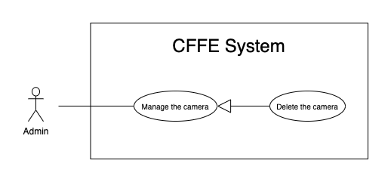

*Figure 29 - <Use Case> Delete the camera*

|  |  |  |  |
| --- | --- | --- | --- |
| ID and Name: | **UC-41 Delete the camera** | | |
| Created By: | HuuDN | Date Created: | 10/05/2021 |
| Primary Actor: | Admin | Secondary Actors: | N/A |
| Description: | This feature allows Admin to delete the camera. | | |
| Trigger: | Admin sends a request to delete the camera. | | |
| Preconditions: | PRE-01. User has logged in the system as manager role.  PRE-02. Admin is on “Camera detail” page. | | |
| Post-conditions: | POST-01:   * Success: CFFE system shows success message and reloads "Camera Detail" page. * Fail: CFFE system shows error message. | | |
| Normal Flow: | **41.0 Delete the camera**   1. Admin focus on "Pending" button then clicks on "Inactive" button. 2. CFFE system shows delete popup with message: "Do you want to inactive this camera?" and required form:  * "Inactive reason": text area * "OK": button * "Cancel" button  1. Admin inputs the field. 2. Admin clicks on "OK" button. (Alternative 41.0) 3. CFFE system validates the camera. (Exception 41.0.E1, 41.0.E2, 41.0.E3) 4. CFFE system updates the camera's status and returns the success message (MSG-040). | | |
| Alternative Flows: | **41.0 Admin cancels the deleting process.**   1. Admin clicks on "Cancel" button. 2. CFFE system closes this popup and terminates this use case. | | |
| Exceptions: | **41.0.E1 Camera does not exist**   1. CFFE system returns error message (MSG-020) and terminates this use case.   **41.0.E2 The camera is still on the shelf or stack.**   1. CFFE system shows error message (MSG-066) and terminates this use case.   **41.0.E3 Admin inputs the inactive reason fields that are not valid**   1. CFFE system returns error message (MSG-067) and terminates this use case. | | |
| Priority: | Medium | | |
| Frequency of Use: | Often | | |
| Business Rules: | BR-032, BR-033, BR-056, BR-058 | | |
| Other Information: | In case of internet connection failure, Admin cannot finish this use case properly. | | |
| Assumptions: | N/A | | |

*Table 24 - <Use Case> Delete the camera*

##### 2.2.3.18 <Admin> Create new camera

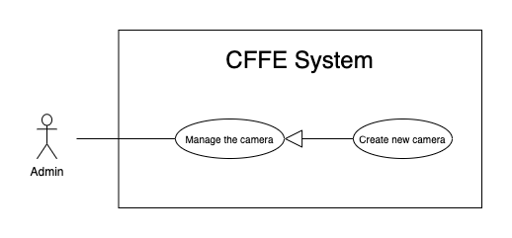

*Figure 30 - <Use Case> Create new camera*

|  |  |  |  |
| --- | --- | --- | --- |
| ID and Name: | **UC-42 Create new camera** | | |
| Created By: | HuuDN | Date Created: | 10/05/2021 |
| Primary Actor: | Admin | Secondary Actors: | N/A |
| Description: | This feature allows Admin to create new camera. | | |
| Trigger: | Admin sends a request to create new camera. | | |
| Preconditions: | PRE-01. User has logged in the system as Admin role.  PRE-02. Admin is on “Camera” page. | | |
| Post-conditions: | POST-01:   * Success: CFFE system shows success message and reloads "Camera" page. * Fail: CFFE system shows error message. | | |
| Normal Flow: | **42.0 Create new camera**   1. Admin clicks on "New" to create new camera. 2. CFFE system shows creating camera popup that includes:    * "Image" button    * "Camera name": input text    * "IP address": input text    * "MAC address": input text    * "RPST string": input text    * "Type detect": radio button    * "Create": button    * "Cancel": button 3. Admin inputs/selects the required fields. 4. Admin clicks on the "Create" button to create new camera. 5. CFFE system validates the required fields (Exception 42.0.E1, 42.0.E2). 6. CFFE system stores newly created camera information and returns the success message (MSG-011). | | |
| Alternative Flows: | **42.0 Admin cancels the creating process.**   1. Admin clicks on "Cancel" button. 2. CFFE system closes this popup and terminates this use case.   **42.1 Admin clicks outside of popup.**   1. Admin clicks outside of popup. 2. CFFE system closes this popup and terminates this use case. | | |
| Exceptions: | **42.0.E1 Admin does not input/select the required fields**   1. CFFE system returns to Admin to input/select the required fields again (MSG-031, MSG-030, MSG-082, MSG-125). 2. If Admin inputs/selects the required fields again, CFFE system returns to step 3 of the normal flow. 3. Else if Admin cancels the creating process, then CFFE system terminates this use case.   **42.0.E1 Admin inputs/selects the fields that are not valid**   1. CFFE system returns to Admin to input/select the fields again (MSG-032, MSG-059, MSG-083, MSG-084, MSG-126). 2. If Admin inputs/selects the fields again, CFFE system returns to step 3 of the normal flow. 3. Else if Admin cancels the creating process, then CFFE system terminates this use case. | | |
| Priority: | Medium | | |
| Frequency of Use: | Often | | |
| Business Rules: | BR-035, BR-055, BR-056, BR-070 | | |
| Other Information: | In case of internet connection failure, Admin cannot finish this use case properly. | | |
| Assumptions: | N/A | | |

*Table 30 - <Use Case> Create new camera*

##### 2.2.3.19 <Admin> Update the category

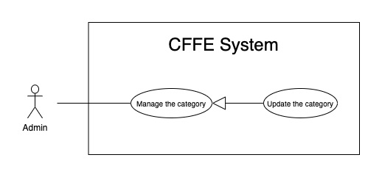

*Figure 33 - <Use Case> Update the category*

|  |  |  |  |
| --- | --- | --- | --- |
| ID and Name: | **UC-43 Update the category** | | |
| Created By: | HuuDN | Date Created: | 18/06/2021 |
| Primary Actor: | Admin | Secondary Actors: | N/A |
| Description: | This feature allows Admin to update category in CFFE system. | | |
| Trigger: | Admin sends a request to update the category. | | |
| Preconditions: | PRE-01. User has logged in the system as Admin role.  PRE-02. Admin is on “Category” page. | | |
| Post-conditions: | POST-01:   * Success: CFFE system shows success message and reloads "Category" page. * Fail: CFFE system shows error message. | | |
| Normal Flow: | **43.0 Update the category** (Alternative 43.0)   1. Admin clicks on "Edit information" to update category information. 2. CFFE system requires category information that includes:  * “Category name”: input text * “OK”: button * “Cancel”: button  1. Admin inputs the required fields. 2. Admin clicks on “Update” button. (Alternative 43.1) 3. CFFE system validates the fields (Exception 43.0.E1, 43.0.E2, 43.0.E3) 4. CFFE system updates camera information and returns the success message (MSG-013). | | |
| Alternative Flows: | **43.0 Reactivate the inactive category.**   1. Admin focus on "Inactive" button then clicks on "Active" button. 2. CFFE system shows confirm popup with message "Do you want to active this category?" and two buttons for Admin selecting:    * "OK": button    * "Cancel": button 3. Admin clicks on "OK" button. (Alternative 43.1, 43.2) 4. CFFE system validates the category. (Exception 43.0.E3) 5. CFFE system updates the category's status and returns the success message (MSG-013).   **43.1 Admin cancels the updating process.**   1. Admin clicks on "Cancel" button. 2. CFFE system closes this popup and terminates this use case.   **43.2 Admin clicks outside of popup.**   1. Admin clicks outside of popup. 2. CFFE system closes this popup and terminates this use case. | | |
| Exceptions: | **43.0.E1 Admin does not input the required fields**   1. CFFE system returns to Admin to input/select the required fields again (MSG-105). 2. If Admin inputs the required fields again, CFFE system returns to step 3 of the normal flow. 3. Else if Admin cancels the updating process, then CFFE system terminates this use case.   **43.0.E2 Admin inputs the fields that are not valid**   1. CFFE system returns to Admin to input/select the fields again (MSG-059, MSG-050). 2. If Admin inputs the fields again, CFFE system returns to step 3 of the normal flow. 3. Else if Admin cancels the updating process, then CFFE system terminates this use case.   **43.0.E3 Category does not exist.**   1. CFFE system returns error message (MSG-029) and terminates this use case. | | |
| Priority: | Medium | | |
| Frequency of Use: | Often | | |
| Business Rules: | BR-032, BR-063 | | |
| Other Information: | In case of internet connection failure, Admin cannot finish this use case properly. | | |
| Assumptions: | N/A | | |

*Table 33 - <Use Case> Update the category*

##### 2.2.3.20 <Admin> Delete the category

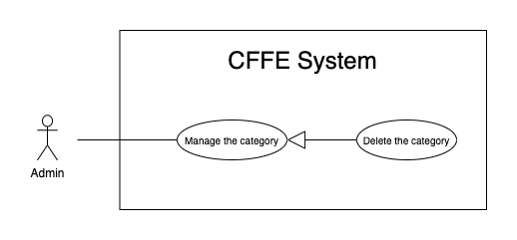

*Figure 33 - <Use Case> Update the category*

|  |  |  |  |
| --- | --- | --- | --- |
| ID and Name: | **UC-44 Delete the category** | | |
| Created By: | HuuDN | Date Created: | 18/06/2021 |
| Primary Actor: | Admin | Secondary Actors: | N/A |
| Description: | This feature allows Admin to delete category in CFFE system. | | |
| Trigger: | Admin sends a request to delete the category. | | |
| Preconditions: | PRE-01. User has logged in the system as Admin role.  PRE-02. Admin is on “Category” page. | | |
| Post-conditions: | POST-01:   * Success: CFFE system shows success message and reloads "Category" page. * Fail: CFFE system shows error message. | | |
| Normal Flow: | **44.0 Delete the category**   1. Admin focus on "Active" button then clicks on "Inactive" button. 2. CFFE system shows confirm popup with message: "Do you want to inactive this category?" and two buttons for Admin selecting:  * "OK": button * "Cancel" button  1. Admin clicks on "OK" button. (Alternative 44.0) 2. CFFE system validates the category. (Exception 44.0.E1, 44.0.E2) 3. CFFE system updates the category's status and returns the success message (MSG-013). | | |
| Alternative Flows: | **44.0 Admin cancels the deleting process.**   1. Admin clicks on "Cancel" button. 2. CFFE system closes this popup and terminates this use case. | | |
| Exceptions: | **44.0.E1 Category does not exist**   1. CFFE system returns error message (MSG-029) and terminates this use case.   **44.0.E2 Category has a product.**   1. CFFE system shows error message (MSG-066) and terminates this use case. | | |
| Priority: | Medium | | |
| Frequency of Use: | Often | | |
| Business Rules: | BR-057 | | |
| Other Information: | In case of internet connection failure, Admin cannot finish this use case properly. | | |
| Assumptions: | N/A | | |

*Table 33 - <Use Case> Update the category*

##### 2.2.3.21 <Admin> Create new category

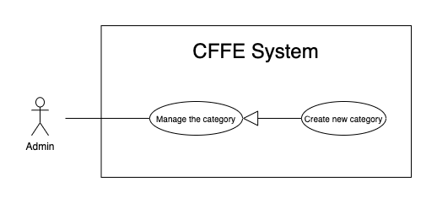

*Figure 35 - <Use Case> Create new category*

|  |  |  |  |
| --- | --- | --- | --- |
| ID and Name: | **UC-45 Create new category** | | |
| Created By: | TruongTN | Date Created: | 10/05/2021 |
| Primary Actor: | Admin | Secondary Actors: | N/A |
| Description: | This feature allows Admin to create new category. | | |
| Trigger: | Admin sends a request to create new category. | | |
| Preconditions: | PRE-01. User has logged in the system as Admin role.  PRE-02. Admin is on “Category” page. | | |
| Post-conditions: | POST-01:   * Success: CFFE system shows success message and reloads "Category" page. * Fail: CFFE system shows error message. | | |
| Normal Flow: | **45.0 Create new category**   1. Admin clicks on "New" to create new category. 2. CFFE system shows creating category popup that includes:    * "Camera name": input text 3. Admin inputs the required fields. 4. Admin clicks on the "Create" button to create new category. (Alternative 45.0, 45.1) 5. CFFE system validates the required fields (Exception 45.0.E1, 45.0.E2). 6. CFFE system stores newly created category information and returns the success message (MSG-011). | | |
| Alternative Flows: | **45.0 Admin cancels the creating process.**   1. Admin clicks on "Cancel" button. 2. CFFE system closes this popup and terminates this use case.   **45.1 Admin clicks outside of popup.**   1. Admin clicks outside of popup. 2. CFFE system closes this popup and terminates this use case. | | |
| Exceptions: | **45.0.E1 Admin does not input the required fields**   1. CFFE system returns to Admin to input the required fields again (MSG-105). 2. If Admin inputs the required fields again, CFFE system returns to step 3 of the normal flow. 3. Else if Admin cancels the creating process, then CFFE system terminates this use case.   **45.0.E1 Admin inputs the fields that are not valid**   1. CFFE system returns to Admin to input the fields again (MSG-059, MSG-050). 2. If Admin inputs the fields again, CFFE system returns to step 3 of the normal flow. 3. Else if Admin cancels the creating process, then CFFE system terminates this use case. | | |
| Priority: | Medium | | |
| Frequency of Use: | Often | | |
| Business Rules: | BR-063 | | |
| Other Information: | In case of internet connection failure, Admin cannot finish this use case properly. | | |
| Assumptions: | N/A | | |

*Table 31 - <Use Case> Create new category*

#### 2.2.5 <System AI> Overview Use Case

*Figure 2 - <Overview Use Case> System AI*

##### 2.2.5.1 <System AI> Analyze facial emotion

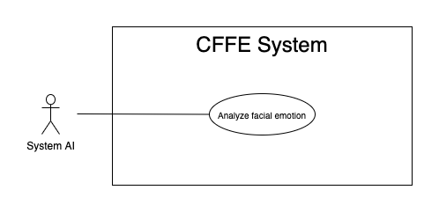

*Figure 3 - <Use Case> Analyze facial emotion*

|  |  |  |  |
| --- | --- | --- | --- |
| ID and Name: | **UC-46 Analyze facial emotion** | | |
| Created By: | HieuHD | Date Created: | 25/06/2021 |
| Primary Actor: | System AI | Secondary Actors: | N/A |
| Description: | This feature allows the System AI to analyze facial emotions. | | |
| Trigger: | When system is received a request to analyse video. | | |
| Pre-conditions: | PRE-01. Manager uploads the video successfully.  PRE-02. Uploaded videos are emotion type. | | |
| Post-conditions: | POST-01:   * Success: CFFE system shows complete notification and stores the detected videos and result. * Fail: CFFE system shows error message. | | |
| Normal Flow: | **46.0 Analyze facial emotion**   1. System AI detects the videos base on video type. 2. CFFE system shows "Detecting" notification during the detection process. 3. System AI sends the complete notification with success and error videos, detection result. 4. CFFE system shows "Complete" notification and stores the detected videos and result. | | |
| Alternative Flows: | N/A | | |
| Exceptions: | N/A | | |
| Priority: | High | | |
| Frequency of Use: | Always | | |
| Business Rules: | N/A | | |
| Other Information: | In case of internet connection failure, System AI cannot finish this use case. | | |
| Assumptions: | N/A | | |

*Table 4 - <Use Case> Analyze facial emotion*

##### 2.2.5.2 <System AI> Count the customers

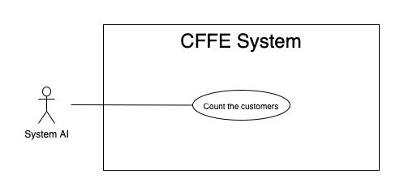

*Figure 3 - <Use Case> Count the customers*

|  |  |  |  |
| --- | --- | --- | --- |
| ID and Name: | **UC-47 Count the costumers** | | |
| Created By: | HieuHD | Date Created: | 25/06/2021 |
| Primary Actor: | System AI | Secondary Actors: | N/A |
| Description: | This feature allows the System AI to count the customers. | | |
| Trigger: | When system is received a request analyze videos. | | |
| Pre-conditions: | PRE-01. Manager uploads the videos successfully.  PRE-02. Uploaded videos are counting type. | | |
| Post-conditions: | POST-01:   * Success: CFFE system shows complete notification and stores the detected videos and result. * Fail: CFFE system shows error message. | | |
| Normal Flow: | **47.0 Count the customers**   1. System AI detects the videos base on video type. 2. CFFE system shows "Detecting" notification during the detection process. 3. System AI sends the complete notification with success and error videos, detection result. 4. CFFE system shows "Complete" notification and stores the detected videos and result. | | |
| Alternative Flows: | N/A | | |
| Exceptions: | N/A | | |
| Priority: | High | | |
| Frequency of Use: | Always | | |
| Business Rules: | N/A | | |
| Other Information: | In case of internet connection failure, System AI cannot finish this use case. | | |
| Assumptions: | N/A | | |

*Table 4 - <Use Case> Count the customers*

### 2.3 User case specification (Mobile)

#### 2.3.1 <Unauthenticated User> Overview Use Case



*Figure 2 - <Overview Use Case> Unauthenticated User*

##### 2.3.1.1 <Unauthenticated User> Login by account



*Figure 3 - <Use Case> Login by account*

|  |  |  |  |
| --- | --- | --- | --- |
| ID and Name: | **UC-01 Login by account** | | |
| Created By: | TruongTN | Date Created: | 25/06/2021 |
| Primary Actor: | Unauthenticated User | Secondary Actors: | N/A |
| Description: | This feature allows the unauthenticated user to login to CFFE system to verify the role and gives them access to more features. | | |
| Trigger: | Unauthenticated User sends a request to login to CFFE system. | | |
| Pre-conditions: | PRE-01. User's account has been created.  PRE-02. User's account has been authorized as Admin or Manager role.  PRE-03. User has not logged in to CFFE system. | | |
| Post-conditions: | POST-01:   * Success: User logins to CFFE system with own role successfully and redirect to "Dashboard" page. * Fail: CFFE system shows error message. | | |
| Normal Flow: | **1.0 Login by account**   1. Unauthenticated User send a request to login to the CFFE system. 2. CFFE system shows required form that includes:  * “Username”: input text * “Password”: input text * “Login”: button  1. Unauthenticated User inputs the required fields. 2. Unauthenticated User clicks on “Login” button. 3. CFFE system validates the username and password. (Exception 1.0.E1, 1.0.E2) 4. CFFE system determines the user’s identity, role, and permission then redirects to the manager page. | | |
| Alternative Flows: | N/A | | |
| Exceptions: | **1.0.E1 Unauthenticated User does not enter the required fields**   1. CFFE system returns to Unauthenticated User to fill the required fields again (MSG-001, MSG-002). 2. If Unauthenticated User inputs the required fields again, CFFE system returns to step 3 of the normal flow. 3. Else if Unauthenticated User cancels the login process, then CFFE system terminates this use case.   **1.0.E2 Unauthenticated User enters wrong username or password.**   1. CFFE system returns to Unauthenticated User to fill the required fields again (MSG-003). 2. If Unauthenticated User inputs username and password again, CFFE system returns to step 3 of the normal flow. 3. Else if Unauthenticated User cancels the login process, then CFFE system terminates this use case. | | |
| Priority: | High | | |
| Frequency of Use: | Always | | |
| Business Rules: | BR-001, BR-002, BR-007 | | |
| Other Information: | In case of internet connection failure, Unauthenticated User cannot finish this use case. | | |
| Assumptions: | N/A | | |

*Table 4 - <Use Case> Login by account*

#### 2.3.2 <Authenticated User> Overview Use Case



*Figure 4 - <Overview Use Case> Authenticated User*

##### 2.3.2.1 <Authenticated User> Logout



*Figure 5 - <Use Case> Logout*

|  |  |  |  |
| --- | --- | --- | --- |
| ID and Name: | **UC-02 Logout** | | |
| Created By: | TruongTN | Date Created: | 25/06/2021 |
| Primary Actor: | Authenticated User | Secondary Actors: | N/A |
| Description: | This feature allows the authenticated user to log out from CFFE system. | | |
| Trigger: | Authenticated user sends a request to log out from CFFE system. | | |
| Pre-conditions: | PRE-01. User has logged into CFFE system. | | |
| Post-conditions: | POST-01. User has successfully logged out CFFE system. | | |
| Normal Flow: | **2.0 Logout**   1. Authenticated user clicks on “Logout” button of the navigation bar. 2. CFFE system deletes information on their local storage and cookie. 3. CFFE system redirects to the login page. | | |
| Alternative Flows: | N/A | | |
| Exceptions: | N/A | | |
| Priority: | Medium | | |
| Frequency of Use: | Usually | | |
| Business Rules: | BR-004, BR-005, BR-006 | | |
| Other Information: | In case of internet connection failure, Authenticated User cannot finish this use case. | | |
| Assumptions: | N/A | | |

*Table 5 - <Use Case> Logout*

##### 2.3.2.2 <Authenticated User> Get own profile



*Figure 43 - <Use Case> Get own profile*

|  |  |  |  |
| --- | --- | --- | --- |
| ID and Name: | **UC-03 Get own profile** | | |
| Created By: | HuuDN | Date Created: | 17/06/2021 |
| Primary Actor: | Authenticated User | Secondary Actors: | N/A |
| Description: | This feature allows the authenticated user to get own profile. | | |
| Trigger: | Authenticated User sends a request to get own profile. | | |
| Preconditions: | PRE-01. User has logged into CFFE system. | | |
| Post-conditions: | POST-01:   * Success: CFFE system redirects to own profile page. * Fail: CFFE system shows error message. | | |
| Normal Flow: | **3.0 Get own profile**   1. Authenticated User clicks on "Profile" button of the navigation bar. 2. CFFE system returns own information and redirects to the profile page. (Exception 3.0.E1) | | |
| Alternative Flows: | N/A | | |
| Exceptions: | **3.0.E1 Authenticated User does not exist.**  1. CFFE system returns the message (MSG-041) and terminates this use case. | | |
| Priority: | Normal | | |
| Frequency of Use: | Sometime | | |
| Business Rules: | N/A | | |
| Other Information: | In case of internet connection failure, Authenticated User cannot finish this use case properly. | | |
| Assumptions: | N/A | | |

*Table 42 - <Use Case> Get own profile*

##### 2.3.2.3 <Authenticated User> Update own profile



*Figure 44 - <Use Case> Update own profile*

|  |  |  |  |
| --- | --- | --- | --- |
| ID and Name: | **UC-04 Update own profile** | | |
| Created By: | HuuDN | Date Created: | 17/06/2021 |
| Primary Actor: | Authenticated User | Secondary Actors: | N/A |
| Description: | This feature allows the authenticated user to update own profile. | | |
| Trigger: | Authenticated User sends a request to update own profile. | | |
| Preconditions: | PRE-01. User has logged in CFFE system.  PRE-02. User is on “Profile” page. | | |
| Post-conditions: | POST-01:   * Success: CFFE system shows success message and reloads "Profile" page. * Fail: CFFE system shows error message. | | |
| Normal Flow: | **4.0 Update information** (Alternative 4.0, 4.1)   1. Authenticated User clicks on "Update Information" button. 2. CFFE system redirects to the update information page and shows required form that includes:  * “Full name”: input text * “Gender”: radio button * “Birthday”: date picker * “Identity card”: input text * “Phone number”: input text * “Email”: input text * “Address”: input text * “City”: select box * “District”: select box * “Back”: button * “Save”: button  1. Authenticated User inputs the required fields. 2. Authenticated User clicks on “Save” button. (Alternative 4.2) 3. CFFE system validates the fields (Exception 4.0.E1, 4.0.E2) 4. CFFE system updates own information and redirects to the profile page with the success message (MSG-013). | | |
| Alternative Flows: | **4.0 Update Avatar**   1. Authenticated User clicks on "Change avatar" button. 2. CFFE system redirects to the change avatar page and shows required form that includes:    * "Choose": button    * "Save": button    * "Back": button 3. Authenticated User clicks on "Choose" button and selects an image. 4. Authenticated User clicks on "Save" button. (Alternative 4.2) 5. CFFE system validates the image (Exception 4.0.E3, 4.0.E4, 4.0.E7) 6. CFFE system updates own avatar and redirects to the profile page with the success message (MSG-013).   **4.1 Update password**   1. Authenticated User clicks on "Change password" button. 2. CFFE system redirects to change password page requires form that includes:    * "Old password": input text    * "New password": input text    * "Retype password": input text    * "Update": button    * "Back": button 3. Authenticated User inputs/selects the fields. 4. Authenticated User clicks on "Update" button. (Alternative 4.2) 5. CFFE system validates the image (Exception 4.0.E5, 4.0.E6) 6. CFFE system updates own password and redirects to the profile page with the success message (MSG-013).   **4.2 Authenticated User cancels the updating process.**   1. Authenticated User clicks on "Back" button. 2. CFFE system redirects to the profile page and terminates this use case. | | |
| Exceptions: | **4.0.E1 Authenticated User does not input/select the required fields**   1. CFFE system returns to Authenticated User to input/select the required fields again (MSG-014, MSG-036, MSG-038, MSG-039, MSG-049, MSG-044, MSG-047, MSG-051, MSG-054). 2. If Authenticated User inputs/selects the required fields again, CFFE system returns to step 3 of the normal flow. 3. Else if Authenticated User cancels the updating process, then CFFE system terminates this use case.   **4.0.E2 Authenticated User inputs/selects the fields that are not valid**   1. CFFE system returns to Authenticated Users to input/select the fields again (MSG-015, MSG-037, MSG-042, MSG-045, MSG-052, MSG-073). 2. If Authenticated User inputs/selects the fields again, CFFE system returns to step 3 of the normal flow. 3. Else if Authenticated User cancels the updating process, then CFFE system terminates this use case.   **4.0.E3 Authenticated User does not select an image**   1. CFFE system will not show “Save” button until User select an image. 2. If Authenticated User click on “Choose” button, CFFE system returns to step 4 of the alternative flow 4.0. 3. Else if Authenticated User cancels the updating process, then CFFE system terminates this use case.   **4.0.E4 Image is not png/jpg/jpeg format.**   1. CFFE system shows message (MSG-027) and terminates this use case.   **4.0.E5 Authenticated User does not input the required fields**   1. CFFE system returns to Authenticated User to input/select the required fields again (MSG-004, MSG-005, MSG-006). 2. If Authenticated User inputs/selects the required fields again, CFFE system returns to step 3 of the alternative flow 4.1. 3. Else if Authenticated User cancels the updating process, then CFFE system terminates this use case.   **4.0.E6 Authenticated User inputs the fields that are not valid**   1. CFFE system returns to Authenticated Users to input/select the fields again (MSG-007, MSG-008, MSG-068). 2. If Authenticated User inputs/selects the fields again, CFFE system returns to step 3 of the alternative flow 4.1. 3. Else if Authenticated User cancels the updating process, then CFFE system terminates this use case.   **4.0.E7 CFFE system cannot upload the image.**   1. CFFE system shows error message (MSG-114) and terminates this use case. | | |
| Priority: | Medium | | |
| Frequency of Use: | Often | | |
| Business Rules: | BR-032, BR-034, BR-060 | | |
| Other Information: | In case of internet connection failure, Authenticated User cannot finish this use case properly. | | |
| Assumptions: | N/A | | |

*Table 37 - <Use Case> Update own profile*

##### 2.3.2.4 <Authenticated User> Get the report



*Figure 7 - <Use Case> Get the report*

|  |  |  |  |
| --- | --- | --- | --- |
| ID and Name: | **UC-05 Get the report** | | |
| Created By: | HuuDN | Date Created: | 15/06/2021 |
| Primary Actor: | Authenticated User | Secondary Actors: | N/A |
| Description: | This feature allows the Authenticated User to get the report. | | |
| Trigger: | Authenticated User sends a request to get the report. | | |
| Preconditions: | PRE-01. User has logged into CFFE system as admin or manager role. | | |
| Post-conditions: | POST-01. Authenticated User has successfully got the report. | | |
| Normal Flow: | **5.0 Get the facial expression analysis report** (Alternative 5.0)   1. Authenticated User clicks on "Dashboard" button on the navigation bar. 2. CFFE system requires the report's information from Authenticated User:  * “Product name”: select box * “Store name”: select box * “Date rage”: date range picker  1. Authenticated User selects the fields. 2. CFFE system returns the reports (Exception 5.0.E1). | | |
| Alternative Flows: | **5.0 Get the counting customer report**   1. Authenticated User clicks on "Dashboard" button of the navigation bar. 2. Authenticated User clicks on "Counting customer" button on the left-bottom navigation bar of the frame. 3. CFFE system requires the report's information from Authenticated User:  * “Store name”: select box * “Shelf name”: select box * “Date rage”: date range picker  1. Authenticated User selects the fields. 2. CFFE system returns the reports (Exception 5.0.E1). | | |
| Exceptions: | **5.0.E1 The report has no data.**   1. CFFE system returns the message (MSG-009). | | |
| Priority: | High | | |
| Frequency of Use: | Often | | |
| Business Rules: | BR-013, BR-014, BR-016 | | |
| Other Information: | In case of internet connection failure, Authenticated User cannot finish this use case properly. | | |
| Assumptions: | N/A | | |

*Table 7 - <Use Case> Get the report*

##### 2.3.2.5 <Authenticated User> Download the report



*Figure 8 - <Use Case> Download the report*

|  |  |  |  |
| --- | --- | --- | --- |
| ID and Name: | **UC-06 Download the report** | | |
| Created By: | HuuDN | Date Created: | 18/06/2021 |
| Primary Actor: | Authenticated User | Secondary Actors: | N/A |
| Description: | This feature allows Authenticated User to download the report. | | |
| Trigger: | Authenticated User sends a request to download the report. | | |
| Preconditions: | PRE-01. User has logged into CFFE system as admin or manager role.  PRE-02. Authenticated User on "Dashboard" page. | | |
| Post-conditions: | POST-01. Authenticated User has successfully downloaded the report. | | |
| Normal Flow: | **6.0 Download the report**   1. Authenticated User right clicks on "Dashboard" page. 2. Authenticated User clicks on "Download as PDF" 3. CFFE system shows the popup that includes:    * "All pages": radio button    * "Select pages": radio button    * "Additional Options": dropdown list      1. "Ignore custom background color": check box      2. "Add a link back to report": check box      3. "Password protect report": check box    * "Download": button    * "Cancel": button 4. Authenticated User selects that fields 5. Authenticated User clicks on "Download" button. (Alternative 6.0, 6.1) 6. CFFE system downloads this report on client-side. | | |
| Alternative Flows: | **6.0 Authenticated User cancels the downloading process.**   1. Authenticated User clicks on "Cancel" button. 2. CFFE system closes this popup and terminates this use case.   **6.1 Authenticated User clicks outside of popup.**   1. Authenticated User clicks outside of popup. 2. CFFE system closes this popup and terminates this use case. | | |
| Exceptions: | N/A | | |
| Priority: | High | | |
| Frequency of Use: | Often | | |
| Business Rules: | BR-008, BR-009. | | |
| Other Information: | In case of internet connection failure, Authenticated User cannot finish this use case properly. | | |
| Assumptions: | N/A | | |

*Table 8 - <Use Case> Download the report*

##### 2.3.2.6 <Authenticated User> Get the video



*Figure 9 - <Use Case> Get the video*

|  |  |  |  |
| --- | --- | --- | --- |
| ID and Name: | **UC-07 Get the video** | | |
| Created By: | HuuDN | Date Created: | 11/06/2021 |
| Primary Actor: | Authenticated User | Secondary Actors: | N/A |
| Description: | This feature allows Authenticated User to get the video. | | |
| Trigger: | Authenticated User sends a request to get the video. | | |
| Preconditions: | PRE-01. User has logged into CFFE system as admin or manager role. | | |
| Post-conditions: | POST-01. Authenticated User has successfully got the video. | | |
| Normal Flow: | **7.0 Get the video**   1. Authenticated User clicks on "Video" button on the navigation bar. 2. CFFE system requires the video's information from Authenticated User:  * “Start Date”: text input * “End Date”: text input * “Counting”: check box * “Emotion”: check box * “Store”: select box * “Shelf”: select box * “Product”: select box  1. Authenticated User inputs/selects the fields. 2. CFFE system returns the corresponding videos (Exception 7.0.E1). | | |
| Alternative Flows: | N/A | | |
| Exceptions: | **7.0.E1 The video list has no data.**   1. CFFE system returns the message (MSG-009). | | |
| Priority: | High | | |
| Frequency of Use: | Often | | |
| Business Rules: | BR-010, BR-011, BR-021 | | |
| Other Information: | In case of internet connection failure, Authenticated User cannot finish this use case properly. | | |
| Assumptions: | N/A | | |

*Table 9 - <Use Case> Get the video*

##### 2.3.3.7 <Authenticated User> Get the products



*Figure 22 - <Use Case> Get the products*

|  |  |  |  |
| --- | --- | --- | --- |
| ID and Name: | **UC-08 Get the products** | | |
| Created By: | HieuNT | Date Created: | 08/05/2021 |
| Primary Actor: | Authenticated User | Secondary Actors: | N/A |
| Description: | This feature allows authenticated user to get the products. | | |
| Trigger: | Authenticated user sends a request to get the products. | | |
| Pre-conditions: | PRE-01. User has logged into the system as admin or manager role. | | |
| Post-conditions: | POST-01. CFFE system returns the list of products. | | |
| Normal Flow: | **8.0 Get the products**   1. Authenticated User clicks on "Product" button on the navigation bar. 2. CFFE system requires the product information:  * “Product name”: input text * “Status”: select box  1. Authenticated user inputs/selects the fields: product name, status. 2. CFFE system returns the list of products based on below conditions and display them (Exception 8.0.E1). | | |
| Alternative Flows: | N/A | | |
| Exceptions: | **8.0.E1 The list of product has no data.**   1. CFFE system returns the message (MSG-009). | | |
| Priority: | High | | |
| Frequency of Use: | Usually | | |
| Business Rules: | BR-044, BR-045 | | |
| Other Information: | In case of internet connection failure, authenticated user cannot finish this use case properly. | | |
| Assumptions: | N/A | | |

*Table 21 - <Use Case> Get the products*

##### 2.3.3.8 <Authenticated User> Get product detail



*Figure 23 - <Use Case> Get product detail*

|  |  |  |  |
| --- | --- | --- | --- |
| ID and Name: | **UC-09 Get product detail** | | |
| Created By: | HieuNT | Date Created: | 10/05/2021 |
| Primary Actor: | Authenticated User | Secondary Actors: | N/A |
| Description: | This feature allows the authenticated user to getproductdetail. | | |
| Trigger: | Authenticated user sends a request to get product detail. | | |
| Preconditions: | PRE-01. User has logged in the system as admin or manager role.  PRE-02. There is at least one product link. | | |
| Post-conditions: | POST-01:   * Success: CFFE system redirects to "Product Detail" page. * Fail: CFFE system shows error message. | | |
| Normal Flow: | **9.0 Get product detail**   1. Authenticated user clicks on the product item. 2. CFFE system validates the product exists (Exception 19.0.E1) 3. CFFE system returns the product information and redirects to product detail page. | | |
| Alternative Flows: | N/A | | |
| Exceptions: | **9.0.E1 The product does not exist.**  1. CFFE system returns the message (MSG-023) and terminates this use case. | | |
| Priority: | High | | |
| Frequency of Use: | Usually | | |
| Business Rules: | BR-046 | | |
| Other Information: | In case of internet connection failure, Authenticated user cannot finish this use case properly. | | |
| Assumptions: | N/A | | |

*Table 22 - <Use Case> Get product detail*

##### 2.3.3.9 <Authenticated User> Get the categories



*Figure 32 - <Use Case> Get the categories*

|  |  |  |  |
| --- | --- | --- | --- |
| ID and Name: | **UC-10 Get the categories** | | |
| Created By: | TruongTN | Date Created: | 08/05/2021 |
| Primary Actor: | Authenticated user | Secondary Actors: | N/A |
| Description: | This feature allows manager to get the categories. | | |
| Trigger: | Authenticated user sends a request to get the categories. | | |
| Pre-conditions: | PRE-01. User has logged into the system as admin or manager role. | | |
| Post-conditions: | POST-01. CFFE system returns the list of categories. | | |
| Normal Flow: | **10.0 Get the categories**   1. Authenticated user clicks on "Category" button on the navigation bar. 2. CFFE system requires the category information:  * “Category name”: input text * “Status”: select box  1. Authenticated user inputs/selects the fields 2. CFFE system returns the list of categories based on below conditions and display them (Exception 10.0.E1). | | |
| Alternative Flows: | N/A | | |
| Exceptions: | **10.0.E1 The list of categories has no data.**   1. CFFE system returns the message (MSG-009). | | |
| Priority: | High | | |
| Frequency of Use: | Usually | | |
| Business Rules: | BR-013, BR-062 | | |
| Other Information: | In case of internet connection failure, authenticated user cannot finish this use case properly. | | |
| Assumptions: | N/A | | |

*Table 31 - <Use Case> Get the categories*

##### 2.3.3.10 <Authenticated User> Get category detail



*Figure 33 - <Use Case> Get category detail*

|  |  |  |  |
| --- | --- | --- | --- |
| ID and Name: | **UC-11 Get category detail** | | |
| Created By: | HuuDN | Date Created: | 10/05/2021 |
| Primary Actor: | Authenticated User | Secondary Actors: | N/A |
| Description: | This feature allows the authenticated user to getcategorydetail. | | |
| Trigger: | Authenticated user sends a request to get categorydetail. | | |
| Preconditions: | PRE-01. User has logged in the system as admin or manager role.  PRE-02. User is on "Category" page. | | |
| Post-conditions: | POST-01:   * Success: CFFE system returns category detail successfully. * Fail: CFFE system shows error message. | | |
| Normal Flow: | **11.0 Get category detail**   1. Authenticated user clicks on the category item. 2. CFFE system validates the categoryexists (Exception 11.0.E1) 3. CFFE system returns the category information and redirects to “Category Detail” page. | | |
| Alternative Flows: | N/A | | |
| Exceptions: | **11.0.E1 The category does not exist.**  1. CFFE system returns the message (MSG-029) and terminates this use case.  **11.0.E2 The list of products that belong to this category has no data.**  1. CFFE system returns the message (MSG-009). | | |
| Priority: | High | | |
| Frequency of Use: | Usually | | |
| Business Rules: | BR-062 | | |
| Other Information: | In case of internet connection failure, Authenticated User cannot finish this use case properly. | | |
| Assumptions: | N/A | | |

*Table 32 - <Use Case> Get category detail*

##### 2.3.3.11 <Authenticated User> Get the cameras



*Figure 27 - <Use Case> Get the cameras*

|  |  |  |  |
| --- | --- | --- | --- |
| ID and Name: | **UC-12 Get the cameras** | | |
| Created By: | HuuDN | Date Created: | 08/05/2021 |
| Primary Actor: | Authenticated user | Secondary Actors: | N/A |
| Description: | This feature allows authenticated user to get the cameras. | | |
| Trigger: | Authenticated user sends a request to get the cameras. | | |
| Pre-conditions: | PRE-01. User has logged into the system as admin or manager role. | | |
| Post-conditions: | POST-01. CFFE system returns the list of cameras. | | |
| Normal Flow: | **12.0 Get the cameras**   1. Authenticated user clicks on "Camera" button on the navigation bar. 2. CFFE system requires the camera information:  * “Camera name”: input text * “Status”: select box  1. Authenticated user inputs/selects the fields. 2. CFFE system returns the list of cameras based on below conditions and display them (Exception 12.0.E1). | | |
| Alternative Flows: | N/A | | |
| Exceptions: | **12.0.E1 The list of cameras has no data.**   1. CFFE system returns the message (MSG-009). | | |
| Priority: | High | | |
| Frequency of Use: | Usually | | |
| Business Rules: | BR-052, BR-053, BR-056 | | |
| Other Information: | In case of internet connection failure, authenticated user cannot finish this use case properly. | | |
| Assumptions: | N/A | | |

*Table 26 - <Use Case> Get the cameras*

##### 2.3.3.11 <Authenticated User> Get camera detail



*Figure 28 - <Use Case> Get camera detail*

|  |  |  |  |
| --- | --- | --- | --- |
| ID and Name: | **UC-13 Get camera detail** | | |
| Created By: | HuuDN | Date Created: | 10/05/2021 |
| Primary Actor: | Authenticated User | Secondary Actors: | N/A |
| Description: | This feature allows the authenticated user to getcameradetail. | | |
| Trigger: | Authenticated User sends a request to get camera detail. | | |
| Preconditions: | PRE-01. User has logged in the system as admin or manager role.  PRE-02. There is at least one camera link. | | |
| Post-conditions: | POST-01:   * Success: CFFE system returns camera detail successfully and redirects to "Camera Detail" page. * Fail: CFFE system shows error message. | | |
| Normal Flow: | **13.0 Get camera detail**   1. Authenticated User clicks on the camera item. 2. CFFE system validates the camera exists (Exception 13.0.E1, 13.1.E1). 3. CFFE system returns the camera information and redirects to ”Camera Detail” page. | | |
| Alternative Flows: | N/A | | |
| Exceptions: | **13.0.E1 The camera does not exist.**  1. CFFE system returns the message (MSG-009) and terminates this use case.  **13.1.E1 The camera access is not allowed.**  1. CFFE system returns the message (MSG-120) and terminates this use case. | | |
| Priority: | High | | |
| Frequency of Use: | Usually | | |
| Business Rules: | BR-022, BR-054, BR-056 | | |
| Other Information: | In case of internet connection failure, Authenticated User cannot finish this use case properly. | | |
| Assumptions: | N/A | | |

*Table 27 - <Use Case> Get camera detail*

#### 2.3.3 <Manager> Overview Use Case



*Figure 11 - <Overview Use Case> Manager*

##### 2.3.3.1 <Manager> Get the shelves

*Figure 12 - <Use Case> Get the shelves*

|  |  |  |  |
| --- | --- | --- | --- |
| ID and Name: | **UC-14 Get the shelves** | | |
| Created By: | TruongTN | Date Created: | 08/05/2021 |
| Primary Actor: | Manager | Secondary Actors: | N/A |
| Description: | This feature allows the manager to get the shelves. | | |
| Trigger: | Manager sends a request to get the shelves. | | |
| Pre-conditions: | PRE-01. User has logged into the system as manager role.  PRE-02. Manager is managing a store. | | |
| Post-conditions: | POST-01. CFFE system returns the list of shelves. | | |
| Normal Flow: | **14.0 Get the shelves**   1. Manager clicks on "Shelf" button on the navigation bar. 2. CFFE system requires the shelf information:  * “Shelf name”: input text * “Status”: select box  1. Manager inputs/selects the fields. 2. CFFE system returns the shelves based on below conditions and display them (Exception 14.0.E1). | | |
| Alternative Flows: | N/A | | |
| Exceptions: | **14.0.E1 The list of shelves has no data.**   1. CFFE system returns the message (MSG-009). | | |
| Priority: | High | | |
| Frequency of Use: | Usually | | |
| Business Rules: | BR-026, BR-027, BR-048 | | |
| Other Information: | In case of internet connection failure, Manager cannot finish this use case properly. | | |
| Assumptions: | N/A | | |

*Table 11 - <Use Case> Get the shelves*

##### 2.3.3.2 <Manager> Get shelf detail



*Figure 13 - <Use Case> Get shelf detail*

|  |  |  |  |
| --- | --- | --- | --- |
| ID and Name: | **UC-15 Get shelf detail** | | |
| Created By: | TruongTN | Date Created: | 10/05/2021 |
| Primary Actor: | Manager | Secondary Actors: | N/A |
| Description: | This feature allows the Manager to get shelf detail. | | |
| Trigger: | Manager sends a request to get shelf detail. | | |
| Preconditions: | PRE-01. User has logged in the system as manager role.  PRE-02. There is at least one shelf link. | | |
| Post-conditions: | POST-01:   * Success: CFFE system returns shelf detail successfully and redirects to "Shelf Detail" page. * Fail: CFFE system shows error message. | | |
| Normal Flow: | **15.0 Get shelf detail**   1. Manager clicks on the shelf item. 2. CFFE system validates the shelf exists (Exception 15.0.E1) 3. CFFE system returns the shelf information and redirects to “Shelf Detail” page. | | |
| Alternative Flows: | N/A | | |
| Exceptions: | **15.0.E1 The shelf does not exist.**  1. CFFE system returns the message (MSG-009) and terminates this use case. | | |
| Priority: | High | | |
| Frequency of Use: | Usually | | |
| Business Rules: | BR-028, BR-048 | | |
| Other Information: | In case of internet connection failure, Manager cannot finish this use case properly. | | |
| Assumptions: | N/A | | |

*Table 12 - <Use Case> Get shelf detail*

##### 2.3.3.3 <Manager> Update the shelf



*Figure 14 - <Use Case> Update the shelf*

|  |  |  |  |
| --- | --- | --- | --- |
| ID and Name: | **UC-16 Update the shelf** | | |
| Created By: | TruongTN | Date Created: | 18/06/2021 |
| Primary Actor: | Manager | Secondary Actors: | N/A |
| Description: | This feature allows Manager to update shelf in CFFE system. | | |
| Trigger: | Manager sends a request to update the shelf. | | |
| Preconditions: | PRE-01. User has logged in the system as manager role.  PRE-02. Manager is on “Shelf detail” page. | | |
| Post-conditions: | POST-01:   * Success: CFFE system shows success message and reloads "Shelf Detail" page. * Fail: CFFE system shows error message. | | |
| Normal Flow: | **16.0 Update the shelf information** (Alternative 16.0, 16.1, 16.2)   1. Manager clicks on "Update Information". 2. CFFE system redirects to “Update Shelf” page and shows required form that includes:  * “Shelf name”: input text * “Description”: input text * “Save”: button * “Back”: button  1. Manager inputs all required fields. 2. Manager clicks on “Save” button. (Alternative 16.3) 3. CFFE system validates the required fields (Exception 16.0.E1, 16.0.E2) 4. CFFE system updates shelf information and redirects to ”Shelf Detail” page with the success message (MSG-013). | | |
| Alternative Flows: | **16.0 Adding the camera to the shelf**   1. Manager clicks on "Add camera" button on the camera box. 2. CFFE system redirects to “Choose Camera” page and shows:    * "Camera": list box 3. Manager clicks on the Camera item. 4. CFFE system shows confirm popup with message "Are you sure to add this camera?" and two buttons for Manager selecting:    * "Yes": button    * "No": button 5. Manager clicks on "Yes" button. (Alternative 16.3) 6. CFFE system validates the chosen camera and shelf. (Exception 16.0.E3, 16.0.E4, 16.0.E5) 7. CFFE system adds the camera to the shelf and redirects to “Shelf Detail” page with the success message (MSG-013).   **16.1 Removing the camera from the shelf**   1. Manager clicks on "Remove camera" button on the camera box. 2. CFFE system shows confirm popup with message "Are you sure to remove this camera" and two buttons for Manager selecting:    * "Yes" button    * "No" button 3. Manager clicks on "Yes" button. (Alternative 16.3) 4. CFFE system validates the camera and shelf. (Exception 16.0.E6) 5. CFFE system remove the camera from the shelf and returns the success message (MSG-013).   **16.2 Reactivate the inactive shelf.**   1. Manager clicks on "Change to Pending" button. 2. CFFE system shows confirm popup with message "The status will change to Pending. Are you sure?" and two buttons for Manager select:    * "Yes" button    * "No" button 3. Manager clicks on "Yes" button. (Alternative 16.3) 4. CFFE system validates the shelf. (Exception 16.0.E7) 5. CFFE system updates the shelf's status and returns the success message (MSG-013).   **16.3 Manager cancels the updating process.**   1. Manager clicks on "No" button. 2. CFFE system closes this popup and terminates this use case. | | |
| Exceptions: | **16.0.E1 Manager does not input the required fields**   1. CFFE system returns to Manager to fill the required fields again (MSG-079, MSG-016). 2. If Manager inputs the required fields again, CFFE system returns to step 3 of the normal flow. 3. Else if Manager cancels the updating process, then CFFE system terminates this use case.   **16.0.E2 Manager inputs the required fields that are not valid**   1. CFFE system returns to Manager to fill the required fields again (MSG-080, MSG-017). 2. If Manager inputs the required fields again, CFFE system returns to step 3 of the normal flow. 3. Else if Manager cancels the updating process, then CFFE system terminates this use case.   **16.0.E3 Shelf does not exist or is active.**   1. CFFE system returns error message (MSG-085) and terminates this use case.   **16.0.E4 Camera does not exist or is active.**   1. CFFE system returns the error message (MSG-086) and terminates this use case.   **16.0.E5 Shelf does not exist.**   1. CFFE system returns the error message (MSG-012) and terminates this use case.   **16.0.E6 Camera on the shelf is full.**   1. CFFE system returns the error message (MSG-128) and terminates this use case.   **16.0.E7 Camera is not on the shelf.**   1. CFFE system returns the error message (MSG-088) and terminates this use case. | | |
| Priority: | High | | |
| Frequency of Use: | Usually | | |
| Business Rules: | BR-024, BR-031, BR-032, BR-039, BR-048, BR-051 | | |
| Other Information: | In case of internet connection failure, Manager cannot finish this use case properly. | | |
| Assumptions: | N/A | | |

*Table 13 - <Use Case> Update the shelf*

##### 2.3.3.4 <Manager> Delete the shelf



*Figure 15 - <Use Case> Delete the shelf*

|  |  |  |  |
| --- | --- | --- | --- |
| ID and Name: | **UC-17 Delete the shelf** | | |
| Created By: | TruongTN | Date Created: | 18/06/2021 |
| Primary Actor: | Manager | Secondary Actors: | N/A |
| Description: | This feature allows Manager to delete the shelf. | | |
| Trigger: | Manager sends a request to delete the shelf. | | |
| Preconditions: | PRE-01. User has logged in the system as manager role.  PRE-02. Manager is on “Shelf detail” page. | | |
| Post-conditions: | POST-01:   * Success: CFFE system shows success message and reloads "Shelf Detail" page. * Fail: CFFE system shows error message. | | |
| Normal Flow: | **17.0 Delete the shelf**   1. Manager clicks on "Change to Inactive" button. 2. CFFE system redirects to “Inactive” page and shows required form:  * "Reason": text area * "Save": button * "Back": button  1. Manager inputs the fields. 2. Manager clicks on "Save" button. (Alternative 17.0) 3. CFFE system validates the required field and the shelf. (Exception 17.0.E1, 17.0.E2, 17.0.E3) 4. CFFE system updates the shelf's status and redirects to “Shelf Detail” page with the success message (MSG-040). | | |
| Alternative Flows: | **17.0 Manager cancels the deleting process.**   1. Manager clicks on "Back" button. 2. CFFE system redirects to “Shelf Detail” page and terminates this use case. | | |
| Exceptions: | **17.0.E1 The shelf does not exist**   1. CFFE system returns error message (MSG-012) and terminates this use case.   **17.0.E2 Manager does not input the inactive reason and remove all stacks, cameras.**   1. CFFE system returns error message (MSG-066) and terminates this use case.   **17.0.E3 Manager inputs the inactive reason fields that are not valid**   1. CFFE system returns error message (MSG-067) and terminates this use case. | | |
| Priority: | Medium | | |
| Frequency of Use: | Often | | |
| Business Rules: | BR-030, BR-032, BR-033, BR-048 | | |
| Other Information: | In case of internet connection failure, Manager cannot finish this use case properly. | | |
| Assumptions: | N/A | | |

*Table 14 - <Use Case> Delete the shelf*

##### 2.3.3.5 <Manager> Create the shelf



*Figure 16 - <Use Case> Create the shelf*

|  |  |  |  |
| --- | --- | --- | --- |
| ID and Name: | **UC-18 Create the shelf** | | |
| Created By: | TruongTN | Date Created: | 10/05/2021 |
| Primary Actor: | Manager | Secondary Actors: | N/A |
| Description: | This feature allows Manager to create the shelf. | | |
| Trigger: | Manager sends a request to create the shelf. | | |
| Preconditions: | PRE-01. User has logged in the system as manager role.  PRE-02. Manager is on “Manage Shelf” page. | | |
| Post-conditions: | POST-01:   * Success: CFFE system shows success message and reloads "Shelf" page. * Fail: CFFE system shows error message. | | |
| Normal Flow: | **18.0 Create the** **shelf**   1. Manager clicks on "New" button. 2. CFFE system redirect to create shelf page and shows required form that includes:  * “Shelf name”: input text * “Description”: input text * “Number of stacks”: drop down list * “Create”: button * “Back”: button  1. Manager inputs the fields. 2. Manager clicks on “Create” button. (Alternative 18.0) 3. CFFE system validates the required fields. (Exception 18.0.E1, 18.0.E2) 4. CFFE system creates newly shelf and redirects to “Shelf” page with the success message (MSG-011). | | |
| Alternative Flows: | **18.0 Manager cancels the creating process.**   1. Manager clicks on "Back" button. 2. CFFE system closes this popup and terminates this use case. | | |
| Exceptions: | **18.0.E1 Manager does not input the required fields**   1. CFFE system returns to Manager to fill the required fields again (MSG-079, MSG-016). 2. If Manager inputs the required fields again, CFFE system returns to step 3 of the normal flow. 3. Else if Manager cancels the creating process, then CFFE system terminates this use case.   **18.0.E2 Manager inputs the required fields that are not valid**   1. CFFE system returns to Manager to fill the required fields again (MSG-080, MSG-017, MSG-019). 2. If Manager inputs the required fields again, CFFE system returns to step 3 of the normal flow. 3. Else if Manager cancels the creating process, then CFFE system terminates this use case. | | |
| Priority: | Medium | | |
| Frequency of Use: | Often | | |
| Business Rules: | BR-025, BR-031, BR-035, BR-048, BR-070 | | |
| Other Information: | In case of internet connection failure, Manager cannot finish this use case properly. | | |
| Assumptions: | N/A | | |

*Table 15 - <Use Case> Create the shelf*

##### 2.3.3.6 <Manager> Get the stacks



*Figure 17 - <Use Case> Get the stacks*

|  |  |  |  |
| --- | --- | --- | --- |
| ID and Name: | **UC19- Get the stacks** | | |
| Created By: | LuanNM | Date Created: | 08/05/2021 |
| Primary Actor: | Manager | Secondary Actors: | N/A |
| Description: | This feature allows manager to get the stacks. | | |
| Trigger: | Manager sends a request to get the stacks. | | |
| Pre-conditions: | PRE-01. User has logged into the system as manager role.  PRE-02. Manager is managing a store.  PRE-03. There is at least one shelf link. | | |
| Post-conditions: | POST-01. CFFE system returns the list of stacks. | | |
| Normal Flow: | **19.0 Get the stacks**   1. Manager clicks on the shelf item. 2. CFFE system validates the shelf exists (Exception 19.0.E1, 19.0.E2) 3. CFFE system returns the stack list and redirects to “Shelf Detail” page. | | |
| Alternative Flows: | N/A | | |
| Exceptions: | **19.0.E1 The shelf does not exist.**  1. CFFE system returns the message (MSG-009) and terminates this use case.  **19.0.E2 The list of stacks has no data.**   1. CFFE system returns the message (MSG-009) and terminates this use case. | | |
| Priority: | High | | |
| Frequency of Use: | Usually | | |
| Business Rules: | BR-009, BR-037 | | |
| Other Information: | In case of internet connection failure, Manager cannot finish this use case properly. | | |
| Assumptions: | N/A | | |

*Table 16 - <Use Case> Get the stacks*

##### 2.3.3.7 <Manager> Get stack detail



*Figure 18 - <Use Case> Get stack detail*

|  |  |  |  |
| --- | --- | --- | --- |
| ID and Name: | **UC-20 Get stack detail** | | |
| Created By: | LuanNM | Date Created: | 10/05/2021 |
| Primary Actor: | Manager | Secondary Actors: | N/A |
| Description: | This feature allows the Manager to getstackdetail. | | |
| Trigger: | Manager sends a request to get stack detail. | | |
| Preconditions: | PRE-01. User has logged in the system as manager role.  PRE-02. Manager is on "Shelf Detail" page. | | |
| Post-conditions: | POST-01. CFFE system returns stack information. | | |
| Normal Flow: | **20.0 Get stack detail**   1. Manager clicks on the stack item. 2. CFFE system validates the stack exists (Exception 20.0.E1) 3. CFFE system returns the stack information and redirects to “Stack Detail” page. | | |
| Alternative Flows: | N/A | | |
| Exceptions: | **20.0.E1 The stack does not exist.**  1. CFFE system returns the message (MSG-022) and terminates this use case. | | |
| Priority: | High | | |
| Frequency of Use: | Usually | | |
| Business Rules: | BR-009, BR-038 | | |
| Other Information: | In case of internet connection failure, Manager cannot finish this use case properly. | | |
| Assumptions: | N/A | | |

*Table 17 - <Use Case> Get stack detail*

##### 2.3.3.8 <Manager> Update the stack



*Figure 19 - <Use Case> Update the stack*

|  |  |  |  |
| --- | --- | --- | --- |
| ID and Name: | **UC-21 Update the stack** | | |
| Created By: | LuanNM | Date Created: | 18/06/2021 |
| Primary Actor: | Manager | Secondary Actors: | N/A |
| Description: | This feature allows Manager to update stack in CFFE system. | | |
| Trigger: | Manager sends a request to update the stack. | | |
| Preconditions: | PRE-01. User has logged in the system as manager role.  PRE-02. Manager is on “Stack detail” page. | | |
| Post-conditions: | POST-01:   * Success: CFFE system shows success message and reloads "Shelf Detail" page. * Fail: CFFE system shows error message. | | |
| Normal Flow: | **21.0 Reactive the inactive stack.** (Alternative 21.0, 21.1, 21.2, 21.3)   1. Manager "Change to Pending" button. 2. CFFE system shows confirm popup with message "The status will change to Pending. Are you sure?" and two buttons for Manager selecting:  * “Yes” button * “No” button  1. Manager clicks on "Yes" button. (Alternative 21.4) 2. CFFE system validates the stack. (Exception 21.0.E1) 3. CFFE system updates stack information and returns the success message (MSG-013). | | |
| Alternative Flows: | **21.0 Adding the product to the stack**   1. Manager clicks on "Add product" button on the product box. 2. CFFE system redirects to “Choose Product” page and shows:    * "Product": list box 3. Manager clicks on the product item. 4. CFFE system shows confirm popup with message "Are you sure to add this product?" and two buttons for Manager selecting:    * "Yes": button    * "No": button 5. Manager clicks on "Yes" button. (Alternative 21.4) 6. CFFE system validates the chosen product and stack (Exception 21.0.E1, 21.0.E2, 21.0.E3, 21.0.E4) 7. CFFE system adds the product to the stack and redirects to “Stack Detail” page with the success message (MSG-013).   **21.1 Removing the product from the stack**   1. Manager clicks on "Remove product" button on the product box. 2. CFFE system shows confirm popup with message "Are you sure to remove this product?" and two buttons for Manager selecting:    1. "Yes" button    2. "No" button 3. Manager clicks on "Yes" button. (Alternative 21.4) 4. CFFE system validates the product and stack. (Exception 21.0.E1, 21.0.E5) 5. CFFE system remove the product from the shelf and return the success message (MSG-013).   **21.2 Adding the camera to the stack**  Manager clicks on "Add camera" button on the camera box.   1. CFFE system redirects to “Choose Camera” page and shows:    1. "Camera": list box 2. Manager clicks on the camera item. 3. CFFE system shows confirm popup with message "Are you sure to add this camera?" and two buttons for Manager selecting:    1. "Yes": button    2. "No": button 4. Manager clicks on "Yes" button. (Alternative 21.4, 21.5) 5. CFFE system validates the chosen camera and stack. (Exception 21.0.E1, 21.0.E6, 21.0.E7, 21.0.E8) 6. CFFE system adds the camera to the stack and redirects to “Stack Detail” page with the success message (MSG-013).   **21.3 Removing the camera from the stack**   1. Manager clicks on "Remove camera" button on the camera box. 2. CFFE system shows confirm popup with message "Are you sure to remove this camera?" and two buttons for Manager selecting:    1. "Yes" button    2. "No" button 3. Manager clicks on "Yes" button. (Alternative 21.4, 21.5) 4. CFFE system validates the camera and stack. (Exception 21.0.E1, 21.0.E9) 5. CFFE system remove the camera from the stack and returns the success message (MSG-013).   **21.4 Manager cancels the updating process.**   1. Manager clicks on "No" button. 2. CFFE system closes this popup and terminates this use case. | | |
| Exceptions: | **21.0.E1 Stack does not exist.**   1. CFFE system returns error message (MSG-022) and terminates this use case.   **21.0.E2 Product does not exist.**   1. CFFE system returns error message (MSG-023) and terminates this use case.   **21.0.E3 Product is inactive.**   1. CFFE system returns error message (MSG-089) and terminates this use case.   **21.0.E4 Stack already has a product.**   1. CFFE system returns error message (MSG-089) and terminates this use case.   **21.0.E5 Product is not on this stack or Camera is already on this stack.**   1. CFFE system returns error message (MSG-092) and terminates this use case.   **21.0.E6 Camera does not exist.**   1. CFFE system returns error message (MSG-020) and terminates this use case.   **21.0.E7 Camera has active or inactive status.**   1. CFFE system returns error message (MSG-093) and terminates this use case.   **21.0.E8 Stack has not a product.**   1. CFFE system returns error message (MSG-100) and terminates this use case.   **21.0.E9 Camera is not on this stack.**   1. CFFE system returns error message (MSG-094) and terminates this use case. | | |
| Priority: | High | | |
| Frequency of Use: | Often | | |
| Business Rules: | BR-009, BR-029, BR-032, BR-036, BR-039, BR-042 | | |
| Other Information: | In case of internet connection failure, Manager cannot finish this use case properly. | | |
| Assumptions: | N/A | | |

*Table 18 - <Use Case> Update the stack*

##### 2.3.3.9 <Manager> Delete the stack



*Figure 20 - <Use Case> Delete the shelf*

|  |  |  |  |
| --- | --- | --- | --- |
| ID and Name: | **UC-22 Delete the stack** | | |
| Created By: | LuanNM | Date Created: | 10/05/2021 |
| Primary Actor: | Manager | Secondary Actors: | N/A |
| Description: | This feature allows Manager to delete the stack. | | |
| Trigger: | Manager sends a request to delete the stack. | | |
| Preconditions: | PRE-01. User has logged in the system as manager role.  PRE-02. Manager is on “Shelf detail” page.  PRE-03. Manager selects a stack. | | |
| Post-conditions: | POST-01:   * Success: CFFE system shows success message and reloads "Shelf Detail" page. * Fail: CFFE system shows error message. | | |
| Normal Flow: | **22.0 Delete the stack**   1. Manager clicks on "Change to Inactive" button. 2. CFFE system redirects to “Inactive” page and shows required form:  * "Reason": text area * "Save": button * "Back": button  1. Manager inputs the field. 2. Manager clicks on "Save" button. (Alternative 22.0) 3. CFFE system validates the required field and the stack. (Exception 22.0.E1, 22.0.E2, 22.0.E3) 4. CFFE system updates the stack's status and redirects to “Stack Detail” page with the success message (MSG-040). | | |
| Alternative Flows: | **22.0 Manager cancels the deleting process.**   1. Manager clicks on "Back" button. 2. CFFE system redirects to “Stack Detail” page and terminates this use case. | | |
| Exceptions: | **22.0.E1 The stack does not exist**   1. CFFE system returns error message (MSG-022) and terminates this use case.   **22.0.E2 Manager does not input the inactive reason and remove the product.**   1. CFFE system returns error message (MSG-095) and terminates this use case.   **22.0.E3 Manager inputs the inactive reason fields that are not valid**   1. CFFE system returns error message (MSG-067) and terminates this use case. | | |
| Priority: | Medium | | |
| Frequency of Use: | Often | | |
| Business Rules: | BR-009, BR-032, BR-033, BR-041 | | |
| Other Information: | In case of internet connection failure, Manager cannot finish this use case properly. | | |
| Assumptions: | N/A | | |

*Table 19 - <Use Case> Delete the stack*

##### 2.3.3.10 <Manager> Create the stack



*Figure 21 - <Use Case> Create the stack*

|  |  |  |  |
| --- | --- | --- | --- |
| ID and Name: | **UC-23 Create the stack** | | |
| Created By: | LuanNM | Date Created: | 10/05/2021 |
| Primary Actor: | Manager | Secondary Actors: | N/A |
| Description: | This feature allows Manager to create the stack. | | |
| Trigger: | Manager sends a request to create the stack. | | |
| Preconditions: | PRE-01. User has logged in the system as manager role.  PRE-02. Manager creates the shelf successfully. | | |
| Post-conditions: | POST-01. CFFE system stores newly created stack information. | | |
| Normal Flow: | **23.0 Create the stack**   1. CFFE system creates the stacks based on "Number of stacks" of the shelf and returns the success message (Exception 23.0.E1). | | |
| Alternative Flows: | N/A | | |
| Exceptions: | N/A | | |
| Priority: | Medium | | |
| Frequency of Use: | Often | | |
| Business Rules: | BR-009, BR-035, BR-50, BR-070 | | |
| Other Information: | In case of internet connection failure, Manager cannot finish this use case properly. | | |
| Assumptions: | N/A | | |

*Table 20 - <Use Case> Create the stack*

#### 2.3.4 <Admin> Overview Use Case

*Figure 36 - <Use Case> Get the cameras*

##### 2.3.4.1 <Admin> Get the stores



*Figure 37 - <Use Case> Get the stores*

|  |  |  |  |
| --- | --- | --- | --- |
| ID and Name: | **UC-25 Get the stores** | | |
| Created By: | LuanNM | Date Created: | 08/05/2021 |
| Primary Actor: | Admin | Secondary Actors: | N/A |
| Description: | This feature allows admin to get the stores. | | |
| Trigger: | Admin sends a request to get the stores. | | |
| Pre-conditions: | PRE-01. User has logged into the system as admin role. | | |
| Post-conditions: | POST-01. CFFE system returns the list of stores. | | |
| Normal Flow: | **25.0 Get the stores**   1. Admin clicks on "Store" button on the navigation bar. 2. CFFE system requires the store information:  * “Store name”: input text * “Status”: select box  1. Admin inputs/selects the fields. 2. CFFE system returns the list of stores based on below conditions and display them (Exception 25.0.E1). | | |
| Alternative Flows: | N/A | | |
| Exceptions: | **25.0.E1 The list of stores has no data.**   1. CFFE system returns the message (MSG-009). | | |
| Priority: | High | | |
| Frequency of Use: | Usually | | |
| Business Rules: | BR-059, BR-064, BR-065 | | |
| Other Information: | In case of internet connection failure, Admin cannot finish this use case properly. | | |
| Assumptions: | N/A | | |

*Table 35 - <Use Case> Get the stores*

##### 2.3.4.2 <Admin> Get store detail



*Figure 38 - <Use Case> Get store detail*

|  |  |  |  |
| --- | --- | --- | --- |
| ID and Name: | **UC-26 Get store detail** | | |
| Created By: | LuanNM | Date Created: | 10/05/2021 |
| Primary Actor: | Admin | Secondary Actors: | N/A |
| Description: | This feature allows the admin to getstoredetail. | | |
| Trigger: | Admin sends a request to get store detail. | | |
| Preconditions: | PRE-01. User has logged in the system as admin role.  PRE-02. There is at least one store link. | | |
| Post-conditions: | POST-01:   * Success: CFFE system returns store detail successfully and redirects to "Store Detail" page. * Fail: CFFE system shows error message. | | |
| Normal Flow: | **26.0 Get store detail**   1. Admin clicks on the store item. 2. CFFE system validates the store exists (Exception 26.0.E1) 3. CFFE system returns the stores information and redirects to “Store Detail” page. | | |
| Alternative Flows: | N/A | | |
| Exceptions: | **26.0.E1 The stores does not exist.**  1. CFFE system returns the message (MSG-035) and terminates this use case. | | |
| Priority: | High | | |
| Frequency of Use: | Usually | | |
| Business Rules: | BR-059, BR-066 | | |
| Other Information: | In case of internet connection failure, Admin cannot finish this use case properly. | | |
| Assumptions: | N/A | | |

*Table 36 - <Use Case> Get camera detail*

##### 2.3.4.3 <Admin> Update the store



*Figure 39 - <Use Case> Update the store*

|  |  |  |  |
| --- | --- | --- | --- |
| ID and Name: | **UC-27 Update the store** | | |
| Created By: | LuanNM | Date Created: | 18/06/2021 |
| Primary Actor: | Admin | Secondary Actors: | N/A |
| Description: | This feature allows Admin to update store in CFFE system. | | |
| Trigger: | Admin sends a request to update the store. | | |
| Preconditions: | PRE-01. User has logged in the system as admin role.  PRE-02. Admin is on “Store detail” page. | | |
| Post-conditions: | POST-01:   * Success: CFFE system shows success message and reloads "Store Detail" page. * Fail: CFFE system shows error message. | | |
| Normal Flow: | **27.0 Update the store information** (Alternative 27.0, 27.1, 27.2, 27.3)   1. Admin clicks on "Update Information" button. 2. CFFE system redirects to “Update Information” page and show required form that includes:  * “Store Name”: input text * “Address”: input text * “City”: select box * “District”: select box * “Save”: button * “Back”: button  1. Admin inputs/selects the required fields. 2. Admin clicks on “Save” button. (Alternative 27.5) 3. CFFE system validates the fields (Exception 27.0.E1, 27.0.E2) 4. CFFE system updates store information and redirects to “Store Detail” page with the success message (MSG-013). | | |
| Alternative Flows: | **27.0 Adding the manager to managing this store**   1. Admin clicks on "Choose manager" button. 2. CFFE system redirects to “Choose Manager” page and shows:    * "Manager": list box 3. Admin clicks on the manager item. 4. CFFE system shows confirm popup with message "Are you sure to map this manager?" and two buttons for Admin selecting:    * "Yes": button    * "No": button 5. Admin clicks on "Yes" button. (Alternative 27.4) 6. CFFE system validates the chosen manager and store. (Exception 27.0.E3, 27.0.E4) 7. CFFE system adds the manager to the store and redirects to “Store Detail” page with the success message. (MSG-013)   **27.1 Removing the manager from this store**   1. Admin clicks on "Remove manager" button. 2. CFFE system shows confirm popup with message "Are you sure to remove this manager?" and two buttons for Admin selecting:    * "Yes" button    * "No" button 3. Admin clicks on "Yes" button. (Alternative 27.4) 4. CFFE system validates the manager and store. (Exception 27.0.E5, 27.0.E6, 27.0.E7) 5. CFFE system remove the manager from the store and returns the success message (MSG-013).   **27.2 Updating store's image.**   1. Admin clicks on "Change image" button. 2. CFFE system redirects to change image page requires form that includes:    * "Choose": button    * "Save": button    * "Back": button 3. Authenticated User clicks on "Choose" button and selects an image. 4. Admin clicks on "Save" button. (Alternative 27.4) 5. CFFE system validates the image. (Exception 27.0.E9, 27.0.E10, 27.0.E11) 6. CFFE system updates the store's image and redirects to “Store Detail” page with the success message (MSG-013).   **27.3 Reactivate the inactive store.**   1. Admin clicks on "Change to Pending" button. 2. CFFE system shows confirm popup with message "The status will change to Pending. Are you sure?" and two buttons for Admin selecting:    * "Yes" button    * "No" button 3. Admin clicks on "Yes" button. (Alternative 27.4) 4. CFFE system validates the store. (Exception 27.0.E5) 5. CFFE system updates the store's status and returns the success message (MSG-013).   **27.4 Admin cancels the updating process.**   1. Admin clicks on "No" button. 2. CFFE system closes this popup and terminates this use case.   **27.5 Admin cancels the updating process.**   1. Admin clicks on "Back" button. 2. CFFE system redirects to “Store Detail” page and terminates this use case. | | |
| Exceptions: | **27.0.E1 Admin does not input/select the required fields**   1. CFFE system returns to Admin to input/select the required fields again (MSG-106, MSG-036, MSG-038, MSG-039). 2. If Admin inputs/selects the required fields again, CFFE system returns to step 3 of the normal flow. 3. Else if Admin cancels the updating process, then CFFE system terminates this use case.   **27.0.E2 Admin inputs/selects the fields that are not valid**   1. CFFE system returns to Admin to input/select the fields again (MSG-129, MSG-037). 2. If Admin inputs/selects the fields again, CFFE system returns to step 3 of the normal flow. 3. Else if Admin cancels the updating process, then CFFE system terminates this use case.   **27.0.E3 Store does not exist or has not pending status.**   1. CFFE system returns error message (MSG-075) and terminates this use case.   **27.0.E4 Manager does not exist or has not pending status.**   1. CFFE system returns error message (MSG-074) and terminates this use case.   **27.0.E5 Store does not exist.**   1. CFFE system returns error message (MSG-035) and terminates this use case.   **27.0.E6 Manager does not exist.**   1. CFFE system returns error message (MSG-041) and terminates this use case.   **27.0.E7 Manager is not managing this store**   1. CFFE system returns error message (MSG-077) and terminates this use case.   **27.0.E8 Manager is not managing this store**   1. CFFE system returns error message (MSG-077) and terminates this use case.   **27.0.E9 Admin does not select the image**   1. CFFE system returns to Admin to select the image again (MSG-112). 2. If Admin selects the image again, CFFE system returns to step 3 of the alternative flow 27.2. 3. Else if Admin cancels the updating process, then CFFE system terminates this use case.   **27.0.E10 Image is not jpg/jpeg/png format.**   1. CFFE system returns to Admin to select the image again (MSG-113). 2. If Admin selects the image again, CFFE system returns to step 3 of the alternative flow 27.2. 3. Else if Admin cancels the updating process, then CFFE system terminates this use case.   **27.0.E11 CFFE system cannot upload the image.**   1. CFFE system shows error message (MSG-114) and terminates this use case. | | |
| Priority: | Medium | | |
| Frequency of Use: | Often | | |
| Business Rules: | BR-032, BR-040, BR-059, BR-067, BR-68 | | |
| Other Information: | In case of internet connection failure, Admin cannot finish this use case properly. | | |
| Assumptions: | N/A | | |

*Table 37 - <Use Case> Update the store*

##### 2.3.4.4 <Admin> Delete the store

*Figure 40 - <Use Case> Delete the store*

|  |  |  |  |
| --- | --- | --- | --- |
| ID and Name: | **UC-28 Delete the store** | | |
| Created By: | LuanNM | Date Created: | 10/05/2021 |
| Primary Actor: | Admin | Secondary Actors: | N/A |
| Description: | This feature allows Admin to delete the store. | | |
| Trigger: | Admin sends a request to delete the store. | | |
| Preconditions: | PRE-01. User has logged in the system as admin role.  PRE-02. Admin is on “Store detail” page. | | |
| Post-conditions: | POST-01:   * Success: CFFE system shows success message and reloads "Store Detail" page. * Fail: CFFE system shows error message. | | |
| Normal Flow: | **28.0 Delete the store**   1. Admin clicks on "Change to Inactive" button. 2. CFFE system redirects to “Inactive Page” and shows required form:    1. "Reason": text area    2. "Save": button    3. "Back": button 3. Admin inputs the field. 4. Admin clicks on "Save" button. (Alternative 28.0) 5. CFFE system validates the required field and the store. (Exception 28.0.E1, 28.0.E2, 28.0.E3) 6. CFFE system updates the store's status and redirects to “Store Detail” page with the success message (MSG-040). | | |
| Alternative Flows: | **28.0 Admin cancels the deleting process.**   1. Admin clicks on "Back" button. 2. CFFE system redirects to “Store Detail” page and terminates this use case. | | |
| Exceptions: | **28.0.E1 The store does not exist**   1. CFFE system returns error message (MSG-012) and terminates this use case.   **28.0.E2 The store has an manager that is managing and has active or pending shelves.**   1. CFFE system returns error message (MSG-066, MSG-081) and terminates this use case.   **28.0.E3 Admin inputs the inactive reason fields that are not valid**   1. CFFE system returns error message (MSG-067) and terminates this use case. | | |
| Priority: | Medium | | |
| Frequency of Use: | Often | | |
| Business Rules: | BR-032, BR-033, BR-059, BR-069 | | |
| Other Information: | In case of internet connection failure, Admin cannot finish this use case properly. | | |
| Assumptions: | N/A | | |

*Table 38 - <Use Case> Delete the store*

##### 2.3.4.5 <Admin> Create the store

*Figure 41 - <Use Case> Create the store*

|  |  |  |  |
| --- | --- | --- | --- |
| ID and Name: | **UC-29 Create the store** | | |
| Created By: | LuanNM | Date Created: | 10/05/2021 |
| Primary Actor: | Admin | Secondary Actors: | N/A |
| Description: | This feature allows Admin to create the store. | | |
| Trigger: | Admin sends a request to create the store. | | |
| Preconditions: | PRE-01. User has logged in the system as admin role.  PRE-02. Admin is on “Store” page. | | |
| Post-conditions: | POST-01:   * Success: CFFE system shows success message and reloads "Store" page. * Fail: CFFE system shows error message. | | |
| Normal Flow: | **29.0 Create the store**   1. Admin clicks on "New" button. 2. CFFE system redirects to “Create Store” page and shows required form that includes:    * "Store name": input text    * "Image": button    * "Address": input text    * "City": select box    * "District": select box    * "Create": button    * "Back": button 3. Admin inputs/selects the required fields. 4. Admin clicks on the "Create" button to create the store. (Alternative 29.0) 5. CFFE system validates the required fields (Exception 29.0.E1, 29.0.E2). 6. CFFE system stores newly created store and redirects to “Store” page with the success message (MSG-011). | | |
| Alternative Flows: | **29.0 Admin cancels the creating process.**   1. Admin clicks on "Back" button. 2. CFFE system redirects to “Store” page and terminates this use case. | | |
| Exceptions: | **29.0.E1 Admin does not input/select the required fields**   1. CFFE system returns to Admin to input/select the required fields again (MSG-106, MSG-036, MSG-038, MSG-039). 2. If Admin inputs/selects the required fields again, CFFE system returns to step 3 of the normal flow. 3. Else if Admin cancels the creating process, then CFFE system terminates this use case.   **29.0.E2 Admin** **inputs/selects the fields that are not valid**   1. CFFE system returns to Admin to input/select the fields again (MSG-109, MSG-037, MSG-062). 2. If Admin inputs/selects the fields again, CFFE system returns to step 3 of the normal flow. 3. Else if Admin cancels the creating process, then CFFE system terminates this use case. | | |
| Priority: | Medium | | |
| Frequency of Use: | Often | | |
| Business Rules: | BR-035, BR-059, BR-067, BR-070 | | |
| Other Information: | In case of internet connection failure, Admin cannot finish this use case properly. | | |
| Assumptions: | N/A | | |

*Table 39 - <Use Case> Create the store*

##### 2.3.4.6 <Admin> Get the managers



*Figure 37 - <Use Case> Get the manager*

|  |  |  |  |
| --- | --- | --- | --- |
| ID and Name: | **UC-30 Get the managers** | | |
| Created By: | HieuNT | Date Created: | 08/05/2021 |
| Primary Actor: | Admin | Secondary Actors: | N/A |
| Description: | This feature allows admin to get the managers. | | |
| Trigger: | Admin sends a request to get the managers. | | |
| Pre-conditions: | PRE-01. User has logged into the system as admin role. | | |
| Post-conditions: | POST-01. CFFE system returns the list of stores. | | |
| Normal Flow: | **30.0 Get the managers**   1. Admin clicks on "Manager" button on the navigation bar. 2. CFFE system requires the manager information from Admin:  * “Manager full name”: input text * “Status”: select box  1. Admin inputs/selects the fields. 2. CFFE system returns the list of managers based on below conditions and display them (Exception 30.0.E1). | | |
| Alternative Flows: | N/A | | |
| Exceptions: | **30.0.E1 The list of managers has no data.**   1. CFFE system returns the message (MSG-009). | | |
| Priority: | High | | |
| Frequency of Use: | Usually | | |
| Business Rules: | BR-015, BR-017, BR-034 | | |
| Other Information: | In case of internet connection failure, Admin cannot finish this use case properly. | | |
| Assumptions: | N/A | | |

*Table 40 - <Use Case> Get the managers*

##### 2.3.4.7 <Admin> Get manager detail



*Figure 43 - <Use Case> Get store detail*

|  |  |  |  |
| --- | --- | --- | --- |
| ID and Name: | **UC-31 Get manager detail** | | |
| Created By: | HieuNT | Date Created: | 10/05/2021 |
| Primary Actor: | Admin | Secondary Actors: | N/A |
| Description: | This feature allows the admin to getmanagerdetail. | | |
| Trigger: | Admin sends a request to get manager detail. | | |
| Preconditions: | PRE-01. User has logged in the system as admin role.  PRE-02. There is at least one manager link. | | |
| Post-conditions: | POST-01:   * Success: CFFE system returns manager detail successfully and redirects to "Manager Detail" page. * Fail: CFFE system shows error message. | | |
| Normal Flow: | **31.0 Get manager detail**   1. Admin clicks on the manager item. 2. CFFE system validates the manager exists (Exception 31.0.E1) 3. CFFE system returns the manager information and redirects to “Manager Detail” page. | | |
| Alternative Flows: | N/A | | |
| Exceptions: | **31.0.E1 The manager does not exist.**  1. CFFE system returns the message (MSG-041) and terminates this use case. | | |
| Priority: | High | | |
| Frequency of Use: | Usually | | |
| Business Rules: | BR-034, BR-061 | | |
| Other Information: | In case of internet connection failure, Admin cannot finish this use case properly. | | |
| Assumptions: | N/A | | |

*Table 42 - <Use Case> Get manager detail*

##### 2.3.4.8 <Admin> Update the manager



*Figure 44 - <Use Case> Update the manager*

|  |  |  |  |
| --- | --- | --- | --- |
| ID and Name: | **UC-32 Update the manager** | | |
| Created By: | HieuNT | Date Created: | 18/06/2021 |
| Primary Actor: | Admin | Secondary Actors: | N/A |
| Description: | This feature allows Admin to update manager in CFFE system. | | |
| Trigger: | Admin sends a request to update the manager. | | |
| Preconditions: | PRE-01. User has logged in the system as admin role.  PRE-02. Admin is on “Manager detail” page. | | |
| Post-conditions: | POST-01:   * Success: CFFE system shows success message and reloads "Manager Detail" page. * Fail: CFFE system shows error message. | | |
| Normal Flow: | **32.0 Update the manager information** (Alternative 32.0, 32.1, 32.2, 32.3, 32.4)   1. Admin clicks on "Update information" button. 2. CFFE system redirects to “Update Information” page and shows required form that includes:  * “Full name”: input text * “Gender”: checkbox * “Birthday”: date picker * “Identify card”: input text * “Phone number”: input text * “Email”: input text * “Address”: input text * “City”: select box * “District”: select box * “Save”: button * “Back”: button  1. Admin inputs/selects the required fields. 2. Admin clicks on “Save” button. (Alternative 32.5) 3. CFFE system validates the fields (Exception 32.0.E1, 32.0.E2) 4. CFFE system updates manager information and redirects to “Manager Detail” page with the success message (MSG-013). | | |
| Alternative Flows: | **32.0 Adding the store to manage**   1. Admin clicks on " Choose store" button. 2. CFFE system redirects to “Choose Store” page and shows:    * "Store": list box 3. Admin clicks on the store item. 4. CFFE system shows confirm popup with message "Are you sure to map this store?" and two buttons for Admin selecting:    * "Yes": button    * "No": button 5. Admin clicks on "Yes" button. (Alternative 32.4) 6. CFFE system validates the chosen store and manager. (Exception 32.0.E3, 32.0.E4) 7. CFFE system adds the store to the manager and redirects to “Manager Detail” page with the success message. (MSG-013)   **32.1 Removing the store that is managing**   1. Admin clicks on "Remove store" button. 2. CFFE system shows confirm popup with message "Are you sure to remove this store?" and two buttons for Admin selecting:    1. "yes" button    2. "No" button 3. Admin clicks on "Yes" button. (Alternative 32.4) 4. CFFE system validates the manager and store. (Exception 32.0.E5, 32.0.E6, 32.0.E7) 5. CFFE system remove the store from the manager and returns the success message (MSG-013).   **32.2 Updating manager avatar.**   1. Admin clicks on "Change avatar" button. 2. CFFE system redirects to “Change Avatar” page and shows required form that includes:    * "Choose": button    * "Save": button    * "Back": button 3. Authenticated User clicks on "Choose" button and selects an image. 4. Admin clicks on "Save" button. (Alternative 32.5) 5. CFFE system validates the image. (Exception 32.0.E9, 32.0.E10, 32.0.E11) 6. CFFE system updates the manager's avatar and redirects to “Manager Detail” page with the success message (MSG-013).   **32.3 Reactivate the inactive manager.**   1. Admin clicks on "Change to Pending" button. 2. CFFE system shows confirm popup with message "The status will change to Pending. Are you sure?" and two buttons for Admin selecting:    * "Yes" button    * "No" button 3. Admin clicks on "Yes" button. (Alternative 32.4) 4. CFFE system validates the manager. (Exception 32.0.E6) 5. CFFE system updates the manager's status and returns the success message (MSG-013).   **32.4 Admin cancels the updating process.**   1. Admin clicks on "No" button. 2. CFFE system closes this popup and terminates this use case.   **32.5 Admin cancels the updating process.**   1. Admin clicks on "Back" button. 2. CFFE system redirects to “Manager Detail” page and terminates this use case. | | |
| Exceptions: | **32.0.E1 Admin does not input/select the required fields**   1. CFFE system returns to Admin to input/select the required fields again (MSG-014, MSG-036, MSG-038, MSG-039, MSG-049, MSG-044, MSG-047, MSG-051, MSG-054). 2. If Admin inputs/selects the required fields again, CFFE system returns to step 3 of the normal flow. 3. Else if Admin cancels the updating process, then CFFE system terminates this use case.   **32.0.E2 Admin inputs/selects the fields that are not valid**   1. CFFE system returns to Admin to input/select the fields again (MSG-015, MSG-037, MSG-042, MSG-045, MSG-052, MSG-073). 2. If Admin inputs/selects the fields again, CFFE system returns to step 3 of the normal flow. 3. Else if Admin cancels the updating process, then CFFE system terminates this use case.   **32.0.E3 Store does not exist or has not pending status.**   1. CFFE system returns error message (MSG-075) and terminates this use case.   **32.0.E4 Manager does not exist or has not pending status.**   1. CFFE system returns error message (MSG-074) and terminates this use case.   **32.0.E5 Store does not exist.**   1. CFFE system returns error message (MSG-035) and terminates this use case.   **32.0.E6 Manager does not exist.**   1. CFFE system returns error message (MSG-041) and terminates this use case.   **32.0.E7 Manager is not managing this store**   1. CFFE system returns error message (MSG-077) and terminates this use case.   **32.0.E9 Admin does not select the image**   1. CFFE system returns to Admin to select the image again (MSG-112). 2. If Admin selects the image again, CFFE system returns to step 3 of the alternative flow 32.2. 3. Else if Admin cancels the updating process, then CFFE system terminates this use case.   **32.0.E10 Image is not jpg/jpeg/png format.**   1. CFFE system returns to Admin to select the image again (MSG-113). 2. If Admin selects the image again, CFFE system returns to step 3 of the alternative flow 32.2. 3. Else if Admin cancels the updating process, then CFFE system terminates this use case.   **32.0.E11 CFFE system cannot upload the image.**   1. CFFE system shows error message (MSG-114) and terminates this use case. | | |
| Priority: | Medium | | |
| Frequency of Use: | Often | | |
| Business Rules: | BR-032, BR-034, BR-040, BR-060, BR-068 | | |
| Other Information: | In case of internet connection failure, Admin cannot finish this use case properly. | | |
| Assumptions: | N/A | | |

*Table 37 - <Use Case> Update the store*

##### 2.3.4.9 <Admin> Reset account's password



*Figure 44 - <Use Case> Reset account's password*

|  |  |  |  |
| --- | --- | --- | --- |
| ID and Name: | **UC-33 Reset account's password** | | |
| Created By: | HieuNT | Date Created: | 18/06/2021 |
| Primary Actor: | Admin | Secondary Actors: | N/A |
| Description: | This feature allows Admin to reset account's password in CFFE system. | | |
| Trigger: | Admin sends a request to reset account's password. | | |
| Preconditions: | PRE-01. User has logged in the system as admin role.  PRE-02. Admin is on “Manager detail” page. | | |
| Post-conditions: | POST-01:   * Success: CFFE system shows success message and sends account's password to manager's email. * Fail: CFFE system shows error message. | | |
| Normal Flow: | **33.0 Reset account's password**   1. Admin clicks on "Reset password" button. 2. CFFE system shows confirm popup with message "Are you sure to reset password for this manager?" and two buttons for Admin selecting:    * "yes" button    * "No" button 3. Admin clicks on “Yes” button. (Alternative 33.0) 4. CFFE system validates the manager and send account's new password to manager's email (Exception 33.0.E1, 33.0.E2) 5. CFFE system updates manager information and returns the success message (MSG-013). | | |
| Alternative Flows: | **33.0 Admin cancels the resetting process.**   1. Admin clicks on "No" button. 2. CFFE system closes this popup and terminates this use case. | | |
| Exceptions: | **33.0.E1 Manager is not found**   1. CFFE system returns error message (MSG-063) and terminates this use case.   **33.0.E2 Send email failed**   1. CFFE system shows error message (MSG-124) and terminates this use case. | | |
| Priority: | Medium | | |
| Frequency of Use: | Often | | |
| Business Rules: | BR-008, BR-012 | | |
| Other Information: | In case of internet connection failure, Admin cannot finish this use case properly. | | |
| Assumptions: | N/A | | |

*Table 37 - <Use Case> Reset account's password*

##### 2.3.4.10 <Admin> Delete the manager



*Figure 45 - <Use Case> Delete the manager*

|  |  |  |  |
| --- | --- | --- | --- |
| ID and Name: | **UC-34 Delete the manager** | | |
| Created By: | LuanNM | Date Created: | 10/05/2021 |
| Primary Actor: | Admin | Secondary Actors: | N/A |
| Description: | This feature allows Admin to delete the manager. | | |
| Trigger: | Admin sends a request to delete the manager. | | |
| Preconditions: | PRE-01. User has logged in the system as admin role.  PRE-02. Admin is on “Manager detail” page. | | |
| Post-conditions: | POST-01:   * Success: CFFE system shows success message and reloads "Manager Detail" page. * Fail: CFFE system shows error message. | | |
| Normal Flow: | **34.0 Delete the manager**   1. Admin clicks on "Change to Inactive" button. 2. CFFE system redirects to “Inactive” page and shows required form:  * "Inactive reason": text area * "Save": button * "Back" button  1. Admin inputs the field. 2. Admin clicks on "Save" button. (Alternative 34.0) 3. CFFE system validates the required field and the manager. (Exception 34.0.E1, 34.0.E2, 34.0.E3) 4. CFFE system updates the manager's status and returns the success message (MSG-040). | | |
| Alternative Flows: | **34.0 Admin cancels the deleting process.**   1. Admin clicks on "No" button. 2. CFFE system redirects to “Manager Detail” page and terminates this use case. | | |
| Exceptions: | **34.0.E1 Manager is not found**   1. CFFE system returns error message (MSG-063) and terminates this use case.   **34.0.E2 Manager is managing a store**   1. CFFE system shows error message (MSG-066) and terminates this use case.   **34.0.E3 Admin inputs the inactive reason fields that are not valid**   1. CFFE system returns error message (MSG-067) and terminates this use case. | | |
| Priority: | Medium | | |
| Frequency of Use: | Often | | |
| Business Rules: | BR-003, BR-032, BR-033, BR-034 | | |
| Other Information: | In case of internet connection failure, Admin cannot finish this use case properly. | | |
| Assumptions: | N/A | | |

*Table 38 - <Use Case> Delete the manager*

##### 2.3.4.11 <Admin> Create the manager



*Figure 46 - <Use Case> Create the manager*

|  |  |  |  |
| --- | --- | --- | --- |
| ID and Name: | **UC-35 Create the manager** | | |
| Created By: | LuanNM | Date Created: | 10/05/2021 |
| Primary Actor: | Admin | Secondary Actors: | N/A |
| Description: | This feature allows Admin to create the manager. | | |
| Trigger: | Admin sends a request to create the manager. | | |
| Preconditions: | PRE-01. User has logged in the system as admin role.  PRE-02. Admin is on “Manager” page. | | |
| Post-conditions: | POST-01:   * Success: CFFE system shows success message and reloads "Manager" page. * Fail: CFFE system shows error message. | | |
| Normal Flow: | **35.0 Create the manager**   1. Admin clicks on "New" button. 2. CFFE system redirects to “Create Manager” page and shows required form that includes:    * "Avatar": button    * "Full name": input text    * "Email": input text    * "Identity card": input text    * "Phone number": input text    * "Gender": checkbox    * "Birthday": date picker    * "Address": input text    * "City": select box    * "District": select box    * "Create": button    * "Cancel": button 3. Admin inputs/selects the required fields. 4. Admin clicks on the "Create" button to create the manager. (Alternative 35.0) 5. CFFE system validates the required fields. (Exception 35.0.E1, 35.0.E2) 6. CFFE system stores newly created manager and redirects to “Manager” page with the success message (MSG-011). | | |
| Alternative Flows: | **35.0 Admin cancels the creating process.**   1. Admin clicks on "Back" button. 2. CFFE system redirects to “Manager” page and terminates this use case. | | |
| Exceptions: | **35.0.E1 Admin does not input/select the required fields**   1. CFFE system returns to Admin to input/select the required fields again (MSG-014, MSG-036, MSG-038, MSG-039, MSG-044, MSG-047, MSG-049, MSG-051, MSG-054). 2. If Admin inputs/selects the required fields again, CFFE system returns to step 3 of the normal flow. 3. Else if Admin cancels the creating process, then CFFE system terminates this use case.   **35.0.E2 Admin inputs/selects the fields that are not valid**   1. CFFE system returns to Admin to input/select the fields again (MSG-015, MSG-037, MSG-042, MSG-045, MSG-048, MSG-052, MSG-055, MSG-056, MSG-073). 2. If Admin inputs/selects the fields again, CFFE system returns to step 3 of the normal flow. 3. Else if Admin cancels the creating process, then CFFE system terminates this use case. | | |
| Priority: | Medium | | |
| Frequency of Use: | Often | | |
| Business Rules: | BR-034, BR-035, BR-060, BR-070 | | |
| Other Information: | In case of internet connection failure, Admin cannot finish this use case properly. | | |
| Assumptions: | N/A | | |

*Table 47 - <Use Case> Create the manager*

##### 2.3.4.12 <Admin> Create the account



*Figure 46 - <Use Case> Create the account*

|  |  |  |  |
| --- | --- | --- | --- |
| ID and Name: | **UC-36 Create the account** | | |
| Created By: | LuanNM | Date Created: | 10/05/2021 |
| Primary Actor: | Admin | Secondary Actors: | N/A |
| Description: | This feature allows Admin to create the manager. | | |
| Trigger: | Admin sends a request to create the account. | | |
| Preconditions: | PRE-01. User has logged in the system as admin role.  PRE-02. Admin creates a manager successfully. | | |
| Post-conditions: | POST-01. CFFE system stores newly accounts and sends manager's account to manager's email. | | |
| Normal Flow: | **36.0 Create the account**   1. CFFE system creates the account for newly manager and sends account to manager's email. | | |
| Alternative Flows: | N/A | | |
| Exceptions: | **36.0.E1 Send email failed**   1. CFFE system shows error message (MSG-124) and terminates this use case. | | |
| Priority: | Medium | | |
| Frequency of Use: | Often | | |
| Business Rules: | BR-008, BR-012, BR-043 | | |
| Other Information: | In case of internet connection failure, Admin cannot finish this use case properly. | | |
| Assumptions: | N/A | | |

*Table 47 - <Use Case> Create new account*

##### 2.3.3.13 <Admin> Update the product

*Figure 24 - <Use Case> Update the product*

|  |  |  |  |
| --- | --- | --- | --- |
| ID and Name: | **UC-37 Update the product** | | |
| Created By: | HieuNT | Date Created: | 18/06/2021 |
| Primary Actor: | Admin | Secondary Actors: | N/A |
| Description: | This feature allows admin to update product in CFFE system. | | |
| Trigger: | Admin sends a request to update the product. | | |
| Preconditions: | PRE-01. User has logged in the system as admin role.  PRE-02. Admin is on “Product detail” page. | | |
| Post-conditions: | POST-01:   * Success: CFFE system shows success message and reloads "Product Detail" page. * Fail: CFFE system shows error message. | | |
| Normal Flow: | **37.0 Update the product information** (Alternative 37.0, 37.1)   1. Admin clicks on "Update information" button. 2. CFFE requires product information that includes:  * “Product name”: input text * “Description”: input text * “Category”: dropdown list * "Save": button * "Back": button  1. Admin inputs/selects the required fields. 2. Admin clicks on “Save” button. (Alternative 37.3) 3. CFFE system validates the fields. (Exception 37.0.E1, 37.0.E2, 37.0.E6) 4. CFFE system updates product information and redirects to “Product Detail” page with the success message (MSG-013). | | |
| Alternative Flows: | **37.0 Updating product’s image.**   1. Admin clicks on "Change image" button. 2. CFFE system redirects to “Change Image” page requires form that includes:    * "Choose": button    * "Save": button    * "Back": button 3. Admin clicks on "Choose" button and selects an image. 4. Admin clicks on "Save" button. (Alternative 37.3) 5. CFFE system validates the image. (Exception 37.0.E3, 37.0.E4, 37.0.E5, 37.0.E6) 6. CFFE system updates the product's image and redirects to “Product Detail” page with the success message (MSG-013).   **37.1 Reactivate the inactive product.**   1. Admin clicks on "Change to Pending" button. 2. CFFE system shows confirm popup with message "The status will change to Pending. Are you sure?" and two buttons for Admin selecting:    * "Yes" button    * "No" button 3. Admin clicks on "Yes" button. (Alternative 37.2) 4. CFFE system validates the product. (Exception 37.0.E6) 5. CFFE system updates the product's status and returns the success message (MSG-013).   **37.2 Admin cancels the updating process.**   1. Admin clicks on "Cancel" button. 2. CFFE system closes this popup and terminates this use case.   **37.3 Admin cancels the updating process.**   1. Admin clicks on "Back" button. 2. CFFE system redirects to “Product Detail” page and terminates this use case. | | |
| Exceptions: | **37.0.E1 Admin does not input/select the required fields**   1. CFFE system returns to Admin to input/select the required fields again (MSG-016, MSG-099, MSG-102). 2. If Admin inputs/selects the required fields again, CFFE system returns to step 3 of the normal flow. 3. Else if Admin cancels the updating process, then CFFE system terminates this use case.   **37.0.E2 Admin inputs/selects the fields that are not valid**   1. CFFE system returns to Admin to input/select the fields again (MSG-017, MSG-060, MSG-103, MSG-104, MSG-130). 2. If Admin inputs/selects the fields again, CFFE system returns to step 3 of the normal flow. 3. Else if Admin cancels the updating process, then CFFE system terminates this use case.   **37.0.E3 Admin does not select the image**   1. CFFE system returns to Admin to select the image again (MSG-112). 2. If Admin selects the image again, CFFE system returns to step 3 of the alternative flow 37.0. 3. Else if Admin cancels the updating process, then CFFE system terminates this use case.   **37.0.E4 Image is not jpg/jpeg/png format.**   1. CFFE system returns to Admin to select the image again (MSG-113). 2. If Admin selects the image again, CFFE system returns to step 3 of the alternative flow 37.0. 3. Else if Admin cancels the updating process, then CFFE system terminates this use case.   **37.0.E5 CFFE system cannot upload the image.**   1. CFFE system shows error message (MSG-114) and terminates this use case.   **37.0.E6 Product does not exist.**   1. CFFE system returns error message (MSG-023) and terminates this use case. | | |
| Priority: | Medium | | |
| Frequency of Use: | Often | | |
| Business Rules: | BR-032, BR-047 | | |
| Other Information: | In case of internet connection failure, Admin cannot finish this use case properly. | | |
| Assumptions: | N/A | | |

*Table 13 - <Use Case> Update the product*

##### 2.3.3.15 <Admin> Delete the product



*Figure 24 - <Use Case> Delete the product*

|  |  |  |  |
| --- | --- | --- | --- |
| ID and Name: | **UC-38 Delete the product** | | |
| Created By: | HieuNT | Date Created: | 10/05/2021 |
| Primary Actor: | Admin | Secondary Actors: | N/A |
| Description: | This feature allows Admin to delete the product. | | |
| Trigger: | Admin sends a request to delete the product. | | |
| Preconditions: | PRE-01. User has logged in the system as Admin role.  PRE-02. Admin is on “Product detail” page. | | |
| Post-conditions: | POST-01:   * Success: CFFE system shows success message and reloads "Product Detail" page. * Fail: CFFE system shows error message. | | |
| Normal Flow: | **38.0 Delete the product**   1. Admin on "Change to Inactive" button. 2. CFFE system redirects to inactive page and shows required form:  * "Inactive reason": text area * " Save": button * " Back " button  1. Admin inputs the field. 2. Admin clicks on " Save " button. (Alternative 38.0) 3. CFFE system validates the product. (Exception 38.0.E1, 38.0.E2, 38.E3) 4. CFFE system updates the product's status and redirects to product detail page with the success message (MSG-040). | | |
| Alternative Flows: | **38.0 Admin cancels the deleting process.**   1. Admin clicks on "Back" button. 2. CFFE system redirects to “Product Detail” page and terminates this use case. | | |
| Exceptions: | **38.0.E1 Product does not exist**   1. CFFE system returns error message (MSG-023) and terminates this use case.   **38.0.E2 The product is still on the stack.**   1. CFFE system shows error message (MSG-097) and terminates this use case.   **38.0.E3 Admin inputs the inactive reason fields that are not valid**   1. CFFE system returns error message (MSG-067) and terminates this use case. | | |
| Priority: | Medium | | |
| Frequency of Use: | Often | | |
| Business Rules: | BR-032, BR-033, BR-049 | | |
| Other Information: | In case of internet connection failure, Admin cannot finish this use case properly. | | |
| Assumptions: | N/A | | |

*Table 24 - <Use Case> Delete the product*

##### 2.3.3.15 <Admin> Create the product



*Figure 26 - <Use Case> Create new product*

|  |  |  |  |
| --- | --- | --- | --- |
| ID and Name: | **UC-39 Create the product** | | |
| Created By: | HieuNT | Date Created: | 10/05/2021 |
| Primary Actor: | Admin | Secondary Actors: | N/A |
| Description: | This feature allows Admin to create the product. | | |
| Trigger: | Admin sends a request to create the product. | | |
| Preconditions: | PRE-01. User has logged in the system as Admin role.  PRE-02. Admin is on “Product” page. | | |
| Post-conditions: | POST-01:   * Success: CFFE system shows success message and reloads "Product" page. * Fail: CFFE system shows error message. | | |
| Normal Flow: | **39.0 Create the product**   1. Admin clicks on "New" button. 2. CFFE system redirects to create product page and shows required form that includes:    * "Image": button    * "Product name": input text    * "Description": input text    * "Category": dropdown list    * "Create": button    * "Back": button 3. Admin inputs/selects the required fields. 4. Admin clicks on the "Create" button to create the product. (Alternative 39.0) 5. CFFE system validates the required fields (Exception 39.0.E1, 39.0.E2) 6. CFFE system stores newly created product information and redirects to “Product” page with the success message (MSG-011). | | |
| Alternative Flows: | **39.0 Admin cancels the creating process.**   1. Admin clicks on "Back" button. 2. CFFE system redirects to “Product” page and terminates this use case. | | |
| Exceptions: | **39.0.E1 Admin does not input/select the required fields**   1. CFFE system returns to Admin to input/select the required fields again (MSG-016, MSG-099, MSG-102). 2. If Admin inputs/selects the required fields again, CFFE system returns to step 3 of the normal flow. 3. Else if Admin cancels the updating process, then CFFE system terminates this use case.   **39.0.E2 Admin inputs/selects the fields that are not valid**   1. CFFE system returns to Admin to input/select the fields again (MSG-017, MSG-060, MSG-103, MSG-104, MSG-130). 2. If Admin inputs/selects the fields again, CFFE system returns to step 3 of the normal flow. 3. Else if Admin cancels the updating process, then CFFE system terminates this use case. | | |
| Priority: | Medium | | |
| Frequency of Use: | Often | | |
| Business Rules: | BR-035, BR-047, BR-070 | | |
| Other Information: | In case of internet connection failure, Admin cannot finish this use case properly. | | |
| Assumptions: | N/A | | |

*Table 25 - <Use Case> Create new product*

##### 2.3.3.15 <Admin> Update the camera

*Figure 29 - <Use Case> Update the camera*

|  |  |  |  |
| --- | --- | --- | --- |
| ID and Name: | **UC-40 Update the camera** | | |
| Created By: | HuuDN | Date Created: | 18/06/2021 |
| Primary Actor: | Admin | Secondary Actors: | N/A |
| Description: | This feature allows Admin to update camera in CFFE system. | | |
| Trigger: | Admin sends a request to update the camera. | | |
| Preconditions: | PRE-01. User has logged in the system as Admin role.  PRE-02. Manager is on “Camera detail” page. | | |
| Post-conditions: | POST-01:   * Success: CFFE system shows success message and reloads "Camera Detail" page. * Fail: CFFE system shows error message. | | |
| Normal Flow: | **40.0 Update the camera information**   1. Admin clicks on "Update information" button. 2. CFFE system redirects to “Update Camera” page and shows required form that includes:  * “Camera name”: input text * “IP address”: input text * "MAC address": input text * “RTSP string”: input text * “Save”: button * “Back”: button  1. Admin inputs the required fields. 2. Admin clicks on “Save” button to update camera information. (Alternative 40.3) 3. CFFE system validates the fields (Exception 40.0.E1, 40.0.E2, 40.0.E6) 4. CFFE system updates camera information and redirects to “Camera Detail” page with the success message (MSG-013). | | |
| Alternative Flows: | **40.0 Updating camera image.**   1. Admin clicks on "Change image " button. 2. CFFE system redirects to “Change Image” page and shows required form that includes:    * "Choose": button    * "Save": button    * "Back": button 3. Admin clicks on "Choose" button and select an image. 4. Admin clicks on "Save" button. (Alternative 40.3) 5. CFFE system validates the image. (Exception 40.0.E3, 40.0.E4, 40.0.E5, 40.0.E6) 6. CFFE system updates the camera's image and redirects to “Camera Detail” page with the success message (MSG-013).   **40.1 Reactivate the inactive camera.**   1. Admin clicks on "Change to Pending" button. 2. CFFE system shows confirm popup with message " The status will change to Pending. Are you sure?" and two buttons for Admin selecting:    * "Yes" button    * "No" button 3. Admin clicks on "Yes" button. (Alternative 40.2) 4. CFFE system validates the camera. (Exception 40.0.E6) 5. CFFE system updates the camera's status and returns the success message (MSG-013).   **40.2 Admin cancels the updating process.**   1. Admin clicks on "Cancel" button. 2. CFFE system closes this popup and terminates this use case.   **40.3 Admin cancels the updating process.**   1. Admin clicks on "Back" button. 2. CFFE system redirects to “Camera Detail” page and terminates this use case. | | |
| Exceptions: | **40.0.E1 Admin does not input the required fields**   1. CFFE system returns to Admin to input the required fields again (MSG-031, MSG-030, MSG-082, MSG-125). 2. If Admin inputs the required fields again, CFFE system returns to step 3 of the normal flow. 3. Else if Admin cancels the updating process, then CFFE system terminates this use case.   **40.0.E2 Admin inputs the fields that are not valid**   1. CFFE system returns to Admin to input the fields again (MSG-032, MSG-059, MSG-083, MSG-126). 2. If Admin inputs the fields again, CFFE system returns to step 3 of the normal flow. 3. Else if Admin cancels the updating process, then CFFE system terminates this use case.   **40.0.E3 Admin does not select the image**   1. CFFE system returns to Admin to select the image again (MSG-112). 2. If Admin selects the image again, CFFE system returns to step 3 of the alternative flow 40.0. 3. Else if Admin cancels the updating process, then CFFE system terminates this use case.   **40.0.E4 Image is not jpg/jpeg/png format.**   1. CFFE system returns to Admin to select the image again (MSG-113). 2. If Admin selects the image again, CFFE system returns to step 3 of the alternative flow 40.0. 3. Else if Admin cancels the updating process, then CFFE system terminates this use case.   **40.0.E5 CFFE system cannot upload the image.**   1. CFFE system shows error message (MSG-114) and terminates this use case.   **40.0.E6 Camera does not exist.**   1. CFFE system returns error message (MSG-020) and terminates this use case. | | |
| Priority: | Medium | | |
| Frequency of Use: | Often | | |
| Business Rules: | BR-029, BR-032, BR-055, BR-056 | | |
| Other Information: | In case of internet connection failure, Admin cannot finish this use case properly. | | |
| Assumptions: | N/A | | |

*Table 28 - <Use Case> Update the camera*

##### 2.3.3.15 <Admin> Delete the camera



*Figure 29 - <Use Case> Delete the camera*

|  |  |  |  |
| --- | --- | --- | --- |
| ID and Name: | **UC-41 Delete the camera** | | |
| Created By: | HuuDN | Date Created: | 10/05/2021 |
| Primary Actor: | Admin | Secondary Actors: | N/A |
| Description: | This feature allows Admin to delete the camera. | | |
| Trigger: | Admin sends a request to delete the camera. | | |
| Preconditions: | PRE-01. User has logged in the system as manager role.  PRE-02. Admin is on “Camera detail” page. | | |
| Post-conditions: | POST-01:   * Success: CFFE system shows success message and reloads "Camera Detail" page. * Fail: CFFE system shows error message. | | |
| Normal Flow: | **41.0 Delete the camera**   1. Admin clicks on "Change to Inactive" button. 2. CFFE system redirects to “Inactive” page and shows required form that includes:  * "Inactive reason": text area * "Save": button * "Back" button  1. Admin inputs the field. 2. Admin clicks on "Save" button. (Alternative 41.0) 3. CFFE system validates the product. (Exception 41.0.E1, 41.0.E2, 41.0.E3) 4. CFFE system updates the camera's status and redirects to “Camera Detail” page with the success message (MSG-040). | | |
| Alternative Flows: | **41.0 Admin cancels the deleting process.**   1. Admin clicks on "Back" button. 2. CFFE system redirects to “Camera Detail” page and terminates this use case. | | |
| Exceptions: | **41.0.E1 Camera does not exist**   1. CFFE system returns error message (MSG-020) and terminates this use case.   **41.0.E2 The camera is still on the shelf or stack.**   1. CFFE system shows error message (MSG-066) and terminates this use case.   **41.0.E3 Admin inputs the inactive reason fields that are not valid**   1. CFFE system returns error message (MSG-067) and terminates this use case. | | |
| Priority: | Medium | | |
| Frequency of Use: | Often | | |
| Business Rules: | BR-032, BR-033, BR-056, BR-058 | | |
| Other Information: | In case of internet connection failure, Admin cannot finish this use case properly. | | |
| Assumptions: | N/A | | |

*Table 24 - <Use Case> Delete the camera*

##### 2.3.3.18 <Admin> Create the camera



*Figure 30 - <Use Case> Create new camera*

|  |  |  |  |
| --- | --- | --- | --- |
| ID and Name: | **UC-42 Create new product** | | |
| Created By: | HuuDN | Date Created: | 10/05/2021 |
| Primary Actor: | Admin | Secondary Actors: | N/A |
| Description: | This feature allows Admin to create the camera. | | |
| Trigger: | Admin sends a request to create the camera. | | |
| Preconditions: | PRE-01. User has logged in the system as Admin role.  PRE-02. Admin is on “Camera” page. | | |
| Post-conditions: | POST-01:   * Success: CFFE system shows success message and reloads "Camera" page. * Fail: CFFE system shows error message. | | |
| Normal Flow: | **42.0 Create new camera**   1. Admin clicks on "New" button. 2. CFFE system redirects to “Create Camera” page and shows required form that includes:    * "Image" button    * "Camera name": input text    * "IP address": input text    * "MAC address": input text    * "RPST string": input text    * "Type detect": radio button    * "Create": button    * "Back": button 3. Admin inputs/selects the required fields. 4. Admin clicks on the "Create" button to create the camera (Alternative 42.0). 5. CFFE system validates the required fields (Exception 42.0.E1, 42.0.E2). 6. CFFE system stores newly created camera information and redirects to “Camera” page with the success message (MSG-011). | | |
| Alternative Flows: | **42.0 Admin cancels the creating process.**   1. Admin clicks on "Back" button. 2. CFFE system redirects to “Camera” page and terminates this use case. | | |
| Exceptions: | **42.0.E1 Admin does not input/select the required fields**   1. CFFE system returns to Admin to input/select the required fields again (MSG-031, MSG-030, MSG-082, MSG-125). 2. If Admin inputs/selects the required fields again, CFFE system returns to step 3 of the normal flow. 3. Else if Admin cancels the creating process, then CFFE system terminates this use case.   **42.0.E1 Admin inputs/selects the fields that are not valid**   1. CFFE system returns to Admin to input/select the fields again (MSG-032, MSG-059, MSG-083, MSG-084, MSG-126). 2. If Admin inputs/selects the fields again, CFFE system returns to step 3 of the normal flow. 3. Else if Admin cancels the creating process, then CFFE system terminates this use case. | | |
| Priority: | Medium | | |
| Frequency of Use: | Often | | |
| Business Rules: | BR-035, BR-055, BR-056, BR-070 | | |
| Other Information: | In case of internet connection failure, Admin cannot finish this use case properly. | | |
| Assumptions: | N/A | | |

*Table 30 - <Use Case> Create new camera*

##### 2.3.3.19 <Admin> Update the category



*Figure 33 - <Use Case> Update the category*

|  |  |  |  |
| --- | --- | --- | --- |
| ID and Name: | **UC-43 Update the category** | | |
| Created By: | HuuDN | Date Created: | 18/06/2021 |
| Primary Actor: | Admin | Secondary Actors: | N/A |
| Description: | This feature allows Admin to update category in CFFE system. | | |
| Trigger: | Admin sends a request to update the category. | | |
| Preconditions: | PRE-01. User has logged in the system as Admin role.  PRE-02. Admin is on “Category” page. | | |
| Post-conditions: | POST-01:   * Success: CFFE system shows success message and reloads "Category" page. * Fail: CFFE system shows error message. | | |
| Normal Flow: | **43.0 Update the category** (Alternative 43.0)   1. Admin clicks on "Update information" button. 2. CFFE system redirects to update category page and shows required form that includes:  * “Category name”: input text * “Save”: button * “Back”: button  1. Admin inputs the required fields. 2. Admin clicks on “Save” button. (Alternative 43.2) 3. CFFE system validates the fields (Exception 43.0.E1, 43.0.E2, 43.0.E3) 4. CFFE system updates camera information and redirects to category detail page with the success message (MSG-013). | | |
| Alternative Flows: | **43.0 Reactivate the inactive camera.**   1. Admin clicks on "Change to Active" button. 2. CFFE system shows confirm popup with message " The status will change to Pending. Are you sure?" and two buttons for Admin selecting:    * "Yes": button    * "No": button 3. Admin clicks on "Yes" button. (Alternative 43.1) 4. CFFE system validates the camera. (Exception 43.0.E3) 5. CFFE system updates the camera's status and returns the success message (MSG-013).   **43.1 Admin cancels the updating process.**   1. Admin clicks on "No" button. 2. CFFE system closes this popup and terminates this use case.   **43.2 Admin cancels the updating process.**   1. Admin clicks on "Back" button.   CFFE system redirects to “Category Detail” page and terminates this use case. | | |
| Exceptions: | **43.0.E1 Admin does not input the required fields**   1. CFFE system returns to Admin to input/select the required fields again (MSG-105). 2. If Admin inputs the required fields again, CFFE system returns to step 3 of the normal flow. 3. Else if Admin cancels the login process, then CFFE system terminates this use case.   **43.0.E2 Admin inputs the fields that are not valid**   1. CFFE system returns to Admin to input/select the fields again (MSG-059, MSG-050). 2. If Admin inputs the fields again, CFFE system returns to step 3 of the normal flow. 3. Else if Admin cancels the login process, then CFFE system terminates this use case.   **43.0.E3 Category does not exist.**   1. CFFE system returns error message (MSG-029) and terminates this use case. | | |
| Priority: | Medium | | |
| Frequency of Use: | Often | | |
| Business Rules: | BR-032, BR-063 | | |
| Other Information: | In case of internet connection failure, Admin cannot finish this use case properly. | | |
| Assumptions: | N/A | | |

*Table 33 - <Use Case> Update the category*

##### 2.3.3.20 <Admin> Delete the category



*Figure 33 - <Use Case> Update the category*

|  |  |  |  |
| --- | --- | --- | --- |
| ID and Name: | **UC-44 Delete the category** | | |
| Created By: | HuuDN | Date Created: | 18/06/2021 |
| Primary Actor: | Admin | Secondary Actors: | N/A |
| Description: | This feature allows Admin to delete category in CFFE system. | | |
| Trigger: | Admin sends a request to delete the category. | | |
| Preconditions: | PRE-01. User has logged in the system as Admin role.  PRE-02. Admin is on “Category” page. | | |
| Post-conditions: | POST-01:   * Success: CFFE system shows success message and reloads "Category" page. * Fail: CFFE system shows error message. | | |
| Normal Flow: | **44.0 Delete the category**   1. Admin clicks on "Change to Inactive" button. 2. CFFE system redirects to “Inactive” page and shows required form that includes:    * "Inactive reason": text area    * "Save": button    * "Back": button 3. Admin clicks on "Save" button. (Alternative 44.0) 4. CFFE system validates the product. (Exception 44.0.E1, 44.0.E2) 5. CFFE system updates the camera's status and redirects to category detail page with the success message (MSG-013). | | |
| Alternative Flows: | **44.0 Admin cancels the deleting process.**   1. Admin clicks on "Back" button. 2. CFFE system redirects to “Detail” page and terminates this use case. | | |
| Exceptions: | **44.0.E1 Category does not exist**   1. CFFE system returns error message (MSG-029) and terminates this use case.   **44.0.E2 Category has a product.**   1. CFFE system shows error message (MSG-066) and terminates this use case. | | |
| Priority: | Medium | | |
| Frequency of Use: | Often | | |
| Business Rules: | BR-057 | | |
| Other Information: | In case of internet connection failure, Admin cannot finish this use case properly. | | |
| Assumptions: | N/A | | |

*Table 33 - <Use Case> Update the category*

##### 2.3.3.21 <Admin> Create new category



*Figure 35 - <Use Case> Create new category*

|  |  |  |  |
| --- | --- | --- | --- |
| ID and Name: | **UC-45 Create new category** | | |
| Created By: | TruongTN | Date Created: | 10/05/2021 |
| Primary Actor: | Admin | Secondary Actors: | N/A |
| Description: | This feature allows Admin to create the category. | | |
| Trigger: | Admin sends a request to create the category. | | |
| Preconditions: | PRE-01. User has logged in the system as Admin role.  PRE-02. Admin is on “Category” page. | | |
| Post-conditions: | POST-01:   * Success: CFFE system shows success message and reloads "Category" page. * Fail: CFFE system shows error message. | | |
| Normal Flow: | **45.0 Create the category**   1. Admin clicks on "New" button. 2. CFFE system redirects to create category page and shows required form that includes:    * "Category name": input text    * “Create”: button    * “Back”: button 3. Admin inputs the required fields. 4. Admin clicks on the "Create" button to create the category. (Alternative 45.0) 5. CFFE system validates the required fields (Exception 45.0.E1, 45.0.E2). 6. CFFE system stores newly created category information and redirects to “Category” page with the success message (MSG-011). | | |
| Alternative Flows: | **45.0 Admin cancels the creating process.**   1. Admin clicks on "Back" button. 2. CFFE system closes this popup and terminates this use case. | | |
| Exceptions: | **45.0.E1 Admin does not input the required fields**   1. CFFE system returns to Admin to input the required fields again (MSG-105). 2. If Admin inputs the required fields again, CFFE system returns to step 3 of the normal flow. 3. Else if Admin cancels the creating process, then CFFE system terminates this use case.   **45.0.E1 Admin inputs the fields that are not valid**   1. CFFE system returns to Admin to input the fields again (MSG-059, MSG-050). 2. If Admin inputs the fields again, CFFE system returns to step 3 of the normal flow. 3. Else if Admin cancels the creating process, then CFFE system terminates this use case. | | |
| Priority: | Medium | | |
| Frequency of Use: | Often | | |
| Business Rules: | BR-063 | | |
| Other Information: | In case of internet connection failure, Admin cannot finish this use case properly. | | |
| Assumptions: | N/A | | |

*Table 31 - <Use Case> Create new category*

## 3. Functional Requirements

### 3.1 System Functional Overview

#### a. Screen Flow

* **Admin**



[Figure 53. Admin Mobile App screen flow](https://drive.google.com/file/d/1lhJlD_IVppbJX3ACV0seNcU3DDNysGU6/view?usp=sharing)



[Figure 53. Admin Web App screen flow](https://drive.google.com/file/d/1lhJlD_IVppbJX3ACV0seNcU3DDNysGU6/view?usp=sharing)

* **Manager**



[Figure 53. Manager Mobile App screen flow](https://drive.google.com/file/d/1lhJlD_IVppbJX3ACV0seNcU3DDNysGU6/view?usp=sharing)



[Figure 53. Manager Web App screen flow](https://drive.google.com/file/d/1lhJlD_IVppbJX3ACV0seNcU3DDNysGU6/view?usp=sharing)

#### b. Screen Detail

* **Admin – mobile**

Table . Staff Web App screen detail

|  |  |  |  |
| --- | --- | --- | --- |
| **Id** | **Feature** | **Screen** | **Description** |
| 01 | Login | Login | Allow user to login with a role |
| 02 | Display general information report | Dashboard | Allow user to view general information report |
| 03 | Download file report | Download file report | Allow user download file report PDF format |
| 04 | Get user’s profile | Profile | Show user’s profile information |
| 05 | Edit user’s profile | Edit Profile | Allow user edit profile |
| 06 | Change password | Change Password | Allow user change password |
| 07 | Get list video detected | List Video Detected | Show list of video detected |
| 08 | Get video information | Video Detail | Show video information |
| 09 | Manage mangers | Manage Managers | Show list of manager in system |
| 10 | Create new manager | Create Manager | Allow user create a new manager |
| 11 | Search a manager | Search Manager | Allow user search a manager |
| 12 | Get manager information | Manager Detail | Show manager information |
| 13 | Change manager’s picture | Change Profile Picture | Allow user change manager’s picture |
| 14 | Edit manager information | Edit Manager Information | Allow user update manager information |
| 15 | Change manager status | Change Manager Status | Allow user change manager status |
| 16 | Reset manager’s password | Reset Password | Allow user reset manager’s password |
| 17 | Add manager to a store, or remove manager from a store | Add/Remove Manager – Store Mapping | Allow user add manager to a store, or remove manager from a store |
| 18 | Manage stores | Manage Stores | Show list of stores |
| 19 | Create new store | Create Store | Allow user create new store |
| 20 | Search a store | Search Store | Allow user search a store |
| 21 | Get store information | Store Detail | Show store information |
| 22 | Change store status | Change Store Status | Allow user change store status |
| 23 | Edit store information | Edit Store Information | Allow user edit store information |
| 24 | Change store image | Change Store Image | Allow user change store image |
| 25 | Manage cameras | Manage Cameras | Show list of cameras |
| 26 | Create new camera | Create Camera | Allow user create new camera |
| 27 | Search a camera | Search Camera | Allow user search a camera |
| 28 | Get camera information | Camera Detail | Show camera information |
| 29 | Edit camera information | Edit Camera Information | Allow user edit camera information |
| 30 | Change camera’s status | Change Camera Status | Allow user change camera status |
| 31 | Manage products | Manage Products | Show list of products in system |
| 32 | Create new product | Create Product | Allow user create new product |
| 33 | Search a product | Search Product | Allow user search a product |
| 34 | Get product information | Product Detail | Show product information |
| 35 | Edit product information | Edit Product Information | Allow user edit product information |
| 36 | Change product’s status | Change Product Status | Allow user change product’s status |
| 37 | Manage categories | Manage Categories | Show list of categories |
| 38 | Create new category | Create Category | Allow user create new category |
| 39 | Search a category | Search Category | Allow user search a category |
| 40 | Get category information | Category Detail | Show category information |
| 41 | Edit category information | Edit Category Information | Allow user edit category information |
| 42 | Change category’s status | Change Category Status | Allow user change category status |
| 43 | Logout | Logout | Logout of the system. |

* **Admin – web**
* Table . Admin Web App screen detail

|  |  |  |  |
| --- | --- | --- | --- |
| **Id** | **Feature** | **Screen** | **Description** |
| 01 | Login | Login | Allow user to login with a role |
| 02 | Display general information report | Dashboard | Allow user to view general information report |
| 03 | Download file report | Download file report | Allow user download file report PDF format |
| 04 | Get user’s profile | Profile | Show user’s profile information |
| 05 | Edit user’s profile | Edit Profile | Allow user edit profile |
| 06 | Change password | Change Password | Allow user change password |
| 07 | Get list video detected | List Video Detected | Show list of video detected |
| 08 | Get video information | Video Detail | Show video information |
| 09 | Manage mangers | Manage Managers | Show list of manager in system |
| 10 | Create new manager | Create Manager | Allow user create a new manager |
| 11 | Search a manager | Search Manager | Allow user search a manager |
| 12 | Get manager information | Manager Detail | Show manager information |
| 13 | Change manager’s picture | Change Profile Picture | Allow user change manager’s picture |
| 14 | Edit manager information | Edit Manager Information | Allow user update manager information |
| 15 | Change manager status | Change Manager Status | Allow user change manager status |
| 16 | Reset manager’s password | Reset Password | Allow user reset manager’s password |
| 17 | Add manager to a store, or remove manager from a store | Add/Remove Manager – Store Mapping | Allow user add manager to a store, or remove manager from a store |
| 18 | Manage stores | Manage Stores | Show list of stores |
| 19 | Create new store | Create Store | Allow user create new store |
| 20 | Search a store | Search Store | Allow user search a store |
| 21 | Get store information | Store Detail | Show store information |
| 22 | Change store status | Change Store Status | Allow user change store status |
| 23 | Edit store information | Edit Store Information | Allow user edit store information |
| 24 | Change store image | Change Store Image | Allow user change store image |
| 25 | Manage cameras | Manage Cameras | Show list of cameras |
| 26 | Create new camera | Create Camera | Allow user create new camera |
| 27 | Search a camera | Search Camera | Allow user search a camera |
| 28 | Get camera information | Camera Detail | Show camera information |
| 29 | Edit camera information | Edit Camera Information | Allow user edit camera information |
| 30 | Change camera’s status | Change Camera Status | Allow user change camera status |
| 31 | Manage products | Manage Products | Show list of products in system |
| 32 | Create new product | Create Product | Allow user create new product |
| 33 | Search a product | Search Product | Allow user search a product |
| 34 | Get product information | Product Detail | Show product information |
| 35 | Edit product information | Edit Product Information | Allow user edit product information |
| 36 | Change product’s status | Change Product Status | Allow user change product’s status |
| 37 | Manage categories | Manage Categories | Show list of categories |
| 38 | Create new category | Create Category | Allow user create new category |
| 39 | Search a category | Search Category | Allow user search a category |
| 40 | Get category information | Category Detail | Show category information |
| 41 | Edit category information | Edit Category Information | Allow user edit category information |
| 42 | Change category’s status | Change Category Status | Allow user change category status |
| 43 | Logout | Logout | Logout of the system. |

* **Manager – mobile**

Table . Manager Mobile App screen detail

|  |  |  |  |
| --- | --- | --- | --- |
| **Id** | **Feature** | **Screen** | **Description** |
| 01 | Login | Login | Allow user to login with a role |
| 02 | Display general information report | Dashboard | Allow user to view general information report |
| 03 | Download file report | Download file report | Allow user download file report PDF format |
| 04 | Get user’s profile | Profile | Show user’s profile information |
| 05 | Edit user’s profile | Edit Profile | Allow user edit profile |
| 06 | Change password | Change Password | Allow user change password |
| 07 | Get list video detected | List Video Detected | Show list of video detected |
| 08 | Get video information | Video Detail | Show video information |
| 25 | Manage cameras | Manage Cameras | Show list of cameras |
| 27 | Search a camera | Search Camera | Allow user search a camera |
| 28 | Get camera information | Camera Detail | Show camera information |
| 31 | Manage products | Manage Products | Show list of products in system |
| 33 | Search a product | Search Product | Allow user search a product |
| 34 | Get product information | Product Detail | Show product information |
| 37 | Manage categories | Manage Categories | Show list of categories |
| 39 | Search a category | Search Category | Allow user search a category |
| 40 | Get category information | Category Detail | Show category information |
| 43 | Logout | Logout | Logout of the system. |
| 44 | Manage Shelves | Manage Shelves | Show list of shelf |
| 45 | Create new shelf | Create Shelf | Allow user create a new shelf |
| 46 | Search a shelf | Search Shelf | Allow user search a shelf |
| 47 | Get shelf information | Shelf Detail | Show shelf information |
| 48 | Edit shelf information | Edit Shelf Information | Allow user edit shelf information |
| 49 | Add camera to shelf, or remove camera from shelf | Add/Remove Shelf’s Camera | Allow user add camera to shelf, or remove camera form shelf |
| 50 | Get stack detail | Stack Detail | Show stack information |
| 51 | Add product to stack, or remove product from stack | Add/Remove Product To Stack | Allow user add product to stack, or remove product from stack |
| 52 | Add camera to stack, or remove camera from stack | Add/Remove Stack’s Camera | Allow user add camera to stack, or remove camera from stack |

* **Manager – web**

Table . Manager Web App screen detail

|  |  |  |  |
| --- | --- | --- | --- |
| **Id** | **Feature** | **Screen** | **Description** |
| 01 | Login | Login | Allow user to login with a role |
| 02 | Display general information report | Dashboard | Allow user to view general information report |
| 03 | Download file report | Download file report | Allow user download file report PDF format |
| 04 | Get user’s profile | Profile | Show user’s profile information |
| 05 | Edit user’s profile | Edit Profile | Allow user edit profile |
| 06 | Change password | Change Password | Allow user change password |
| 07 | Get list video detected | List Video Detected | Show list of video detected |
| 08 | Get video information | Video Detail | Show video information |
| 25 | Manage cameras | Manage Cameras | Show list of cameras |
| 27 | Search a camera | Search Camera | Allow user search a camera |
| 28 | Get camera information | Camera Detail | Show camera information |
| 31 | Manage products | Manage Products | Show list of products in system |
| 33 | Search a product | Search Product | Allow user search a product |
| 34 | Get product information | Product Detail | Show product information |
| 37 | Manage categories | Manage Categories | Show list of categories |
| 39 | Search a category | Search Category | Allow user search a category |
| 40 | Get category information | Category Detail | Show category information |
| 43 | Logout | Logout | Logout of the system. |
| 44 | Manage Shelves | Manage Shelves | Show list of shelf |
| 45 | Create new shelf | Create Shelf | Allow user create a new shelf |
| 46 | Search a shelf | Search Shelf | Allow user search a shelf |
| 47 | Get shelf infomation | Shelf Detail | Show shelf information |
| 48 | Edit shelf information | Edit Shelf Information | Allow user edit shelf information |
| 49 | Add camera to shelf, or remove camera from shelf | Add/Remove Shelf’s Camera | Allow user add camera to shelf, or remove camera form shelf |
| 50 | Get stack detail | Stack Detail | Show stack information |
| 51 | Add product to stack, or remove product from stack | Add/Remove Product To Stack | Allow user add product to stack, or remove product from stack |
| 52 | Add camera to stack, or remove camera from stack | Add/Remove Stack’s Camera | Allow user add camera to stack, or remove camera from stack |
| 53 | Upload video | Upload Video | Allow user upload video to detect |

#### c. Screen Authorization

##### c1. Web Application Screen Authorization

Table . Web Application Screen Authorization

|  |  |  |  |
| --- | --- | --- | --- |
| **Screen/Popup** | **Unauthenticated User** | **Administrator** | **Manager** |
| Login | X |  |  |
| Logout |  | X | X |
| Dashboard |  | X | X |
| Download file report |  | X | X |
| Profile |  | X | X |
| Edit profile |  | X | X |
| Change password |  | X | X |
| List video detected |  | X | X |
| Video detected detail |  | X | X |
| Manage manager |  | X |  |
| Create manager |  | X |  |
| Search manager |  | X |  |
| Manager detail |  | X |  |
| Edit manager information |  | X |  |
| Change manager status |  | X |  |
| Reset manager password |  | X |  |
| Add/Remove manager store mapping |  | X |  |
| Manage store |  | X |  |
| Create store |  | X |  |
| Search store |  | X |  |
| Store detail |  | X | X |
| Change store status |  | X |  |
| Edit store information |  | X |  |
| Manage camera |  | X |  |
| Create camera |  | X |  |
| Search camera |  | X | X |
| Camera detail |  | X | X |
| Edit camera information |  | X |  |
| Change camera status |  | X |  |
| Manage product |  | X |  |
| Create product |  | X |  |
| Search product |  | X | X |
| Product detail |  | X | X |
| Edit product information |  | X |  |
| Change product status |  | X |  |
| Manage categories |  | X |  |
| Create category |  | X |  |
| Search category |  | X | X |
| Category detail |  | X | X |
| Edit category information |  | X |  |
| Change category status |  | X |  |
| Upload video |  |  | X |
| Manage shelves |  |  | X |
| Create shelf |  |  | X |
| Search shelf |  |  | X |
| Shelf detail |  |  | X |
| Edit shelf information |  |  | X |
| Add/Remove camera to shelf |  |  | X |
| Stack detail |  |  | X |
| Add/Remove product to stack |  |  | X |
| Add/Remove camera to stack |  |  | X |

***Annotation:***

* Unauthenticated User: a user who has not logged in to CFFE.
* Administrator: a user who has logged in to CFFE with role admin.
* Manager: a user who has logged in to CFFE with role manager.

##### c2. Web Application Screen Authorization

Table . Mobile Application Screen Authorization

|  |  |  |  |
| --- | --- | --- | --- |
| **Screen/Popup** | **Unauthenticated User** | **Administrator** | **Manager** |
| Login | X |  |  |
| Logout |  | X | X |
| Dashboard |  | X | X |
| Download file report |  | X | X |
| Profile |  | X | X |
| Edit profile |  | X | X |
| Change password |  | X | X |
| List video detected |  | X | X |
| Video detected detail |  | X | X |
| Manage manager |  | X |  |
| Create manager |  | X |  |
| Search manager |  | X |  |
| Manager detail |  | X |  |
| Edit manager information |  | X |  |
| Change manager status |  | X |  |
| Reset manager password |  | X |  |
| Add/Remove manager store mapping |  | X |  |
| Manage store |  | X |  |
| Create store |  | X |  |
| Search store |  | X |  |
| Store detail |  | X | X |
| Change store status |  | X |  |
| Edit store information |  | X |  |
| Manage camera |  | X |  |
| Create camera |  | X |  |
| Search camera |  | X | X |
| Camera detail |  | X | X |
| Edit camera information |  | X |  |
| Change camera status |  | X |  |
| Manage product |  | X |  |
| Create product |  | X |  |
| Search product |  | X | X |
| Product detail |  | X | X |
| Edit product information |  | X |  |
| Change product status |  | X |  |
| Manage categories |  | X |  |
| Create category |  | X |  |
| Search category |  | X | X |
| Category detail |  | X | X |
| Edit category information |  | X |  |
| Change category status |  | X |  |
| Manage shelves |  |  | X |
| Create shelf |  |  | X |
| Search shelf |  |  | X |
| Shelf detail |  |  | X |
| Edit shelf information |  |  | X |
| Add/Remove camera to shelf |  |  | X |
| Stack detail |  |  | X |
| Add/Remove product to stack |  |  | X |
| Add/Remove camera to stack |  |  | X |

***Annotation:***

* Unauthenticated User: a user who has not logged in to CFFE.
* Administrator: a user who has logged in to CFFE with role admin.
* Manager: a user who has logged in to CFFE with role manager.

#### d. Non-Screen Functions

Table . Non-Screen functions

|  |  |  |
| --- | --- | --- |
| **#** | **System Function** | **Description** |
| 1 | Count the customer | System AI will statistic number of customers |
| 2 | Detect emotion | System AI will recognise facial emotions |

#### e. Entity Relationship Diagram

***Note:*** *using Crow's foot notation*

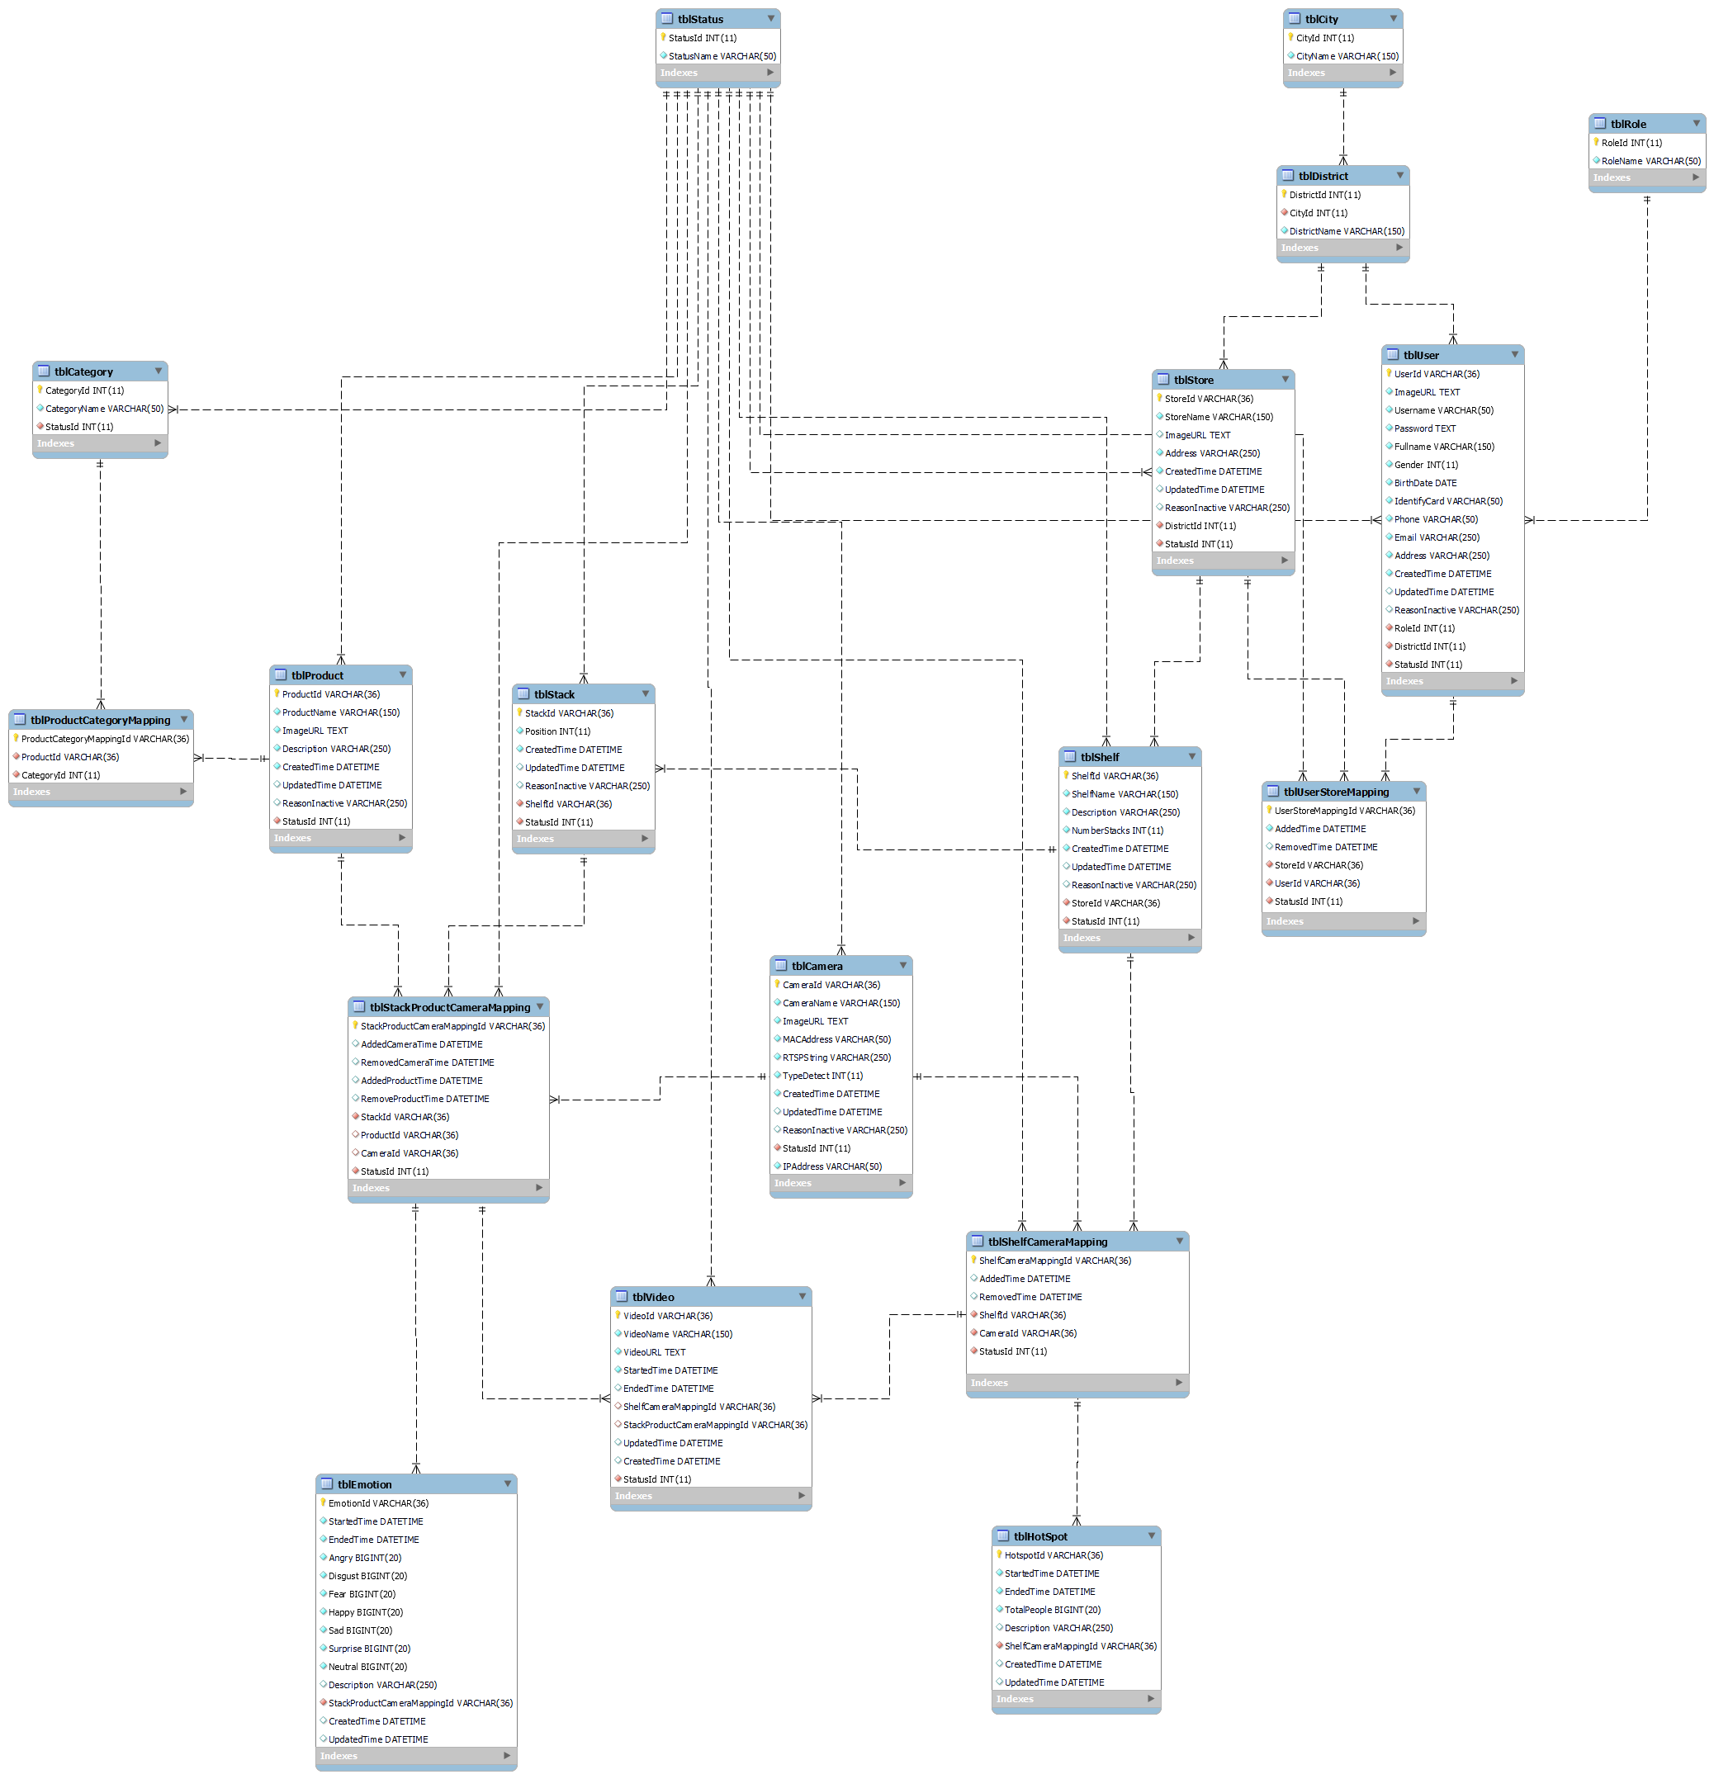

Figure 55 . Entity relationship diagram

Table . Entity description

|  |  |  |
| --- | --- | --- |
| **#** | **Entity** | **Description** |
| 1 | tblCity | tblCity represents the cities in the system. |
| 2 | tblDistrict | tblCity represents the districts in the system. |
| 3 | tblCategory | tblCategory represents the category of products in the system. |
| 4 | tblStatus | tblStatus represents the status in the system. |
| 5 | tblRole | tblRole represents the role in the system. |
| 6 | tblUser | tblUser store information of user in the system includes username and password. |
| 7 | tblStore | tblStore represents the information of stores in the system. |
| 8 | tblUserStoreMapping | Mapping user with store, it means a manager manage stores. |
| 9 | tblShelf | tblShelf represents the information of shelf in a store. |
| 10 | tblStack | tblStack represents the information of stack on the shelf. |
| 11 | tblShelfCameraMapping | Mapping camera with shelf, it means mount the camera on the shelf. |
| 12 | tblStackProductCameraMapping | Mapping product and camera with stack, it means mount the camera and product on stack. |
| 13 | tblCamera | tblCamera represent the cameras that are running and operating in the system. Cameras are used for record video of shelf or stack. That includes the camera’s information. |
| 14 | tblProduct | tblProduct represent the products that are running in the system. Product are used for show on the stack in store. That includes the product’s information. |
| 15 | tblProductCategoryMapping | Mapping product with categories. |
| 16 | tblVideo | tblVideo represent the products that are detected in the system. That includes the video’s informantion. |
| 17 | tblEmotion | Store result of video detect emotion. |
| 18 | tblHotSpot | Store result of video detect “hot spot”. |

## 4. Non-Functional Requirements

### 4.1 External Interfaces

#### a. User Interfaces

UI-1: UI must be in English.

UI-2: GUI must be friendly, clear and easy to use.

UI-3: Information content pages should be concise, clear and users can focus easily.

UI-4: Content will fit the screen of almost android phone, allows users to view the main content without zooming or scrolling horizontally.

UI-5: Elements are designed for touching gesture to help users interact with app easily and more comfortable.

UI-6: Background and font colors have great contrast to help users easy to read text.

#### b. Software Interfaces

SI-1:Web application: browser Safari (version 14.1.2 or higher), Google Chrome (version 70 or higher), Firefox (version 60 or higher), Internet Explorer (version 10 or higher).

SI-2:Mobile application: phone operating system requires Android version 10.0 or higher.

#### c. Hardware Interfaces

HI-1: Desktop or laptop.

HI-2: Camera IP.

#### d. Communications Interfaces

CI-1: System handler will send emails to manager based on specific functions.

### 4.2 Quality Attributes

#### a. Usability

* Users will probably take at least 2 days to learn how to use the system.
* The UI of website fits for each browser on each device.
* The system should be intuitive and easy so that even non-IT staff can use.

#### b. Reliability

* The accuracy of detect emotion must be over 60%.
* The accuracy of counting customer must be over 60%.

#### c. Performance

* Normal response time is less than 500ms.

#### d. Dependability

##### d1. Security

* Each role in system can only access its own functions.
* Before saving data to database, all input is validated.

##### d2. Safety

* Integration of CFFE system is low-impact on the workflow of manager.

#### e. Supportability

* Should apply RESTFUL Web API Standard.
* Should follow the coding convention.
* All development tools should be listed with attached documents.

#### f. Design Constraints

* Using OpenCV, Tensorflow and open source frameworks.
* Coding language:
  + Python: video processing and detection.
  + Java: back-end server.
  + Dart: UI of mobile programming.
  + JavaScript, CSS, HTML: UI of web programming.

#### g. Support Documents

* Manual documents should be step-by-step, simple and clear.
* Installation instructions should be easy and straightforward.
* Include full of configuration parameters.

#### h. Purchased Components

* Google Cloud Service

## 5. Other Requirements

### 5.1 Messages List

|  |  |  |  |  |
| --- | --- | --- | --- | --- |
| **No** | **Message code** | **Message Type** | **Context** | **Content** |
| 1 | MSG-001 | Toast message | Username is empty | Username is required |
| 2 | MSG-002 | Toast message | Password is empty | Password is required |
| 3 | MSG-003 | Toast message | Login with invalid username or password | Invalid username or password |
| 4 | MSG-004 | Toast message | Old password is empty | Old password is required |
| 5 | MSG-005 | Toast message | New password is empty | New password is required |
| 6 | MSG-006 | Toast message | Retype password is empty | Retype password is required |
| 7 | MSG-007 | Toast message | New password and Retype password is not matched | New password and retype password must be matched |
| 8 | MSG-008 | Toast message | The password is not following format:  - At least one digit. - At least one lowercase character. - At least one uppercase character. - At least one special character. - At least 8 characters and a maximum of 20 characters. | The password format is wrong |
| 9 | MSG-009 | Toast message | The list has no data | No data |
| 10 | MSG-010 | Toast message | Uploading video is successful | Videos upload is successful! |
| 11 | MSG-011 | Toast message | Creating objects process is successful | Creating process is successful |
| 12 | MSG-012 | Toast message | The shelf doesn't exist | Shelf doesn't exist |
| 13 | MSG-013 | Toast message | Updating objects process is successful | Updating process is successful |
| 14 | MSG-014 | Toast message | Full name is empty | Full name is required |
| 15 | MSG-015 | Toast message | Full name is not between 1 to 100 characters | Full name is between 1 to 100 characters |
| 16 | MSG-016 | Toast message | Description is empty | Description is required |
| 17 | MSG-017 | Toast message | Description is not between 1 to 250 characters | Description is between 1 to 250 characters |
| 18 | MSG-018 | Toast message | Number of stacks is empty | Shelf's number of stacks is required |
| 19 | MSG-019 | Toast message | Number of stacks is not between 1 to 30 stacks | Shelf's number of stacks is between 1 to 30 stacks |
| 20 | MSG-020 | Toast message | The camera doesn't exist in CFFE system. | Camera doesn't exist |
| 21 | MSG-021 | Toast message | Deleting objects process is successful | Deleting process is successful |
| 22 | MSG-022 | Toast message | The stack doesn't exist in CFFE system | Stack doesn't exist |
| 23 | MSG-023 | Toast message | The product doesn't exist in CFFE system | Product doesn't exist |
| 24 | MSG-024 | Toast message | The camera id is empty | Camera id is required |
| 25 | MSG-025 | Toast message | The shelf has number of stacks is maximum | Shelf is full |
| 26 | MSG-026 | Toast message | The image is empty | Image is required |
| 27 | MSG-027 | Toast message | The image is not png, jpg, jpeg format | The image must be png, jpg, jpeg format |
| 28 | MSG-028 | Toast message | The category is empty | Category is required |
| 29 | MSG-029 | Toast message | The category does not exist | Category does not exist |
| 30 | MSG-030 | Toast message | The RTSP is empty | The RTSP string is required |
| 31 | MSG-031 | Toast message | The IP address is empty | The IP address is required |
| 32 | MSG-032 | Toast message | The IP address is wrong format | The IP address must be x.x.x.x format (x is number between 0 to 255) |
| 33 | MSG-033 | Toast message | The category doesn't exist | Category doesn't exist |
| 34 | MSG-034 | Toast message | The name already exists | Name already exists |
| 35 | MSG-035 | Toast message | The store doesn't exist | Store doesn't exist |
| 36 | MSG-036 | Toast message | The address is empty | Address is required |
| 37 | MSG-037 | Toast message | Address is not between 1 to 250 characters | Address is between 1 to 250 characters |
| 38 | MSG-038 | Toast message | City has not been selected | City is required |
| 39 | MSG-039 | Toast message | District has not been selected | District is required |
| 40 | MSG-040 | Toast message | Deleting object process is successful | Deleting process is successful |
| 41 | MSG-041 | Toast message | The manager doesn't exist | The user doesn't exist |
| 42 | MSG-042 | Toast message | Phone number is not between 10 to 13 digits | Phone is between 10 to 13 digits |
| 43 | MSG-043 | Toast message | Manager already exists | Manager already exists |
| 44 | MSG-044 | Toast message | Email is empty | Email is required |
| 45 | MSG-045 | Toast message | Email does not match /^(([^<>()[\]\\.,;:\s@"]+(\.[^<>()[\]\\.,;:\s@"]+)*)|(".+"))@((\[[0-9]{1,3}\.[0-9]{1,3}\.[0-9]{1,3}\.[0-9]{1,3}\])|(([a-zA-Z\-0-9]+\.)+[a-zA-Z]{2,}))$/ regex | The email format is wrong |
| 46 | MSG-046 | Toast message | Status doesn't exist | Status doesn't exist |
| 47 | MSG-047 | Toast message | Birthdate is empty | Birthdate is required |
| 48 | MSG-048 | Toast message | Birthdate is greater than current date. | Birthdate is invalid |
| 49 | MSG-049 | Toast message | Phone is empty | Phone is required |
| 50 | MSG-050 | Toast message | Category name is not between 1 to 100 characters | Category name is between 1 to 100 characters |
| 51 | MSG-051 | Toast message | Identity card is empty | Identity card is required |
| 52 | MSG-052 | Toast message | Identity card does not include from 9 to 12 digits | Identity card includes from 9 to 12 digits |
| 53 | MSG-053 | Toast message | Password is wrong | Password is wrong |
| 54 | MSG-054 | Toast message | Gender is not selected | Gender is required |
| 55 | MSG-055 | Toast message | Email exists. | Email already exists |
| 56 | MSG-056 | Toast message | Identify card is exist | Identify card already exists |
| 57 | MSG-057 | Toast message | IP address exists | IP address already exists |
| 58 | MSG-058 | Toast message | RTSP String exists | RTSP string already exists |
| 59 | MSG-059 | Toast message | Category name exists | Category name already exists |
| 60 | MSG-060 | Toast message | Product name exists | ProductName already exists |
| 61 | MSG-061 | Toast message | Shelf name exists | Shelf name already exists |
| 62 | MSG-062 | Toast message | Store name exists | Store name already exists |
| 63 | MSG-063 | Toast message | The manager is not found. | The manager is not found |
| 64 | MSG-064 | Toast message | Create manager successfully. | Create manager successfully |
| 65 | MSG-065 | Toast message | This status does not exist. | Status does not exist |
| 66 | MSG-066 | Toast message | Pending status can be changed to be inactive status if it has an inactive reason and mappings are inactive.  Inactive status only changing to be pending status. | Changing status fail |
| 67 | MSG-067 | Toast message | Inactive reason is not from 1 to 250 characters. | Inactive reason must be from 1 to 250 characters |
| 68 | MSG-068 | Toast message | The old password is not correct. | Old password is not correct |
| 69 | MSG-069 | Toast message | Store ID cannot empty. | Store ID is required |
| 70 | MSG-070 | Toast message | Analyzed time cannot empty. | Analyzed time is required |
| 71 | MSG-071 | Toast message | Shelf Id cannot empty when get shelf detail | Shelf Id is required |
| 72 | MSG-072 | Toast message | Wrong time format (HH:MM:SS) | Time must be format (HH:MM:SS) |
| 73 | MSG-073 | Toast message | Birthday is not YYYY-MM-DD format | Birthday must be followed by YYYY-MM-DD format |
| 74 | MSG-074 | Toast message | Manager is not found  Manager status is not pending | Manager is not available |
| 75 | MSG-075 | Toast message | Store is not found Store status is not pending | Store is not available |
| 76 | MSG-076 | Toast message | System cannot finish this action | System cannot finish this action |
| 77 | MSG-077 | Toast message | Store and Manager is not mapping | Store and Manager is not mapping |
| 78 | MSG-078 | Toast message | Stack ID is empty | Stack ID is required |
| 79 | MSG-079 | Toast message | Shelf name is empty | Shelf name is required |
| 80 | MSG-080 | Toast message | Shelf name is not from 1 to 100 characters. | Shelf name must be from 1 to 100 characters |
| 81 | MSG-081 | Toast message | Store contain shelfs active or pending. | Store contain shelves active or pending |
| 82 | MSG-082 | Toast message | Camera name cannot be empty | Camera name is required |
| 83 | MSG-083 | Toast message | Camera name is not from 1 to 100 characters. | Camera name must be from 1 to 100 characters |
| 84 | MSG-084 | Toast message | Type detect is not 1 or 2. | Type detect does not exist |
| 85 | MSG-085 | Toast message | Shelf must be existed and not active. | Shelf must be existed |
| 86 | MSG-086 | Toast message | Camera must be existed and not active. | Camera must be existed and not active |
| 87 | MSG-087 | Toast message | Camera or Shelf is not available. | Camera or Shelf is not available |
| 88 | MSG-088 | Toast message | Shelf and Camera is not mapping | Shelf and Camera is not mapping |
| 89 | MSG-089 | Toast message | Product is not active. | Product is not active |
| 90 | MSG-090 | Toast message | Stack's status is active or inactive. | Stack is already active or inactive |
| 91 | MSG-091 | Toast message | Stack already has a product. | Stack already has a product |
| 92 | MSG-092 | Toast message | Product and Stack is not mapping. | Product and Stack is not mapping or stack already has camera |
| 93 | MSG-093 | Toast message | Camera is already active or inactive. | Camera is already active or inactive |
| 94 | MSG-094 | Toast message | Camera and Stack is not mapping. | Camera and Stack is not mapping |
| 95 | MSG-095 | Toast message | Stack contain product. | Stack contain product |
| 96 | MSG-096 | Toast message | Product ID is required. | Product ID is required |
| 97 | MSG-097 | Toast message | Have stack contain this product. | Have stack contain this product |
| 98 | MSG-098 | Toast message | Active status can be changed to be inactive status if it has an inactive reason, and no any stack contain it. | Changing status fail |
| 99 | MSG-099 | Toast message | Product name is required. | Product name is required |
| 100 | MSG-100 | Toast message | Stack much contain product. | Stack must contain product |
| 101 | MSG-101 | Toast message | Stack already active. | Stack already active |
| 102 | MSG-102 | Toast message | Category is required. | Category is required |
| 103 | MSG-103 | Toast message | Product does not belong 1 - 3 categories | Category list at least 1 item, and maximum is 3 |
| 104 | MSG-104 | Toast message | Category list contain invalid id. | Category list contain invalid id |
| 105 | MSG-105 | Toast message | Category name is required. | Category name is required |
| 106 | MSG-106 | Toast message | Store name is required. | Store name is required |
| 107 | MSG-107 | Toast message | Store address is required. | Store address is required |
| 108 | MSG-108 | Toast message | Store analysed time is required. | Store analyzed time is required |
| 109 | MSG-109 | Toast message | This category is being used. | This category is being used |
| 110 | MSG-110 | Toast message | Active status can be changed to be inactive status if it has no product using it | Changing status fail |
| 111 | MSG-111 | Toast message | System have some problem | System have some problem Please try later |
| 112 | MSG-112 | Toast message | Don't select the image to change image | Please select an image |
| 113 | MSG-113 | Toast message | Image is not jpg, jpeg, png format. | jpg/jpeg/png file types are supported |
| 114 | MSG-114 | Toast message | System upload video to storage fail. | System could not create the directory where the uploaded files will be stored in server |
| 115 | MSG-115 | Toast message | End date is empty | End date is required |
| 116 | MSG-116 | Toast message | Choose End date greater than Start date | End date need to greater than Start date |
| 117 | MSG-117 | Toast message | Date is wrong format | Date must be followed by format YYY-MM-dd |
| 118 | MSG-118 | Toast message | Uploading videos is not mp4 format | Mp4 file type is supported |
| 119 | MSG-119 | Toast message | Don't select the video to upload | Please select a video |
| 120 | MSG-120 | Toast message | Access to URL is not permission | You have no permission to access |
| 121 | MSG-121 | Toast message | Uploading videos is wrong name format | There are at least 1 video have invalid name |
| 122 | MSG-122 | Toast message | Uploading videos don't belong to any store's cameras | There are at least 1 video does not map with camera |
| 123 | MSG-123 | Toast message | Uploading videos are duplicated | There are at least 1 video duplicated |
| 124 | MSG-124 | Toast message | Sending email for the manager is failed | Sending email fail |
| 125 | MSG-125 | Toast message | MAC address is empty | MAC address is required |
| 126 | MSG-126 | Toast message | MAC address is wrong format | MAC address must contain 12 hexadecimal digits (XX-XX-XX-XX-XX-XX) |
| 127 | MSG-127 | Toast message | MAC address exists in CFFE system | MAC address already exists |
| 128 | MSG-128 | Toast message | The number of cameras added to the shelf exceeds 2 | The maximum camera on the shelf is 2 |
| 129 | MSG-129 | Toast message | Store name is between 1 to 100 characters | Store name is between 1 to 100 characters. |
| 130 | MSG-130 | Toast message | Product name is not between 1 to 100 characters | Product name is between 1 to 100 characters. |

# IV. Software Design Description

## 1. Overall Description

### 1.1 Assumptions

This system is designed basing on these following assumptions:

* Software/OS:
  + Windows 10
  + Safari browser 14.1.2
  + MySQL 8.0
  + Java 8.0
  + NodeJS 14.16.1
  + Flutter 2.0.6
* Hardware:
  + Computer that have internet connection
  + Camera IP

### 1.2 Design Constraints

* End-user environment: OS with have Safari, android phone, camera.
* Network communication: this system works based on the network connection.

## 2. System Architecture Design

### 2.1 Overall Architecture

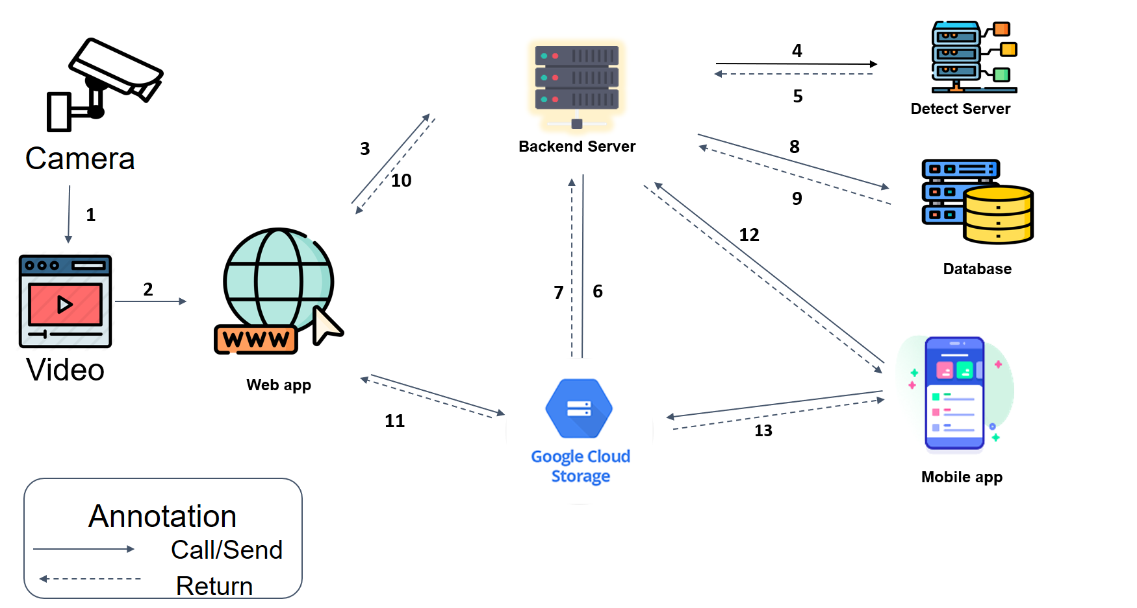

Figure . Overall architecture

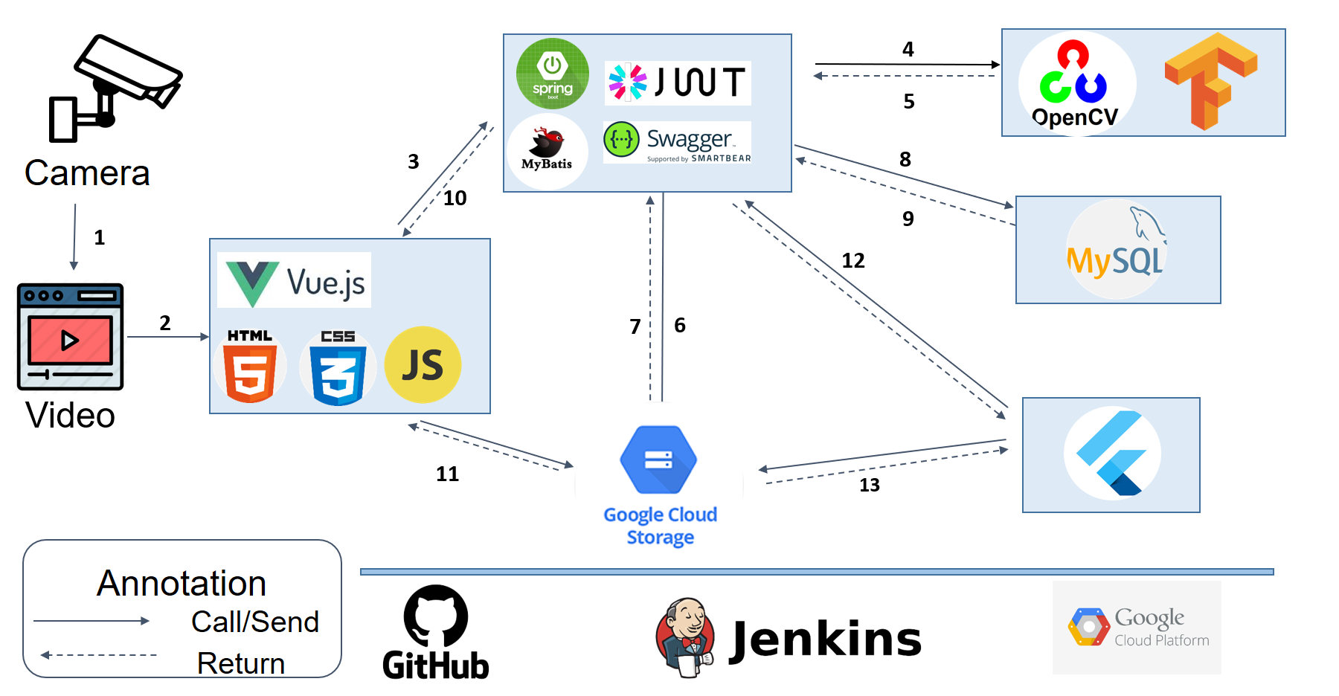

Figure . Overall architecture technology applied

### 2.3 Package Diagram



Figure . <Package Diagram> Back-end



Figure . <Package Diagram> Web App



Figure . <Package Diagram> Mobile App

## 3. System Detailed Design

### 3.1 Class Diagram

<img class diagram>

### 3.2 Class Specification

#### 3.2.1 Camera

Table . <Class Specification> Camera

|  |  |  |
| --- | --- | --- |
| **Property** | **Type** | **Description** |
| CameraId | string | Unique identifier of camera |
| CameraName | string | Name of camera |
| ImageURL | string | Image of camera |
| MACAddress | string | MAC address of camera |
| RTSPString | string | RTSP of camera |
| TypeDetect | int | Type of camera |
| CreatedTime | string | Created date of camera |
| UpdatedTime | string | Last modified date of camera |
| ReasonInactive | string | Reason inactive of camera |
| StatusId | int | Unique identifier of status |
| IPAddress | String | IP address of camera |
| getter() | data type | Get attribute of class |
| setter() | void | Set value of class’s attribute |

#### 3.2.2 Category

Table . <Class Specification> Category

|  |  |  |
| --- | --- | --- |
| **Property** | **Type** | **Description** |
| CategoryId | int | Unique identifier of category |
| CategoryName | string | Name of category |
| StatusId | int | Unique identifier of status |
| getter() | data type | Get attribute of class |
| setter() | void | Set value of class’s attribute |

#### 3.2.3 City

Table . <Class Specification> City

|  |  |  |
| --- | --- | --- |
| **Property** | **Type** | **Description** |
| CityId | int | Unique identifier of city |
| CityName | string | Name of city |
| getter() | data type | Get attribute of class |
| setter() | void | Set value of class’s attribute |

#### 3.2.4 District

Table . <Class Specification> District

|  |  |  |
| --- | --- | --- |
| **Property** | **Type** | **Description** |
| DistrictId | int | Unique identifier of district |
| CityId | Int | Unique identifier of city |
| DistrictName | string | Name of district |
| getter() | data type | Get attribute of class |
| setter() | void | Set value of class’s attribute |

#### 3.2.5 Emotion

Table . <Class Specification> Emotion

|  |  |  |
| --- | --- | --- |
| **Property** | **Type** | **Description** |
| EmotionId | string | Unique identifier of emotion |
| StartedTime | string | Time started of video |
| EndedTime | string | Time ended of video |
| Angry | int | Number of angry |
| Disgust | int | Number of disgust |
| Fear | int | Number of fear |
| Happy | int | Number of happy |
| Sad | int | Number of sad |
| Surprise | int | Number of surprise |
| Neutral | int | Number of neutral |
| Description | string | Description of emotion |
| StackProductCameraMappingId | string | Unique identifier of stack product camera mapping |
| CreatedTime | string | Created date of emotion |
| UpdatedTime | string | Last modified date of emotion |
| getter() | data type | Get attribute of class |
| setter() | void | Set value of class’s attribute |

#### 3.2.6 HotSpot

Table . <Class Specification> HotSpot

|  |  |  |
| --- | --- | --- |
| **Property** | **Type** | **Description** |
| HotspotId | string | Unique identifier of hot spot |
| StartedTime | string | Time started of video |
| EndedTime | string | Time ended of video |
| TotalPeople | int | Number of customer |
| Description | string | Description of hot spot |
| ShelfCameraMappingId | string | Unique identifier of shelf camera mapping |
| CreatedTime | string | Created date of hot spot |
| UpdatedTime | string | Last modified date of hot spot |
| getter() | data type | Get attribute of class |
| setter() | void | Set value of class’s attribute |

#### 3.2.7 Product

Table . <Class Specification> Product

|  |  |  |
| --- | --- | --- |
| **Property** | **Type** | **Description** |
| ProductId | string | Unique identifier of product |
| ProductName | string | Name of product |
| ImageURL | string | Image URL of product |
| Description | string | Description of product |
| CreatedTime | string | Created date of product |
| UpdatedTime | string | Last modified date of product |
| ReasonInactive | string | Reason inactive of product |
| StatusId | int | Unique identifier of status |
| getter() | data type | Get attribute of class |
| setter() | void | Set value of class’s attribute |

#### 3.2.8 ProductCategoryMapping

Table . <Class Specification> ProductCategoryMapping

|  |  |  |
| --- | --- | --- |
| **Property** | **Type** | **Description** |
| ProductCategoryMappingId | string | Unique identifier of product category mapping |
| ProductId | string | Unique identifier of product |
| CategoryId | int | Unique identifier of category |
| getter() | data type | Get attribute of class |
| setter() | void | Set value of class’s attribute |

#### 3.2.9 Role

Table . <Class Specification> Role

|  |  |  |
| --- | --- | --- |
| **Property** | **Type** | **Description** |
| RoleId | int | Unique identifier of role |
| RoleName | string | Name of role |
| getter() | data type | Get attribute of class |
| setter() | void | Set value of class’s attribute |

#### 3.2.10 Shelf

Table . <Class Specification> Shelf

|  |  |  |
| --- | --- | --- |
| **Property** | **Type** | **Description** |
| ShelfId | string | Unique identifier of shelf |
| ShelfName | string | Name of shelf |
| Description | string | Description of shelf |
| NumberStacks | int | Number stack of shelf |
| CreatedTime | string | Created date of shelf |
| UpdatedTime | string | Last modified date of shelf |
| ReasonInactive | string | Reason inactive of shelf |
| StoreId | string | Unique identifier of store |
| StatusId | int | Unique identifier of status |
| getter() | data type | Get attribute of class |
| setter() | void | Set value of class’s attribute |

#### 3.2.11 ShelfCameraMapping

Table . <Class Specification> ShelfCameraMapping

|  |  |  |
| --- | --- | --- |
| **Property** | **Type** | **Description** |
| ShelfCameraMappingId | string | Unique identifier of shelf camera mapping |
| AddedTime | string | Added time of camera |
| RemovedTime | string | Removed time ò camera |
| ShelfId | string | Unique identifier of shelf |
| CameraId | string | Unique identifier of camera |
| StatusId | int | Unique identifier of status |
| getter() | data type | Get attribute of class |
| setter() | void | Set value of class’s attribute |

#### 3.2.12 Stack

Table . <Class Specification> Stack

|  |  |  |
| --- | --- | --- |
| **Property** | **Type** | **Description** |
| StackId | string | Unique identifier of stack |
| Position | int | Position of stack |
| CreatedTime | string | Created date of stack |
| UpdatedTime | string | Last modified date of stack |
| ReasonInactive | string | Reason inactive of stack |
| ShelfId | string | Unique identifier of shelf |
| StatusId | int | Unique identifier of status |
| getter() | data type | Get attribute of class |
| setter() | void | Set value of class’s attribute |

#### 3.2.13 StackProductCameraMapping

Table . <Class Specification> StackProductCameraMapping

|  |  |  |
| --- | --- | --- |
| **Property** | **Type** | **Description** |
| StackProductCameraMappingId | string | Unique identifier of stack product camera mapping |
| AddedCameraTime | string | Added time of camera |
| RemovedCameraTime | string | Removed time of camera |
| AddedProductTime | string | Added time of product |
| RemoveProductTime | string | Removed time of product |
| StackId | string | Unique identifier of stack |
| ProductId | string | Unique identifier of product |
| CameraId | string | Unique identifier of camera |
| StatusId | int | Unique identifier of status |
| getter() | data type | Get attribute of class |
| setter() | void | Set value of class’s attribute |

#### 3.2.14 Status

Table . <Class Specification> Status

|  |  |  |
| --- | --- | --- |
| **Property** | **Type** | **Description** |
| StatusId | int | Unique identifier of status |
| StatusName | string | Name of status |
| getter() | data type | Get attribute of class |
| setter() | void | Set value of class’s attribute |

#### 3.2.15 Store

Table . <Class Specification> Store

|  |  |  |
| --- | --- | --- |
| **Property** | **Type** | **Description** |
| StoreId | string | Unique identifier of store |
| StoreName | string | Name of store |
| ImageURL | string | Image URL of store |
| Address | string | Address of store |
| CreatedTime | string | Created date of store |
| UpdatedTime | string | Last modified date of store |
| ReasonInactive | string | Reason Inactive of store |
| DistrictId | int | Unique identifier of district |
| StatusId | int | Unique identifier of status |
| getter() | data type | Get attribute of class |
| setter() | void | Set value of class’s attribute |

#### 3.2.16 User

Table . <Class Specification> User

|  |  |  |
| --- | --- | --- |
| **Property** | **Type** | **Description** |
| UserId | string | Unique identifier of user |
| ImageURL | string | Image URL of user |
| Username | string | Username of user |
| Password | string | Password of user |
| Fullname | string | Name of user |
| Gender | int | Gender of user |
| BirthDate | string | Day of birth of user |
| IdentifyCard | string | Identify card of user |
| Phone | string | Phone number of user |
| Email | string | Email of user |
| Address | string | Address of user |
| CreatedTime | string | Created date of user |
| UpdatedTime | string | Last modified date of user |
| ReasonInactive | string | Reason inactive of user |
| RoleId | int | Unique identifier of role |
| DistrictId | int | Unique identifier of district |
| StatusId | int | Unique identifier of status |
| getter() | data type | Get attribute of class |
| setter() | void | Set value of class’s attribute |

#### 3.2.17 UserStoreMapping

Table . <Class Specification> UserStoreMapping

|  |  |  |
| --- | --- | --- |
| **Property** | **Type** | **Description** |
| UserStoreMappingId | string | Unique identifier of user store mapping |
| AddedTime | string | Added time of user |
| RemovedTime | string | Removed time of user |
| StoreId | string | Unique identifier of store |
| UserId | string | Unique identifier of user |
| StatusId | int | Unique identifier of status |
| getter() | data type | Get attribute of class |
| setter() | void | Set value of class’s attribute |

#### 3.2.18 Video

Table . <Class Specification> Video

|  |  |  |
| --- | --- | --- |
| **Property** | **Type** | **Description** |
| VideoId | string | Unique identifier of video |
| VideoName | string | Name of video |
| VideoURL | string | URL of video |
| StartedTime | string | Started time of video |
| EndedTime | string | Ended time of video |
| ShelfCameraMappingId | string | Unique identifier of shelf camera mapping |
| StackProductCameraMappingId | string | Unique identifier of stack product camera mapping |
| UpdatedTime | string | Created date of video |
| CreatedTime | string | Last modified date of video |
| getter() | data type | Get attribute of class |
| setter() | void | Set value of class’s attribute |

### 3.3 Sequence Diagrams

#### 1. Login case



Figure x. Login case Sequence Diagram

#### 2. Reset manager’s account password case



Figure x. Reset manager’s account password case Sequence Diagram

#### 3. Change the password case



Figure x. Change the password case Sequence Diagram

#### 4. Get own profile case

Figure x. Get own profile case Sequence Diagram

#### 5. Update own profile case



Figure x. Update the own profile case Sequence Diagram

#### 6. Create the manager case



Figure x. Create the manager case Sequence Diagram

#### 7. Delete the manager case



Figure x. Delete the manager case Sequence Diagram

#### 8. Update the manager case



Figure x. Update the manager case Sequence Diagram

#### 9. Get the manager detail case



Figure x. Get the manager detail case Sequence Diagram

#### 10. Get the managers case



Figure x. Get the managers case Sequence Diagram

#### 11. Create the store case



Figure x. Create the store case Sequence Diagram

#### 12. Delete the store case



Figure x. Delete the store case Sequence Diagram

#### 13. Update the store case



Figure x. Update the store case Sequence Diagram

#### 14. Get the store detail case

Figure x. Get the store detail case Sequence Diagram

#### 15. Get the stores case



Figure x. Get the stores case Sequence Diagram

#### 16. Create the shelf case



Figure x. Create the shelf case Sequence Diagram

#### 17. Delete the shelf case



Figure x. Delete the shelf case Sequence Diagram

#### 18. Update the shelf case



Figure x. Update the shelf case Sequence Diagram

#### 19. Get the shelf detail case



Figure x. Get the shelf detail case Sequence Diagram

#### 20. Get the shelves case



Figure x. Get the shelves case Sequence Diagram

#### 21. Create the stack case



Figure x. Create the stack case Sequence Diagram

#### 22. Delete the stack case



Figure x. Delete the stack case Sequence Diagram

#### 23. Update the stack case



Figure x. Update the stack case Sequence Diagram

#### 24. Get the stack detail case



Figure x. Get the stack detail case Sequence Diagram

#### 25. Get the stacks case



Figure x. Get the stacks case Sequence Diagram

#### 26. Create the product case



Figure x. Create the product case Sequence Diagram

#### 27. Delete the product case



Figure x. Delete the product case Sequence Diagram

#### 28. Update the product case



Figure x. Update the product case Sequence Diagram

#### 29. Get the product detail case



Figure x. Get the product detail case Sequence Diagram

#### 30. Get the products case



Figure x. Get the products case Sequence Diagram

#### 31. Create the category case



Figure x. Create the category case Sequence Diagram

#### 32. Delete the category case



Figure x. Delete the category case Sequence Diagram

#### 33. Update the category case



Figure x. Update the category case Sequence Diagram

#### 34. Get the category detail case



Figure x. Get the category detail case Sequence Diagram

#### 35. Get the categories case



Figure x. Get the categories case Sequence Diagram

#### 36. Get the video case



Figure x. Get the video case Sequence Diagram

#### 37. Upload the video case



Figure x. Upload the video case Sequence Diagram

### 3.4 Activity Diagram(s)

##### d1 <Unauthenticated User> Activity Diagram(s)

###### d1.1 <Unauthenticated User> Login by account

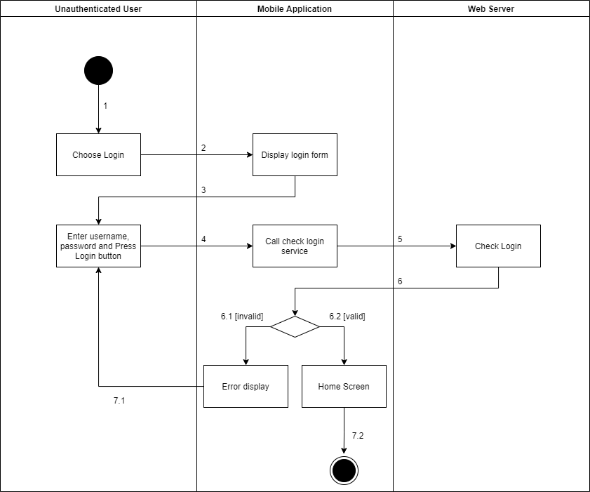

*Figure 1 - <Activity Diagram> Login by account*

##### d2 <Admin> Activity Diagram(s)

###### d2.1 <Admin> Get the stores

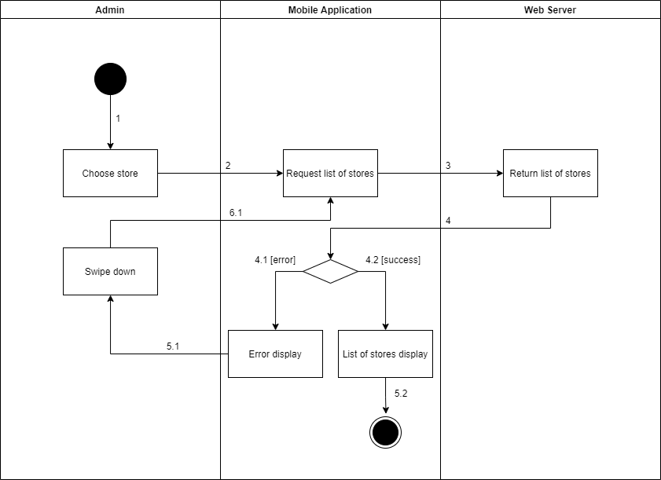

*Figure 1 - <Activity Diagram> Get the stores*

###### d2.2 <Admin> Get store detail

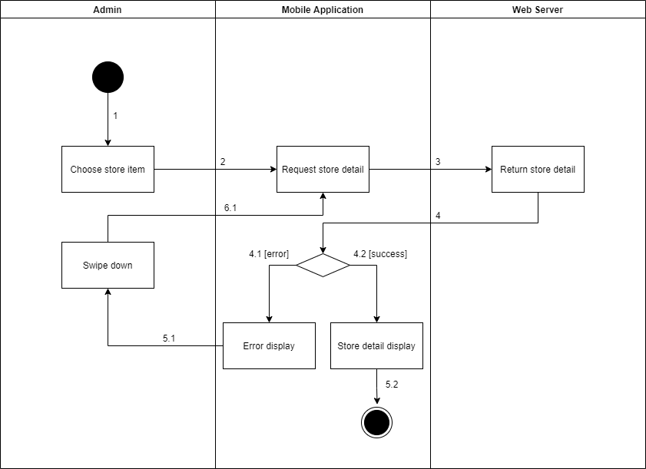

*Figure 1 - <Activity Diagram> Get store detail*

###### d2.3 <Admin> Update the store

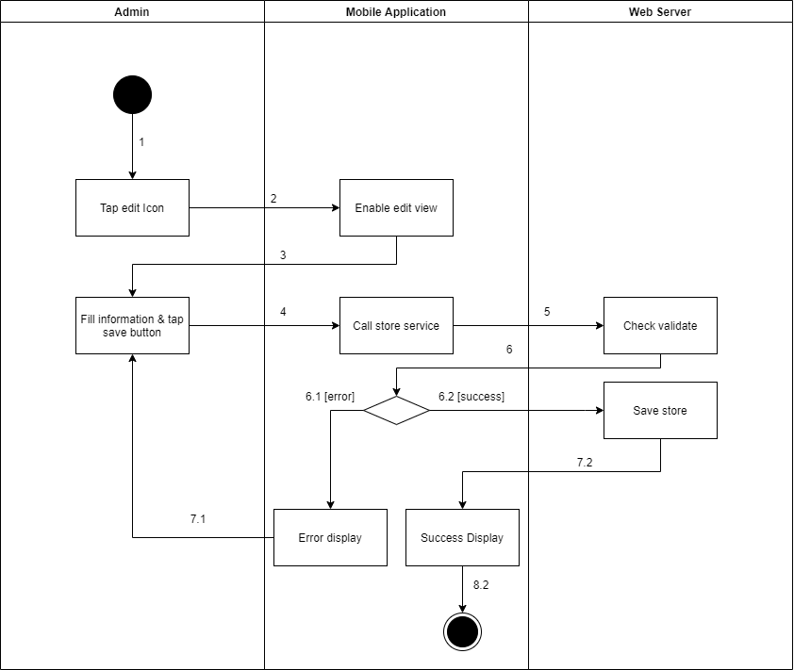

*Figure 1 - <Activity Diagram> Update the store*

###### d2.4 <Admin> Delete the stores

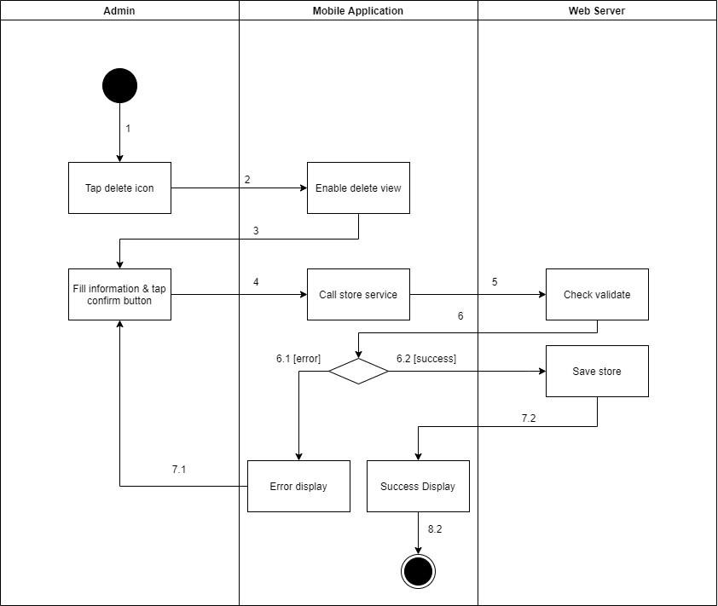

*Figure 1 - <Activity Diagram> Delete the stores*

###### d2.5 <Admin> Create new stores

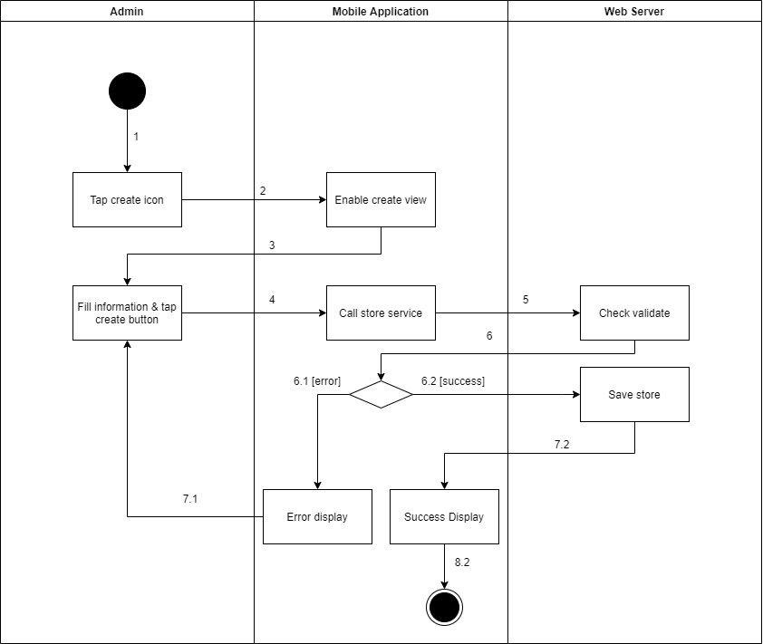

*Figure 1 - <Activity Diagram> Create new stores*

###### d2.6 <Admin> Get the managers

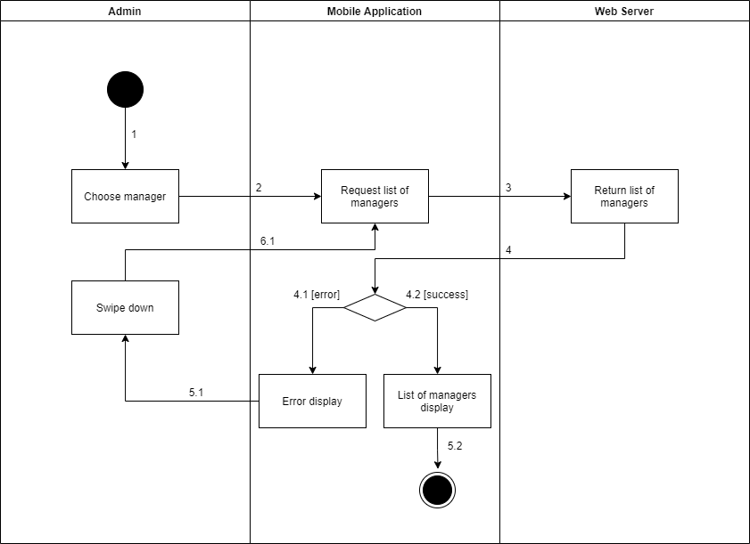

*Figure 1 - <Activity Diagram> Get the managers*

###### d2.7 <Admin> Get manager detail

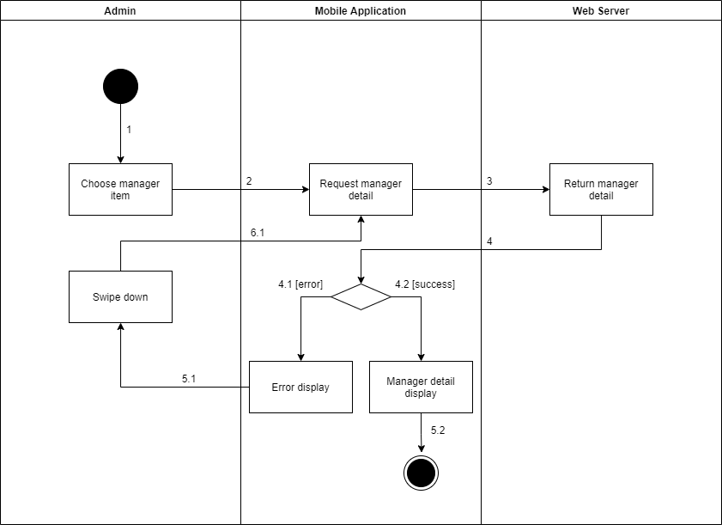

*Figure 1 - <Activity Diagram> Get manager detail*

###### d2.8 <Admin> Update the stores

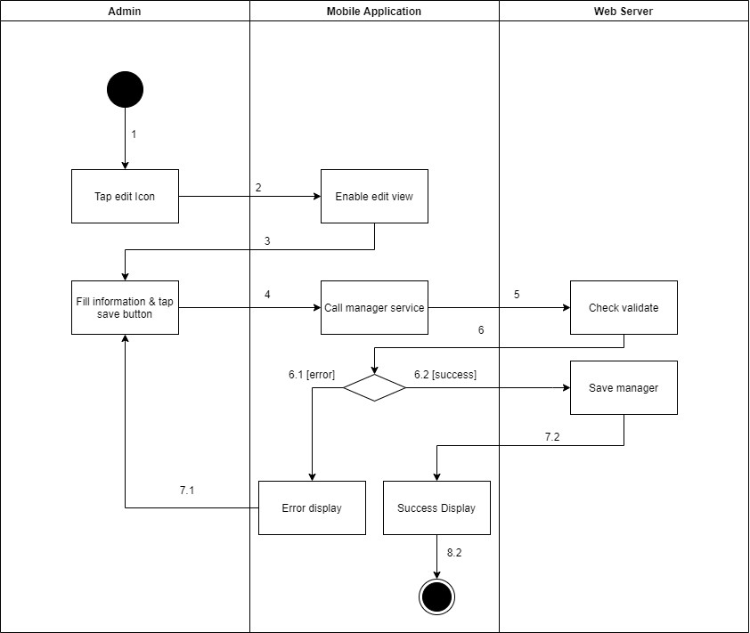

*Figure 1 - <Activity Diagram> Update the stores*

###### d2.9 <Admin> Delete the stores

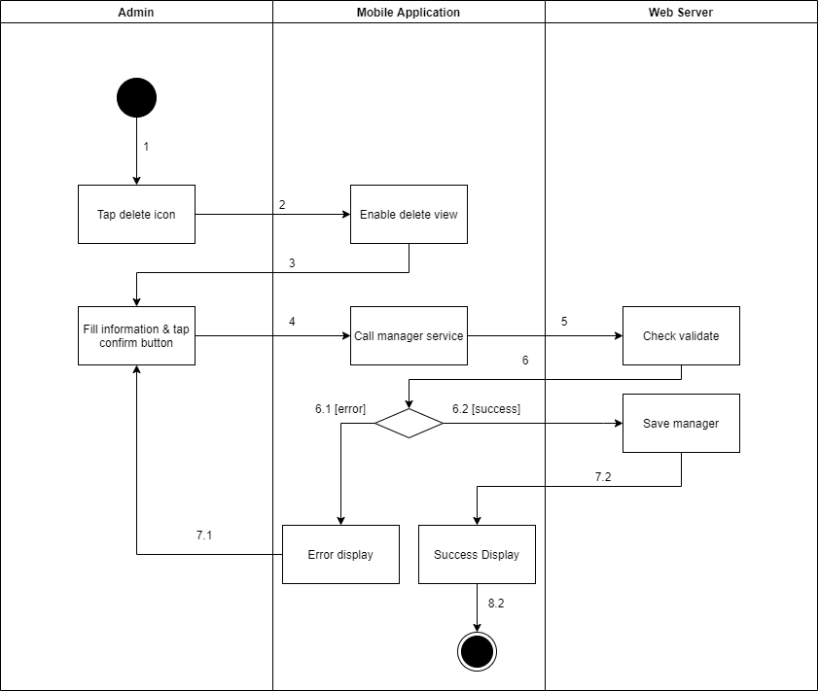

*Figure 1 - <Activity Diagram> Delete the stores*

###### d2.10 <Admin> Create new stores

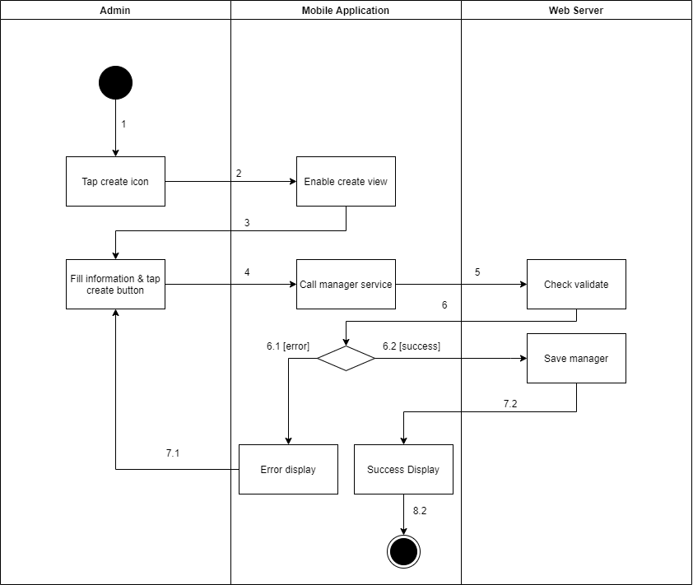

*Figure 1 - <Activity Diagram> Create new stores*

###### d2.11 <Admin> Update the product

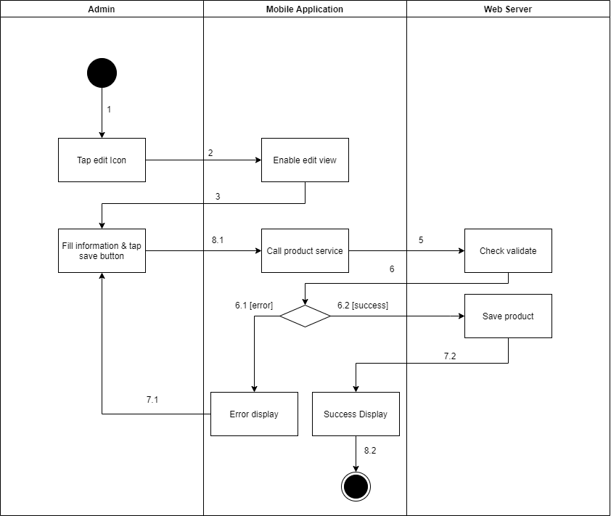

*Figure 1 - <Activity Diagram> Update the product*

###### d2.12 <Admin> Delete the product

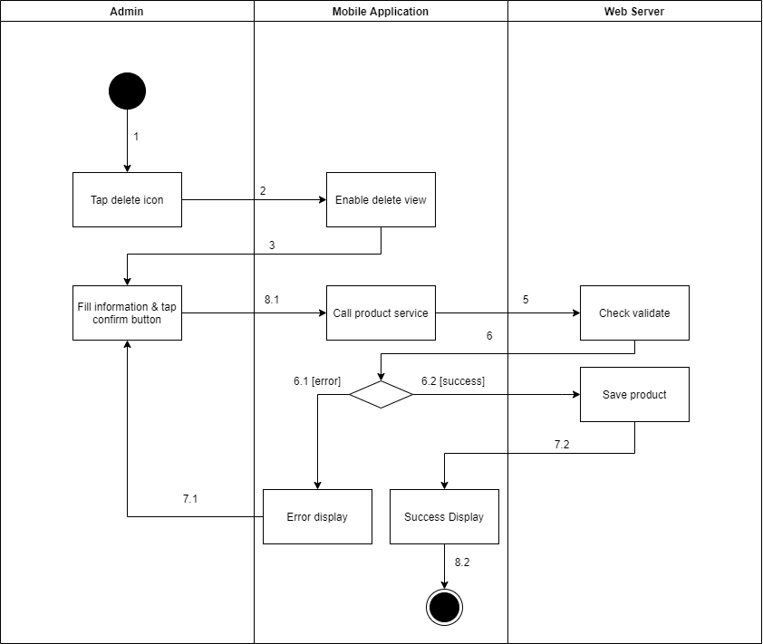

*Figure 1 - <Activity Diagram> Delete the product*

###### d2.13 <Admin> Create new product

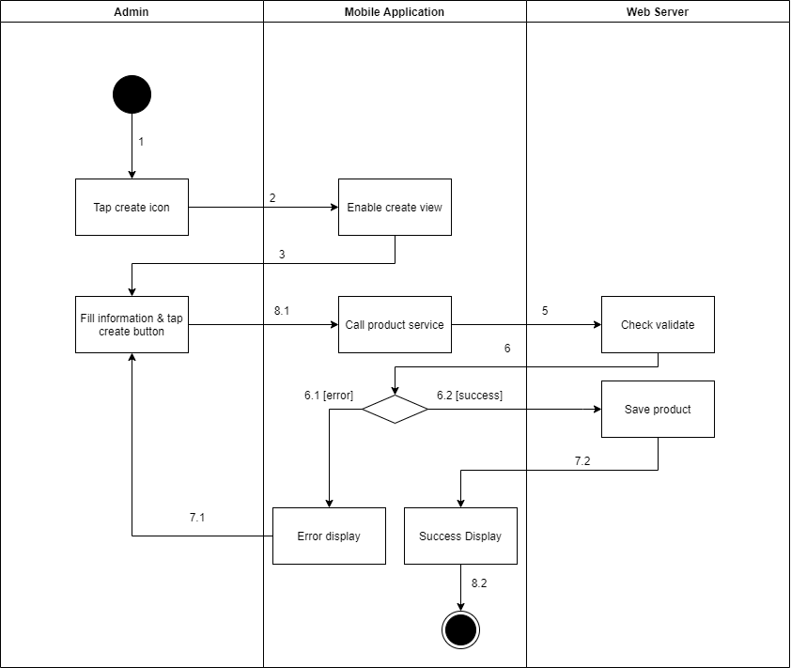

*Figure 1 - <Activity Diagram> Create new product*

###### d2.14 <Admin> Update the camera

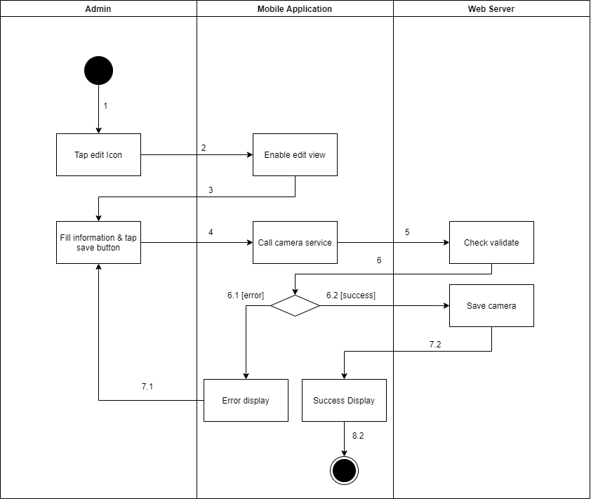

*Figure 1 - <Activity Diagram> Update the camera*

###### d2.15 <Admin> Create new camera

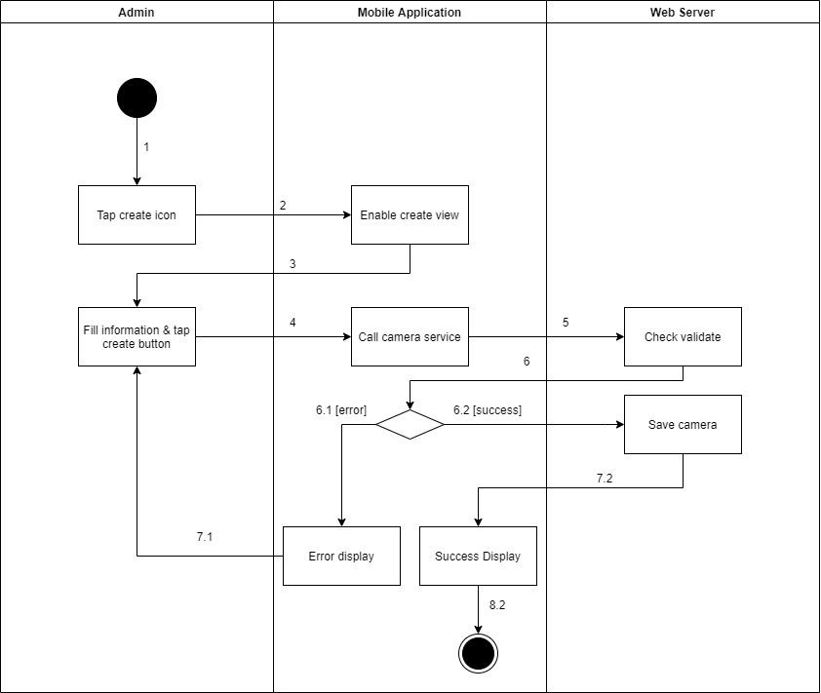

*Figure 1 - <Activity Diagram> Create new camera*

###### d2.16 <Admin> Delete the camera

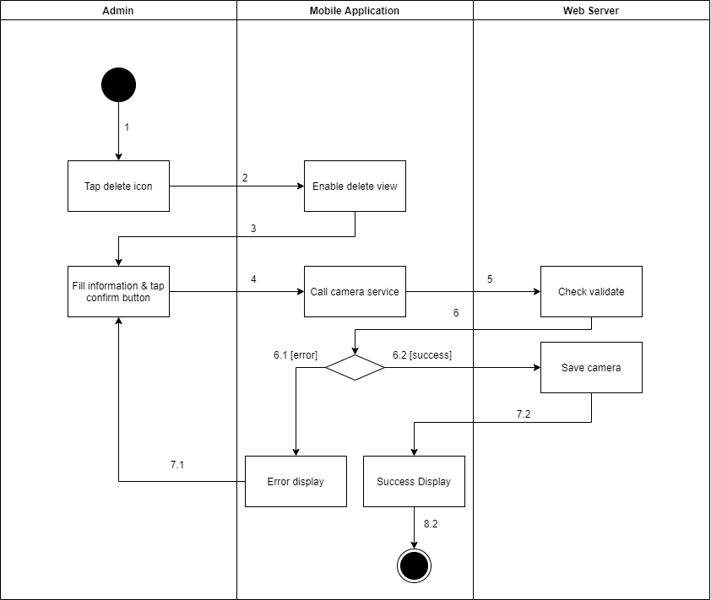

*Figure 1 - <Activity Diagram> Delete the camera*

###### d2.17 <Admin> Update the category

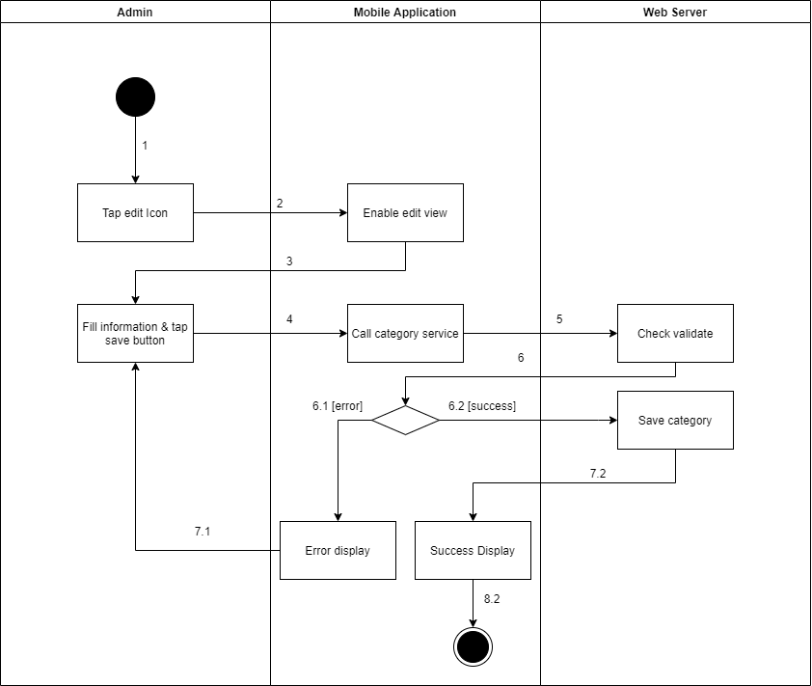

*Figure 1 - <Activity Diagram> Update the category*

###### d2.18 <Admin> Create new category

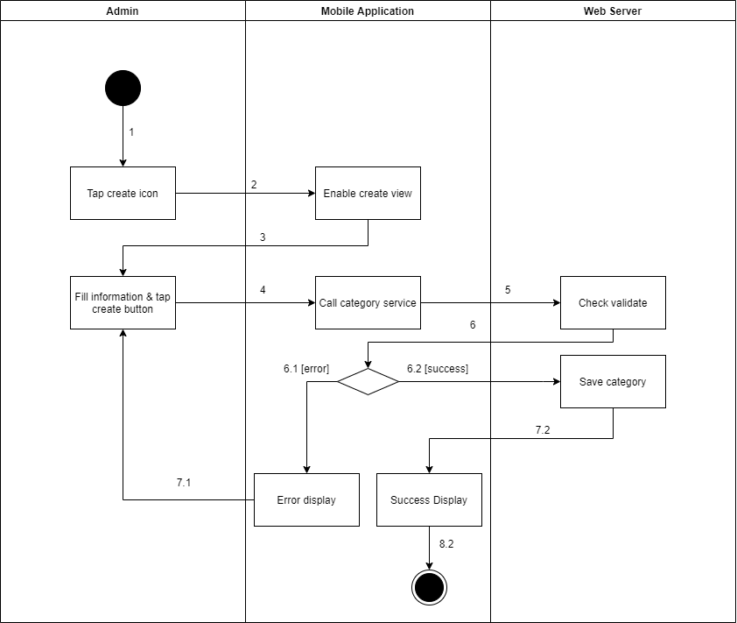

*Figure 1 - <Activity Diagram> Create new category*

##### d3 <Manager> Activity Diagram(s)

###### d3.1 <Manager> Get the shelve

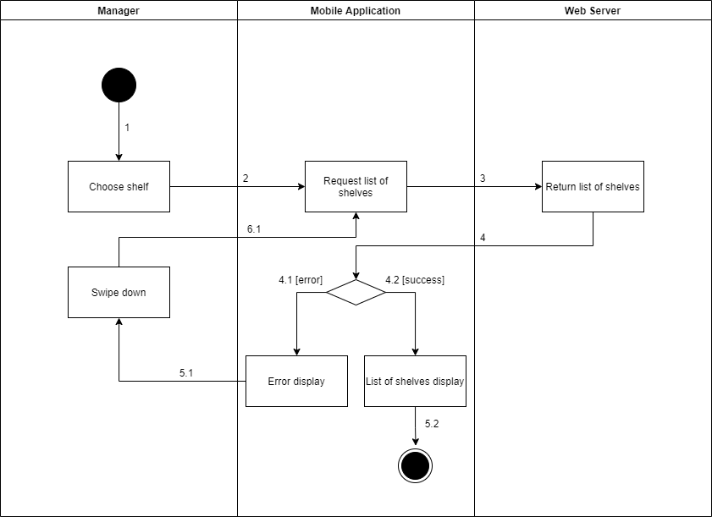

*Figure 1 - <Activity Diagram> Get the shelve*

###### d3.2 <Manager> Get shelf detail

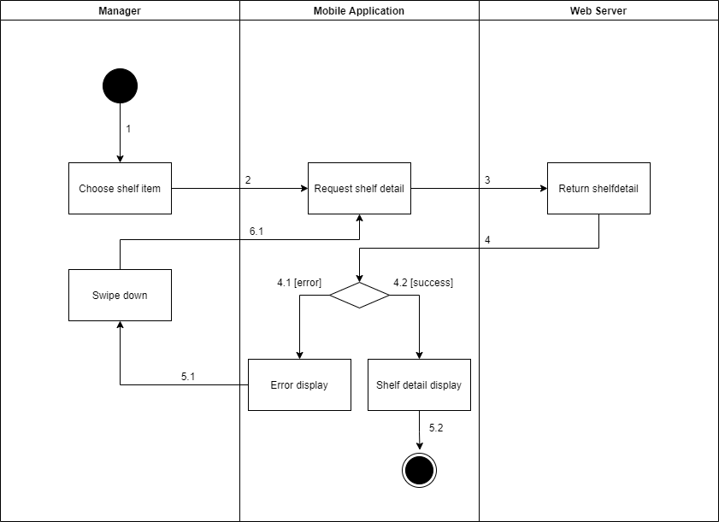

*Figure 1 - <Activity Diagram> Get shelf detail*

###### d3.3 <Manager> Update the shelf

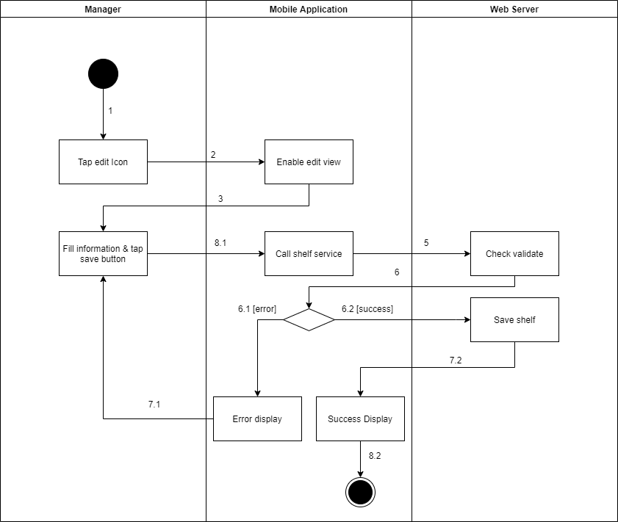

*Figure 1 - <Activity Diagram> Update the shelf*

###### d3.4 <Manager> Delete the shelf

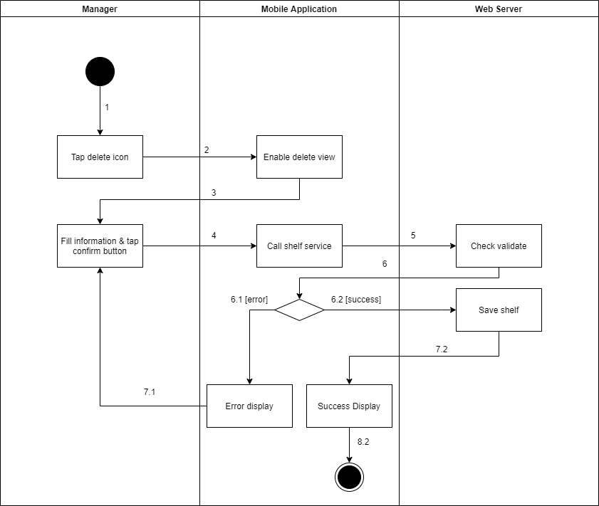

*Figure 1 - <Activity Diagram> Delete the shelf*

###### d3.5 <Manager> Create new shelf

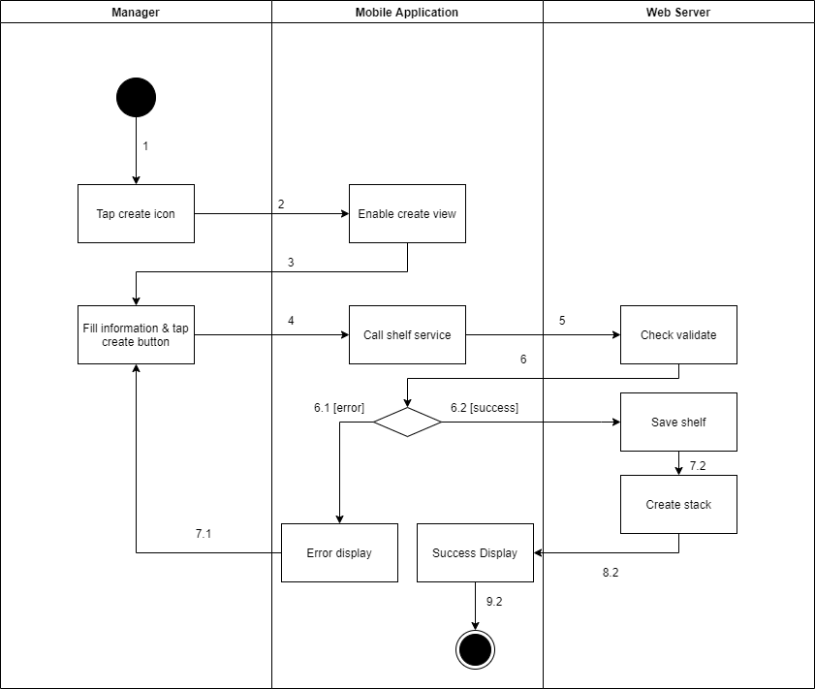

*Figure 1 - <Activity Diagram> Create new shelf*

###### d3.6 <Manager> Get the stacks

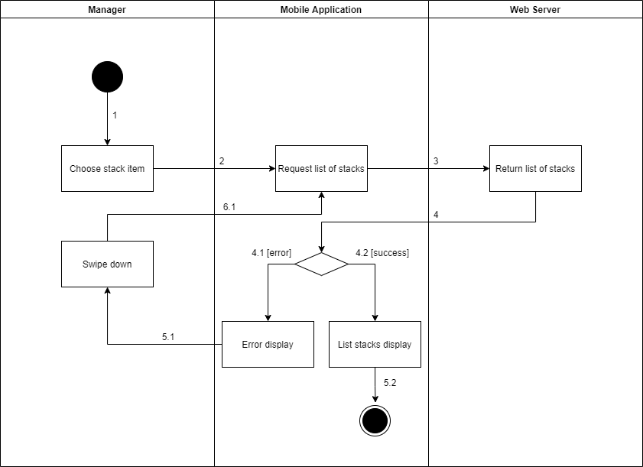

*Figure 1 - <Activity Diagram> Get the stacks*

###### d3.7 <Manager> Get stack detail

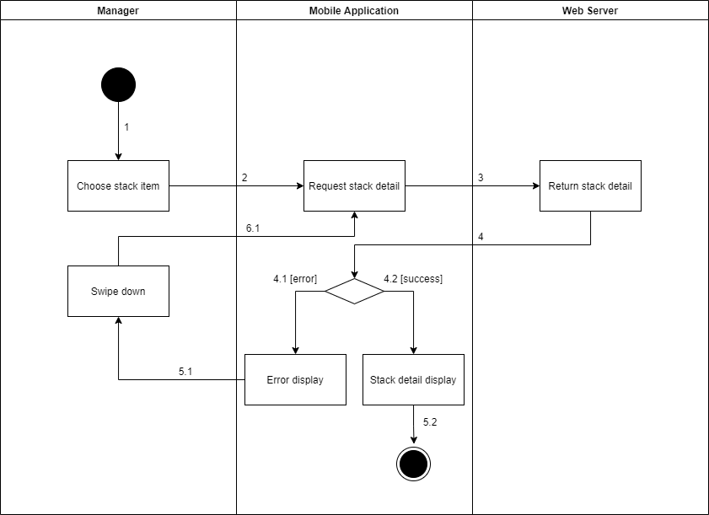

*Figure 1 - <Activity Diagram> Get stack detail*

###### d3.8 <Manager> Update the stack

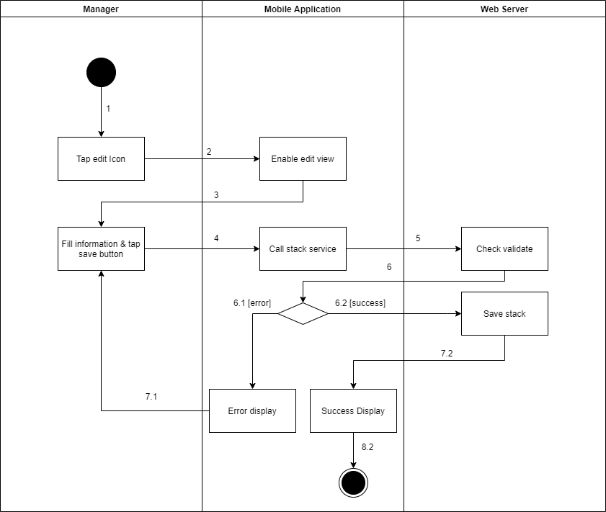

*Figure 1 - <Activity Diagram> Update the stack*

###### d3.9 <Manager> Delete the stack

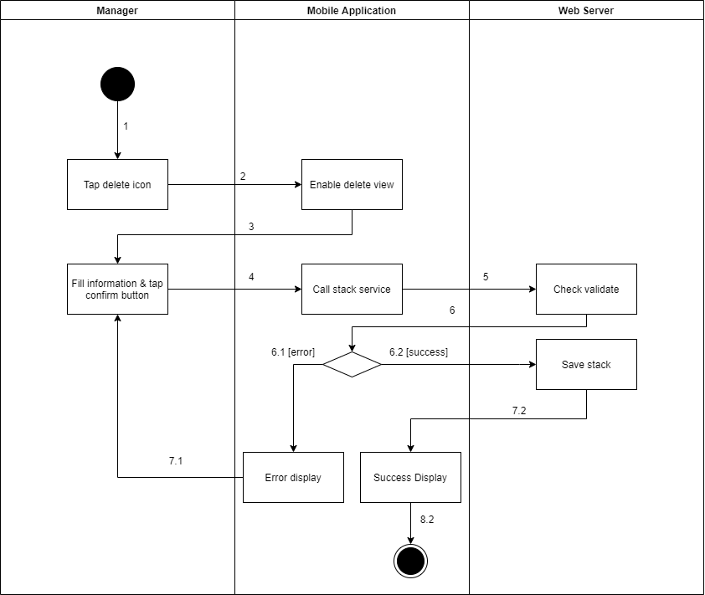

*Figure 1 - <Activity Diagram> Delete the stack*

##### d4 <Authenticated User> Activity Diagram(s)

###### d4.1 <Authenticated User> Logout

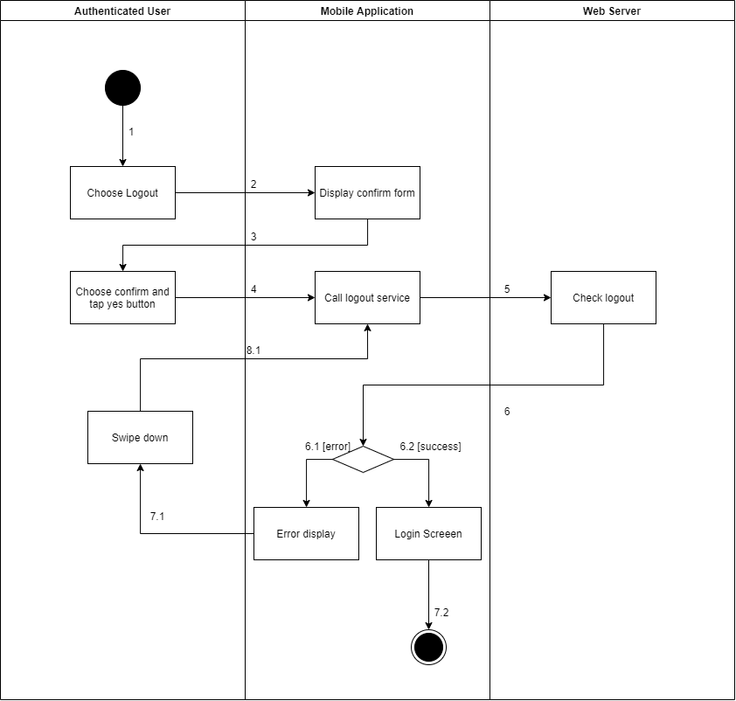

*Figure 1 - <Activity Diagram> Logout*

###### d4.2 <Authenticated User> Change account's password

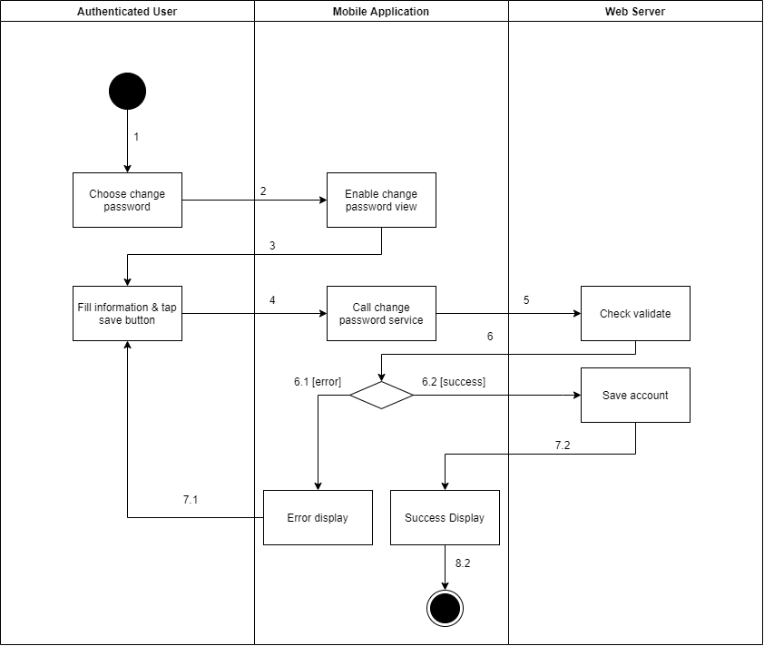

*Figure 1 - <Activity Diagram> Change account's password*

###### d4.3 <Authenticated User> Get the report

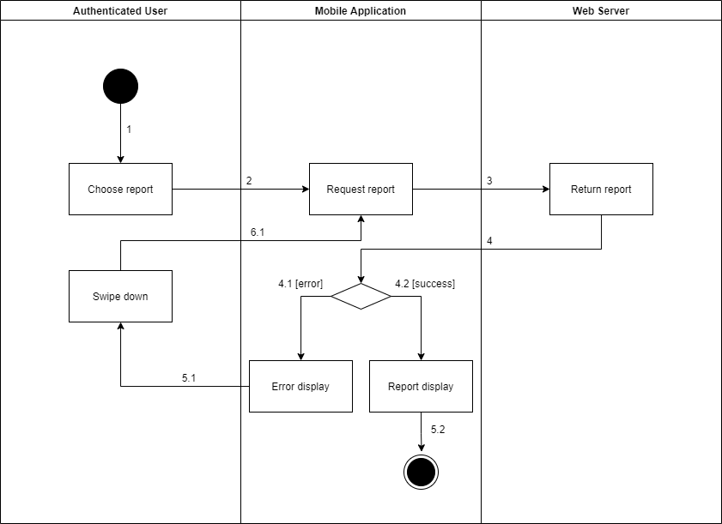

*Figure 1 - <Activity Diagram> Get the report*

###### d4.5 <Authenticated User> Get the video

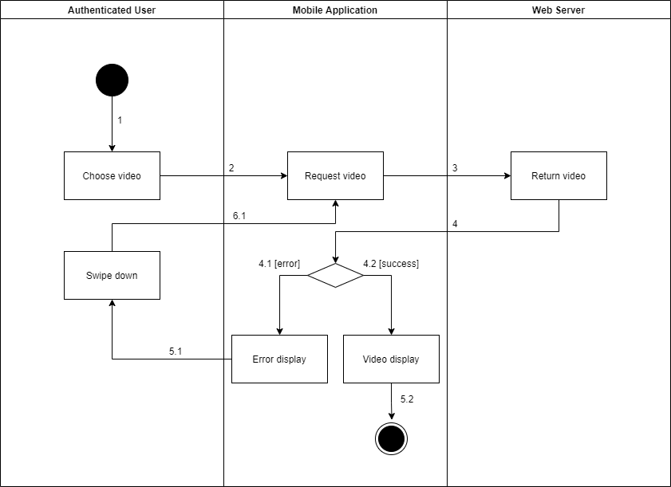

*Figure 1 - <Activity Diagram> Get the video*

###### d4.6 <Authenticated User> Get the products

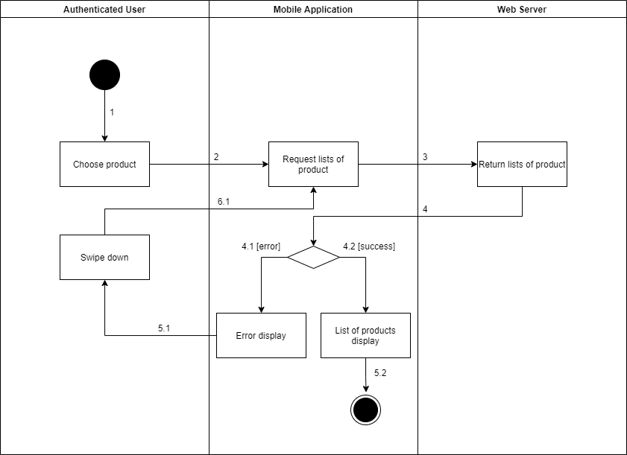

*Figure 1 - <Activity Diagram> Get the products*

###### d4.7 <Authenticated User> Get product detail

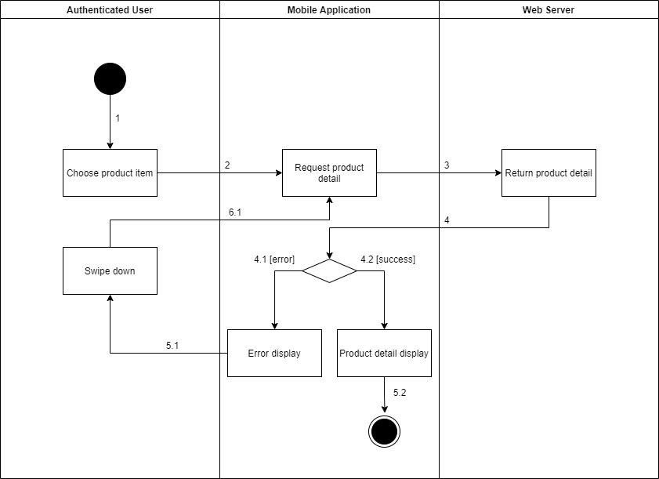

*Figure 1 - <Activity Diagram> Get product detail*

###### d4.8 <Authenticated User> Get the categories

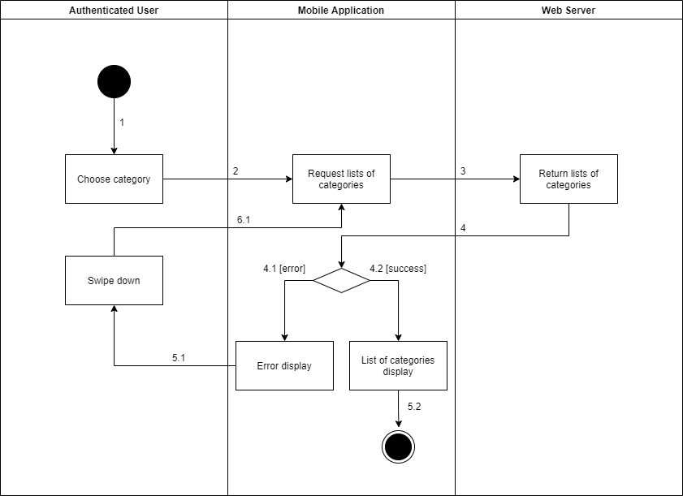

*Figure 1 - <Activity Diagram> Get the categories*

###### d4.9 <Authenticated User> Get category detail

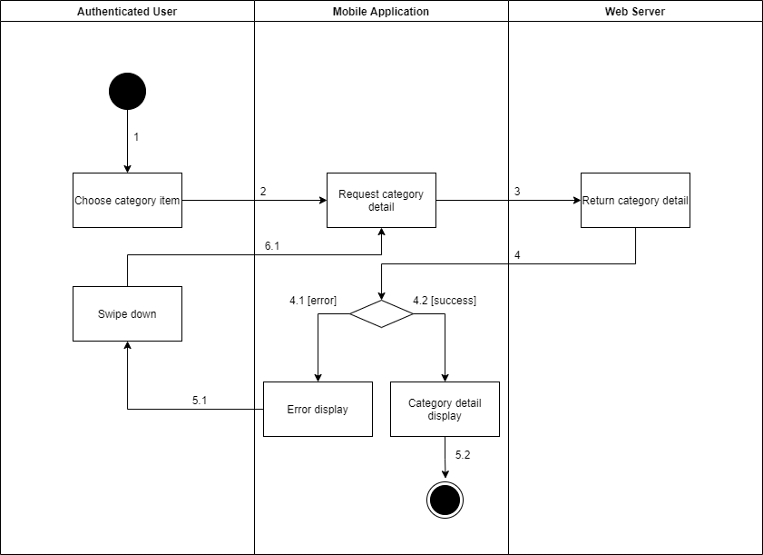

*Figure 1 - <Activity Diagram> Get category detail*

###### d4.10 <Authenticated User> Get camera detail

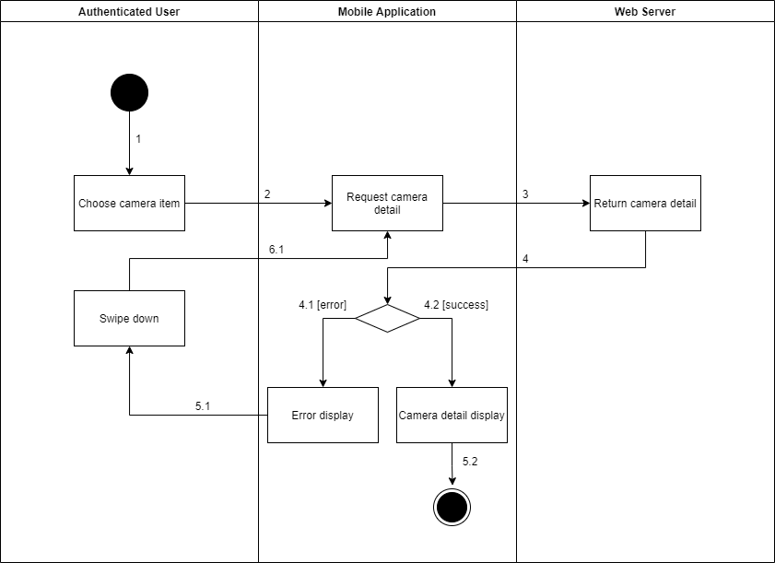

*Figure 1 - <Activity Diagram> Get camera detail*

###### d4.11 <Authenticated User> Get the cameras

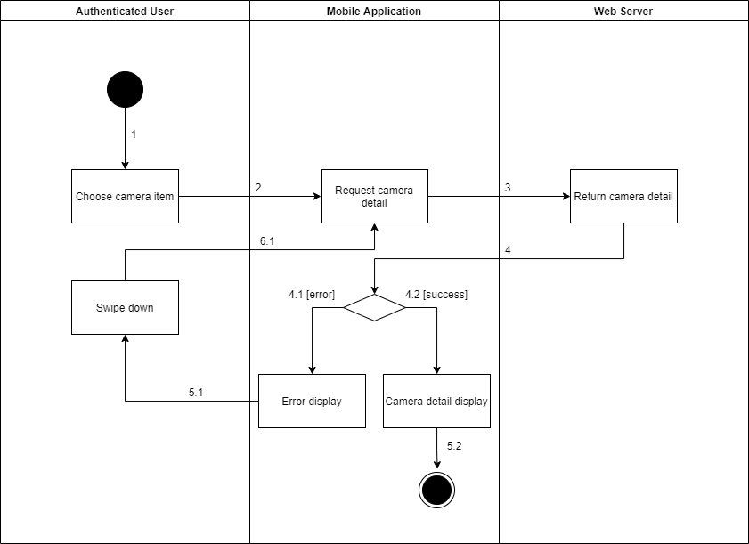

*Figure 1 - <Activity Diagram> Get the cameras*

## 4. Data & Database Design

### 4.1 Database Design



*Figure 1 – Database Design*

#### 3.1.1 tblCity

|  |  |  |  |  |  |  |
| --- | --- | --- | --- | --- | --- | --- |
| **Field name** | **Type** | **Size** | **Unique** | **Not Null** | **PK/FK** | **Notes** |
| CityId | int | 11 | Yes | Yes | PK | Unique identifier of city |
| CityName | varchar | 150 | Yes | Yes |  | Name of city |

#### 3.1.2 tblDistrict

|  |  |  |  |  |  |  |
| --- | --- | --- | --- | --- | --- | --- |
| **Field name** | **Type** | **Size** | **Unique** | **Not Null** | **PK/FK** | **Notes** |
| DistrictId | int | 11 | Yes | Yes | PK | Unique identifier of district |
| CityId | int | 11 | Yes | Yes | FK | Unique identifier of city |
| DistrictName | varchar | 150 | No | Yes |  | Name of district |

#### 3.1.3 tblRole

|  |  |  |  |  |  |  |
| --- | --- | --- | --- | --- | --- | --- |
| **Field name** | **Type** | **Size** | **Unique** | **Not Null** | **PK/FK** | **Notes** |
| RoleId | int | 11 | Yes | Yes | PK | Unique identifier of role |
| RoleName | varchar | 50 | Yes | Yes |  | Name of role |

#### 3.1.4 tblStatus

|  |  |  |  |  |  |  |
| --- | --- | --- | --- | --- | --- | --- |
| **Field name** | **Type** | **Size** | **Unique** | **Not Null** | **PK/FK** | **Notes** |
| StatusId | int | 11 | Yes | Yes | PK | Unique identifier of status |
| StatusName | varchar | 50 | Yes | Yes |  | Name of status |

#### 3.1.5 tblUser

|  |  |  |  |  |  |  |
| --- | --- | --- | --- | --- | --- | --- |
| **Field name** | **Type** | **Size** | **Unique** | **Not Null** | **PK/FK** | **Notes** |
| UserId | varchar | 36 | Yes | Yes | PK | Unique identifier of user |
| ImageURL | text |  | No | No |  | Image URL of user |
| UserName | varchar | 50 | Yes | Yes |  | Username of user |
| Password | text |  | No | Yes |  | Password of user |
| Fullname | varchar | 150 | No | Yes |  | Name of user |
| Gender | int | 11 | No | Yes |  | Gender of user |
| BirthDate | date |  | No | Yes |  | Day of birth of user |
| IdentifyCard | varchar | 50 | Yes | Yes |  | Identify card of user |
| Phone | varchar | 50 | Yes | Yes |  | Phone number of user |
| Email | varchar | 250 | Yes | Yes |  | Email of user |
| Address | varchar | 250 | No | Yes |  | Address of user |
| CreatedTime | datetime |  | No | Yes |  | Created date of user |
| UpdatedTime | datetime |  | No | No |  | Last modified date of user |
| ReasonInactive | varchar | 250 | No | No |  | Reason inactive of user |
| RoleId | int | 11 | No | Yes | FK | Unique identifier of role |
| DistrictId | int | 11 | No | Yes | FK | Unique identifier of district |
| StatusId | int | 11 | No | Yes | FK | Unique identifier of status |

#### 3.1.6 tblStore

|  |  |  |  |  |  |  |
| --- | --- | --- | --- | --- | --- | --- |
| **Field name** | **Type** | **Size** | **Unique** | **Not Null** | **PK/FK** | **Notes** |
| StoreId | varchar | 36 | Yes | Yes | PK | Unique identifier of store |
| StoreName | varchar | 150 | Yes | Yes |  | Name of store |
| ImageURL | text |  | No | No |  | Image URL of store |
| Address | varchar | 250 | No | Yes |  | Address of store |
| CreatedTime | datetime |  | No | Yes |  | Created date of store |
| UpdatedTime | datetime |  | Yes | No |  | Last modified date of store |
| ReasonInactive | varchar | 250 | No | Yes |  | Reason Inactive of store |
| DistrictId | int | 11 | No | Yes | FK | Unique identifier of district |
| StatusId | int | 11 | No | Yes | FK | Unique identifier of status |

#### 3.1.7 tblCamera

|  |  |  |  |  |  |  |
| --- | --- | --- | --- | --- | --- | --- |
| **Field name** | **Type** | **Size** | **Unique** | **Not Null** | **PK/FK** | **Notes** |
| CameraId | varchar | 36 | Yes | Yes | PK | Unique identifier of camera |
| CameraName | varchar | 150 | Yes | Yes |  | Name of camera |
| ImageURL | text |  | No | No |  | Image of camera |
| MACAddress | varchar | 150 | Yes | Yes |  | MAC address of camera |
| RTSPString | varchar | 150 | Yes | Yes |  | RTSP of camera |
| TypeDetect | int | 11 | No | Yes |  | Type of camera |
| CreatedTime | datetime |  | No | Yes |  | Created date of camera |
| UpdatedTime | datetime |  | No | No |  | Last modified date of camera |
| ReasonInactive | varchar | 250 | No | No |  | Reason inactive of camera |
| StatusId | int | 11 | No | Yes | FK | Unique identifier of status |
| IPAddress | varchar | 150 | Yes | Yes |  | IP address of camera |

#### 3.1.8 tblCategory

|  |  |  |  |  |  |  |
| --- | --- | --- | --- | --- | --- | --- |
| **Field name** | **Type** | **Size** | **Unique** | **Not Null** | **PK/FK** | **Notes** |
| CategoryId | int | 11 | Yes | Yes | PK | Unique identifier of category |
| CategoryName | varchar | 50 | Yes | Yes |  | Name of category |
| StatusId | int | 11 | No | Yes | FK | Unique identifier of status |

#### 3.1.9 tblEmotion

|  |  |  |  |  |  |  |
| --- | --- | --- | --- | --- | --- | --- |
| **Field name** | **Type** | **Size** | **Unique** | **Not Null** | **PK/FK** | **Notes** |
| EmotionId | varchar | 36 | Yes | Yes | PK | Unique identifier of emotion |
| StartedTime | datetime |  | No | Yes |  | Time started of video |
| EndedTime | datetime |  | No | Yes |  | Time ended of video |
| Angry | bigint | 20 | No | Yes |  | Number of angry |
| Disgust | bigint | 20 | No | Yes |  | Number of disgust |
| Fear | bigint | 20 | No | Yes |  | Number of fear |
| Happy | bigint | 20 | No | Yes |  | Number of happy |
| Sad | bigint | 20 | No | Yes |  | Number of sad |
| Surprise | bigint | 20 | No | Yes |  | Number of surprise |
| Neutral | bigint | 20 | No | Yes |  | Number of neutral |
| Description | varchar | 250 | No | No |  | Description of emotion |
| StackProductCameraMappingId | varchar | 36 | No | Yes | FK | Unique identifier of stack product camera mapping |
| CreatedTime | datetime |  | No | Yes |  | Created date of emotion |
| UpdatedTime | datetime |  | No | No |  | Last modified date of emotion |

#### 3.1.10 tblHotSpot

|  |  |  |  |  |  |  |
| --- | --- | --- | --- | --- | --- | --- |
| **Field name** | **Type** | **Size** | **Unique** | **Not Null** | **PK/FK** | **Notes** |
| HotspotId | varchar | 36 | Yes | Yes | PK | Unique identifier of hot spot |
| StartedTime | datetime |  | No | Yes |  | Time started of video |
| EndedTime | datetime |  | No | Yes |  | Time ended of video |
| TotalPeople | bigint | 20 | No | Yes |  | Number of customer |
| Description | varchar | 250 | No | No |  | Description of hot spot |
| ShelfCameraMappingId | varchar | 36 | No | Yes | FK | Unique identifier of shelf camera mapping |
| CreatedTime | datetime |  | No | Yes |  | Created date of hot spot |
| UpdatedTime | datetime |  | No | No |  | Last modified date of hot spot |

#### 3.1.11 tblProduct

|  |  |  |  |  |  |  |
| --- | --- | --- | --- | --- | --- | --- |
| **Field name** | **Type** | **Size** | **Unique** | **Not Null** | **PK/FK** | **Notes** |
| ProductId | varchar | 36 | Yes | Yes | PK | Unique identifier of product |
| ProductName | varchar | 150 | Yes | Yes |  | Name of product |
| ImageURL | text |  | No | No |  | Image URL of product |
| Description | varchar | 250 | No | No |  | Description of product |
| CreatedTime | datetime |  | No | Yes |  | Created date of product |
| UpdatedTime | datetime |  | No | No |  | Last modified date of product |
| ReasonInactive | varchar | 250 | No | No |  | Reason inactive of product |
| StatusId | int | 11 | No | Yes | FK | Unique identifier of status |

#### 3.1.12 tblProductCategoryMapping

|  |  |  |  |  |  |  |
| --- | --- | --- | --- | --- | --- | --- |
| **Field name** | **Type** | **Size** | **Unique** | **Not Null** | **PK/FK** | **Notes** |
| ProductCategoryMappingId | varchar | 36 | Yes | Yes | PK | Unique identifier of product category mapping |
| ProductId | varchar | 36 | No | Yes | FK | Unique identifier of product |
| CategoryId | int | 11 | No | Yes | FK | Unique identifier of category |

#### 3.1.13 tblShelf

|  |  |  |  |  |  |  |
| --- | --- | --- | --- | --- | --- | --- |
| **Field name** | **Type** | **Size** | **Unique** | **Not Null** | **PK/FK** | **Notes** |
| ShelfId | varchar | 36 | Yes | Yes | PK | Unique identifier of shelf |
| ShelfName | varchar | 150 | No | Yes |  | Name of shelf |
| Description | varchar | 250 | No | Yes |  | Description of shelf |
| NumberStacks | int | 11 | No | Yes |  | Number stack of shelf |
| CreatedTime | datetime |  | No | Yes |  | Created date of shelf |
| UpdatedTime | datetime |  | No | No |  | Last modified date of shelf |
| ReasonInactive | varchar | 250 | Yes | No |  | Reason inactive of shelf |
| StoreId | varchar | 36 | No | Yes | FK | Unique identifier of store |
| StatusId | Int | 11 | No | Yes | FK | Unique identifier of status |

#### 3.1.14 tblShelfCameraMapping

|  |  |  |  |  |  |  |
| --- | --- | --- | --- | --- | --- | --- |
| **Field name** | **Type** | **Size** | **Unique** | **Not Null** | **PK/FK** | **Notes** |
| ShelfCameraMappingId | varchar | 36 | Yes | Yes | PK | Unique identifier of shelf camera mapping |
| AddedTime | datetime |  | No | Yes |  | Added time of camera |
| RemovedTime | datetime |  | No | No |  | Removed time ò camera |
| ShelfId | varchar | 36 | No | Yes | FK | Unique identifier of shelf |
| CameraId | varchar | 36 | No | Yes | FK | Unique identifier of camera |
| StatusId | int | 11 | No | Yes | FK | Unique identifier of status |

#### 3.1.15 tblStack

|  |  |  |  |  |  |  |
| --- | --- | --- | --- | --- | --- | --- |
| **Field name** | **Type** | **Size** | **Unique** | **Not Null** | **PK/FK** | **Notes** |
| StackId | varchar | 36 | Yes | Yes | PK | Unique identifier of stack |
| Position | int | 11 | No | Yes |  | Position of stack |
| CreatedTime | datetime |  | No | Yes |  | Created date of stack |
| UpdatedTime | datetime |  | No | No |  | Last modified date of stack |
| ReasonInactive | varchar | 250 | No | No |  | Reason inactive of stack |
| ShelfId | varchar | 36 | No | Yes | FK | Unique identifier of shelf |
| StatusId | int | 11 | No | Yes | FK | Unique identifier of status |

#### 3.1.16 tblStackProductCameraMapping

|  |  |  |  |  |  |  |
| --- | --- | --- | --- | --- | --- | --- |
| **Field name** | **Type** | **Size** | **Unique** | **Not Null** | **PK/FK** | **Notes** |
| StackProductCameraMappingId | varchar | 36 | Yes | Yes | PK | Unique identifier of stack product camera mapping |
| AddedCameraTime | datetime |  | No | No |  | Added time of camera |
| RemovedCameraTime | datetime |  | No | No |  | Removed time of camera |
| AddedProductTime | datetime |  | No | No |  | Added time of product |
| RemovedProductTime | datetime |  | No | No |  | Removed time of product |
| StackId | varchar | 36 | No | Yes | FK | Unique identifier of stack |
| ProductId | varchar | 36 | No | No | FK | Unique identifier of product |
| CameraId | varchar | 36 | No | No | FK | Unique identifier of camera |
| StatusId | int | 11 | No | Yes | FK | Unique identifier of status |

#### 3.1.17 tblUserStoreMapping

|  |  |  |  |  |  |  |
| --- | --- | --- | --- | --- | --- | --- |
| **Field name** | **Type** | **Size** | **Unique** | **Not Null** | **PK/FK** | **Notes** |
| UserStoreMappingId | varchar | 36 | Yes | Yes | PK | Unique identifier of user store mapping |
| AddedTime | datetime |  | No | Yes |  | Added time of user |
| RemovedTime | datetime |  | No | No |  | Removed time of user |
| StoreId | varchar | 36 | No | Yes | FK | Unique identifier of store |
| UserId | varchar | 36 | No | Yes | FK | Unique identifier of user |
| StatusId | int | 11 | No | Yes | FK | Unique identifier of status |

#### 3.1.18 tblVideo

|  |  |  |  |  |  |  |
| --- | --- | --- | --- | --- | --- | --- |
| **Field name** | **Type** | **Size** | **Unique** | **Not Null** | **PK/FK** | **Notes** |
| VideoId | varchar | 36 | Yes | Yes | PK | Unique identifier of video |
| VideoName | varchar | 150 | No | Yes |  | Name of video |
| VideoURL | text |  | No | Yes |  | URL of video |
| StartedTime | datetime |  | No | Yes |  | Started time of video |
| EndedTime | datetime |  | No | No |  | Ended time of video |
| ShelfCameraMappingId | varchar | 36 | No | No | FK | Unique identifier of shelf camera mapping |
| StackProductCameraMappingId | varchar | 36 | No | No | FK | Unique identifier of stack product camera mapping |
| UpdatedTime | datetime |  | No | No |  | Last modified date of video |
| CreatedTime | datetime |  | No | Yes |  | Created date of video |

# V. Software Testing Documentation

## 1. Overall Description

### 1.1 Test Model

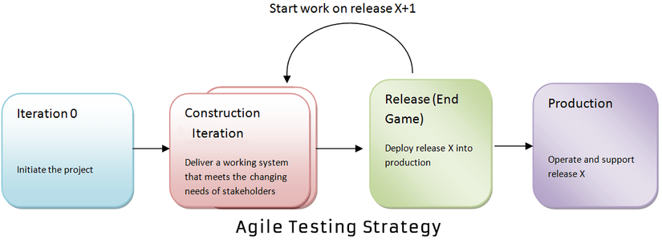

Figure 209. Agile model

***Source:***[*What is Agile Testing? Methodology, Process & Life Cycle (guru99.com)*](https://www.guru99.com/agile-testing-a-beginner-s-guide.html)

We apply Agile Testing because of the following reasons:

* It makes the interaction between developers and customers more fast and simple.
* It can quickly adapt to the rate of change required.
* It helps developers pay more attention to quality, performance and usability.

### 1.2 Testing Levels

* Unit testing
* Integration testing
* System testing

### 1.3 Testing Types

* Function testing
* UI testing

## 2. Test Plan

### 2.1 Test Stages

Table 89. Test stages

|  |  |  |  |  |
| --- | --- | --- | --- | --- |
| **Type of Tests** | **Stage of Test** | | | |
| **Unit** | **Integration** | **System** | **Acceptance** |
| Function Test | X | X | X | X |
| User Interface Test | X |  | X |  |

### 2.2 Resources

#### a. Human Resources

Table 90. Human resources

|  |  |  |
| --- | --- | --- |
| **Worker/Doer** | **Role** | **Specific Responsibilities/Comments** |
| Nguyen Minh Luan | Test Leader | Write test plans, test cases, do test, and report |
| Than Nhat Truong | Tester | Do test and report |
| Do Ngoc Huu | Tester | Do test and report |
| Nguyen Thanh Hieu | Tester | Do test and report |

### 2.3 Test Milestones

Table 91. Test milestones

|  |  |  |  |
| --- | --- | --- | --- |
| **Milestone Task** | **Effort (md)** | **Start Date** | **End Date** |
| Create Test Plan | 3 | 27/07/2021 | 27/07/2021 |
| Create unit tests for module Web App | 2 | 28/07/2021 | 30/07/2021 |
| Create integration test cases for Web App | 2 | 01/08/2021 | 03/08/2021 |
| Create system test cases for Web App | 2 | 05/08/2021 | 07/08/2021 |
| Create unit tests for module Mobile App | 2 | 09/08/2021 | 11/08/2021 |
| Create integration test cases for Mobile App | 2 | 12/08/2021 | 14/08/2021 |
| Create system test cases for Mobile App | 2 | 14/08/2021 | 16/08/2021 |
| Create reports for testing | 2 | 16/08/2021 | 17/08/2021 |

### 2.4 Deliverables

Table 92. Deliverables

|  |  |  |
| --- | --- | --- |
| **No** | **Deliverables** | **Due Date** |
| 1 | Test Plan | 27/07/2021 |
| 2 | Test Case Suite for Web App | 07/07/2021 |
| 3 | Test Case Suite for Mobile App | 16/08/2021 |
| 4 | Report on Testing | 17/08/2021 |

## 3. Test Cases

* Unit Test Cases: Report5_Unit Test Case.xls
* Other Test Cases: Report5_ Test Case.xls

## 4. Test Reports

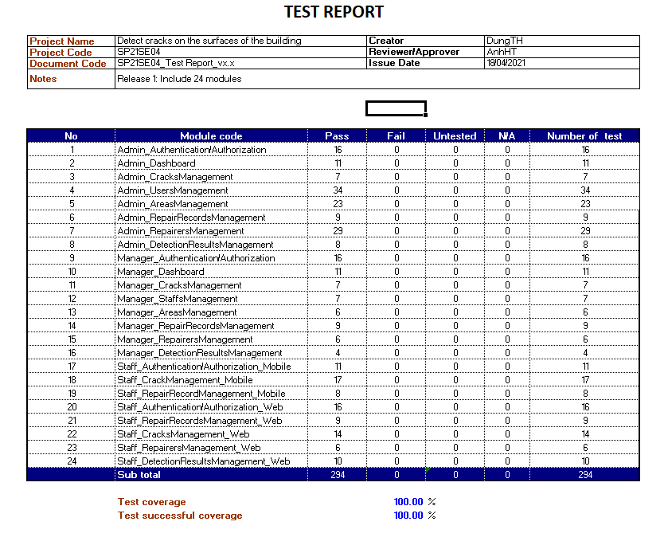

Figure 210. Test case report

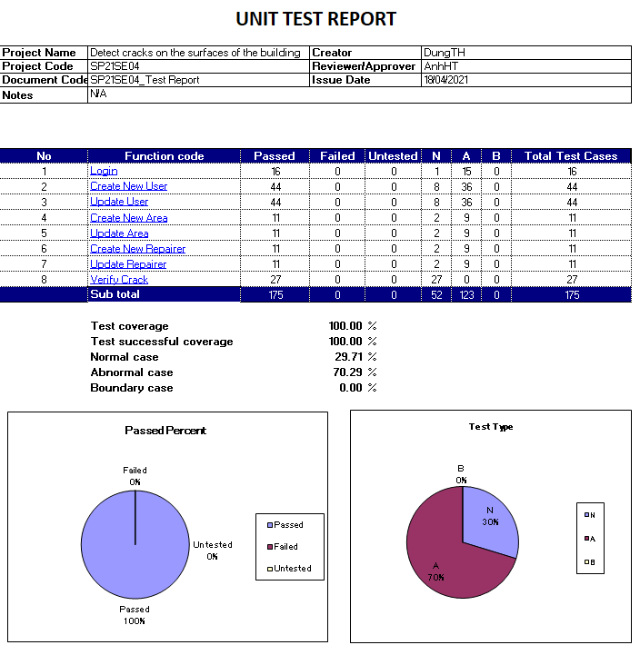

Figure 211. Unit test case report

# VI. Release Package & User Guides

## 1. Deliverable Package

### 1.1 Source codes & documents

Table x. Source codes & Documents

|  |  |  |
| --- | --- | --- |
| **No** | **Items** | **Sub-Items** |
| **Code packages** | | |
| 1 | CFFE.CapstoneBE.zip | Counting-People, Facial-Emotion-Recognition |
| 2 | CFFE.CapstoneFE.zip |  |
| 3 | CFFE.Mobile.apk |  |
| **Databases** | | |
| 1 | Script | CFFE_Database.sql |
| **Install environments** | | |
| 1 | Script | InstallModules.sh |
| **Deploy server application** | | |
| 1 | Script | DeploymentApp.sh |

### 1.2 Known Issues, Limitations & Restrictions

- Due to the influence of the Covid-19 epidemic, testing is limited.

- The application only serves one system with many stores, not for managing many different systems at the same time.

## 2. Installation Guides

### 2.1 System Requirements

#### a. Back End Server requirements:

* Tested OS: RedHat 8 or above.
* Network: LAN, Internet access capability.
* Hardware configurations:

Table x. Back End Server – Recommended hardware configuration

|  |  |  |  |
| --- | --- | --- | --- |
| **Type** | **Part/Component** | **Minimum** | **Recommended** |
| Computer | OS supported | RedHat | _ |
| Computer | Network | Internet | _ |
| Computer | RAM | 2GB | > 2GB |
| Computer | Cluster | 4 machines | > 4 machines |
| Computer | Storage Space | 50GB | > 50GB |
| Computer | Ports | Network | _ |

* Software requirements:
  + Java SE Development Kit 8u281
  + Apache Maven 3.6.3
  + MySQL 8.0
  + Python 3.8.2

#### b. Web Server requirements

* Tested OS: RedHat 8 or above.
* Network: LAN, Internet access capability.
* Hardware configurations:

Table x. Web Server – Recommended hardware configuration

|  |  |  |  |
| --- | --- | --- | --- |
| **Type** | **Part/Component** | **Minimum** | **Recommended** |
| Computer | OS supported | RedHat | _ |
| Computer | Network | Internet | _ |
| Computer | RAM | 2GB | > 2GB |
| Computer | Cluster | 4 machines | > 4 machines |
| Computer | Storage Space | 50GB | > 50GB |
| Computer | Ports | Network | _ |

* Software requirements:
  + Nodejs
  + Vue3

#### c. Mobile requirements

* Tested OS: EMUI 9.1 (Based on Android 9).
* Network: WLAN, Internet access capability.
* Hardware configurations:

Table xx. Back End Server – Recommended hardware configuration

|  |  |  |  |
| --- | --- | --- | --- |
| **Type** | **Part/Component** | **Minimum** | **Recommended** |
| Mobile | Android supported | Version 10 | _ |
| Mobile | Network | Internet | _ |
| Mobile | RAM | 2GB | > 2GB |
| Mobile | Storage Space | 32GB | >32GB |
| Mobile | Ports | Network | _ |

### 2.2 Environment setup requirements

* Operating system: RedHat 8.
* Java SE Runtime 8.
* Soft wares: MySQL 8.0.

### 2.3 Setup Files

* CFFE.CapstoneBE.zip: API for applications.
* CFFE.CapstoneWeb.zip: Web for Module Web.
* CFFE.CapstoneDetect.zip: Detect for Module Detect.
* CFFE.Mobile.apk:APK mobile for android*.*
* InstallModules.sh: Install the environments.
* DeploymentApp.sh: Deploy back-end server and font-end server.

### 2.4 Installation Instruction

#### a. Setup server environment

##### 1. Setup and start a RedHat OS (RedHat 8 or above).

**1.** Open browser and go to this URL: [Console Google Cloud](https://console.cloud.google.com/) then Login in with **Google account**



Figure xx. Login GCP form

**2.** Create a VM Instance with Red Hat Enterprise Linux 8:

1. Further information: Go to this URL [Create a Linux VM Instance | GCP](https://cloud.google.com/compute/docs/quickstart-linux)

2. Fill information and choose Boot Disk is Red Hat Enterprise Linux 8 image (1). Then, click “Create” Button (2).



Figure xx. Choose configs VM

##### 2. Install Java Development Kit, Apache Maven, Python, NodeJS, MySQL.

1. Connect Linux VM Instance. Further information: [Connecting to Linux VM Instance | GCP](https://cloud.google.com/compute/docs/instances/ssh#console)

2. Install the environments using the script file:

1. Run as root user with this command: **sudo su –**



Figure xx. Run as root user

2. Prepare a “InstallModules.sh” file with this content:



Figure xx. “InstallModules.sh” file contents.

3.Start to install environment: **yes y | source ./InstallModules.sh**



Figure xx. Run the bash script file

4. Reload bash file system with this command: **source ~/.bashrc**



Figure xx. Reload the config bash file

5. Verification modules installed with commands:

* Check installed JDK (1): **java -version**
* Check installed Apache Maven (2): **mvn –version**
* Check installed Python (3): **python3.8 --version**
* Check installed NodeJS (4): **node –version**
* Check installed MySQL (5): **mysql –version**
* Check MySQL active status (6): **systemctl status mysqld.service**



Figure xx. Check the installed modules

6. Check “CFFE_SYSTEM.zip” file is downloaded with this command: **ls**



Figure xx. Check “CFFE_SYSTEM.zip” file

##### 3. Deploy the CFFE application.

1. Create the “CFFE_Database”:

1. Get the temporary password with this command: **grep 'temporary password' /var/log/mysqld.log**



Figure xx. View MySQL temporary password

2. Change the password MySQL with this command: **mysql_secure_installation**

1. Input temporary password (1)

2. Input “y” to the change password (2)

3. Input new password and re-type password (3)

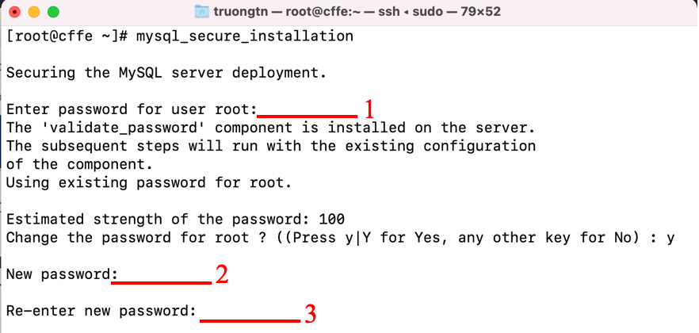

Figure xx. Change MySQL password

2. Create the “CFFE_Database” by running **mysql -u root -p < CFFE_Create_All_Table.sql** command with the password.



Figure xx. Execute database script file

3. Check created “CFFE_Database”: run **mysql -u root -p** command with the password. Then, run **show databases;** command.



Figure xx. Check database created

2. Edit config files.

1. Edit password MySQL in the file: **/root/CapstoneAPI/src/main/resources/SqlMapConfig.xml**



Figure xx. Configure the MySQL new password for Backend API

2. Get the public IP address with this command: **curl ifconfig.me**



Figure xx. Get public IP backend API server

3. Change the public IP address in this file:

**Capstone-web/src/services/api.js**



Figure xx. Configure URL API for Font-end

3. Deployment CFFE application.

1. Deploy the application with this command: **source ./DeploymentAPP.sh**



Figure xx. Deploy Backend API

2. Access Backend API: Open browser and input URL:

**[public IP Address]:9091/swagger-ui/index.html**



Figure xx. Access Backend API

3. Access CFFE web: Open browser and input URL:

**[public IP Address]:8080**



Figure xx. Access CFFE web

##### 4. Run Mobile Application.

1. Click in Mobile.apkfile:



2. Show popup then click **Install**.



3. Wait for install Mobile app



4. Finish install then click **Open**



5. Show login page in Mobile app

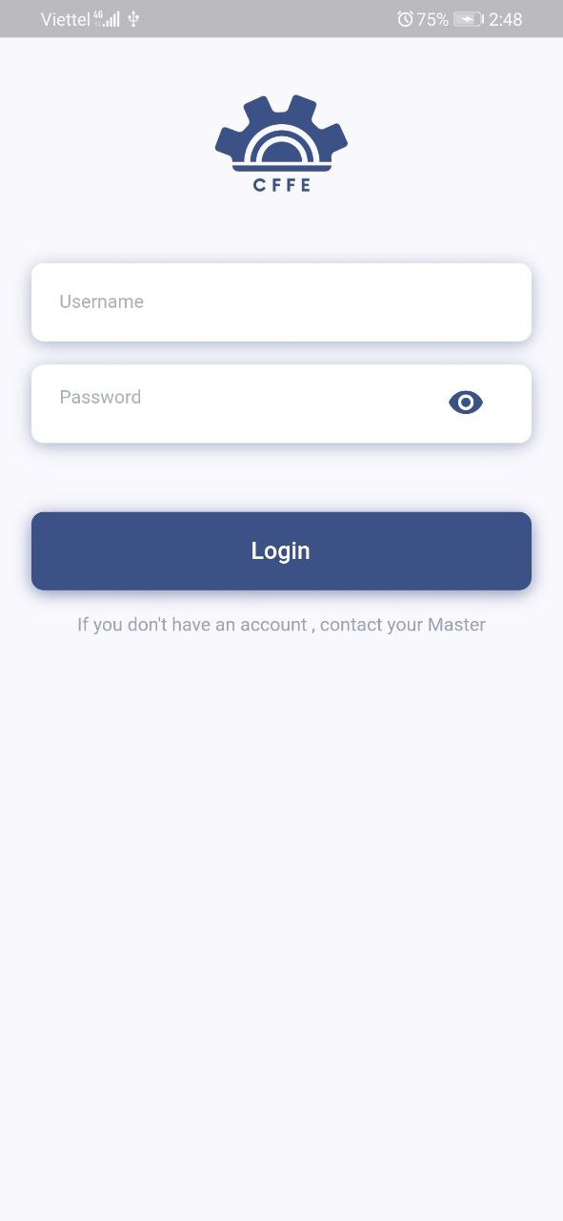

## 3. User Manual

### 3.1 Application Usage

#### 3.1.1. CFFE-Web-Admin

##### a. Overview

Application used by admin when want to:

+ Login

+ Logout

+ View statistics

+ View video

+ Manage manager

+ Manage store

+ Manage camera

+ Manage product

+ Manage category

+ Manage own profile

Hình của Luận

##### b. Login page



Figure xx. Login Page

Table xx. <User Guide> Login

|  |  |
| --- | --- |
| **Step** | **Description** |
| 1 | Admin inputs the own account information. |
| 2 | Admin clicks “Login” button. |

##### c. Home page



Table x. <User Guide> Home Page



Table x. <User Guide> Home Page

|  |  |
| --- | --- |
| **Step** | **Description** |
| 1 | Admin clicks own username to drop down items. |
| 2 | Admin clicks “Profile” item to view own profile. |
| 3 | Admin clicks “Logout” item to logout from the application. |
| 4 | Admin clicks “Emotion” to view the emotion report. |
| 5 | Admin clicks “Counting Customer” to view the counting customer reports. |

##### d. Profile page



Figure xx. Profile page

Table x. <User Guide> Profile page

|  |  |
| --- | --- |
| **Step** | **Description** |
| 1 | Admin clicks the icon to change own avatar. |
| 2 | Admin clicks the icon to change own password. |
| 3 | Admin clicks the icon to update own information. |
| 4 | Admin clicks “Emotion” button to view the emotion report. |
| 5 | Admin clicks “Counting Customers” button to view the counting customers report. |

1. Change own avatar.



Figure xx. Change own avatar.

Table x. <User Guide> Change own avatar

|  |  |
| --- | --- |
| **Step** | **Description** |
| 1 | Admin clicks the icon to close the popup. |
| 2 | Admin clicks the button to choose an avatar from own computer. |
| 3 | Admin clicks “Cancel” button to cancel the command |
| 4 | Admin clicks “Ok” button to change own avatar. |

2. Change own password



Figure xx. Change own password.

Table x. <User Guide> Change own password.

|  |  |
| --- | --- |
| **Step** | **Description** |
| 1 | Admin inputs own old password. |
| 2 | Admin inputs own new password. |
| 3 | Admin inputs own re-type password |
| 4 | Admin clicks “Cancel” button to cancel the command |
| 5 | Admin clicks “Ok” button to change own password. |

3. Update own information



Figure xx. Update own information.

Table x. <User Guide> Update own information

|  |  |
| --- | --- |
| **Step** | **Description** |
| 1 | Admin edits the necessary information. |
| 2 | Admin clicks “Cancel” button to cancel the command. |
| 3 | Admin clicks “Update” button to update own information |

##### e. Video page



Figure xx. Video page.

Table x. <User Guide> Video page

|  |  |
| --- | --- |
| **Step** | **Description** |
| 1 | Admin chooses a filter which is from start date to end date. |
| 2 | Admin chooses a filter which is counting or emotion. |
| 3 | Admin chooses a filter which is all stores or a store in the dropdown list. |
| 4 | Admin clicks a video to watch the video. |

##### f. Manager page



Figure xx. Manager page.

Table x. <User Guide> Manager page

|  |  |
| --- | --- |
| **Step** | **Description** |
| 1 | Admin inputs a search value. |
| 2 | Admin chooses a search field which is full name or username. |
| 3 | Admin chooses a filter which is all statuses, active, pending or inactive. |
| 4 | Admin clicks “New” button to create the new manager. |
| 5 | Admin clicks a username to view manager detail. |
| 6 | Admin clicks a store to view store detail |

1. Create the manager



Figure xx. Create the manager.

Table x. <User Guide> Create the manager

|  |  |
| --- | --- |
| **Step** | **Description** |
| 1 | Admin clicks the close button to close the pop up. |
| 2 | Admin enters the manager information. |
| 3 | Admin clicks “Cancel” button to cancel the command |
| 4 | Admin clicks “Ok” button to create the manager. |

##### g. Manager detail page



Figure xx. Manager detail page.



Figure xx. Manager detail page.

Table x. <User Guide> Manager detail page

|  |  |
| --- | --- |
| **Step** | **Description** |
| 1 | Admin clicks the icon to change the manager avatar. |
| 2 | Admin clicks “Pending” button to show “Inactive” button. |
| 3 | Admin clicks “Inactive” button to delete the manager. |
| 4 | Admin clicks the icon to reset the manager’s account password. |
| 5 | Admin clicks the icon to update the manager’s information. |
| 6 | Admin clicks the icon to add the store into the manager. |
| 7 | Admin clicks the icon to remove the store from the manager. |

1. Change the manager avatar.



Figure xx. Change the manger avatar.

Table x. <User Guide> Change the manger avatar

|  |  |
| --- | --- |
| **Step** | **Description** |
| 1 | Admin clicks the icon to close the popup. |
| 2 | Admin clicks the button to choose the manager avatar from own computer. |
| 3 | Admin clicks “Cancel” button to cancel the command. |
| 4 | Admin clicks “Ok” button to change the manager avatar. |

2. Delete the manager



Figure xx. Delete the manger.

Table x. <User Guide> Delete the manger

|  |  |
| --- | --- |
| **Step** | **Description** |
| 1 | Admin inputs an inactive reason. |
| 2 | Admin clicks “Cancel” button to cancel the command |
| 3 | Admin clicks “Ok” button to delete the manager. |

3. Reset manager’s account password.



Figure xx. Reset the manager password.

Table x. <User Guide> Reset the manager password

|  |  |
| --- | --- |
| **Step** | **Description** |
| 1 | Admin clicks “Cancel” button to cancel the command. |
| 2 | Admin clicks “Ok” button to reset the manager’s account password. |

4. Update the manager information



Figure xx. Update the manger information.

Table x. <User Guide> Update the manger information

|  |  |
| --- | --- |
| **Step** | **Description** |
| 1 | Admin edits the necessary information of the manager. |
| 2 | Admin clicks “Cancel” button to cancel the command. |
| 3 | Admin clicks “Update” button to update the manager information. |

5.Add the store into the manager



Figure xx. Add the store into the manager

Table x. <User Guide> Add the store into the manager

|  |  |
| --- | --- |
| **Step** | **Description** |
| 1 | Admin inputs a search value to find by store name. |
| 2 | Admin chooses a store in the available list. |
| 3 | Admin clicks “Cancel” button to cancel the command. |
| 4 | Admin clicks “Ok” button to add the store into the manager. |

6. Remove the store from the manager.



Figure xx. Remove the store from the manager

Table x. <User Guide> Remove the store from the manager

|  |  |
| --- | --- |
| **Step** | **Description** |
| 1 | Admin clicks “Cancel” button to cancel the command. |
| 2 | Admin clicks “Ok” button to remove the store from the manager. |

##### h. Store page



Figure xx. Store page

Table x. <User Guide> Store page

|  |  |
| --- | --- |
| **Step** | **Description** |
| 1 | Admin inputs a search value. |
| 2 | Admin chooses a filter which is all cities or a city in the dropdown list. |
| 3 | Admin chooses a filter which is all statuses, active, pending or inactive. |
| 4 | Admin clicks “New” button to create the new manager. |
| 5 | Admin clicks a username to view manager detail. |
| 6 | Admin clicks a store to view store detail. |

1. Create the store



Figure xx. Create the store.

Table x. <User Guide> Create the store

|  |  |
| --- | --- |
| **Step** | **Description** |
| 1 | Admin clicks the close button to close the pop up. |
| 2 | Admin enters store information. |
| 3 | Admin clicks “Cancel” button to cancel the command |
| 4 | Admin clicks “Ok” button to create the store. |

##### i. Store detail page



Figure xx. Store detail page.



Figure xx. Store detail page.

Table x. <User Guide> Store detail page

|  |  |
| --- | --- |
| **Step** | **Description** |
| 1 | Admin clicks the icon to change the store avatar. |
| 2 | Admin clicks “Pending” button to show “Inactive” button. |
| 3 | Admin clicks “Inactive” button to delete the store |
| 4 | Admin clicks the icon to view the store information. |
| 5 | Admin clicks the icon to update the store information. |
| 6 | Admin clicks the icon to add the manager into the store. |
| 7 | Admin clicks the icon to view product list of the store. |
| 8 | Admin clicks the icon to view camera list of the store. |
| 9 | Admin clicks the icon to remove the manager from the store. |

1. Change the store avatar



Figure xx. Change the store avatar.

Table x. <User Guide> Change the store avatar

|  |  |
| --- | --- |
| **Step** | **Description** |
| 1 | Admin clicks the icon to close the popup. |
| 2 | Admin clicks the button to choose the store avatar from own computer. |
| 3 | Admin clicks “Cancel” button to cancel the command |
| 4 | Admin clicks “Ok” button to change the store avatar. |

2. Delete the store.



Figure xx. Delete the store.

Table x. <User Guide> Delete the store

|  |  |
| --- | --- |
| **Step** | **Description** |
| 1 | Admin inputs an inactive reason. |
| 2 | Admin clicks “Cancel” button to cancel the command |
| 3 | Admin clicks “Ok” button to delete the store. |

3. Update the store information.



Figure xx. Update the store information.

Table x. <User Guide> Update the store information

|  |  |
| --- | --- |
| **Step** | **Description** |
| 1 | Admin edits the necessary information of the store. |
| 2 | Admin clicks “Cancel” button to cancel the command. |
| 3 | Admin clicks “Update” button to update the store information. |

4. Add the manager into the store



Figure xx. Add the manager into the store

Table x. <User Guide> Add the manager into the store

|  |  |
| --- | --- |
| **Step** | **Description** |
| 1 | Admin inputs a search value to find by username. |
| 2 | Admin chooses a store in the available list. |
| 3 | Admin clicks “Cancel” button to cancel the command. |
| 4 | Admin clicks “Ok” button to add the manager into the store. |

5. Remove the manager from the store



Figure xx. Remove the manager from the store.

Table x. <User Guide> Remove the manager from the store

|  |  |
| --- | --- |
| **Step** | **Description** |
| 1 | Admin clicks “Cancel” button to cancel the command. |
| 2 | Admin clicks “Ok” button to remove the manager from the store. |

##### j. Camera page



Figure xx. Camera page

Table x. <User Guide> Camera page

|  |  |
| --- | --- |
| **Step** | **Description** |
| 1 | Admin inputs a search value to find by camera name. |
| 2 | Admin chooses a filter which is all stores or a store name in the dropdown list. |
| 3 | Admin chooses a filter which is all statuses, active, pending or inactive. |
| 4 | Admin clicks “New” button to create the new camera. |
| 5 | Admin clicks a camera name to view camera detail. |
| 6 | Admin clicks a store name to view store detail. |

1. Create the camera



Figure xx. > Create the camera

Table x. <User Guide> Create the camera

|  |  |
| --- | --- |
| **Step** | **Description** |
| 1 | Admin clicks the close button to close the pop up. |
| 2 | Admin enters camera information. |
| 3 | Admin clicks “Cancel” button to cancel the command |
| 4 | Admin clicks “Ok” button to create the camera. |

##### k. Camera detail



Figure xx. Camera detail page

Table x. <User Guide> Camera detail page

|  |  |
| --- | --- |
| **Step** | **Description** |
| 1 | Admin clicks the icon to change the camera avatar. |
| 2 | Admin clicks “Pending” button to show “Inactive” button. |
| 3 | Admin clicks “Inactive” button to delete the camera. |
| 4 | Admin clicks the icon to update the camera information. |

1. Change the camera avatar.



Figure xx. Change the camera avatar.

Table x. <User Guide> Change the camera avatar

|  |  |
| --- | --- |
| **Step** | **Description** |
| 1 | Admin clicks the icon to close the popup. |
| 2 | Admin clicks the button to choose the camera avatar from own computer. |
| 3 | Admin clicks “Cancel” button to cancel the command |
| 4 | Admin clicks “Ok” button to change the camera avatar. |

2. Delete the camera



Figure xx. Delete the camera.

Table x. <User Guide> Delete the camera

|  |  |
| --- | --- |
| **Step** | **Description** |
| 1 | Admin inputs an inactive reason. |
| 2 | Admin clicks “Cancel” button to cancel the command |
| 3 | Admin clicks “Ok” button to delete the camera. |

3. Update the camera information



Figure xx. Update the camera information

Table x. <User Guide> Update the camera information

|  |  |
| --- | --- |
| **Step** | **Description** |
| 1 | Admin edits the necessary information of the camera. |
| 2 | Admin clicks “Cancel” button to cancel the command. |
| 3 | Admin clicks “Update” button to update the camera information. |

##### l. Product page



Figure xx. Product page

Table x. <User Guide> Product page

|  |  |
| --- | --- |
| **Step** | **Description** |
| 1 | Admin inputs a search value to find by product name. |
| 2 | Admin chooses a filter which is all categories or a category in the dropdown list. |
| 3 | Admin chooses a filter which is all statuses, active or inactive. |
| 4 | Admin clicks “New” button to create the product. |
| 5 | Admin clicks a camera name to view camera detail. |

1. Create the product



Figure xx. Create the product

Table x. <User Guide> Create the product

|  |  |
| --- | --- |
| **Step** | **Description** |
| 1 | Admin clicks the close button to close the pop up. |
| 2 | Admin enters product information. |
| 3 | Admin clicks “Cancel” button to cancel the command |
| 4 | Admin clicks “Ok” button to create the product. |

##### m. Product detail page



Figure xx. Product detail page

Table x. <User Guide> Product detail page

|  |  |
| --- | --- |
| **Step** | **Description** |
| 1 | Admin clicks the icon to change the product avatar. |
| 2 | Admin clicks “Active” button to show “Inactive” button. |
| 3 | Admin clicks “Inactive” button to delete the product. |
| 4 | Admin clicks the icon to update the product information. |

1. Change the product avatar.



Figure xx Change the product avatar.

Table x. Change the product avatar

|  |  |
| --- | --- |
| **Step** | **Description** |
| 1 | Admin clicks the icon to close the popup. |
| 2 | Admin clicks the button to choose the product avatar from own computer. |
| 3 | Admin clicks “Cancel” button to cancel the command |
| 4 | Admin clicks “Ok” button to change the product avatar. |

2. Delete the product



Figure xx. Delete the product

Table x. <User Guide> Delete the product

|  |  |
| --- | --- |
| **Step** | **Description** |
| 1 | Admin inputs an inactive reason. |
| 2 | Admin clicks “Cancel” button to cancel the command |
| 3 | Admin clicks “Ok” button to delete the product. |

3. Update the product information



Figure xx. Update the product information

Table x. <User Guide> Update the product information

|  |  |
| --- | --- |
| **Step** | **Description** |
| 1 | Admin edits the necessary information of the product. |
| 2 | Admin clicks “Cancel” button to cancel the command. |
| 3 | Admin clicks “Update” button to update the product information. |

##### n. Category page



Figure xx. Category page



Figure xx. Category page

Table x. <User Guide> Category page

|  |  |
| --- | --- |
| **Step** | **Description** |
| 1 | Admin inputs a search value to find by category name. |
| 2 | Admin chooses a filter which is all statuses, active or inactive. |
| 3 | Admin clicks the category name to view product list by the category. |
| 4 | Admin clicks “New” button to create the category. |
| 5 | Admin clicks the edit icon to edit the category name. |
| 6 | Admin clicks a product name to view the product detail. |
| 7 | Admin clicks “Active” button to show “Inactive” button. |
| 8 | Admin clicks “Inactive” button to delete the category. |

1. Create the category



Figure xx. Create the category

Table x. <User Guide> Create the category

|  |  |
| --- | --- |
| **Step** | **Description** |
| 1 | Admin clicks the icon to close the popup. |
| 2 | Admin inputs the category name. |
| 3 | Admin clicks “Cancel” button to cancel the command |
| 4 | Admin clicks “Ok” button to create the category. |

2. Update the category information



Figure xx. Update the category information

Table x. <User Guide> Update the category information

|  |  |
| --- | --- |
| **Step** | **Description** |
| 1 | Admin edits the category name. |
| 2 | Admin clicks “Cancel” button to cancel the command. |
| 3 | Admin clicks “Update” button to update the category. |

3. Delete the category



Figure xx. Delete the category

Table x. <User Guide> Delete the category

|  |  |
| --- | --- |
| **Step** | **Description** |
| 1 | Admin clicks “Cancel” button to cancel the command. |
| 2 | Admin clicks “Ok” button to delete the category. |

#### 3.1.2. CFFE-Web-Manager

##### a. Overview

Application used by manager when want to:

+ Login

+ Logout

+ Manage own profile

+ View statistics

+ View video

+ Manage shelf

+ Manage stack

+ Manage camera

+ Manage product

Hình của Luận

##### b. Login page



Figure xx. Login page

Table x. Login page

|  |  |
| --- | --- |
| **Step** | **Description** |
| 1 | Manager inputs the own account information. |
| 2 | Manager clicks “Login” button. |

##### c. Home page



Figure xx. Home page



Figure xx. Home page

Table x. Home page

|  |  |
| --- | --- |
| **Step** | **Description** |
| 1 | Manager clicks own username to drop down items. |
| 2 | Manager clicks “Profile” item to view own profile. |
| 3 | Manager clicks “Logout” item to logout from the application. |
| 4 | Manager clicks “Emotion” to view the emotion report. |
| 5 | Manager clicks “Counting Customer” to view the counting customer reports. |

##### d. Profile page



Figure xx. Profile page

Table x. Profile page

|  |  |
| --- | --- |
| **Step** | **Description** |
| 1 | Manager clicks the icon to change own avatar. |
| 2 | Manager clicks the icon to change own password. |
| 3 | Manager clicks the icon to update own information. |

1. Change own avatar.



Figure xx. Change own avatar

Table x. Change own avatar

|  |  |
| --- | --- |
| **Step** | **Description** |
| 1 | Manager clicks the icon to close the popup. |
| 2 | Manager clicks the button to choose an avatar from own computer. |
| 3 | Manager clicks “Cancel” button to cancel the command |
| 4 | Manager clicks “Ok” button to change own avatar. |

2. Change own password



Figure xx. Change own password

Table x. Change own password

|  |  |
| --- | --- |
| **Step** | **Description** |
| 1 | Manager inputs own old password. |
| 2 | Manager inputs own new password. |
| 3 | Manager inputs own re-type password |
| 4 | Manager clicks “Cancel” button to cancel the command |
| 5 | Manager clicks “Ok” button to change own password. |

3. Update own information



Figure xx. Update own information

Table x. Update own information

|  |  |
| --- | --- |
| **Step** | **Description** |
| 1 | Manager edits the necessary information. |
| 2 | Manager clicks “Cancel” button to cancel the command. |
| 3 | Manager clicks “Update” button to update own information |

##### e. Video page



Figure xx. Video page

Table x. Video page

|  |  |
| --- | --- |
| **Step** | **Description** |
| 1 | Manager chooses a filter which is from start date to end date. |
| 2 | Manager chooses a filter which is counting or emotion. |
| 3 | Manager chooses a filter which is all stores or a store in the dropdown list. |
| 4 | Manager uploads videos to detect. |
| 5 | Manager clicks a video to watch the video. |

1. Upload videos



Figure xx. Upload video

Table x. Upload video

|  |  |
| --- | --- |
| **Step** | **Description** |
| 1 | Manager chooses videos that need to detect. |
| 2 | Manager clicks “Cancel” button to cancel the command. |
| 3 | Manager clicks “Ok” button to upload videos. |

##### f. Shelf page



Figure xx. Shelf page

Table x. Shelf page

|  |  |
| --- | --- |
| **Step** | **Description** |
| 1 | Manager inputs a search value to find by shelf name. |
| 2 | Manager chooses a filter which is all statuses, active, pending or inactive. |
| 3 | Manager clicks “New” button to create the shelf. |
| 4 | Manager clicks a shelf name to view shelf detail. |

1. Create the shelf



Figure xx. Create the shelf

Table x. Create the shelf

|  |  |
| --- | --- |
| **Step** | **Description** |
| 1 | Manager clicks the close button to close the pop up. |
| 2 | Manager enters shelf information. |
| 3 | Manager clicks “Cancel” button to cancel the command |
| 4 | Manager clicks “Ok” button to create the shelf. |

##### g. Shelf detail page



Figure xx. Shelf detail page



Figure xx. Shelf detail page



Figure xx. Shelf detail page

Table x. Shelf detail page

|  |  |
| --- | --- |
| **Step** | **Description** |
| 1 | Manager clicks the icon to update the shelf information. |
| 2 | Manager clicks “Pending” button to show “Inactive” button. |
| 3 | Manager clicks “Inactive” button to delete the shelf. |
| 4 | Manager clicks the box to view the stack detail. |
| 5 | Manager clicks the icon to add the camera into the shelf. |
| 6 | Manager clicks the icon to add the camera into the shelf. |
| 7 | Manager clicks the icon to add the product into the stack. |
| 8 | Manager clicks the icon to remove the camera from the shelf. |
| 9 | Manager clicks the icon to remove the camera from the shelf. |
| 10 | Manager click “Pending” button to show “Inactive” button. |
| 11 | Manager clicks “Inactive” button to delete the stack. |
| 12 | Manager clicks the icon to remove the product from the stack. |
| 13 | Manager clicks the icon to add the camera into the stack. |
| 14 | Manager clicks the icon to remove the camera from the stack. |

1. Update the shelf information



Figure xx. Update the shelf information

Table x. Update the shelf information

|  |  |
| --- | --- |
| **Step** | **Description** |
| 1 | Manager edits the necessary information. |
| 2 | Manager clicks “Cancel” button to cancel the command. |
| 3 | Manager clicks “Update” button to update the shelf information. |

2. Delete the shelf



Figure xx. Delete the shelf

Table x. Delete the shelf

|  |  |
| --- | --- |
| **Step** | **Description** |
| 1 | Manager inputs an inactive reason. |
| 2 | Manager clicks “Cancel” button to cancel the command |
| 3 | Manager clicks “Ok” button to delete the shelf. |

3. Add the camera into the shelf



Figure xx. Add the camera into the shelf

Table x. Add the camera into the shelf

|  |  |
| --- | --- |
| **Step** | **Description** |
| 1 | Manager inputs a search value to find by camera name |
| 2 | Manager chooses a camera in the available list. |
| 3 | Manager clicks “Cancel” button to cancel the command. |
| 4 | Manager clicks “Ok” button to add the camera into the shelf. |

4. Add the product into the stack



Figure xx. Add the product into the stack

Table x. Add the product into the stack

|  |  |
| --- | --- |
| **Step** | **Description** |
| 1 | Manager inputs a search value to find by product name |
| 2 | Manager chooses a camera in the available list. |
| 3 | Manager clicks “Cancel” button to cancel the command. |
| 4 | Manager clicks “Ok” button to add the product into the stack. |

5. Remove the camera from the shelf



Figure xx. Remove the camera from the shelf

Table x. Remove the camera from the shelf

|  |  |
| --- | --- |
| **Step** | **Description** |
| 1 | Manager clicks “Cancel” button to cancel the command. |
| 2 | Manager clicks “Ok” button to remove the camera from the shelf. |

6. Delete the stack



Figure xx. Delete the stack

Table x. Delete the stack

|  |  |
| --- | --- |
| **Step** | **Description** |
| 1 | Manager inputs an inactive reason. |
| 2 | Manager clicks “Cancel” button to cancel the command |
| 3 | Manager clicks “Ok” button to delete the stack. |

7. Remove the product from the stack



Figure xx. Remove the product from the stack

Table x. Remove the product from the stack

|  |  |
| --- | --- |
| **Step** | **Description** |
| 1 | Manager clicks “Cancel” button to cancel the command. |
| 2 | Manager clicks “Ok” button to remove the camera from the shelf. |

8. Add the camera into the stack



Figure xx. Add the camera into the stack

Table x. Add the camera into the stack

|  |  |
| --- | --- |
| **Step** | **Description** |
| 1 | Manager inputs a search value to find by camera name |
| 2 | Manager chooses a camera in the available list. |
| 3 | Manager clicks “Cancel” button to cancel the command. |
| 4 | Manager clicks “Ok” button to add the camera into the stack. |

9. Remove the camera from the stack



Figure xx. Remove the camera from the stack

Table x. Remove the camera from the stack

|  |  |
| --- | --- |
| **Step** | **Description** |
| 1 | Manager clicks “Cancel” button to cancel the command. |
| 2 | Manager clicks “Ok” button to remove the camera from the stack. |

##### h. Camera page



Figure xx. Camera page

Table x. Camera page

|  |  |
| --- | --- |
| **Step** | **Description** |
| 1 | Manager inputs a search value to find by camera name. |
| 2 | Manager chooses a filter which is all stores or a store in the dropdown list. |
| 3 | Manager chooses a filter which is all statuses, active, pending or inactive. |
| 4 | Manager clicks a camera name to view camera detail |
| 5 | Manager clicks an own store name to view own store detail. |

##### I. Product page



Figure xx. Product page

Table x. Product page

|  |  |
| --- | --- |
| **Step** | **Description** |
| 1 | Manager inputs a search value to find by product name. |
| 2 | Manager chooses a filter which is all categories or a category in the dropdown list. |
| 3 | Manager chooses a filter which is all statuses, active or inactive. |
| 4 | Manager clicks a camera name to view camera detail. |

##### j. Category page



Figure xx. Category page

Table x. Category page

|  |  |
| --- | --- |
| **Step** | **Description** |
| 1 | Manager inputs a search value to find by category name. |
| 2 | Manager chooses a filter which is all statuses, active or inactive. |
| 3 | Manager clicks a category name to view product list by the category. |
| 4 | Manager clicks a product name to view product detail. |

#### 3.3.3. CFFE-Mobile-Admin

##### a. Overview

Application used by admin when want to:

+ Login

+ Logout

+ View statistics

+ View video

+ Manage manager

+ Manage store

+ Manage camera

+ Manage product

+ Manage category

+ Manage own profile

Hình của Luận

##### b. Login page



Figure xx. Login Page

Table x. <User Guide> Login

|  |  |
| --- | --- |
| **Step** | **Description** |
| 1 | Admin inputs the account. |
| 2 | Admin clicks the “Login” button. |

##### c. Home page



Figure xx. Dashboard Page



Figure xx. Dashboard Page

Table x. <User Guide> Navigation

|  |  |
| --- | --- |
| **Step** | **Description** |
| 1 | Admin clicks the “navigator” icon to view drawer navigator. |
| 2 | Admin clicks the “Profile” item to view own profile. |
| 3 | Admin clicks the “Logout” item to logout from the application. |

##### d. Profile page



Figure xx. Manager detail page

Table x. <User Guide> Manager detail page

|  |  |
| --- | --- |
| **Step** | **Description** |
| 1 | Admin clicks the item to change own information. |
| 2 | Admin clicks the item to change own avatar. |
| 3 | Admin clicks the item to change own password. |

1. Change own information.



Figure xx. Change own information

Table x. <User Guide> Change own information

|  |  |
| --- | --- |
| **Step** | **Description** |
| 1 | Admin clicks the “back” icon to cancel the command. |
| 2 | Admin edits the information. |
| 3 | Admin clicks the “Save” button to change own information |

2. Change own avatar.



Figure xx. Change own avatar



Figure xx. Change own avatar

Table x. <User Guide> Change own avatar

|  |  |
| --- | --- |
| **Step** | **Description** |
| 1 | Admin clicks the “back” icon to cancel the command. |
| 2 | Admin clicks the “camera” icon to choose image from mobile. |
| 3 | Admin clicks the “Save” button to change own avatar. |

1. Change own password



Figure xx. Change own password

Table x. <User Guide> Change own password

|  |  |
| --- | --- |
| **Step** | **Description** |
| 1 | Admin clicks the “back” icon to cancel the command. |
| 2 | Admin inputs the information. |
| 3 | Admin clicks the “Update” button to change own password. |

##### e. Video page



Figure xx. Video page

Table x. <User Guide> Video page

|  |  |
| --- | --- |
| **Step** | **Description** |
| 1 | Admin chooses the value of filter to search the video. |
| 2 | Admin clicks the “Search” button to search the video. |
| 3 | Admin clicks the item to view the video detail page. |

##### f. Manager page



Figure xx. Manager page

Table x. <User Guide> Manager page

|  |  |
| --- | --- |
| **Step** | **Description** |
| 1 | Admin inputs the search value and chooses the value of filter. |
| 2 | Admin clicks the item to view the manager detail page. |
| 3 | Admin clicks the “Add” icon to create the manager. |

1. Create the manager



Figure xx. Create the manager

Table x. <User Guide> Create the manager

|  |  |
| --- | --- |
| **Step** | **Description** |
| 1 | Admin clicks the “back” icon to cancel the command. |
| 2 | Admin inputs the manager’s information. |
| 3 | Admin clicks the “Create” button to create the manager. |

##### g. Manager Detail page



Figure xx. Manager detail page



Figure xx. Manager detail page

Table x. <User Guide> Manager detail page

|  |  |
| --- | --- |
| **Step** | **Description** |
| 1 | Admin clicks the item to change the manager’s information. |
| 2 | Admin clicks the item to change the manager’s avatar. |
| 3 | Admin clicks the item to reset the manager’s password. |
| 4 | Admin clicks the item to delete the manager. |
| 5 | Admin clicks the “Choose Store” button to choose the store from the manager. |
| 6 | Admin clicks the “Remove Store” button remove the store from the manager. |

1. Change the manager’s information



Figure xx. Change the manager’s information

Table x. <User Guide> Change the manager’s information

|  |  |
| --- | --- |
| **Step** | **Description** |
| 1 | Admin clicks the “back” icon to cancel the command. |
| 2 | Admin inputs the manager’s information. |
| 3 | Admin clicks the “Save” button to change the manager’s information. |

2. Change the manager’s avatar.



Figure xx. Change the manager’s avatar



Figure xx. Change the manager’s avatar

Table x. <User Guide> Change the manager’s avatar

|  |  |
| --- | --- |
| **Step** | **Description** |
| 1 | Admin clicks the “back” icon to cancel the command. |
| 2 | Admin clicks the “camera” icon to choose image from mobile. |
| 3 | Admin clicks the “Save” button to change the manager’s avatar. |

3. Reset the manager’s password.



Figure xx. Reset the manager’s password

Table x. <User Guide> Reset the manager’s password

|  |  |
| --- | --- |
| **Step** | **Description** |
| 1 | Admin clicks the “No” button to cancel the command. |
| 2 | Admin clicks the “Yes” button to reset the manager’s password. |

1. Delete the manager



Figure xx. Delete the manager

Table x. <User Guide> Delete the manager

|  |  |
| --- | --- |
| **Step** | **Description** |
| 1 | Admin clicks the “back” icon to cancel the command. |
| 2 | Admin inputs an inactive reason. |
| 3 | Admin clicks the “Save” button to delete the manager. |

5.Add the store into the manager



Figure xx. Add the store into the manager



Figure xx. Add the store into the manager

Table x. <User Guide> Add the store into the manager

|  |  |
| --- | --- |
| **Step** | **Description** |
| 1 | Admin inputs the search value to find the store by store name. |
| 2 | Admin chooses the store item. |
| 3 | Admin clicks the “No” button to cancel the command. |
| 4 | Admin clicks the “Yes” button to add the store into the manager. |

6. Remove the store from the manager.

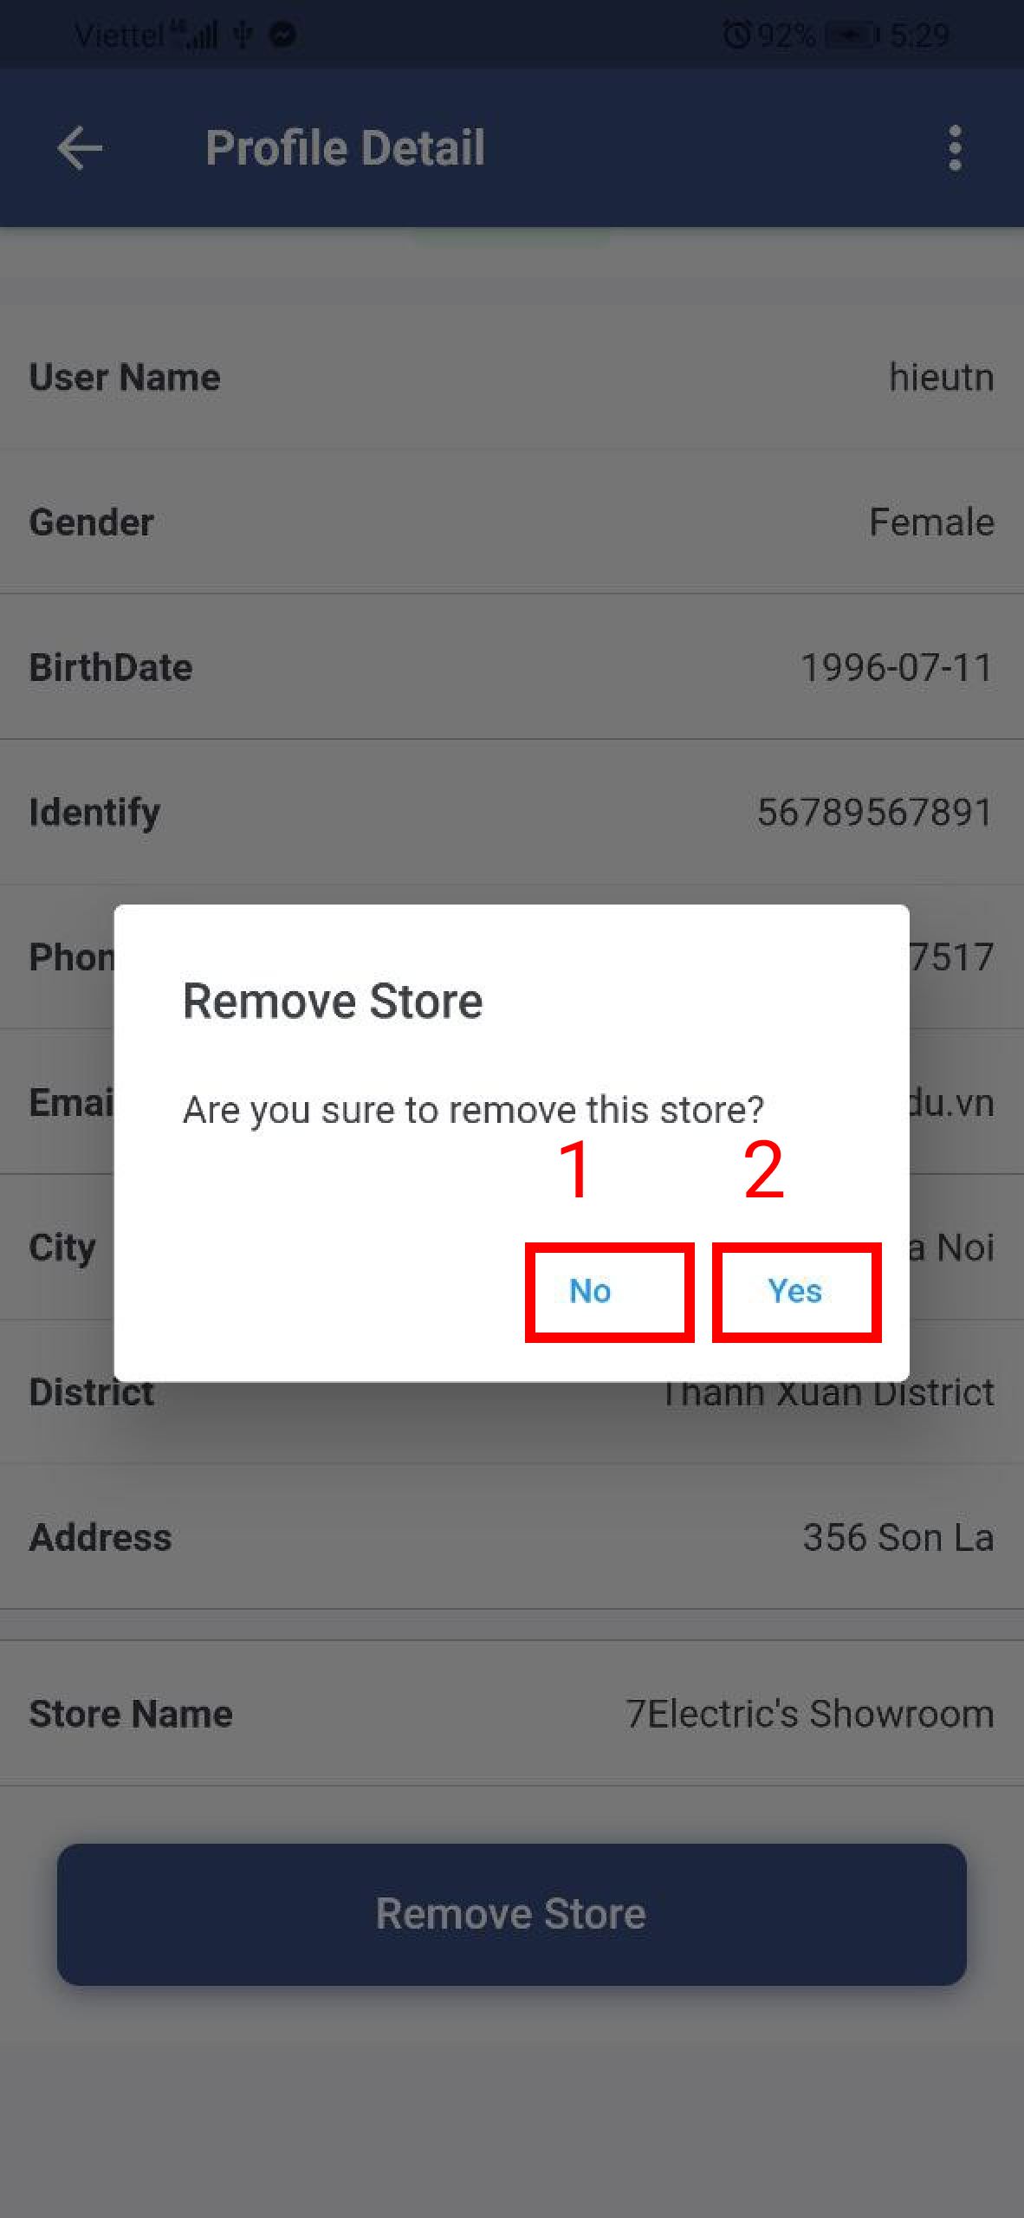

Figure xx. Remove the store from the manager

Table x. <User Guide> Remove the store from the manager

|  |  |
| --- | --- |
| **Step** | **Description** |
| 1 | Admin clicks the “No” button to cancel the command. |
| 2 | Admin clicks the “Yes” button to remove the store from the manager. |

##### h. Store page



Figure xx. Store page

Table x. <User Guide> Store page

|  |  |
| --- | --- |
| **Step** | **Description** |
| 1 | Admin inputs the search value and chooses the value of filter. |
| 2 | Admin clicks the item to view the store detail page. |
| 3 | Admin clicks the “Add” icon to create the store. |

1. Create the store



Figure xx. Create the store

Table x. <User Guide> Create the store

|  |  |
| --- | --- |
| **Step** | **Description** |
| 1 | Admin clicks the “back” icon to cancel the command. |
| 2 | Admin inputs the store’s information. |
| 3 | Admin clicks the “Create” button to create the store. |

##### i. Store detail page



Figure xx. Store detail page



Figure xx. Store detail page

Table x. <User Guide> Store detail page

|  |  |
| --- | --- |
| **Step** | **Description** |
| 1 | Admin clicks the item to change the store’s information. |
| 2 | Admin clicks the item to change the store’s image. |
| 3 | Admin clicks the item to delete the store. |
| 4 | Admin clicks the “Choose Manager” button to choose the manager from the store. |
| 5 | Admin clicks the “Remove Manager” button remove the manager from the store. |
| 3 | Admin clicks the item to reset the manager’s password. |

1. Change the store’s information



Figure xx. Change the store’s information

Table x. <User Guide> Change the store’s information

|  |  |
| --- | --- |
| **Step** | **Description** |
| 1 | Admin clicks the “back” icon to cancel the command. |
| 2 | Admin inputs the store’s information. |
| 3 | Admin clicks the “Save” button to change the store’s information. |

2. Change the store’s image.



Figure xx. Change the store’s image



Figure xx. Change the store’s image

Table x. <User Guide> Change the store’s image

|  |  |
| --- | --- |
| **Step** | **Description** |
| 1 | Admin clicks the “back” icon to cancel the command. |
| 2 | Admin clicks the “camera” icon to choose image from mobile. |
| 3 | Admin clicks the “Save” button to change the store’s image. |

3. Delete the store.



Figure xx. Delete the store

Table x. <User Guide> Delete the store

|  |  |
| --- | --- |
| **Step** | **Description** |
| 1 | Admin clicks the “back” icon to cancel the command. |
| 2 | Admin inputs an inactive reason. |
| 3 | Admin clicks the “Save” button to delete the store. |

4. Add the manager into the store



Figure xx. Add the manager into the store



Figure xx. Add the manager into the store

Table x. <User Guide> Add the manager into the store

|  |  |
| --- | --- |
| **Step** | **Description** |
| 1 | Admin inputs the search value to find the manager by full name. |
| 2 | Admin chooses the manager item. |
| 3 | Admin clicks the “No” button to cancel the command. |
| 4 | Admin clicks the “Yes” button to add the manager into the store. |

1. Remove the manager from the store



Figure xx. Remove the manager from the store

Table x. <User Guide> Remove the manager from the store

|  |  |
| --- | --- |
| **Step** | **Description** |
| 1 | Admin clicks the “No” button to cancel the command. |
| 2 | Admin clicks the “Yes” button to remove the manager from the store. |

##### j. Camera page



Figure xx. Camera page

Table x. <User Guide> Camera page

|  |  |
| --- | --- |
| **Step** | **Description** |
| 1 | Admin inputs the search value and chooses the value of filter. |
| 2 | Admin clicks the item to view the camera detail page. |
| 3 | Admin clicks the “Add” icon to create the camera. |

1. Create the camera



Figure xx. Create the camera

Table x. <User Guide> Create the camera

|  |  |
| --- | --- |
| **Step** | **Description** |
| 1 | Admin clicks the “back” icon to cancel the command. |
| 2 | Admin inputs the camera’s information. |
| 3 | Admin clicks the “Create” button to create the camera. |

##### k. Camera detail



Figure xx. Camera detail page

Table x. <User Guide> Camera detail page

|  |  |
| --- | --- |
| **Step** | **Description** |
| 1 | Admin clicks the item to change the camera’s information. |
| 2 | Admin clicks the item to change the camera’s image. |
| 3 | Admin clicks the item to delete the camera. |

1. Change the camera’s information



Figure xx. Change the camera’s information

Table x. <User Guide> Change the camera’s information

|  |  |
| --- | --- |
| **Step** | **Description** |
| 1 | Admin clicks the “back” icon to cancel the command. |
| 2 | Admin inputs the camera’s information. |
| 3 | Admin clicks the “Save” button to change the camera’s information. |

2. Change the camera’s image.



Figure xx. Change the camera’s image



Figure xx. Change the camera’s image

Table x. <User Guide> Change the camera’s image

|  |  |
| --- | --- |
| **Step** | **Description** |
| 1 | Admin clicks the “back” icon to cancel the command. |
| 2 | Admin clicks the “camera” icon to choose image from mobile. |
| 3 | Admin clicks the “Save” button to change the camera’s image. |

3. Delete the camera



Figure xx. Delete the camera

Table x. <User Guide> Delete the camera

|  |  |
| --- | --- |
| **Step** | **Description** |
| 1 | Admin clicks the “back” icon to cancel the command. |
| 2 | Admin inputs an inactive reason. |
| 3 | Admin clicks the “Save” button to delete the camera. |

##### l. Product page



Figure xx. Product page

Table x. <User Guide> Product page

|  |  |
| --- | --- |
| **Step** | **Description** |
| 1 | Admin inputs the search value and chooses the value of filter. |
| 2 | Admin clicks the item to view the product detail page. |
| 3 | Admin clicks the “Add” icon to create the product. |

1. Create the product



Figure xx. Create the product

Table x. <User Guide> Create the product

|  |  |
| --- | --- |
| **Step** | **Description** |
| 1 | Admin clicks the “back” icon to cancel the command. |
| 2 | Admin inputs the product’s information. |
| 3 | Admin clicks the “Create” button to create the product. |

##### m. Product detail page



Figure xx. Product detail page

Table x. <User Guide> Product detail page

|  |  |
| --- | --- |
| **Step** | **Description** |
| 1 | Admin clicks the item to change the product’s information. |
| 2 | Admin clicks the item to change the product’s image. |
| 3 | Admin clicks the item to delete the product. |

1. Change the product’s information.



Figure xx. Change the product’s information

Table x. <User Guide> Change the product’s information

|  |  |
| --- | --- |
| **Step** | **Description** |
| 1 | Admin clicks the “back” icon to cancel the command. |
| 2 | Admin inputs the product’s information. |
| 3 | Admin clicks the “Save” button to change the product’s information. |

2. Change the product’s image



Figure xx. Change the product’s image



Figure xx. Change the product’s image

Table x. <User Guide> Change the product’s image

|  |  |
| --- | --- |
| **Step** | **Description** |
| 1 | Admin clicks the “back” icon to cancel the command. |
| 2 | Admin clicks the “camera” icon to choose image from mobile. |
| 3 | Admin clicks the “Save” button to change the product’s image. |

3. Delete the product



Figure xx. Delete the product

Table x. <User Guide> Delete the product

|  |  |
| --- | --- |
| **Step** | **Description** |
| 1 | Admin clicks the “back” icon to cancel the command. |
| 2 | Admin inputs an inactive reason. |
| 3 | Admin clicks the “Save” button to delete the product. |

##### n. Category page



Figure xx. Category page

Table x. <User Guide> Category page

|  |  |
| --- | --- |
| **Step** | **Description** |
| 1 | Admin inputs the search value and chooses the value of filter. |
| 2 | Admin clicks the item to view the category detail page. |
| 3 | Admin clicks the “Add” icon to create the category. |

1. Create the category

.

Figure xx. Create the category

Table x. <User Guide> Create the category

|  |  |
| --- | --- |
| **Step** | **Description** |
| 1 | Admin clicks the “back” icon to cancel the command. |
| 2 | Admin inputs the category’s information. |
| 3 | Admin clicks the “Create” button to create the category. |

##### o. Category detail page



Figure xx. Category detail page

Table x. <User Guide> Category detail page

|  |  |
| --- | --- |
| **Step** | **Description** |
| 1 | Admin clicks the item to change the category’s information. |
| 2 | Admin clicks the item to delete the category. |

1. Change the category’s information.



Figure xx. Change the category’s information

Table x. <User Guide> Change the category’s information

|  |  |
| --- | --- |
| **Step** | **Description** |
| 1 | Admin clicks the “back” icon to cancel the command. |
| 2 | Admin inputs the category’s information. |
| 3 | Admin clicks the “Save” button to change the category’s information. |

2. Delete the category



Figure xx. Delete the category

Table x. <User Guide> Delete the category

|  |  |
| --- | --- |
| **Step** | **Description** |
| 1 | Admin clicks the “No” button to cancel the command. |
| 2 | Admin clicks the “Yes” button to delete the category. |

#### 3.3.4. CFFE-Mobile-Manager

##### a. Overview

Application used by admin when want to:

+ Login

+ Logout

+ Manage own profile

+ View statistics

+ View video

+ Manage shelf

+ Manage stack

+ Manage camera

+ Manage product

##### b. Login page



Figure xx. Login page

Table x. <User Guide> Login page

|  |  |
| --- | --- |
| **Step** | **Description** |
| 1 | Manager inputs the account. |
| 2 | Manager clicks the “Login” button. |

##### c. Home page



Figure xx. Dashboard page



Figure xx.

Table x. <User Guide> Dashboard page

|  |  |
| --- | --- |
| **Step** | **Description** |
| 1 | Manager clicks the “navigator” icon to view drawer navigator. |
| 2 | Manager clicks the “Profile” item to view own profile. |
| 3 | Manager clicks the “Logout” item to logout from the application. |

##### d. Profile page



Figure xx. Manager profile page

Table x. <User Guide> Manager profile page

|  |  |
| --- | --- |
| **Step** | **Description** |
| 1 | Manager clicks the item to change own information. |
| 2 | Manager clicks the item to change own avatar. |
| 3 | Manager clicks the item to change own password. |

1. Change own information.



Figure xx. Change the own information

Table x. <User Guide> Change the own information

|  |  |
| --- | --- |
| **Step** | **Description** |
| 1 | Manager clicks the “back” icon to cancel the command. |
| 2 | Manager edits the information. |
| 3 | Manager clicks the “Save” button to change own information |

2. Change own avatar.



Figure xx. Change own avatar



Figure xx. Change own avatar

Table x. <User Guide> Change own avatar

|  |  |
| --- | --- |
| **Step** | **Description** |
| 1 | Manager clicks the “back” icon to cancel the command. |
| 2 | Manager clicks the “camera” icon to choose image from mobile. |
| 3 | Manager clicks the “Save” button to change own avatar. |

1. Change own password



Figure xx. Change own password

Table x. <User Guide> Change own password

|  |  |
| --- | --- |
| **Step** | **Description** |
| 1 | Manager clicks the “back” icon to cancel the command. |
| 2 | Manager inputs the information. |
| 3 | Manager clicks the “Update” button to change own password. |

##### e. Video page



Figure xx. Video page

Table x. <User Guide> Video page

|  |  |
| --- | --- |
| **Step** | **Description** |
| 1 | Manager chooses the value of filter to search the video. |
| 2 | Manager clicks the “Search” button to search the video. |
| 3 | Manager clicks the item to view the video detail page. |

##### f. Shelf page



Figure xx. Shelf page

Table x. <User Guide> Shelf page

|  |  |
| --- | --- |
| **Step** | **Description** |
| 1 | Manager inputs the search value and chooses the value of filter. |
| 2 | Manager clicks the item to view the shelf detail page. |
| 3 | Manager clicks the “Add” icon to create the shelf. |

1. Create the shelf



Figure xx. Create the shelf

Table x. <User Guide> Create the shelf

|  |  |
| --- | --- |
| **Step** | **Description** |
| 1 | Manager clicks the “back” icon to cancel the command. |
| 2 | Manager inputs the shelf’s information. |
| 3 | Manager clicks the “Create” button to create the shelf. |

##### g. Shelf detail page



Figure xx. Shelf detail page



Figure xx. Shelf detail page

Table x. <User Guide> Shelf detail page

|  |  |
| --- | --- |
| **Step** | **Description** |
| 1 | Manager clicks the item to change the shelf’s information. |
| 2 | Manager clicks the item to delete the shelf. |
| 3 | Manager clicks the “add” icon to add the camera into the shelf. |
| 4 | Manager clicks the item to view stack detail page. |
| 5 | Manager clicks the “remove” icon to remove the camera from the shelf. |

1. Change the shelf’s information



Figure xx. Change the shelf’s information

Table x. <User Guide> Change the shelf’s information

|  |  |
| --- | --- |
| **Step** | **Description** |
| 1 | Manager clicks the “back” icon to cancel the command. |
| 2 | Manager inputs the shelf’s information. |
| 3 | Manager clicks the “Save” button to change the shelf’s information. |

1. Delete the shelf



Figure xx. Delete the shelf

Table x. <User Guide> Dele the shelf

|  |  |
| --- | --- |
| **Step** | **Description** |
| 1 | Manager clicks the “back” icon to cancel the command. |
| 2 | Manager inputs an inactive reason. |
| 3 | Manager clicks the “Save” button to delete the shelf. |

1. Add the camera into the shelf



Figure xx. Add the camera into the shelf

Table x. <User Guide>

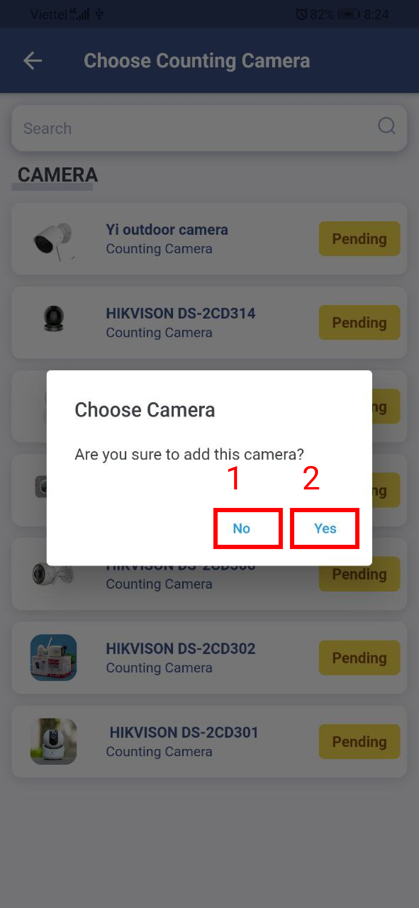

Figure xx. Add the camera into the shelf

Table x. <User Guide> Add the camera into the shelf

|  |  |
| --- | --- |
| **Step** | **Description** |
| 1 | Manager inputs the search value to find the camera by name. |
| 2 | Manager chooses the camera item. |
| 3 | Manager clicks the “No” button to cancel the command. |
| 4 | Manager clicks the “Yes” button to add the camera into the shelf. |

1. Remove the camera from the shelf



Figure xx. Remove the camera form the shelf

Table x. <User Guide> Remove the camera from the shelf

|  |  |
| --- | --- |
| **Step** | **Description** |
| 1 | Manager clicks the “No” button to cancel the command. |
| 2 | Manager clicks the “Yes” button to remove the camera from the shelf. |

##### h. Stack detail page



Figure xx. Stack detail page



Figure xx. Stack detail page

Table x. <User Guide> Stack detail page

|  |  |
| --- | --- |
| **Step** | **Description** |
| 1 | Manager clicks the item to delete the stack. |
| 2 | Manager clicks the “add” icon to add the product into the stack. |
| 3 | Manager clicks the “add” icon to add the camera into the stack. |
| 4 | Manager clicks the “remove” icon to remove the camera from the stack. |
| 5 | Manager clicks the “remove” icon to remove the product from the stack. |

1. Delete the stack.



Figure xx. Delete the stack

Table x. <User Guide> Delete the stack

|  |  |
| --- | --- |
| **Step** | **Description** |
| 1 | Manager clicks the “back” icon to cancel the command. |
| 2 | Manager inputs an inactive reason. |
| 3 | Manager clicks the “Save” button to delete the stack. |

1. Add the product into the stack.



Figure xx. Add the product into the stack



Figure xx. Add the product into the stack

Table x. <User Guide> Add the product into the stack

|  |  |
| --- | --- |
| **Step** | **Description** |
| 1 | Manager inputs the search value to find the product by name. |
| 2 | Manager chooses the product item. |
| 3 | Manager clicks the “No” button to cancel the command. |
| 4 | Manager clicks the “Yes” button to add the product into the stack. |

1. Add the camera into the stack.



Figure xx. Add the camera into the stack



Figure xx. Add the camera into the stack

Table x. <User Guide> Add the camera into the stack

|  |  |
| --- | --- |
| **Step** | **Description** |
| 1 | Manager inputs the search value to find the camera by name. |
| 2 | Manager chooses the camera item. |
| 3 | Manager clicks the “No” button to cancel the command. |
| 4 | Manager clicks the “Yes” button to add the camera into the stack. |

1. Remove the camera from the stack.

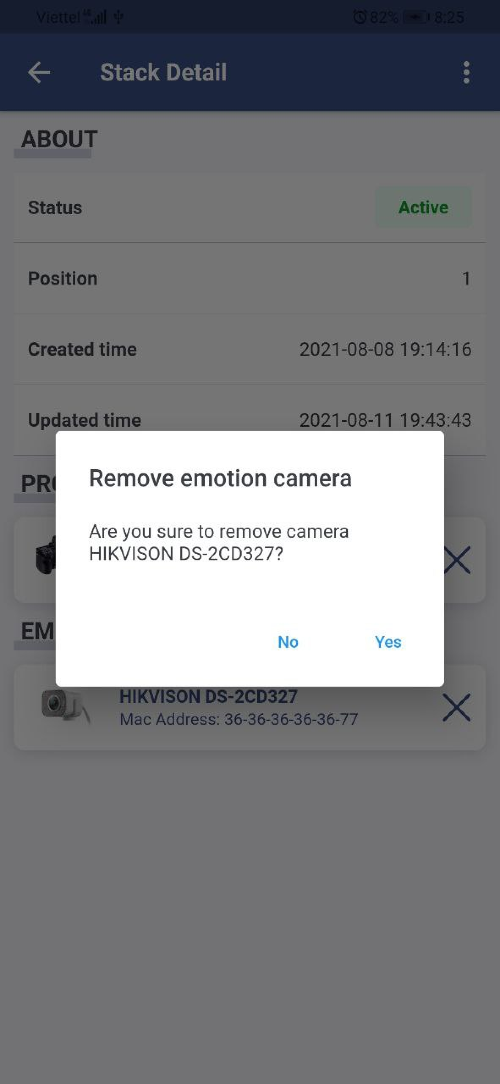

Figure xx. Remove the camera from the stack

Table x. <User Guide> Remove the camera from the stack

|  |  |
| --- | --- |
| **Step** | **Description** |
| 1 | Manager clicks the “No” button to cancel the command. |
| 2 | Manager clicks the “Yes” button to remove the camera from the stack. |

1. Remove the product from the stack.



Figure xx. Remove the product from the stack

Table x. <User Guide> Remove the product from the stack

|  |  |
| --- | --- |
| **Step** | **Description** |
| 1 | Manager clicks the “No” button to cancel the command. |
| 2 | Manager clicks the “Yes” button to remove the product from the stack. |

##### i. Camera detail page



Figure xx. Camera page

Table x. <User Guide> Camera page

|  |  |
| --- | --- |
| **Step** | **Description** |
| 1 | Manager inputs the search value and chooses the value of filter. |
| 2 | Manager clicks the item to view the camera detail page. |

##### j. Product page



Figure xx. Product page

Table x. <User Guide> Product page

|  |  |
| --- | --- |
| **Step** | **Description** |
| 1 | Manager inputs the search value and chooses the value of filter. |
| 2 | Manager clicks the item to view the product detail page. |

##### k. Category page



Figure xx. Category page

Table x. <User Guide> Category page

|  |  |
| --- | --- |
| **Step** | **Description** |
| 1 | Manager inputs the search value and chooses the value of filter. |
| 2 | Manager clicks the item to view the category detail page. |